Anexo Estadístico

**Aguascalientes**

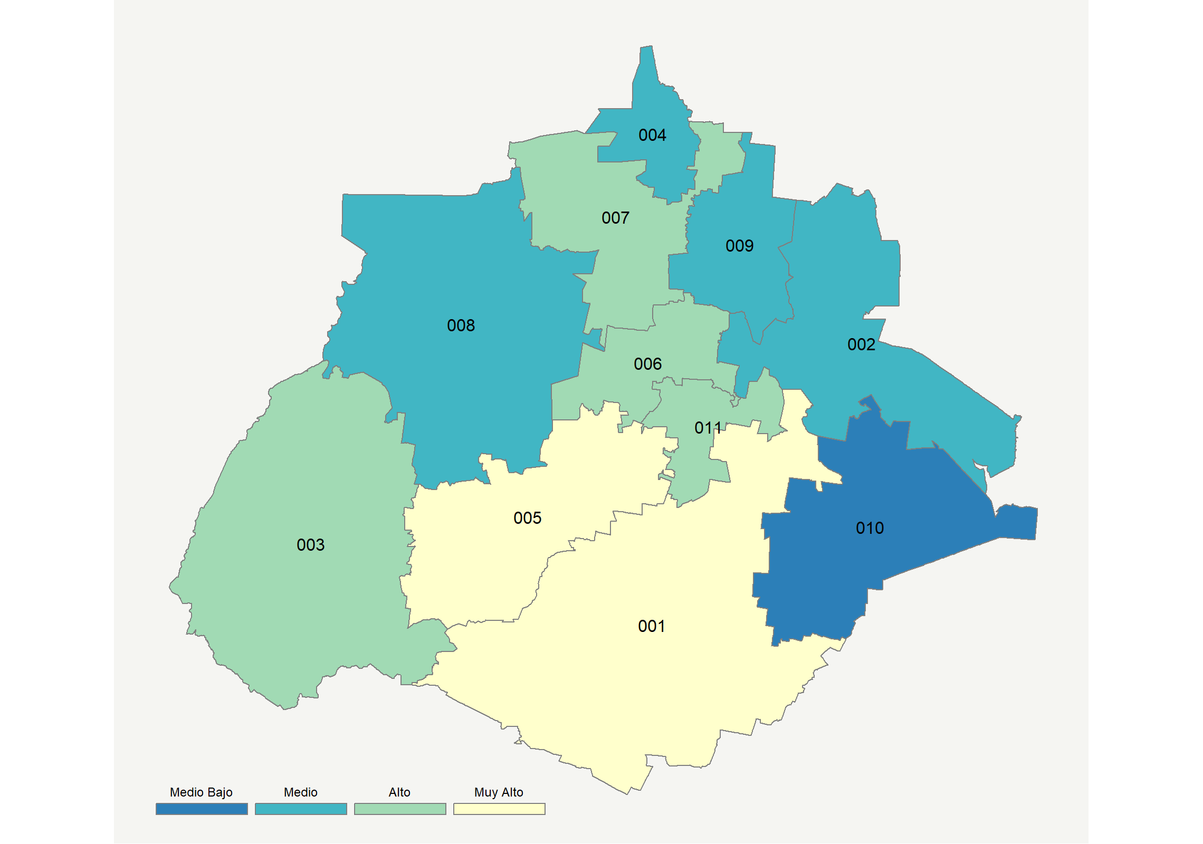

|  |  |  |  |  |  |  |  |  |  |  |  |  |  |
| --- | --- | --- | --- | --- | --- | --- | --- | --- | --- | --- | --- | --- | --- |
| **Clave del Municipio** | **Municipio** | **Telefonía fija a** | **Telefonía Celular a** | **Internet a** | **Televisión de paga a** | **Población Total a** | **Hasta 2 Salarios Mínimos b** | **Índice de Marginación** | **índice** | **Índice Escala 0-100** | **Lugar Nacional** | **Lugar Estatal** | **Estrato** |
| 001 | Aguascalientes | 44.1 | 88.9 | 42.1 | 51.5 | 877190 | 31.1 | -1.68 | 1.66 | 62.6 | 86 | 1 | Muy Alto |
| 002 | Asientos | 16.3 | 71.5 | 9.8 | 38.0 | 46464 | 52.8 | -0.57 | 0.10 | 31.8 | 1037 | 9 | Medio |
| 003 | Calvillo | 38.0 | 71.8 | 17.5 | 34.2 | 56048 | 62.0 | -0.70 | 0.60 | 41.8 | 523 | 5 | Alto |
| 004 | Cosío | 15.9 | 74.1 | 9.1 | 38.8 | 15577 | 49.8 | -0.67 | 0.11 | 32.1 | 1025 | 8 | Medio |
| 005 | Jesús María | 38.6 | 88.7 | 34.2 | 46.2 | 120405 | 33.8 | -1.26 | 1.32 | 55.9 | 175 | 2 | Muy Alto |
| 006 | Pabellón de Arteaga | 27.6 | 81.7 | 25.4 | 43.2 | 46473 | 41.5 | -1.13 | 0.82 | 46.0 | 385 | 3 | Alto |
| 007 | Rincón de Romos | 21.8 | 76.4 | 18.4 | 35.0 | 53866 | 43.4 | -1.05 | 0.41 | 38.1 | 705 | 6 | Alto |
| 008 | San José de Gracia | 23.8 | 79.0 | 10.4 | 43.5 | 8896 | 44.9 | -0.74 | 0.37 | 37.2 | 743 | 7 | Medio |
| 009 | Tepezalá | 14.2 | 72.8 | 9.2 | 32.4 | 20926 | 49.4 | -0.60 | 0.00 | 29.9 | 1146 | 10 | Medio |
| 010 | El Llano | 10.7 | 71.5 | 5.6 | 26.6 | 20245 | 48.8 | -0.61 | -0.23 | 25.5 | 1418 | 11 | Medio Bajo |
| 011 | San Francisco de los Romo | 16.3 | 90.1 | 21.7 | 48.6 | 46454 | 35.5 | -1.16 | 0.69 | 43.4 | 464 | 4 | Alto |
| a Porcentaje de viviendas que cuentas con el servicio  b Ingreso por trabajo de la población ocupada en porcentaje  Fuente: Elaboración propia con datos de Encuesta Intercensal 2015 de INEGI y CONAPO | | | | | | | | | | | | | |

**Baja California**

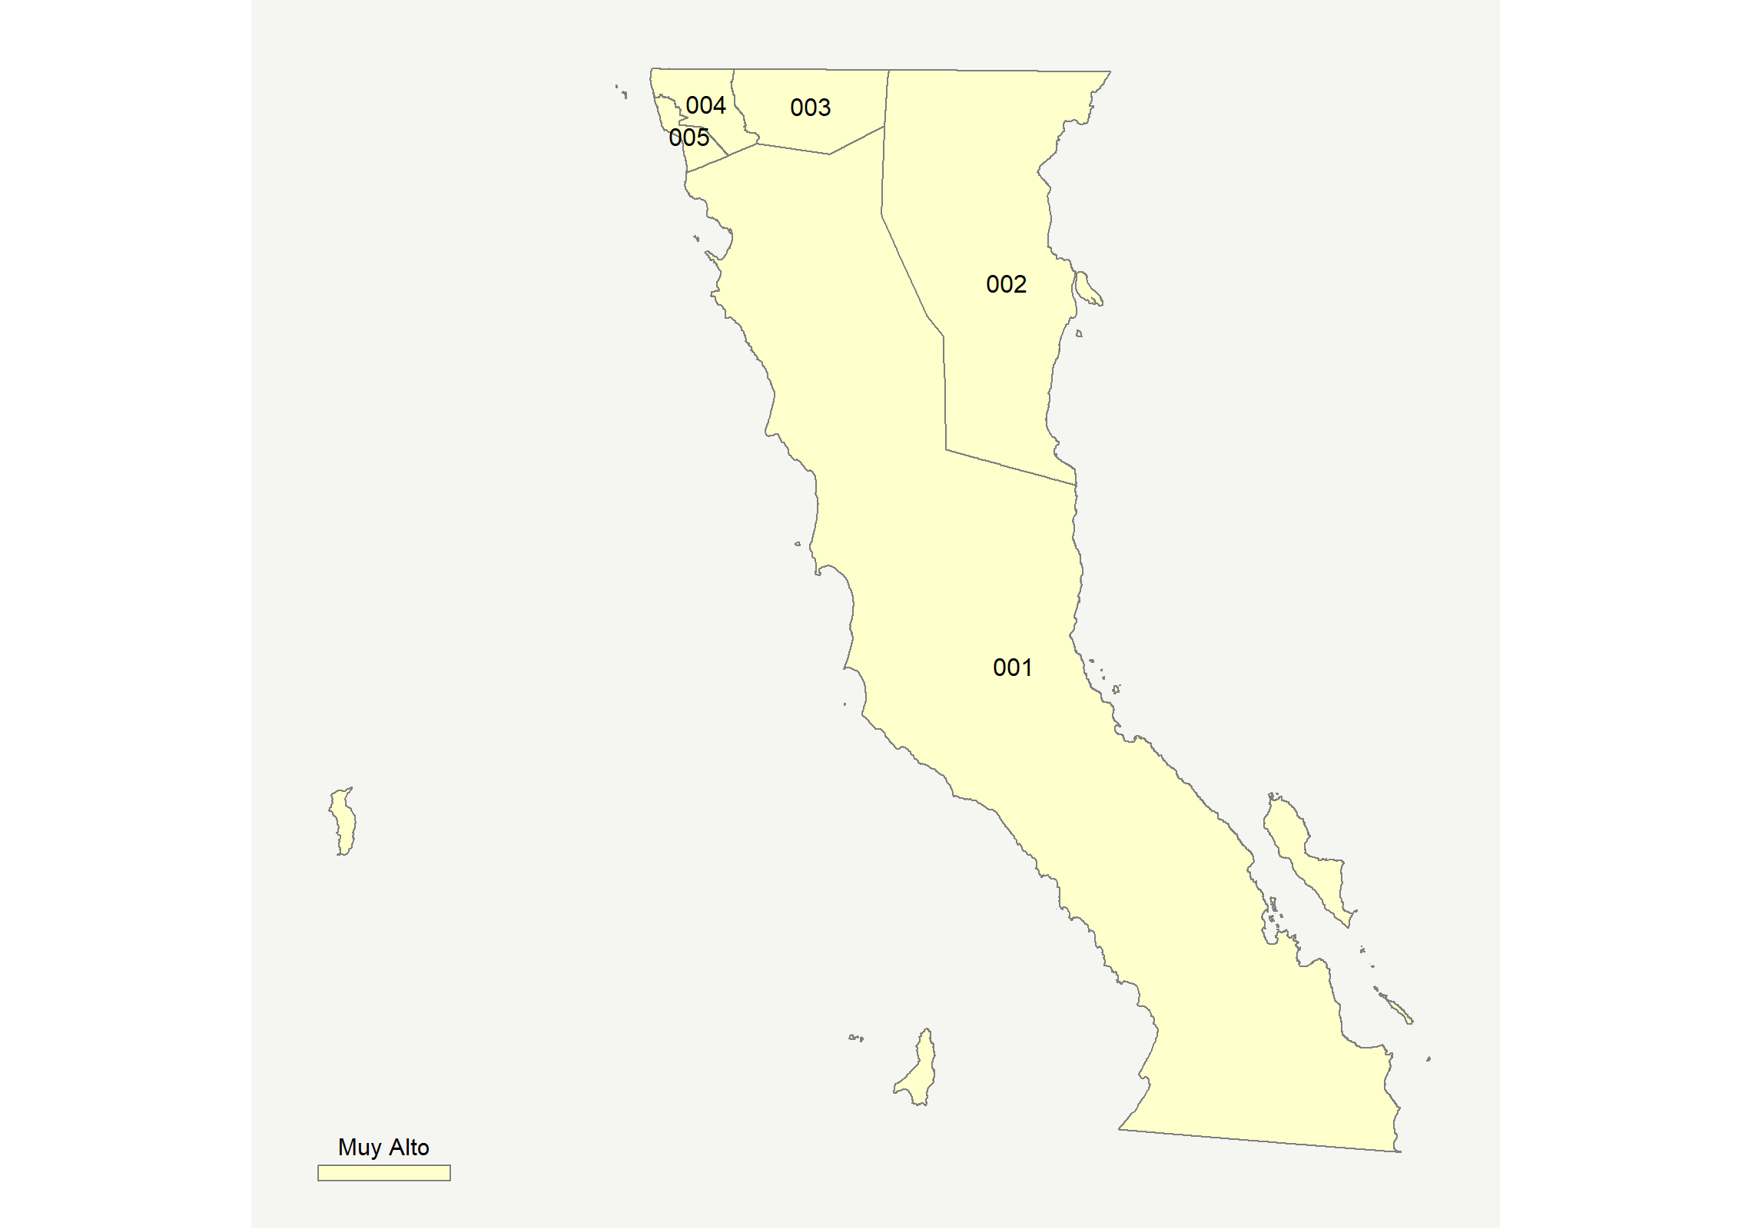

|  |  |  |  |  |  |  |  |  |  |  |  |  |  |
| --- | --- | --- | --- | --- | --- | --- | --- | --- | --- | --- | --- | --- | --- |
| **Clave del Municipio** | **Municipio** | **Telefonía fija a** | **Telefonía Celular a** | **Internet a** | **Televisión de paga a** | **Población Total a** | **Hasta 2 Salarios Mínimos b** | **Índice de Marginación** | **índice** | **Índice Escala 0-100** | **Lugar Nacional** | **Lugar Estatal** | **Estrato** |
| 001 | Ensenada | 38.1 | 90.7 | 44.8 | 66.0 | 486639 | 29.6 | -1.32 | 1.80 | 65.5 | 62 | 3 | Muy Alto |
| 002 | Mexicali | 44.4 | 91.7 | 49.0 | 51.1 | 988417 | 23.1 | -1.65 | 1.85 | 66.5 | 55 | 2 | Muy Alto |
| 003 | Tecate | 33.8 | 90.5 | 46.2 | 63.3 | 102406 | 25.4 | -1.41 | 1.73 | 64.1 | 73 | 5 | Muy Alto |
| 004 | Tijuana | 41.6 | 91.1 | 51.3 | 57.4 | 1641570 | 20.5 | -1.71 | 1.93 | 67.9 | 47 | 1 | Muy Alto |
| 005 | Playas de Rosarito | 33.6 | 89.1 | 46.1 | 67.3 | 96734 | 25.7 | -1.46 | 1.76 | 64.6 | 69 | 4 | Muy Alto |
| a Porcentaje de viviendas que cuentas con el servicio  b Ingreso por trabajo de la población ocupada en porcentaje  Fuente: Elaboración propia con datos de Encuesta Intercensal 2015 de INEGI y CONAPO | | | | | | | | | | | | | |

**Baja California Sur**

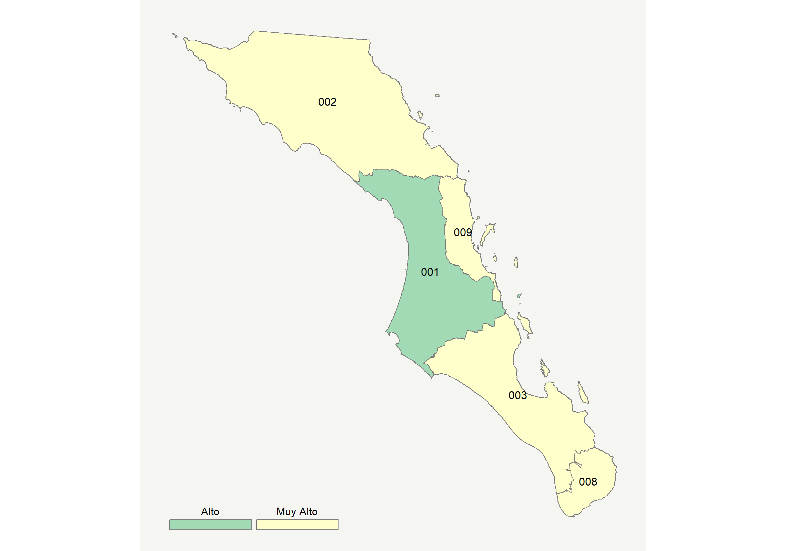

|  |  |  |  |  |  |  |  |  |  |  |  |  |  |
| --- | --- | --- | --- | --- | --- | --- | --- | --- | --- | --- | --- | --- | --- |
| **Clave del Municipio** | **Municipio** | **Telefonía fija a** | **Telefonía Celular a** | **Internet a** | **Televisión de paga a** | **Población Total a** | **Hasta 2 Salarios Mínimos b** | **Índice de Marginación** | **índice** | **Índice Escala 0-100** | **Lugar Nacional** | **Lugar Estatal** | **Estrato** |
| 001 | Comondú | 29.0 | 86.9 | 27.3 | 57.7 | 72564 | 40.1 | -1.02 | 1.10 | 51.6 | 258 | 5 | Alto |
| 002 | Mulegé | 32.9 | 87.5 | 30.4 | 70.1 | 60171 | 28.2 | -1.05 | 1.38 | 57.2 | 152 | 4 | Muy Alto |
| 003 | La Paz | 46.7 | 93.9 | 50.7 | 63.8 | 272711 | 22.2 | -1.66 | 2.10 | 71.3 | 35 | 1 | Muy Alto |
| 008 | Los Cabos | 31.6 | 94.5 | 43.4 | 59.9 | 287671 | 17.3 | -1.30 | 1.63 | 62.1 | 92 | 2 | Muy Alto |
| 009 | Loreto | 35.8 | 86.7 | 42.3 | 61.9 | 18912 | 27.5 | -1.35 | 1.62 | 61.9 | 97 | 3 | Muy Alto |
| a Porcentaje de viviendas que cuentas con el servicio  b Ingreso por trabajo de la población ocupada en porcentaje  Fuente: Elaboración propia con datos de Encuesta Intercensal 2015 de INEGI y CONAPO | | | | | | | | | | | | | |

**Campeche**

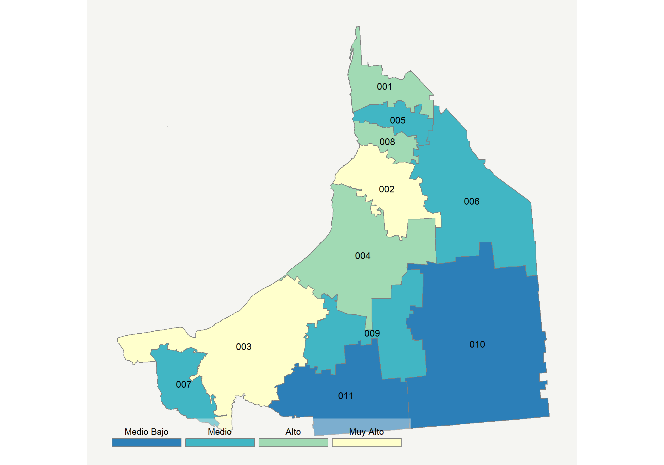

|  |  |  |  |  |  |  |  |  |  |  |  |  |  |
| --- | --- | --- | --- | --- | --- | --- | --- | --- | --- | --- | --- | --- | --- |
| **Clave del Municipio** | **Municipio** | **Telefonía fija a** | **Telefonía Celular a** | **Internet a** | **Televisión de paga a** | **Población Total a** | **Hasta 2 Salarios Mínimos b** | **Índice de Marginación** | **índice** | **Índice Escala 0-100** | **Lugar Nacional** | **Lugar Estatal** | **Estrato** |
| 001 | Calkiní | 11.5 | 68.6 | 15.7 | 74.0 | 56537 | 54.5 | -0.25 | 0.53 | 40.5 | 577 | 4 | Alto |
| 002 | Campeche | 31.4 | 89.2 | 41.9 | 61.2 | 283025 | 38.2 | -1.28 | 1.56 | 60.6 | 109 | 2 | Muy Alto |
| 003 | Carmen | 32.3 | 90.4 | 41.4 | 69.5 | 248303 | 22.4 | -1.19 | 1.66 | 62.7 | 84 | 1 | Muy Alto |
| 004 | Champotón | 12.2 | 74.4 | 12.9 | 69.1 | 90244 | 56.8 | -0.16 | 0.48 | 39.4 | 628 | 5 | Alto |
| 005 | Hecelchakán | 6.1 | 66.0 | 7.7 | 70.2 | 31230 | 51.4 | -0.29 | 0.18 | 33.5 | 944 | 7 | Medio |
| 006 | Hopelchén | 9.3 | 49.2 | 5.8 | 59.9 | 40100 | 66.6 | 0.36 | -0.09 | 28.2 | 1243 | 9 | Medio |
| 007 | Palizada | 9.5 | 76.8 | 6.8 | 65.0 | 8971 | 59.8 | 0.16 | 0.27 | 35.2 | 850 | 6 | Medio |
| 008 | Tenabo | 3.8 | 69.8 | 30.2 | 68.4 | 10665 | 63.6 | -0.13 | 0.71 | 43.9 | 454 | 3 | Alto |
| 009 | Escárcega | 14.5 | 74.1 | 10.4 | 41.4 | 58553 | 58.8 | -0.17 | 0.15 | 32.8 | 980 | 8 | Medio |
| 010 | Calakmul | 2.7 | 41.7 | 1.5 | 48.7 | 28424 | 44.8 | 0.71 | -0.50 | 20.0 | 1738 | 11 | Medio Bajo |
| 011 | Candelaria | 10.8 | 39.7 | 3.7 | 50.1 | 43879 | 60.3 | 0.77 | -0.32 | 23.6 | 1527 | 10 | Medio Bajo |
| a Porcentaje de viviendas que cuentas con el servicio  b Ingreso por trabajo de la población ocupada en porcentaje  Fuente: Elaboración propia con datos de Encuesta Intercensal 2015 de INEGI y CONAPO | | | | | | | | | | | | | |

**Chiapas**

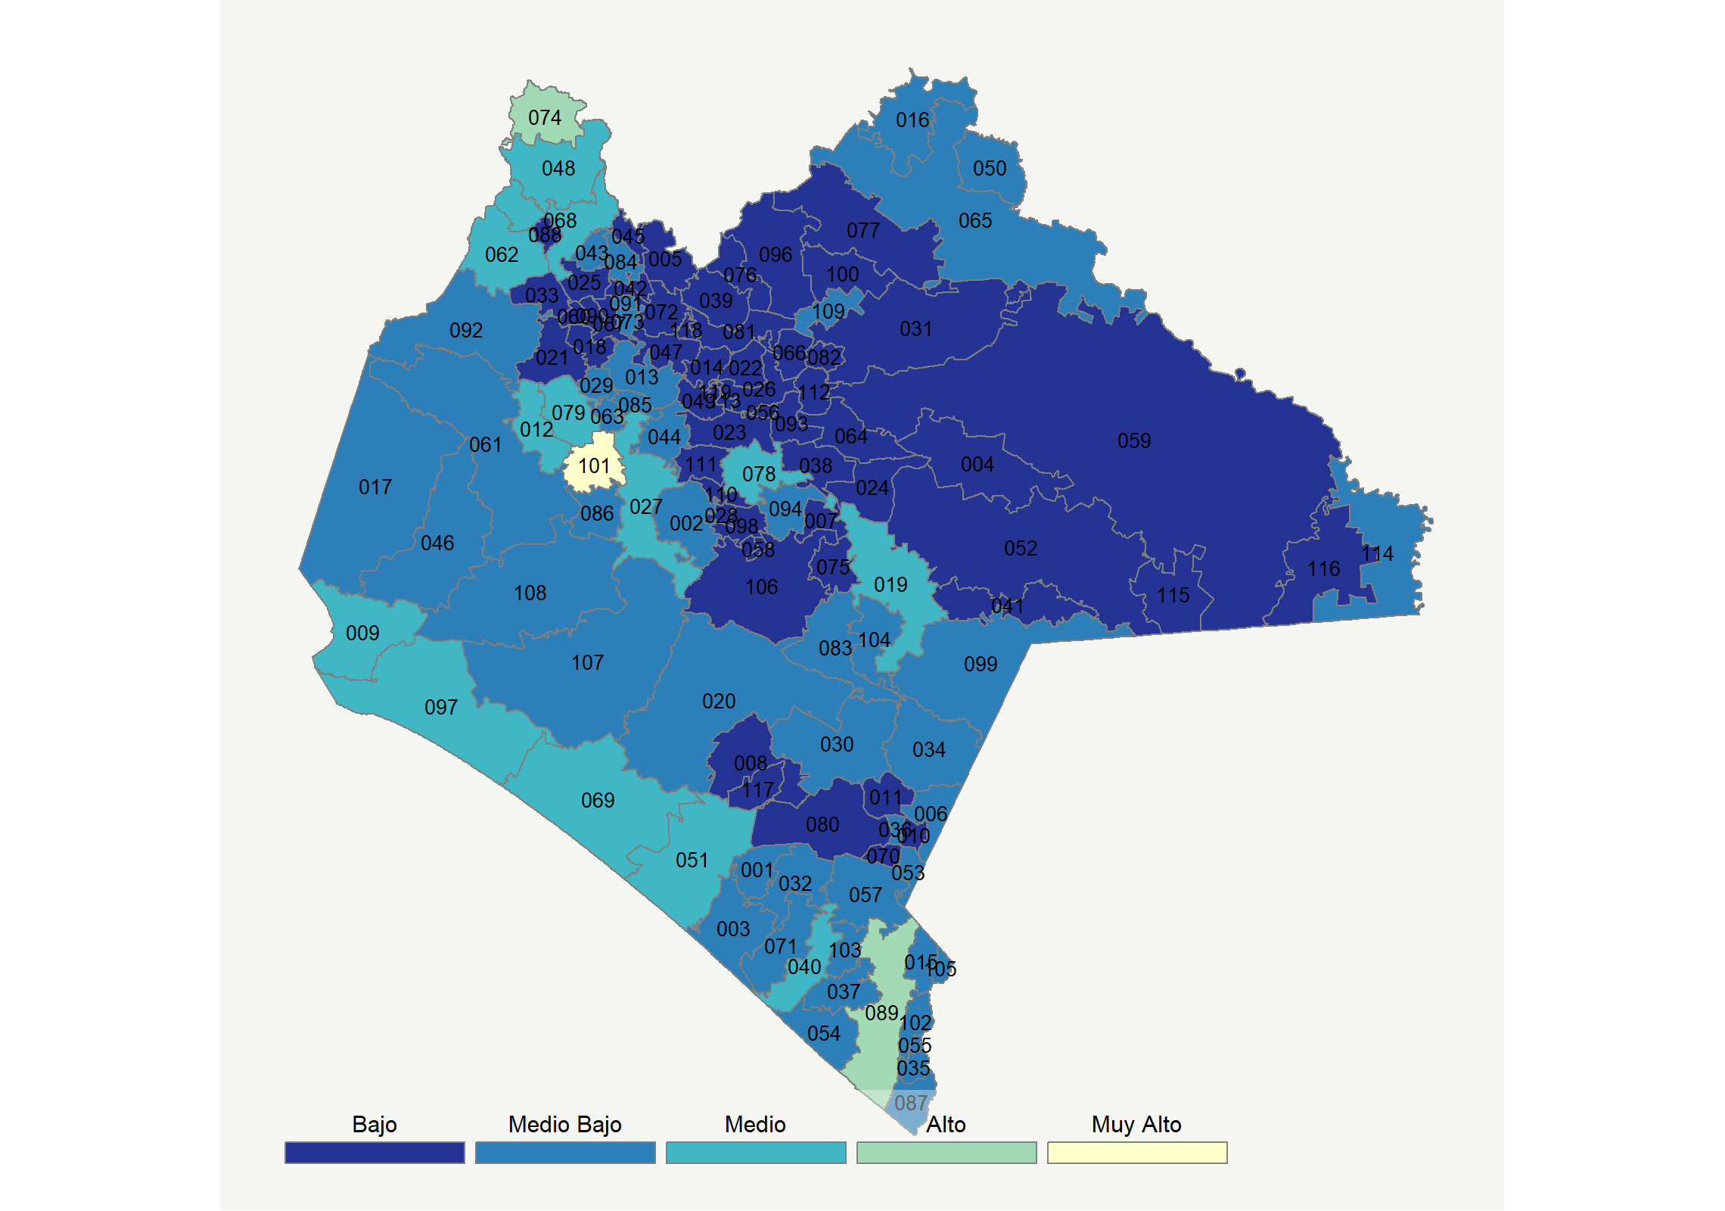

|  |  |  |  |  |  |  |  |  |  |  |  |  |  |
| --- | --- | --- | --- | --- | --- | --- | --- | --- | --- | --- | --- | --- | --- |
| **Clave del Municipio** | **Municipio** | **Telefonía fija a** | **Telefonía Celular a** | **Internet a** | **Televisión de paga a** | **Población Total a** | **Hasta 2 Salarios Mínimos b** | **Índice de Marginación** | **índice** | **Índice Escala 0-100** | **Lugar Nacional** | **Lugar Estatal** | **Estrato** |
| 001 | Acacoyagua | 6.1 | 68.7 | 3.0 | 35.6 | 18082 | 66.7 | 0.24 | -0.29 | 24.2 | 1492 | 28 | Medio Bajo |
| 002 | Acala | 5.4 | 64.6 | 3.1 | 19.9 | 31424 | 64.1 | 0.28 | -0.51 | 19.8 | 1751 | 45 | Medio Bajo |
| 003 | Acapetahua | 10.7 | 46.1 | 3.5 | 41.2 | 28380 | 71.6 | 0.74 | -0.36 | 22.8 | 1577 | 33 | Medio Bajo |
| 004 | Altamirano * | 1.6 | 29.8 | 1.5 | 11.9 | 32872 | 80.6 | 1.41 | -1.05 | 9.2 | 2213 | 85 | Bajo |
| 005 | Amatán | 1.1 | 15.4 | 0.9 | 9.6 | 19348 | 80.4 | 1.40 | -1.24 | 5.5 | 2321 | 104 | Bajo |
| 006 | Amatenango de la Frontera | 10.3 | 57.0 | 1.4 | 34.5 | 30732 | 70.6 | 0.51 | -0.39 | 22.3 | 1602 | 35 | Medio Bajo |
| 007 | Amatenango del Valle * | 0.5 | 25.9 | 0.2 | 1.1 | 9913 | 89.0 | 2.19 | -1.26 | 5.1 | 2327 | 105 | Bajo |
| 008 | Angel Albino Corzo | 4.3 | 47.4 | 4.4 | 16.3 | 28162 | 73.5 | 0.72 | -0.71 | 15.9 | 1933 | 65 | Bajo |
| 009 | Arriaga | 16.3 | 74.4 | 11.5 | 38.7 | 40114 | 63.4 | -0.27 | 0.17 | 33.4 | 956 | 7 | Medio |
| 010 | Bejucal de Ocampo | 2.4 | 37.3 | 0.5 | 5.5 | 7494 | 76.8 | 1.08 | -1.06 | 9.1 | 2215 | 86 | Bajo |
| 011 | Bella Vista | 8.4 | 32.8 | 0.9 | 11.5 | 20142 | 68.8 | 0.64 | -0.93 | 11.6 | 2115 | 78 | Bajo |
| 012 | Berriozábal | 7.3 | 75.0 | 14.6 | 32.6 | 51722 | 57.0 | 0.15 | 0.04 | 30.7 | 1107 | 10 | Medio |
| 013 | Bochil | 5.5 | 48.1 | 4.9 | 23.8 | 34997 | 77.9 | 0.66 | -0.59 | 18.3 | 1826 | 50 | Medio Bajo |
| 014 | El Bosque * | 1.5 | 46.9 | 4.7 | 8.8 | 22606 | 82.3 | 1.26 | -0.84 | 13.3 | 2049 | 73 | Bajo |
| 015 | Cacahoatán | 7.1 | 68.7 | 5.2 | 16.6 | 45594 | 71.4 | 0.09 | -0.43 | 21.4 | 1654 | 40 | Medio Bajo |
| 016 | Catazajá | 16.0 | 58.8 | 4.5 | 37.1 | 17065 | 70.1 | 0.58 | -0.17 | 26.5 | 1343 | 20 | Medio Bajo |
| 017 | Cintalapa | 12.2 | 66.7 | 7.7 | 33.3 | 84455 | 65.7 | 0.00 | -0.12 | 27.5 | 1284 | 18 | Medio Bajo |
| 018 | Coapilla | 2.1 | 49.8 | 1.0 | 11.8 | 9210 | 77.6 | 0.75 | -0.86 | 13.0 | 2065 | 75 | Bajo |
| 019 | Comitán de Domínguez | 13.4 | 74.6 | 11.8 | 20.8 | 153448 | 62.2 | -0.24 | -0.06 | 28.7 | 1214 | 12 | Medio |
| 020 | La Concordia | 6.9 | 51.9 | 8.1 | 15.3 | 46405 | 79.4 | 1.06 | -0.55 | 19.1 | 1782 | 47 | Medio Bajo |
| 021 | Copainalá | 3.1 | 41.6 | 1.8 | 23.4 | 21800 | 71.2 | 0.40 | -0.77 | 14.7 | 1996 | 71 | Bajo |
| 022 | Chalchihuitán * | 0.1 | 13.4 | 0.1 | 1.0 | 16803 | 84.9 | 2.85 | -1.39 | 2.5 | 2392 | 116 | Bajo |
| 023 | Chamula * | 3.3 | 32.6 | 0.4 | 0.7 | 87332 | 85.3 | 1.99 | -1.15 | 7.3 | 2269 | 92 | Bajo |
| 024 | Chanal * | 1.5 | 21.5 | 0.0 | 0.2 | 12181 | 47.7 | 1.48 | -1.30 | 4.3 | 2351 | 110 | Bajo |
| 025 | Chapultenango | 3.6 | 6.6 | 1.1 | 27.0 | 7644 | 62.4 | 0.34 | -1.09 | 8.5 | 2237 | 88 | Bajo |
| 026 | Chenalhó * | 1.6 | 26.8 | 0.6 | 2.8 | 39648 | 73.8 | 1.96 | -1.20 | 6.2 | 2309 | 102 | Bajo |
| 027 | Chiapa de Corzo | 10.5 | 80.8 | 13.0 | 38.3 | 100751 | 52.4 | -0.20 | 0.17 | 33.3 | 958 | 8 | Medio |
| 028 | Chiapilla | 4.5 | 54.1 | 0.5 | 14.2 | 5899 | 77.3 | 1.01 | -0.76 | 14.9 | 1990 | 69 | Bajo |
| 029 | Chicoasén * | 4.5 | 73.2 | 3.0 | 43.2 | 5000 | 44.2 | -0.02 | -0.19 | 26.2 | 1370 | 22 | Medio Bajo |
| 030 | Chicomuselo | 8.5 | 49.7 | 1.5 | 15.1 | 34744 | 71.4 | 0.79 | -0.70 | 16.0 | 1926 | 62 | Medio Bajo |
| 031 | Chilón * | 0.8 | 21.2 | 0.5 | 9.3 | 127914 | 75.0 | 2.24 | -1.20 | 6.3 | 2306 | 101 | Bajo |
| 032 | Escuintla | 8.3 | 45.1 | 3.6 | 40.9 | 31822 | 70.3 | 0.31 | -0.41 | 21.8 | 1629 | 37 | Medio Bajo |
| 033 | Francisco León | 0.7 | 10.4 | 0.5 | 20.2 | 7430 | 86.2 | 1.11 | -1.19 | 6.5 | 2299 | 98 | Bajo |
| 034 | Frontera Comalapa | 10.1 | 59.6 | 3.2 | 24.8 | 73436 | 76.7 | 0.34 | -0.43 | 21.5 | 1650 | 39 | Medio Bajo |
| 035 | Frontera Hidalgo | 4.2 | 59.2 | 5.9 | 12.7 | 14416 | 68.7 | 0.58 | -0.60 | 18.0 | 1840 | 51 | Medio Bajo |
| 036 | La Grandeza * | 7.6 | 65.6 | 1.9 | 12.6 | 7057 | 62.2 | 0.48 | -0.58 | 18.5 | 1814 | 48 | Medio Bajo |
| 037 | Huehuetán | 8.7 | 62.6 | 4.4 | 23.8 | 35017 | 64.3 | 0.51 | -0.41 | 21.9 | 1624 | 36 | Medio Bajo |
| 038 | Huixtán | 2.2 | 28.9 | 0.8 | 2.0 | 23625 | 63.7 | 1.02 | -1.18 | 6.7 | 2291 | 97 | Bajo |
| 039 | Huitiupán | 0.8 | 13.6 | 0.4 | 10.0 | 23172 | 67.0 | 1.25 | -1.27 | 4.8 | 2335 | 108 | Bajo |
| 040 | Huixtla | 10.1 | 65.4 | 9.6 | 36.3 | 54332 | 67.4 | 0.14 | -0.09 | 28.2 | 1241 | 15 | Medio |
| 041 | La Independencia | 3.2 | 49.3 | 1.5 | 22.6 | 44891 | 72.4 | 0.52 | -0.71 | 15.9 | 1931 | 64 | Bajo |
| 042 | Ixhuatán | 1.1 | 51.0 | 2.0 | 23.6 | 11342 | 83.4 | 0.49 | -0.71 | 16.0 | 1928 | 63 | Bajo |
| 043 | Ixtacomitán | 2.3 | 56.5 | 6.7 | 27.6 | 10772 | 66.5 | 0.60 | -0.47 | 20.6 | 1702 | 43 | Medio Bajo |
| 044 | Ixtapa | 6.0 | 56.4 | 3.9 | 11.6 | 27198 | 74.7 | 0.48 | -0.66 | 16.9 | 1890 | 58 | Medio Bajo |
| 045 | Ixtapangajoya * | 2.1 | 34.3 | 1.1 | 16.2 | 5384 | 74.5 | 0.85 | -0.96 | 11.0 | 2140 | 80 | Bajo |
| 046 | Jiquipilas | 10.5 | 53.4 | 3.1 | 35.6 | 39109 | 74.1 | 0.28 | -0.37 | 22.7 | 1580 | 34 | Medio Bajo |
| 047 | Jitotol * | 2.3 | 40.8 | 0.9 | 15.6 | 20606 | 72.1 | 0.78 | -0.90 | 12.1 | 2098 | 77 | Bajo |
| 048 | Juárez | 9.1 | 74.7 | 20.4 | 46.4 | 21222 | 57.3 | 0.01 | 0.36 | 37.0 | 754 | 4 | Medio |
| 049 | Larráinzar * | 0.8 | 41.6 | 4.2 | 2.3 | 23889 | 83.8 | 1.21 | -0.99 | 10.4 | 2164 | 82 | Bajo |
| 050 | La Libertad | 9.4 | 69.7 | 4.4 | 30.5 | 4915 | 76.3 | 0.32 | -0.25 | 25.0 | 1446 | 27 | Medio Bajo |
| 051 | Mapastepec | 9.1 | 64.2 | 4.9 | 49.4 | 47932 | 66.8 | 0.25 | -0.09 | 28.2 | 1237 | 13 | Medio |
| 052 | Las Margaritas | 4.6 | 27.9 | 2.9 | 14.4 | 122821 | 81.1 | 1.39 | -0.96 | 11.1 | 2139 | 79 | Bajo |
| 053 | Mazapa de Madero | 5.5 | 54.5 | 2.1 | 21.7 | 7769 | 64.6 | 0.35 | -0.62 | 17.7 | 1860 | 53 | Medio Bajo |
| 054 | Mazatán | 7.8 | 57.1 | 4.3 | 19.5 | 29239 | 76.8 | 0.82 | -0.53 | 19.5 | 1762 | 46 | Medio Bajo |
| 055 | Metapa * | 12.2 | 76.4 | 9.2 | 21.6 | 5743 | 64.8 | 0.00 | -0.12 | 27.6 | 1278 | 17 | Medio Bajo |
| 056 | Mitontic * | 3.3 | 4.8 | 0.2 | 2.7 | 11906 | 78.8 | 2.12 | -1.40 | 2.3 | 2403 | 117 | Bajo |
| 057 | Motozintla | 6.6 | 44.5 | 4.2 | 24.4 | 72967 | 63.0 | 0.26 | -0.62 | 17.7 | 1861 | 54 | Medio Bajo |
| 058 | Nicolás Ruíz * | 5.0 | 10.5 | 0.3 | 4.7 | 4262 | 86.3 | 1.26 | -1.29 | 4.4 | 2346 | 109 | Bajo |
| 059 | Ocosingo | 3.9 | 35.9 | 3.6 | 19.5 | 218893 | 63.0 | 1.42 | -0.82 | 13.8 | 2038 | 72 | Bajo |
| 060 | Ocotepec | 1.6 | 8.2 | 0.2 | 15.1 | 12508 | 75.6 | 1.85 | -1.26 | 5.1 | 2328 | 106 | Bajo |
| 061 | Ocozocoautla de Espinosa | 8.2 | 55.5 | 7.0 | 22.0 | 92103 | 64.4 | 0.38 | -0.44 | 21.2 | 1666 | 41 | Medio Bajo |
| 062 | Ostuacán | 2.3 | 55.6 | 13.7 | 53.7 | 18128 | 69.5 | 0.72 | -0.02 | 29.5 | 1170 | 11 | Medio |
| 063 | Osumacinta * | 4.8 | 67.9 | 2.5 | 37.1 | 3682 | 66.7 | 0.02 | -0.32 | 23.7 | 1521 | 29 | Medio Bajo |
| 064 | Oxchuc | 0.3 | 13.7 | 0.5 | 1.9 | 48126 | 56.8 | 2.08 | -1.37 | 3.0 | 2387 | 115 | Bajo |
| 065 | Palenque | 5.9 | 51.3 | 4.9 | 32.7 | 119826 | 63.3 | 0.48 | -0.45 | 21.0 | 1678 | 42 | Medio Bajo |
| 066 | Pantelhó * | 0.9 | 26.3 | 0.4 | 8.4 | 22011 | 77.9 | 2.48 | -1.16 | 7.0 | 2280 | 94 | Bajo |
| 067 | Pantepec | 1.1 | 31.4 | 0.5 | 17.8 | 12136 | 71.9 | 1.30 | -1.00 | 10.2 | 2174 | 84 | Bajo |
| 068 | Pichucalco | 8.4 | 70.1 | 13.3 | 55.5 | 31107 | 63.5 | 0.12 | 0.23 | 34.5 | 889 | 6 | Medio |
| 069 | Pijijiapan | 14.8 | 60.1 | 5.0 | 44.2 | 53525 | 70.5 | 0.51 | -0.09 | 28.2 | 1239 | 14 | Medio |
| 070 | El Porvenir | 0.7 | 18.2 | 0.2 | 11.8 | 14121 | 83.7 | 0.48 | -1.21 | 6.0 | 2311 | 103 | Bajo |
| 071 | Villa Comaltitlán | 8.0 | 49.1 | 1.5 | 24.2 | 28961 | 72.0 | 0.73 | -0.61 | 17.8 | 1854 | 52 | Medio Bajo |
| 072 | Pueblo Nuevo Solistahuacán | 3.2 | 45.1 | 3.1 | 17.8 | 31942 | 58.4 | 0.85 | -0.77 | 14.8 | 1994 | 70 | Bajo |
| 073 | Rayón | 2.8 | 59.2 | 2.3 | 16.9 | 9578 | 50.4 | 0.51 | -0.66 | 16.8 | 1899 | 59 | Medio Bajo |
| 074 | Reforma | 14.6 | 86.0 | 16.6 | 50.3 | 45104 | 28.1 | -0.90 | 0.51 | 40.1 | 595 | 2 | Alto |
| 075 | Las Rosas | 4.4 | 53.7 | 2.6 | 14.1 | 28261 | 80.7 | 1.39 | -0.72 | 15.8 | 1937 | 66 | Bajo |
| 076 | Sabanilla * | 0.6 | 10.4 | 0.3 | 5.1 | 26921 | 89.3 | 1.87 | -1.36 | 3.1 | 2383 | 114 | Bajo |
| 077 | Salto de Agua | 4.3 | 18.6 | 1.1 | 25.8 | 63446 | 82.1 | 1.48 | -0.97 | 10.8 | 2150 | 81 | Bajo |
| 078 | San Cristóbal de las Casas | 20.8 | 82.2 | 18.1 | 19.2 | 209591 | 56.3 | -0.73 | 0.27 | 35.2 | 847 | 5 | Medio |
| 079 | San Fernando | 6.2 | 73.4 | 7.8 | 38.4 | 39204 | 55.8 | 0.22 | -0.09 | 28.1 | 1251 | 16 | Medio |
| 080 | Siltepec | 2.4 | 22.9 | 0.8 | 17.2 | 35192 | 88.0 | 0.99 | -1.06 | 8.9 | 2220 | 87 | Bajo |
| 081 | Simojovel * | 2.2 | 35.2 | 1.5 | 11.5 | 44295 | 72.9 | 1.56 | -0.99 | 10.4 | 2168 | 83 | Bajo |
| 082 | Sitalá * | 0.1 | 18.0 | 0.1 | 8.2 | 13844 | 89.9 | 3.95 | -1.27 | 4.9 | 2330 | 107 | Bajo |
| 083 | Socoltenango | 4.5 | 57.1 | 2.2 | 13.3 | 18539 | 78.7 | 0.86 | -0.70 | 16.1 | 1923 | 61 | Medio Bajo |
| 084 | Solosuchiapa | 2.2 | 48.0 | 4.8 | 24.6 | 8082 | 78.2 | 0.86 | -0.64 | 17.3 | 1876 | 56 | Medio Bajo |
| 085 | Soyaló | 2.2 | 63.5 | 1.3 | 23.6 | 10707 | 69.0 | 0.29 | -0.58 | 18.4 | 1820 | 49 | Medio Bajo |
| 086 | Suchiapa | 7.7 | 70.8 | 7.4 | 28.9 | 24049 | 58.2 | 0.03 | -0.21 | 25.8 | 1396 | 23 | Medio Bajo |
| 087 | Suchiate | 6.9 | 62.2 | 7.4 | 19.3 | 38797 | 70.7 | 0.58 | -0.42 | 21.7 | 1634 | 38 | Medio Bajo |
| 088 | Sunuapa * | 2.9 | 32.1 | 1.3 | 34.3 | 2283 | 79.4 | 0.64 | -0.76 | 14.9 | 1989 | 68 | Bajo |
| 089 | Tapachula | 21.2 | 81.4 | 20.9 | 27.5 | 348156 | 53.3 | -0.58 | 0.43 | 38.4 | 691 | 3 | Alto |
| 090 | Tapalapa * | 1.2 | 19.0 | 0.6 | 11.1 | 3839 | 49.1 | 0.44 | -1.19 | 6.4 | 2304 | 100 | Bajo |
| 091 | Tapilula | 4.6 | 63.5 | 11.5 | 27.9 | 12887 | 65.8 | -0.02 | -0.25 | 25.1 | 1442 | 26 | Medio Bajo |
| 092 | Tecpatán | 3.2 | 40.4 | 2.5 | 35.6 | 41305 | 77.3 | 0.79 | -0.63 | 17.5 | 1871 | 55 | Medio Bajo |
| 093 | Tenejapa * | 7.4 | 17.0 | 0.3 | 4.5 | 43593 | 81.4 | 1.27 | -1.19 | 6.4 | 2303 | 99 | Bajo |
| 094 | Teopisca | 3.0 | 60.1 | 2.4 | 15.4 | 43175 | 83.3 | 1.10 | -0.67 | 16.8 | 1901 | 60 | Medio Bajo |
| 096 | Tila * | 1.3 | 22.5 | 1.0 | 12.7 | 77554 | 82.3 | 1.59 | -1.13 | 7.6 | 2260 | 91 | Bajo |
| 097 | Tonalá | 13.6 | 73.0 | 8.8 | 39.6 | 89178 | 65.0 | -0.03 | 0.06 | 31.1 | 1080 | 9 | Medio |
| 098 | Totolapa | 1.3 | 34.5 | 0.4 | 1.3 | 7284 | 82.9 | 1.44 | -1.15 | 7.2 | 2275 | 93 | Bajo |
| 099 | La Trinitaria | 7.6 | 50.6 | 1.7 | 20.1 | 76917 | 71.5 | 0.68 | -0.65 | 17.1 | 1882 | 57 | Medio Bajo |
| 100 | Tumbalá | 1.3 | 8.5 | 0.3 | 10.1 | 34305 | 56.2 | 1.56 | -1.31 | 4.0 | 2355 | 111 | Bajo |
| 101 | Tuxtla Gutiérrez | 33.7 | 92.2 | 39.1 | 42.1 | 598710 | 35.7 | -1.29 | 1.34 | 56.4 | 164 | 1 | Muy Alto |
| 102 | Tuxtla Chico | 7.3 | 71.9 | 10.4 | 21.9 | 41823 | 63.9 | 0.30 | -0.21 | 25.7 | 1399 | 24 | Medio Bajo |
| 103 | Tuzantán | 5.0 | 60.9 | 9.1 | 28.1 | 31755 | 78.1 | 0.62 | -0.32 | 23.5 | 1529 | 30 | Medio Bajo |
| 104 | Tzimol | 5.5 | 61.8 | 2.3 | 25.3 | 15316 | 82.9 | 0.54 | -0.50 | 20.1 | 1733 | 44 | Medio Bajo |
| 105 | Unión Juárez | 8.3 | 72.1 | 7.1 | 16.2 | 15350 | 83.8 | 0.42 | -0.34 | 23.3 | 1547 | 31 | Medio Bajo |
| 106 | Venustiano Carranza | 5.7 | 52.9 | 2.4 | 11.3 | 65009 | 79.9 | 0.85 | -0.74 | 15.4 | 1961 | 67 | Bajo |
| 107 | Villa Corzo | 10.6 | 61.5 | 7.6 | 30.9 | 79003 | 80.0 | 0.77 | -0.23 | 25.4 | 1421 | 25 | Medio Bajo |
| 108 | Villaflores | 9.3 | 69.8 | 6.6 | 36.8 | 104833 | 70.2 | 0.21 | -0.13 | 27.4 | 1291 | 19 | Medio Bajo |
| 109 | Yajalón | 7.9 | 56.7 | 7.3 | 29.0 | 37833 | 69.0 | 1.35 | -0.35 | 23.0 | 1560 | 32 | Medio Bajo |
| 110 | San Lucas | 1.5 | 31.7 | 0.3 | 2.8 | 7202 | 85.2 | 1.31 | -1.16 | 7.0 | 2282 | 95 | Bajo |
| 111 | Zinacantán | 2.0 | 36.1 | 0.6 | 3.0 | 41112 | 84.4 | 1.69 | -1.10 | 8.2 | 2243 | 89 | Bajo |
| 112 | San Juan Cancuc | 0.2 | 19.3 | 0.4 | 0.7 | 34829 | 77.4 | 2.60 | -1.33 | 3.7 | 2363 | 112 | Bajo |
| 113 | Aldama | 0.2 | 17.5 | 0.2 | 1.2 | 6712 | 79.1 | 1.17 | -1.34 | 3.4 | 2379 | 113 | Bajo |
| 114 | Benemérito de las Américas | 2.6 | 65.8 | 2.8 | 53.6 | 20193 | 68.8 | 0.93 | -0.18 | 26.3 | 1363 | 21 | Medio Bajo |
| 115 | Maravilla Tenejapa | 2.8 | 11.3 | 1.1 | 20.0 | 12945 | 89.9 | 1.69 | -1.13 | 7.6 | 2259 | 90 | Bajo |
| 116 | Marqués de Comillas | 5.8 | 16.1 | 0.5 | 34.5 | 11444 | 59.3 | 1.18 | -0.89 | 12.4 | 2086 | 76 | Bajo |
| 117 | Montecristo de Guerrero | 1.6 | 43.7 | 0.4 | 20.5 | 7682 | 82.2 | 1.01 | -0.84 | 13.3 | 2051 | 74 | Bajo |
| 118 | San Andrés Duraznal | 0.2 | 9.8 | 0.0 | 1.4 | 5163 | 88.2 | 1.34 | -1.42 | 1.8 | 2420 | 118 | Bajo |
| 119 | Santiago el Pinar | 0.1 | 35.2 | 0.4 | 1.6 | 3684 | 75.6 | 1.57 | -1.16 | 7.0 | 2283 | 96 | Bajo |
| a Porcentaje de viviendas que cuentas con el servicio  b Ingreso por trabajo de la población ocupada en porcentaje  Fuente: Elaboración propia con datos de Encuesta Intercensal 2015 de INEGI y CONAPO | | | | | | | | | | | | | |

**Chihuahua**

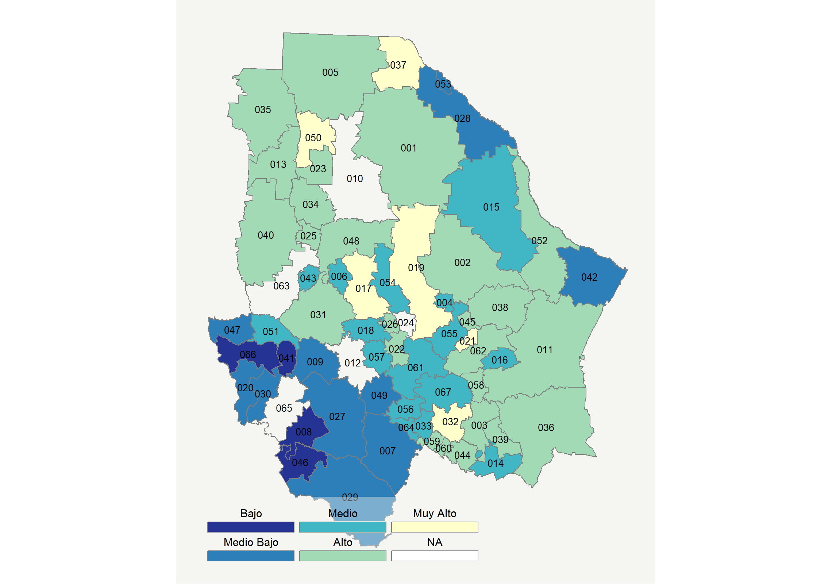

|  |  |  |  |  |  |  |  |  |  |  |  |  |  |
| --- | --- | --- | --- | --- | --- | --- | --- | --- | --- | --- | --- | --- | --- |
| **Clave del Municipio** | **Municipio** | **Telefonía fija a** | **Telefonía Celular a** | **Internet a** | **Televisión de paga a** | **Población Total a** | **Hasta 2 Salarios Mínimos b** | **Índice de Marginación** | **índice** | **Índice Escala 0-100** | **Lugar Nacional** | **Lugar Estatal** | **Estrato** |
| 001 | Ahumada | 22.5 | 87.7 | 21.2 | 61.2 | 12568 | 37.7 | -1.16 | 0.89 | 47.6 | 341 | 14 | Alto |
| 002 | Aldama | 34.7 | 90.4 | 26.4 | 39.2 | 24761 | 29.4 | -1.50 | 1.00 | 49.7 | 289 | 12 | Alto |
| 003 | Allende | 30.9 | 74.9 | 21.4 | 47.1 | 8751 | 39.1 | -0.95 | 0.75 | 44.8 | 428 | 17 | Alto |
| 004 | Aquiles Serdán | 8.8 | 94.4 | 12.0 | 33.2 | 15516 | 29.5 | -1.47 | 0.20 | 33.8 | 926 | 41 | Medio |
| 005 | Ascensión | 19.2 | 85.7 | 18.3 | 40.0 | 24966 | 40.4 | -0.96 | 0.51 | 40.0 | 597 | 27 | Alto |
| 006 | Bachíniva | 21.6 | 84.3 | 3.0 | 57.6 | 6156 | 39.0 | -0.80 | 0.37 | 37.1 | 748 | 34 | Medio |
| 007 | Balleza * | 10.5 | 50.8 | 4.3 | 26.2 | 16824 | 53.8 | 2.37 | -0.47 | 20.7 | 1695 | 55 | Medio Bajo |
| 008 | Batopilas * | 1.5 | 19.9 | 0.4 | 15.0 | 11289 | 62.1 | 5.03 | -1.14 | 7.4 | 2266 | 62 | Bajo |
| 009 | Bocoyna | 10.1 | 59.9 | 10.8 | 36.7 | 27909 | 48.5 | 0.84 | -0.11 | 27.7 | 1271 | 49 | Medio Bajo |
| 011 | Camargo | 31.9 | 85.9 | 29.2 | 49.5 | 51572 | 41.3 | -1.40 | 1.09 | 51.5 | 260 | 10 | Alto |
| 013 | Casas Grandes | 24.9 | 78.9 | 17.1 | 46.3 | 11432 | 51.4 | -0.97 | 0.58 | 41.4 | 538 | 21 | Alto |
| 014 | Coronado * | 22.3 | 67.1 | 4.6 | 54.8 | 2096 | 46.8 | -0.82 | 0.21 | 34.1 | 900 | 38 | Medio |
| 015 | Coyame del Sotol * | 21.8 | 73.2 | 3.3 | 46.6 | 1684 | 32.3 | -0.60 | 0.14 | 32.8 | 981 | 45 | Medio |
| 016 | La Cruz * | 16.3 | 82.4 | 6.9 | 56.9 | 3861 | 39.6 | -1.01 | 0.34 | 36.7 | 774 | 36 | Medio |
| 017 | Cuauhtémoc | 39.6 | 91.6 | 33.6 | 43.1 | 168482 | 24.9 | -1.47 | 1.31 | 55.8 | 177 | 4 | Muy Alto |
| 018 | Cusihuiriachi | 15.3 | 83.5 | 2.6 | 53.8 | 4594 | 43.8 | -0.71 | 0.20 | 33.9 | 922 | 40 | Medio |
| 019 | Chihuahua | 51.9 | 92.4 | 51.3 | 53.8 | 878062 | 20.8 | -1.91 | 2.07 | 70.8 | 37 | 1 | Muy Alto |
| 020 | Chínipas * | 8.7 | 49.0 | 2.4 | 44.5 | 7501 | 40.3 | 0.69 | -0.36 | 22.9 | 1567 | 54 | Medio Bajo |
| 021 | Delicias | 33.0 | 90.4 | 38.0 | 57.2 | 148045 | 31.2 | -1.59 | 1.46 | 58.6 | 132 | 3 | Muy Alto |
| 022 | Dr. Belisario Domínguez * | 47.0 | 62.1 | 1.5 | 53.1 | 2491 | 58.1 | -0.49 | 0.48 | 39.4 | 624 | 28 | Alto |
| 023 | Galeana | 21.8 | 88.1 | 13.0 | 63.2 | 6021 | 36.9 | -0.63 | 0.71 | 43.9 | 452 | 18 | Alto |
| 025 | Gómez Farías | 29.0 | 80.5 | 18.5 | 43.7 | 8905 | 51.4 | -1.13 | 0.67 | 43.1 | 476 | 19 | Alto |
| 026 | Gran Morelos * | 35.0 | 70.0 | 5.8 | 58.8 | 2466 | 48.5 | -0.62 | 0.53 | 40.3 | 585 | 25 | Alto |
| 027 | Guachochi * | 7.9 | 45.5 | 7.6 | 18.5 | 45544 | 55.2 | 2.36 | -0.57 | 18.7 | 1804 | 56 | Medio Bajo |
| 028 | Guadalupe | 11.7 | 79.6 | 11.6 | 9.9 | 5272 | 46.5 | -0.86 | -0.17 | 26.6 | 1336 | 50 | Medio Bajo |
| 029 | Guadalupe y Calvo * | 3.4 | 47.9 | 2.8 | 32.8 | 56130 | 55.7 | 2.22 | -0.58 | 18.5 | 1812 | 58 | Medio Bajo |
| 030 | Guazapares * | 7.4 | 56.5 | 5.9 | 39.2 | 7429 | 32.9 | 0.92 | -0.28 | 24.4 | 1477 | 51 | Medio Bajo |
| 031 | Guerrero | 20.4 | 75.3 | 14.6 | 50.9 | 39064 | 44.9 | -0.51 | 0.46 | 39.1 | 647 | 29 | Alto |
| 032 | Hidalgo del Parral | 46.4 | 86.8 | 42.4 | 54.1 | 109510 | 33.8 | -1.59 | 1.71 | 63.7 | 76 | 2 | Muy Alto |
| 033 | Huejotitán * | 18.0 | 68.6 | 1.3 | 49.3 | 952 | 60.0 | -0.31 | 0.02 | 30.3 | 1129 | 47 | Medio |
| 034 | Ignacio Zaragoza | 27.3 | 79.1 | 10.3 | 59.2 | 6903 | 54.7 | -0.83 | 0.60 | 41.8 | 525 | 20 | Alto |
| 035 | Janos | 28.4 | 80.3 | 8.0 | 48.5 | 10974 | 38.0 | -0.89 | 0.46 | 38.9 | 653 | 30 | Alto |
| 036 | Jiménez | 31.7 | 79.1 | 23.8 | 44.0 | 42860 | 39.9 | -1.37 | 0.83 | 46.3 | 378 | 15 | Alto |
| 037 | Juárez | 39.3 | 89.6 | 40.2 | 29.4 | 1391180 | 42.7 | -1.52 | 1.30 | 55.5 | 182 | 5 | Muy Alto |
| 038 | Julimes | 22.3 | 88.5 | 15.0 | 44.2 | 4448 | 38.5 | -0.79 | 0.56 | 40.9 | 557 | 22 | Alto |
| 039 | López * | 31.9 | 75.1 | 21.0 | 49.4 | 4007 | 44.4 | -0.78 | 0.79 | 45.5 | 402 | 16 | Alto |
| 040 | Madera | 21.7 | 82.1 | 13.2 | 44.8 | 29233 | 44.2 | -0.83 | 0.45 | 38.7 | 667 | 31 | Alto |
| 041 | Maguarichi * | 0.2 | 51.1 | 1.0 | 19.2 | 1593 | 45.2 | 1.64 | -0.79 | 14.3 | 2014 | 60 | Bajo |
| 042 | Manuel Benavides * | 16.2 | 17.5 | 1.0 | 45.2 | 1403 | 36.9 | -0.64 | -0.57 | 18.7 | 1807 | 57 | Medio Bajo |
| 043 | Matachí * | 21.3 | 79.9 | 9.2 | 34.1 | 2961 | 55.8 | -0.65 | 0.20 | 34.0 | 916 | 39 | Medio |
| 044 | Matamoros * | 26.5 | 73.6 | 14.4 | 49.9 | 4371 | 45.8 | -0.76 | 0.53 | 40.4 | 583 | 24 | Alto |
| 045 | Meoqui | 25.9 | 86.6 | 26.7 | 52.7 | 44752 | 41.7 | -1.24 | 0.98 | 49.2 | 305 | 13 | Alto |
| 046 | Morelos * | 0.7 | 26.8 | 0.3 | 29.8 | 7797 | 62.1 | 2.05 | -0.92 | 11.7 | 2110 | 61 | Bajo |
| 047 | Moris | 9.9 | 52.2 | 0.3 | 45.2 | 5141 | 43.1 | 0.19 | -0.35 | 23.1 | 1556 | 52 | Medio Bajo |
| 048 | Namiquipa | 22.3 | 86.4 | 11.1 | 53.6 | 23255 | 35.1 | -0.94 | 0.55 | 40.7 | 567 | 23 | Alto |
| 049 | Nonoava * | 12.1 | 77.6 | 0.8 | 39.9 | 2574 | 51.2 | 0.10 | -0.11 | 27.8 | 1266 | 48 | Medio Bajo |
| 050 | Nuevo Casas Grandes | 37.9 | 88.2 | 32.0 | 48.8 | 63412 | 40.1 | -1.57 | 1.28 | 55.1 | 192 | 6 | Muy Alto |
| 051 | Ocampo | 5.1 | 75.2 | 5.6 | 63.2 | 7569 | 22.4 | -0.21 | 0.13 | 32.5 | 993 | 46 | Medio |
| 052 | Ojinaga | 28.8 | 89.9 | 27.3 | 58.3 | 28040 | 24.6 | -1.51 | 1.13 | 52.3 | 243 | 9 | Alto |
| 053 | Praxedis G. Guerrero | 8.8 | 82.3 | 5.9 | 7.8 | 5486 | 54.8 | -0.64 | -0.35 | 23.0 | 1563 | 53 | Medio Bajo |
| 054 | Riva Palacio | 24.2 | 92.5 | 12.7 | 20.4 | 7969 | 24.1 | -0.92 | 0.31 | 36.0 | 807 | 37 | Medio |
| 055 | Rosales | 13.3 | 87.1 | 16.4 | 41.4 | 16896 | 42.8 | -0.96 | 0.40 | 37.8 | 721 | 32 | Medio |
| 056 | Rosario * | 30.4 | 78.4 | 2.1 | 53.9 | 2018 | 59.7 | -0.24 | 0.39 | 37.6 | 724 | 33 | Medio |
| 057 | San Francisco de Borja | 19.5 | 77.4 | 2.2 | 53.4 | 2136 | 48.2 | -0.38 | 0.20 | 33.8 | 930 | 42 | Medio |
| 058 | San Francisco de Conchos * | 25.1 | 79.5 | 4.7 | 67.1 | 2471 | 35.4 | -1.16 | 0.52 | 40.2 | 590 | 26 | Alto |
| 059 | San Francisco del Oro | 32.4 | 84.0 | 31.6 | 53.1 | 5086 | 25.8 | -1.09 | 1.18 | 53.2 | 226 | 8 | Alto |
| 060 | Santa Bárbara | 33.0 | 87.7 | 30.5 | 53.1 | 10721 | 24.3 | -1.53 | 1.20 | 53.7 | 219 | 7 | Alto |
| 061 | Satevó * | 16.7 | 78.2 | 3.3 | 69.4 | 3159 | 40.8 | -0.74 | 0.36 | 37.1 | 750 | 35 | Medio |
| 062 | Saucillo | 25.3 | 88.1 | 23.0 | 68.9 | 31196 | 29.8 | -1.23 | 1.07 | 51.1 | 268 | 11 | Alto |
| 064 | El Tule * | 14.2 | 80.9 | 6.4 | 44.7 | 1697 | 58.2 | -0.13 | 0.15 | 32.9 | 977 | 44 | Medio |
| 066 | Uruachi * | 4.8 | 41.1 | 0.7 | 26.9 | 6094 | 56.9 | 1.52 | -0.74 | 15.4 | 1959 | 59 | Bajo |
| 067 | Valle de Zaragoza | 24.8 | 78.2 | 8.9 | 29.5 | 5199 | 32.7 | -0.75 | 0.19 | 33.6 | 939 | 43 | Medio |
| a Porcentaje de viviendas que cuentas con el servicio  b Ingreso por trabajo de la población ocupada en porcentaje  Fuente: Elaboración propia con datos de Encuesta Intercensal 2015 de INEGI y CONAPO | | | | | | | | | | | | | |

**Ciudad de México**

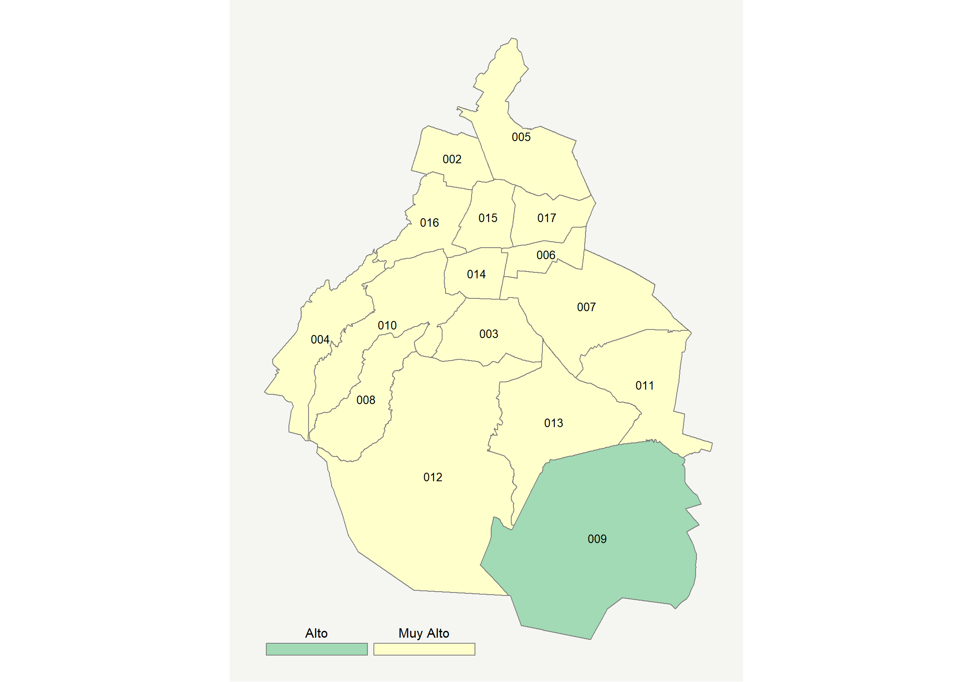

|  |  |  |  |  |  |  |  |  |  |  |  |  |  |
| --- | --- | --- | --- | --- | --- | --- | --- | --- | --- | --- | --- | --- | --- |
| **Clave del Municipio** | **Municipio** | **Telefonía fija a** | **Telefonía Celular a** | **Internet a** | **Televisión de paga a** | **Población Total a** | **Hasta 2 Salarios Mínimos b** | **Índice de Marginación** | **índice** | **Índice Escala 0-100** | **Lugar Nacional** | **Lugar Estatal** | **Estrato** |
| 002 | Azcapotzalco | 72.2 | 84.0 | 60.3 | 42.2 | 400161 | 26.0 | -1.87 | 2.41 | 77.5 | 12 | 7 | Muy Alto |
| 003 | Coyoacán | 78.9 | 87.8 | 69.9 | 54.7 | 608479 | 24.5 | -1.99 | 2.93 | 87.7 | 4 | 3 | Muy Alto |
| 004 | Cuajimalpa de Morelos | 72.8 | 89.6 | 64.5 | 55.2 | 199224 | 22.2 | -1.82 | 2.72 | 83.6 | 6 | 4 | Muy Alto |
| 005 | Gustavo A. Madero | 67.3 | 82.6 | 52.8 | 37.4 | 1164477 | 31.0 | -1.73 | 2.08 | 71.0 | 36 | 12 | Muy Alto |
| 006 | Iztacalco | 72.7 | 86.3 | 58.5 | 41.5 | 390348 | 27.3 | -1.89 | 2.39 | 77.1 | 14 | 9 | Muy Alto |
| 007 | Iztapalapa | 62.4 | 81.8 | 46.8 | 30.6 | 1827868 | 34.0 | -1.63 | 1.77 | 64.9 | 66 | 13 | Muy Alto |
| 008 | La Magdalena Contreras | 67.1 | 82.0 | 52.9 | 43.9 | 243886 | 28.5 | -1.66 | 2.15 | 72.3 | 30 | 11 | Muy Alto |
| 009 | Milpa Alta | 47.3 | 75.3 | 27.1 | 15.2 | 137927 | 44.8 | -1.03 | 0.81 | 45.9 | 388 | 16 | Alto |
| 010 | Álvaro Obregón | 69.5 | 86.6 | 60.7 | 53.7 | 749982 | 26.5 | -1.78 | 2.53 | 79.8 | 9 | 6 | Muy Alto |
| 011 | Tláhuac | 60.6 | 82.4 | 45.6 | 31.5 | 361593 | 39.9 | -1.54 | 1.73 | 64.0 | 74 | 15 | Muy Alto |
| 012 | Tlalpan | 68.7 | 88.5 | 58.9 | 46.2 | 677104 | 28.0 | -1.74 | 2.41 | 77.4 | 13 | 8 | Muy Alto |
| 013 | Xochimilco | 62.5 | 84.4 | 46.8 | 27.9 | 415933 | 33.8 | -1.53 | 1.77 | 64.8 | 68 | 14 | Muy Alto |
| 014 | Benito Juárez | 83.3 | 93.0 | 81.9 | 71.5 | 417416 | 12.7 | -2.23 | 3.53 | 99.6 | 2 | 1 | Muy Alto |
| 015 | Cuauhtémoc | 71.7 | 89.0 | 65.8 | 51.3 | 532553 | 24.8 | -1.95 | 2.69 | 82.9 | 7 | 5 | Muy Alto |
| 016 | Miguel Hidalgo | 78.9 | 91.0 | 75.9 | 67.6 | 364439 | 15.4 | -2.13 | 3.25 | 94.1 | 3 | 2 | Muy Alto |
| 017 | Venustiano Carranza | 70.5 | 84.0 | 56.7 | 41.3 | 427263 | 29.0 | -1.81 | 2.29 | 75.0 | 21 | 10 | Muy Alto |
| a Porcentaje de viviendas que cuentas con el servicio  b Ingreso por trabajo de la población ocupada en porcentaje  Fuente: Elaboración propia con datos de Encuesta Intercensal 2015 de INEGI y CONAPO | | | | | | | | | | | | | |

**Coahuila**

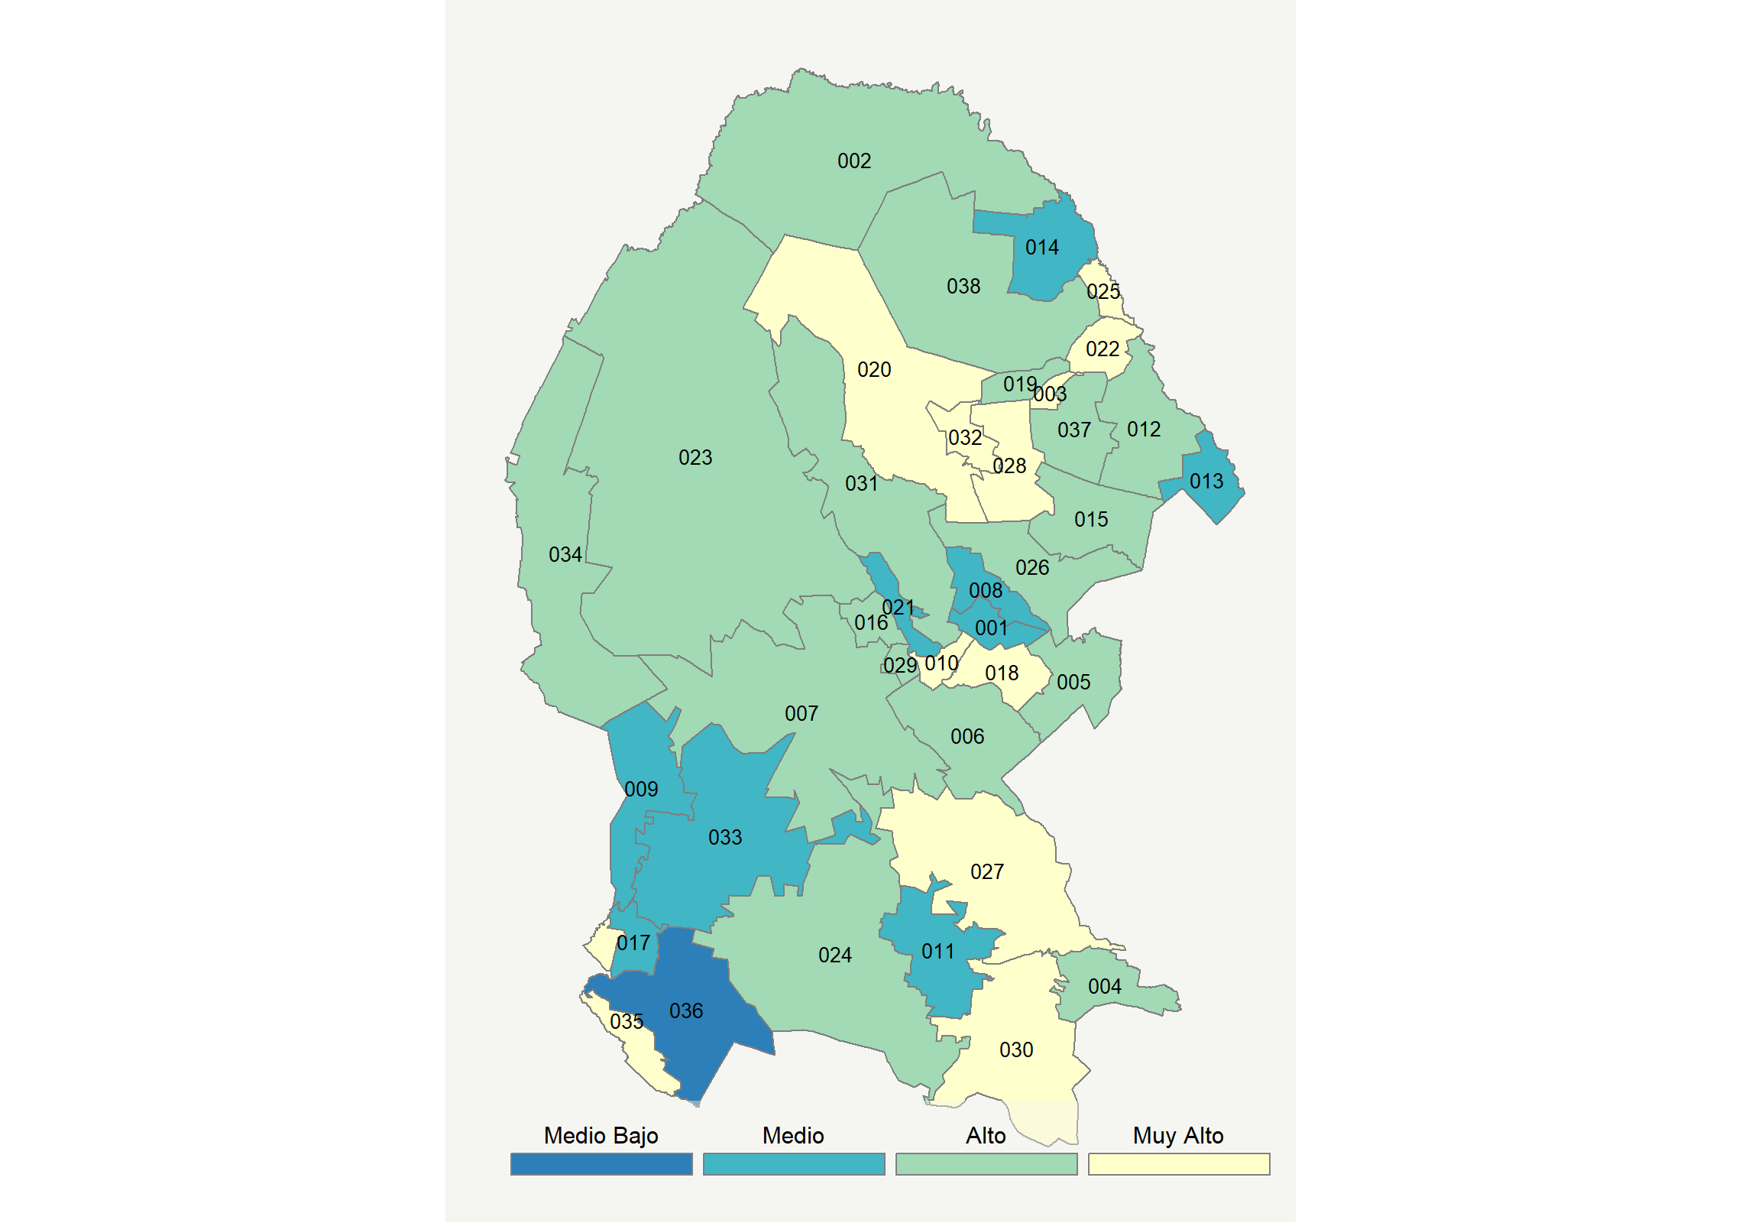

|  |  |  |  |  |  |  |  |  |  |  |  |  |  |  |
| --- | --- | --- | --- | --- | --- | --- | --- | --- | --- | --- | --- | --- | --- | --- |
| **Clave del Municipio** | **Municipio** | **Telefonía fija a** | **Telefonía Celular a** | **Internet a** | **Televisión de paga a** | **Población Total a** | **Hasta 2 Salarios Mínimos b** | **Índice de Marginación** | **índice** | **Índice Escala 0-100** | **Lugar Nacional** | **Lugar Estatal** | **Estrato** | |
| 001 | Abasolo * | 36.8 | 72.5 | 5.8 | 33.9 | 1015 | 43.3 | -1.18 | 0.30 | 35.9 | 817 | 32 | Medio | |
| 002 | Acuña | 24.7 | 89.1 | 22.3 | 44.5 | 147809 | 44.3 | -1.35 | 0.78 | 45.4 | 408 | 15 | Alto | |
| 003 | Allende | 45.2 | 81.6 | 31.4 | 48.9 | 22654 | 28.0 | -1.60 | 1.32 | 55.9 | 173 | 8 | Muy Alto | |
| 004 | Arteaga | 22.1 | 72.8 | 18.1 | 43.7 | 23271 | 40.1 | -0.85 | 0.47 | 39.2 | 639 | 25 | Alto | |
| 005 | Candela * | 25.2 | 76.3 | 13.7 | 59.9 | 1720 | 43.5 | -0.65 | 0.63 | 42.4 | 503 | 19 | Alto | |
| 006 | Castaños | 30.4 | 79.0 | 23.2 | 37.7 | 28068 | 24.8 | -1.48 | 0.72 | 44.2 | 441 | 16 | Alto | |
| 007 | Cuatro Ciénegas | 21.9 | 76.1 | 18.6 | 45.3 | 13546 | 41.2 | -0.99 | 0.53 | 40.4 | 584 | 21 | Alto | |
| 008 | Escobedo * | 21.9 | 78.5 | 10.5 | 40.9 | 3077 | 36.4 | -0.77 | 0.31 | 36.0 | 811 | 31 | Medio | |
| 009 | Francisco I. Madero | 15.1 | 78.8 | 16.9 | 30.2 | 58360 | 44.7 | -1.02 | 0.23 | 34.5 | 886 | 33 | Medio | |
| 010 | Frontera | 39.4 | 86.6 | 33.2 | 42.6 | 80991 | 19.3 | -1.66 | 1.24 | 54.5 | 205 | 9 | Muy Alto | |
| 011 | General Cepeda | 9.4 | 65.0 | 6.8 | 63.3 | 12471 | 38.4 | -0.62 | 0.13 | 32.5 | 992 | 34 | Medio | |
| 012 | Guerrero * | 21.3 | 83.8 | 11.4 | 46.8 | 1697 | 40.8 | -0.67 | 0.44 | 38.5 | 679 | 27 | Alto | |
| 013 | Hidalgo * | 8.4 | 89.5 | 4.2 | 42.4 | 1565 | 21.9 | -0.80 | 0.06 | 31.1 | 1087 | 36 | Medio | |
| 014 | Jiménez | 8.1 | 84.3 | 8.4 | 29.9 | 10243 | 54.8 | -0.45 | -0.04 | 29.2 | 1181 | 37 | Medio | |
| 015 | Juárez * | 40.8 | 69.7 | 0.7 | 57.7 | 1574 | 32.9 | -0.96 | 0.48 | 39.5 | 622 | 24 | Alto | |
| 016 | Lamadrid * | 21.4 | 77.7 | 5.8 | 62.8 | 1773 | 40.6 | -1.01 | 0.42 | 38.2 | 696 | 28 | Alto | |
| 017 | Matamoros | 18.4 | 82.8 | 17.9 | 27.0 | 108950 | 42.7 | -1.10 | 0.31 | 36.1 | 801 | 30 | Medio | |
| 018 | Monclova | 49.4 | 88.3 | 44.3 | 54.3 | 231107 | 17.9 | -1.84 | 1.82 | 65.9 | 60 | 1 | Muy Alto | |
| 019 | Morelos | 40.4 | 78.0 | 30.9 | 48.6 | 8599 | 33.0 | -1.43 | 1.19 | 53.4 | 223 | 12 | Alto | |
| 020 | Múzquiz | 39.9 | 76.3 | 29.7 | 56.4 | 69102 | 33.2 | -1.34 | 1.22 | 54.0 | 214 | 11 | Muy Alto | |
| 021 | Nadadores | 14.0 | 84.0 | 8.3 | 34.4 | 6614 | 30.5 | -1.11 | 0.10 | 32.0 | 1027 | 35 | Medio | |
| 022 | Nava | 35.5 | 85.0 | 31.6 | 52.5 | 30698 | 30.2 | -1.40 | 1.24 | 54.3 | 209 | 10 | Muy Alto | |
| 023 | Ocampo | 18.0 | 70.2 | 12.2 | 68.6 | 11671 | 33.3 | -0.76 | 0.51 | 40.0 | 598 | 22 | Alto | |
| 024 | Parras | 28.9 | 75.7 | 23.3 | 38.1 | 44799 | 54.5 | -0.97 | 0.67 | 43.2 | 470 | 18 | Alto | |
| 025 | Piedras Negras | 35.9 | 88.5 | 39.4 | 43.0 | 163595 | 31.7 | -1.53 | 1.36 | 56.7 | 156 | 6 | Muy Alto | |
| 026 | Progreso * | 36.4 | 64.9 | 15.9 | 55.9 | 3304 | 32.4 | -0.82 | 0.71 | 44.0 | 447 | 17 | Alto | |
| 027 | Ramos Arizpe | 31.5 | 88.6 | 38.1 | 49.2 | 92828 | 16.5 | -1.73 | 1.32 | 56.1 | 169 | 7 | Muy Alto | |
| 028 | Sabinas | 50.2 | 81.6 | 39.4 | 58.8 | 63522 | 23.7 | -1.68 | 1.70 | 63.5 | 77 | 2 | Muy Alto | |
| 029 | Sacramento * | 16.7 | 88.4 | 12.0 | 49.5 | 2360 | 31.7 | -1.08 | 0.45 | 38.8 | 662 | 26 | Alto | |
| 030 | Saltillo | 45.1 | 86.8 | 46.8 | 45.0 | 807537 | 17.0 | -1.82 | 1.70 | 63.4 | 78 | 3 | Muy Alto | |
| 031 | San Buenaventura | 35.3 | 85.1 | 28.1 | 44.2 | 23587 | 21.9 | -1.76 | 1.06 | 50.8 | 274 | 13 | Alto | |
| 032 | San Juan de Sabinas | 52.0 | 78.9 | 38.5 | 53.6 | 43232 | 29.4 | -1.61 | 1.63 | 62.0 | 94 | 4 | Muy Alto | |
| 033 | San Pedro | 16.4 | 77.2 | 18.2 | 37.7 | 106142 | 56.3 | -0.82 | 0.35 | 36.9 | 764 | 29 | Medio | |
| 034 | Sierra Mojada | 17.1 | 69.2 | 13.7 | 65.2 | 6988 | 21.2 | -1.01 | 0.48 | 39.5 | 621 | 23 | Alto | |
| 035 | Torreón | 44.8 | 86.9 | 42.3 | 46.6 | 679288 | 31.8 | -1.72 | 1.60 | 61.5 | 100 | 5 | Muy Alto | |
| 036 | Viesca | 13.7 | 63.4 | 3.5 | 26.2 | 21549 | 57.4 | -0.38 | -0.31 | 23.8 | 1513 | 38 | Medio Bajo | |
| 037 | Villa Unión | 28.9 | 80.4 | 16.9 | 42.1 | 6352 | 46.9 | -1.19 | 0.61 | 42.0 | 518 | 20 | Alto | |
| 038 | Zaragoza | 36.9 | 76.8 | 24.1 | 49.3 | 13257 | 40.1 | -1.26 | 0.96 | 48.9 | 309 | 14 | Alto | |
| a Porcentaje de viviendas que cuentas con el servicio  b Ingreso por trabajo de la población ocupada en porcentaje  Fuente: Elaboración propia con datos de Encuesta Intercensal 2015 de INEGI y CONAPO | | | | | | | | | | | | | |

**Colima**

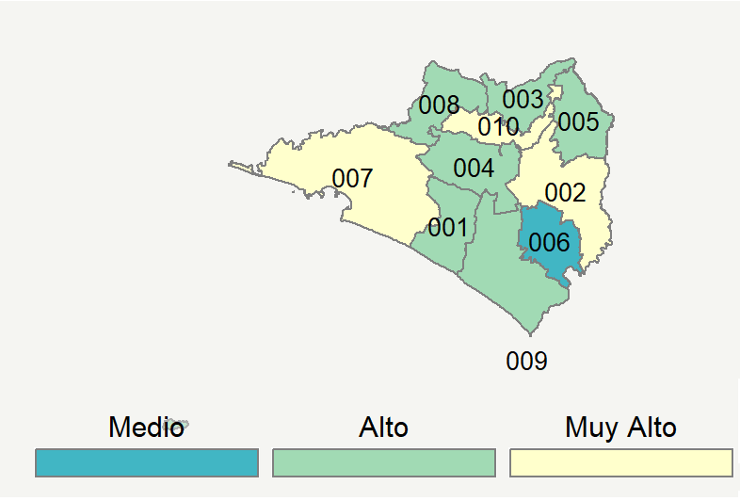

|  |  |  |  |  |  |  |  |  |  |  |  |  |  |
| --- | --- | --- | --- | --- | --- | --- | --- | --- | --- | --- | --- | --- | --- |
| **Clave del Municipio** | **Municipio** | **Telefonía fija a** | **Telefonía Celular a** | **Internet a** | **Televisión de paga a** | **Población Total a** | **Hasta 2 Salarios Mínimos b** | **Índice de Marginación** | **índice** | **Índice Escala 0-100** | **Lugar Nacional** | **Lugar Estatal** | **Estrato** |
| 001 | Armería | 27.2 | 76.0 | 15.7 | 44.4 | 29599 | 55.3 | -0.48 | 0.53 | 40.5 | 576 | 8 | Alto |
| 002 | Colima | 50.0 | 87.4 | 49.9 | 47.3 | 150673 | 27.8 | -1.60 | 1.88 | 67.1 | 51 | 2 | Muy Alto |
| 003 | Comala | 33.3 | 72.7 | 28.1 | 29.7 | 21544 | 43.6 | -0.87 | 0.74 | 44.5 | 436 | 6 | Alto |
| 004 | Coquimatlán | 32.0 | 79.7 | 25.3 | 34.0 | 20198 | 39.6 | -0.95 | 0.77 | 45.0 | 422 | 5 | Alto |
| 005 | Cuauhtémoc | 41.4 | 78.9 | 30.7 | 38.3 | 30198 | 35.2 | -1.29 | 1.09 | 51.5 | 261 | 4 | Alto |
| 006 | Ixtlahuacán | 18.9 | 59.4 | 9.9 | 40.1 | 5527 | 62.4 | -0.26 | 0.05 | 30.8 | 1100 | 10 | Medio |
| 007 | Manzanillo | 37.1 | 88.3 | 38.3 | 55.1 | 184541 | 22.4 | -1.51 | 1.49 | 59.2 | 125 | 3 | Muy Alto |
| 008 | Minatitlán | 22.9 | 76.1 | 12.7 | 49.7 | 8985 | 33.8 | -0.76 | 0.45 | 38.8 | 663 | 9 | Alto |
| 009 | Tecomán | 27.8 | 77.3 | 20.0 | 45.9 | 123191 | 46.6 | -0.72 | 0.68 | 43.3 | 467 | 7 | Alto |
| 010 | Villa de Álvarez | 43.9 | 93.0 | 52.6 | 51.9 | 136779 | 24.9 | -1.80 | 1.95 | 68.5 | 43 | 1 | Muy Alto |
| a Porcentaje de viviendas que cuentas con el servicio  b Ingreso por trabajo de la población ocupada en porcentaje  Fuente: Elaboración propia con datos de Encuesta Intercensal 2015 de INEGI y CONAPO | | | | | | | | | | | | | |

**Durango**

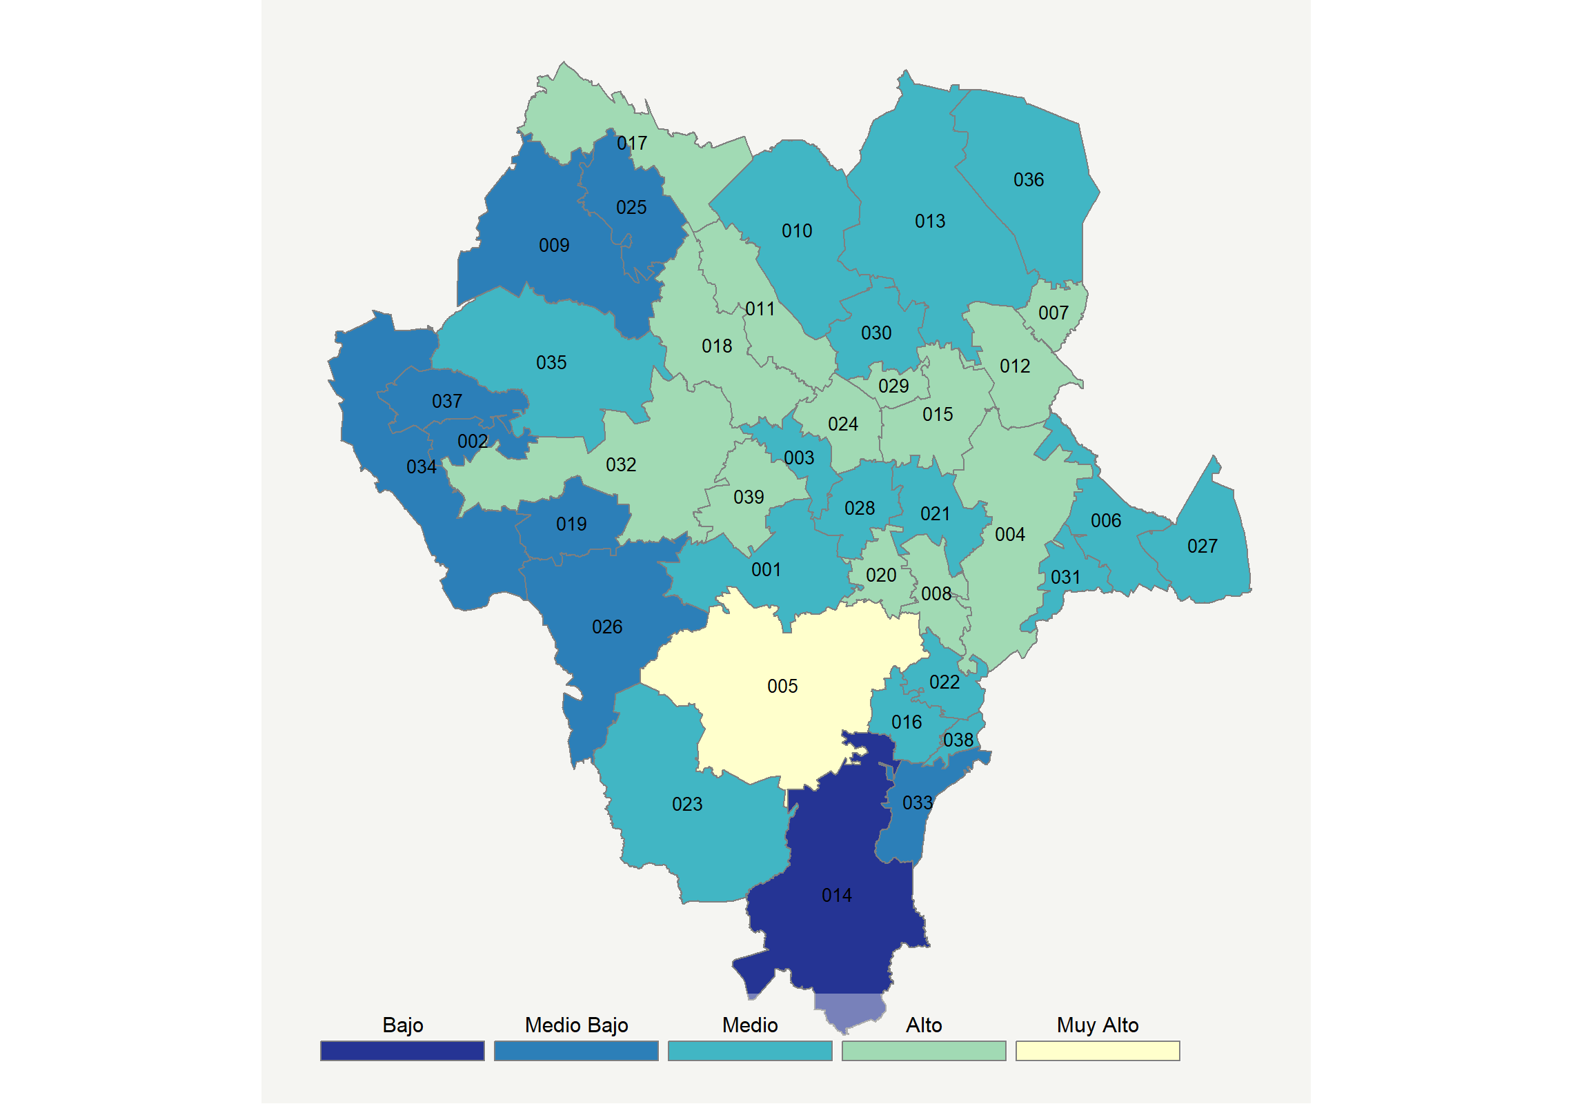

|  |  |  |  |  |  |  |  |  |  |  |  |  |  |
| --- | --- | --- | --- | --- | --- | --- | --- | --- | --- | --- | --- | --- | --- |
| **Clave del Municipio** | **Municipio** | **Telefonía fija a** | **Telefonía Celular a** | **Internet a** | **Televisión de paga a** | **Población Total a** | **Hasta 2 Salarios Mínimos b** | **Índice de Marginación** | **índice** | **Índice Escala 0-100** | **Lugar Nacional** | **Lugar Estatal** | **Estrato** |
| 001 | Canatlán | 31.5 | 72.7 | 10.9 | 33.8 | 32852 | 57.4 | -0.82 | 0.34 | 36.6 | 780 | 17 | Medio |
| 002 | Canelas | 7.1 | 14.4 | 4.7 | 57.1 | 4683 | 32.5 | 0.45 | -0.53 | 19.5 | 1766 | 37 | Medio Bajo |
| 003 | Coneto de Comonfort * | 24.0 | 72.2 | 7.3 | 49.6 | 4390 | 57.2 | -0.42 | 0.30 | 35.8 | 820 | 20 | Medio |
| 004 | Cuencamé | 26.4 | 74.5 | 11.3 | 56.2 | 35415 | 47.1 | -0.73 | 0.53 | 40.4 | 579 | 9 | Alto |
| 005 | Durango | 43.0 | 89.0 | 40.2 | 42.1 | 654876 | 35.5 | -1.59 | 1.49 | 59.3 | 124 | 1 | Muy Alto |
| 006 | General Simón Bolívar | 26.5 | 61.9 | 4.3 | 46.1 | 10110 | 56.8 | -0.11 | 0.13 | 32.5 | 994 | 25 | Medio |
| 007 | Gómez Palacio | 31.4 | 83.6 | 29.8 | 30.5 | 342286 | 31.5 | -1.49 | 0.87 | 47.0 | 356 | 4 | Alto |
| 008 | Guadalupe Victoria | 34.4 | 74.0 | 25.4 | 42.5 | 35380 | 52.0 | -1.02 | 0.85 | 46.7 | 361 | 5 | Alto |
| 009 | Guanaceví | 13.1 | 52.3 | 3.2 | 52.4 | 9851 | 41.0 | 0.23 | -0.14 | 27.1 | 1311 | 33 | Medio Bajo |
| 010 | Hidalgo * | 33.0 | 67.8 | 1.1 | 59.8 | 3838 | 44.7 | -0.69 | 0.37 | 37.2 | 744 | 15 | Medio |
| 011 | Indé | 30.1 | 73.0 | 1.0 | 68.0 | 4927 | 59.2 | -0.44 | 0.46 | 39.0 | 649 | 13 | Alto |
| 012 | Lerdo | 28.4 | 81.5 | 27.1 | 43.2 | 153311 | 40.3 | -1.22 | 0.87 | 47.1 | 350 | 3 | Alto |
| 013 | Mapimí | 21.7 | 76.4 | 10.1 | 37.8 | 26502 | 44.8 | -0.75 | 0.24 | 34.6 | 877 | 21 | Medio |
| 014 | Mezquital * | 3.6 | 16.0 | 1.6 | 12.2 | 39288 | 44.4 | 4.85 | -1.15 | 7.3 | 2272 | 39 | Bajo |
| 015 | Nazas | 27.5 | 69.0 | 6.2 | 61.5 | 12957 | 61.4 | -0.40 | 0.43 | 38.5 | 686 | 14 | Alto |
| 016 | Nombre de Dios | 33.1 | 67.5 | 7.8 | 26.1 | 19694 | 54.5 | -0.73 | 0.15 | 33.0 | 967 | 24 | Medio |
| 017 | Ocampo | 32.0 | 67.3 | 11.3 | 54.7 | 9567 | 49.2 | -0.56 | 0.54 | 40.5 | 573 | 8 | Alto |
| 018 | El Oro | 34.6 | 70.4 | 16.6 | 70.2 | 11496 | 38.0 | -1.09 | 0.91 | 47.9 | 335 | 2 | Alto |
| 019 | Otáez * | 4.9 | 11.6 | 3.2 | 58.9 | 5385 | 59.8 | 0.96 | -0.61 | 17.9 | 1852 | 38 | Medio Bajo |
| 020 | Pánuco de Coronado | 37.1 | 64.4 | 14.8 | 35.7 | 12290 | 48.8 | -0.76 | 0.47 | 39.1 | 643 | 12 | Alto |
| 021 | Peñón Blanco | 24.6 | 71.2 | 10.4 | 34.7 | 10922 | 59.5 | -0.70 | 0.21 | 34.0 | 911 | 22 | Medio |
| 022 | Poanas | 39.5 | 66.6 | 9.4 | 27.5 | 25241 | 57.5 | -0.85 | 0.31 | 35.9 | 814 | 19 | Medio |
| 023 | Pueblo Nuevo | 14.3 | 69.3 | 10.6 | 36.9 | 50417 | 41.8 | 0.11 | 0.05 | 30.9 | 1098 | 28 | Medio |
| 024 | Rodeo | 31.4 | 71.2 | 12.6 | 45.0 | 13554 | 61.2 | -0.52 | 0.49 | 39.6 | 616 | 11 | Alto |
| 025 | San Bernardo * | 19.4 | 51.1 | 1.1 | 49.8 | 3205 | 46.5 | -0.10 | -0.13 | 27.3 | 1296 | 32 | Medio Bajo |
| 026 | San Dimas | 6.0 | 37.0 | 4.4 | 53.7 | 19383 | 28.7 | -0.26 | -0.37 | 22.6 | 1582 | 35 | Medio Bajo |
| 027 | San Juan de Guadalupe | 23.1 | 55.3 | 1.1 | 50.7 | 5564 | 66.3 | 0.13 | -0.02 | 29.6 | 1161 | 30 | Medio |
| 028 | San Juan del Río | 29.6 | 78.3 | 7.7 | 37.7 | 12747 | 48.6 | -0.56 | 0.33 | 36.5 | 791 | 18 | Medio |
| 029 | San Luis del Cordero * | 38.0 | 68.3 | 8.6 | 52.5 | 2077 | 52.4 | -0.48 | 0.56 | 40.9 | 558 | 7 | Alto |
| 030 | San Pedro del Gallo * | 37.0 | 30.2 | 0.5 | 62.3 | 1478 | 58.2 | -0.50 | 0.08 | 31.4 | 1058 | 26 | Medio |
| 031 | Santa Clara | 31.3 | 72.8 | 4.4 | 22.4 | 7089 | 68.5 | -0.43 | 0.05 | 31.0 | 1093 | 27 | Medio |
| 032 | Santiago Papasquiaro | 27.3 | 74.8 | 17.6 | 37.8 | 48482 | 48.3 | -0.68 | 0.50 | 39.8 | 607 | 10 | Alto |
| 033 | Súchil | 23.1 | 61.7 | 8.4 | 21.9 | 6343 | 59.9 | -0.22 | -0.10 | 27.9 | 1261 | 31 | Medio Bajo |
| 034 | Tamazula | 2.9 | 45.7 | 3.2 | 52.6 | 26709 | 62.4 | 1.62 | -0.38 | 22.5 | 1591 | 36 | Medio Bajo |
| 035 | Tepehuanes | 27.3 | 54.6 | 10.7 | 42.5 | 11060 | 45.2 | 0.14 | 0.18 | 33.5 | 942 | 23 | Medio |
| 036 | Tlahualilo | 16.1 | 77.5 | 7.1 | 29.1 | 22895 | 51.4 | -0.79 | -0.01 | 29.7 | 1154 | 29 | Medio |
| 037 | Topia | 9.1 | 28.8 | 8.1 | 66.1 | 9351 | 33.2 | 0.32 | -0.17 | 26.5 | 1342 | 34 | Medio Bajo |
| 038 | Vicente Guerrero | 28.9 | 76.6 | 15.0 | 26.6 | 21861 | 56.4 | -1.12 | 0.36 | 36.9 | 763 | 16 | Medio |
| 039 | Nuevo Ideal | 30.6 | 83.2 | 17.9 | 31.3 | 27278 | 54.2 | -1.00 | 0.57 | 41.1 | 554 | 6 | Alto |
| a Porcentaje de viviendas que cuentas con el servicio  b Ingreso por trabajo de la población ocupada en porcentaje  Fuente: Elaboración propia con datos de Encuesta Intercensal 2015 de INEGI y CONAPO | | | | | | | | | | | | | |

**Guanajuato**

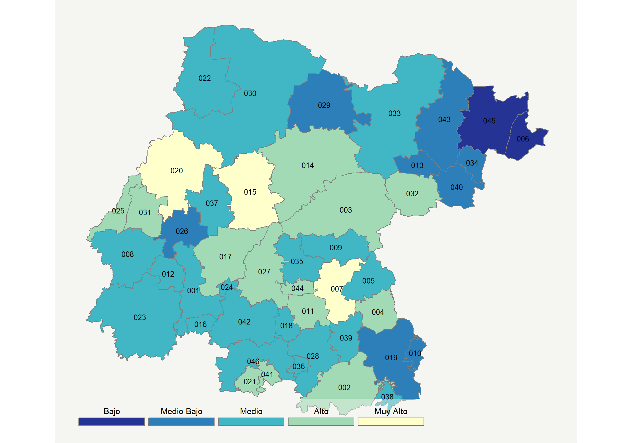

|  |  |  |  |  |  |  |  |  |  |  |  |  |  |
| --- | --- | --- | --- | --- | --- | --- | --- | --- | --- | --- | --- | --- | --- |
| **Clave del Municipio** | **Municipio** | **Telefonía fija a** | **Telefonía Celular a** | **Internet a** | **Televisión de paga a** | **Población Total a** | **Hasta 2 Salarios Mínimos b** | **Índice de Marginación** | **índice** | **Índice Escala 0-100** | **Lugar Nacional** | **Lugar Estatal** | **Estrato** |
| 001 | Abasolo | 20.0 | 65.5 | 9.7 | 23.1 | 90990 | 62.5 | -0.27 | -0.07 | 28.6 | 1222 | 35 | Medio |
| 002 | Acámbaro | 37.7 | 68.1 | 17.7 | 29.9 | 112125 | 49.8 | -0.86 | 0.52 | 40.1 | 594 | 11 | Alto |
| 003 | San Miguel de Allende | 34.5 | 75.1 | 29.5 | 42.7 | 171857 | 38.0 | -0.61 | 0.96 | 48.9 | 310 | 7 | Alto |
| 004 | Apaseo el Alto | 25.9 | 72.1 | 17.7 | 35.5 | 68455 | 42.8 | -0.64 | 0.42 | 38.3 | 693 | 15 | Alto |
| 005 | Apaseo el Grande | 21.2 | 75.2 | 18.7 | 28.6 | 92605 | 39.9 | -0.80 | 0.33 | 36.3 | 794 | 18 | Medio |
| 006 | Atarjea | 4.3 | 4.5 | 2.9 | 31.8 | 5128 | 34.7 | 0.63 | -1.00 | 10.2 | 2176 | 46 | Bajo |
| 007 | Celaya | 44.7 | 80.6 | 38.8 | 42.9 | 494304 | 36.2 | -1.39 | 1.41 | 57.8 | 141 | 1 | Muy Alto |
| 008 | Manuel Doblado | 33.7 | 66.3 | 13.4 | 22.3 | 38832 | 45.7 | -0.43 | 0.25 | 34.8 | 869 | 21 | Medio |
| 009 | Comonfort | 19.6 | 63.4 | 13.9 | 14.7 | 82572 | 50.7 | -0.20 | -0.09 | 28.2 | 1240 | 36 | Medio |
| 010 | Coroneo | 14.1 | 72.0 | 6.3 | 16.9 | 12068 | 56.1 | -0.42 | -0.25 | 24.9 | 1453 | 41 | Medio Bajo |
| 011 | Cortazar | 35.1 | 73.7 | 21.0 | 24.9 | 95961 | 45.2 | -0.97 | 0.55 | 40.9 | 561 | 9 | Alto |
| 012 | Cuerámaro | 27.0 | 69.9 | 13.9 | 19.1 | 28320 | 59.7 | -0.48 | 0.15 | 32.8 | 979 | 26 | Medio |
| 013 | Doctor Mora | 10.1 | 69.4 | 9.3 | 22.6 | 24219 | 47.3 | -0.29 | -0.21 | 25.8 | 1394 | 39 | Medio Bajo |
| 014 | Dolores Hidalgo | 23.8 | 72.1 | 19.3 | 38.7 | 152113 | 52.4 | -0.27 | 0.46 | 39.1 | 645 | 14 | Alto |
| 015 | Guanajuato | 42.0 | 81.7 | 36.7 | 48.5 | 184239 | 27.3 | -1.27 | 1.39 | 57.3 | 149 | 2 | Muy Alto |
| 016 | Huanímaro | 29.8 | 62.6 | 11.1 | 15.4 | 21638 | 67.4 | -0.53 | 0.01 | 30.2 | 1132 | 33 | Medio |
| 017 | Irapuato | 38.1 | 78.5 | 29.5 | 42.9 | 574344 | 37.0 | -1.28 | 1.06 | 50.8 | 272 | 5 | Alto |
| 018 | Jaral del Progreso | 26.0 | 66.2 | 12.6 | 13.4 | 38412 | 56.2 | -0.80 | 0.00 | 29.9 | 1147 | 34 | Medio |
| 019 | Jerécuaro | 20.5 | 60.5 | 4.6 | 13.7 | 49053 | 60.9 | -0.02 | -0.34 | 23.3 | 1546 | 42 | Medio Bajo |
| 20 | León | 40.1 | 83.5 | 36.7 | 42.9 | 1578626 | 26.4 | -1.49 | 1.31 | 55.8 | 176 | 3 | Muy Alto |
| 021 | Moroleón | 47.7 | 67.7 | 28.7 | 35.9 | 50377 | 47.8 | -1.20 | 1.01 | 49.9 | 287 | 6 | Alto |
| 022 | Ocampo | 15.3 | 69.8 | 6.4 | 51.5 | 23528 | 63.4 | -0.17 | 0.13 | 32.5 | 990 | 27 | Medio |
| 023 | Pénjamo | 30.3 | 63.0 | 12.2 | 25.7 | 150570 | 52.7 | -0.30 | 0.17 | 33.2 | 960 | 25 | Medio |
| 024 | Pueblo Nuevo | 27.0 | 65.4 | 14.3 | 24.3 | 11872 | 55.7 | -0.41 | 0.17 | 33.2 | 959 | 24 | Medio |
| 025 | Purísima del Rincón | 25.2 | 79.3 | 16.6 | 37.5 | 79798 | 27.7 | -1.00 | 0.48 | 39.4 | 625 | 13 | Alto |
| 026 | Romita | 20.9 | 62.8 | 11.0 | 17.6 | 59879 | 54.2 | -0.45 | -0.11 | 27.7 | 1272 | 37 | Medio Bajo |
| 027 | Salamanca | 41.9 | 79.1 | 34.4 | 38.3 | 273271 | 35.3 | -1.30 | 1.19 | 53.5 | 222 | 4 | Alto |
| 028 | Salvatierra | 39.4 | 62.7 | 18.1 | 15.2 | 100391 | 53.1 | -0.64 | 0.34 | 36.6 | 782 | 17 | Medio |
| 029 | San Diego de la Unión | 17.9 | 66.7 | 5.9 | 24.4 | 39668 | 66.2 | 0.27 | -0.17 | 26.6 | 1340 | 38 | Medio Bajo |
| 030 | San Felipe | 17.9 | 69.9 | 8.3 | 40.6 | 113109 | 54.8 | -0.04 | 0.10 | 31.9 | 1034 | 30 | Medio |
| 031 | San Francisco del Rincón | 32.5 | 74.5 | 25.4 | 41.9 | 119510 | 30.5 | -1.06 | 0.82 | 46.0 | 387 | 8 | Alto |
| 032 | San José Iturbide | 18.5 | 81.3 | 17.3 | 45.6 | 78794 | 28.4 | -0.91 | 0.50 | 39.7 | 609 | 12 | Alto |
| 033 | San Luis de la Paz | 20.8 | 72.5 | 13.7 | 37.1 | 121027 | 50.2 | -0.25 | 0.27 | 35.2 | 844 | 19 | Medio |
| 034 | Santa Catarina * | 16.2 | 55.7 | 4.4 | 35.5 | 5261 | 50.2 | 0.15 | -0.22 | 25.6 | 1409 | 40 | Medio Bajo |
| 035 | Santa Cruz de Juventino Rosas | 23.9 | 69.1 | 15.7 | 14.4 | 83060 | 57.0 | -0.43 | 0.08 | 31.5 | 1056 | 31 | Medio |
| 036 | Santiago Maravatío | 41.1 | 50.3 | 15.2 | 10.8 | 6824 | 56.1 | -0.39 | 0.13 | 32.4 | 1001 | 29 | Medio |
| 037 | Silao de la Victoria | 18.1 | 74.2 | 16.9 | 31.7 | 189567 | 37.9 | -0.79 | 0.25 | 34.9 | 864 | 20 | Medio |
| 038 | Tarandacuao | 29.0 | 70.9 | 12.7 | 20.7 | 12256 | 66.2 | -0.57 | 0.18 | 33.5 | 949 | 23 | Medio |
| 039 | Tarimoro | 35.5 | 62.0 | 10.9 | 11.9 | 34263 | 53.1 | -0.45 | 0.06 | 31.1 | 1090 | 32 | Medio |
| 040 | Tierra Blanca | 11.5 | 47.5 | 6.2 | 19.3 | 18960 | 49.7 | 0.41 | -0.52 | 19.7 | 1753 | 44 | Medio Bajo |
| 041 | Uriangato | 35.6 | 67.9 | 20.8 | 28.9 | 62761 | 50.4 | -1.01 | 0.55 | 40.7 | 570 | 10 | Alto |
| 042 | Valle de Santiago | 33.3 | 59.6 | 16.3 | 18.8 | 142672 | 54.8 | -0.55 | 0.20 | 34.0 | 917 | 22 | Medio |
| 043 | Victoria | 19.8 | 32.4 | 6.1 | 34.7 | 20166 | 35.3 | 0.06 | -0.36 | 22.9 | 1568 | 43 | Medio Bajo |
| 044 | Villagrán | 27.1 | 77.5 | 19.7 | 23.7 | 58830 | 40.0 | -1.02 | 0.41 | 38.1 | 703 | 16 | Alto |
| 045 | Xichú | 11.6 | 5.4 | 6.7 | 34.2 | 11639 | 57.1 | 0.68 | -0.75 | 15.1 | 1978 | 45 | Bajo |
| 046 | Yuriria | 34.3 | 61.3 | 13.5 | 14.9 | 69763 | 59.1 | -0.42 | 0.13 | 32.4 | 1000 | 28 | Medio |
| a Porcentaje de viviendas que cuentas con el servicio  b Ingreso por trabajo de la población ocupada en porcentaje  Fuente: Elaboración propia con datos de Encuesta Intercensal 2015 de INEGI y CONAPO | | | | | | | | | | | | | |

**Guerrero**

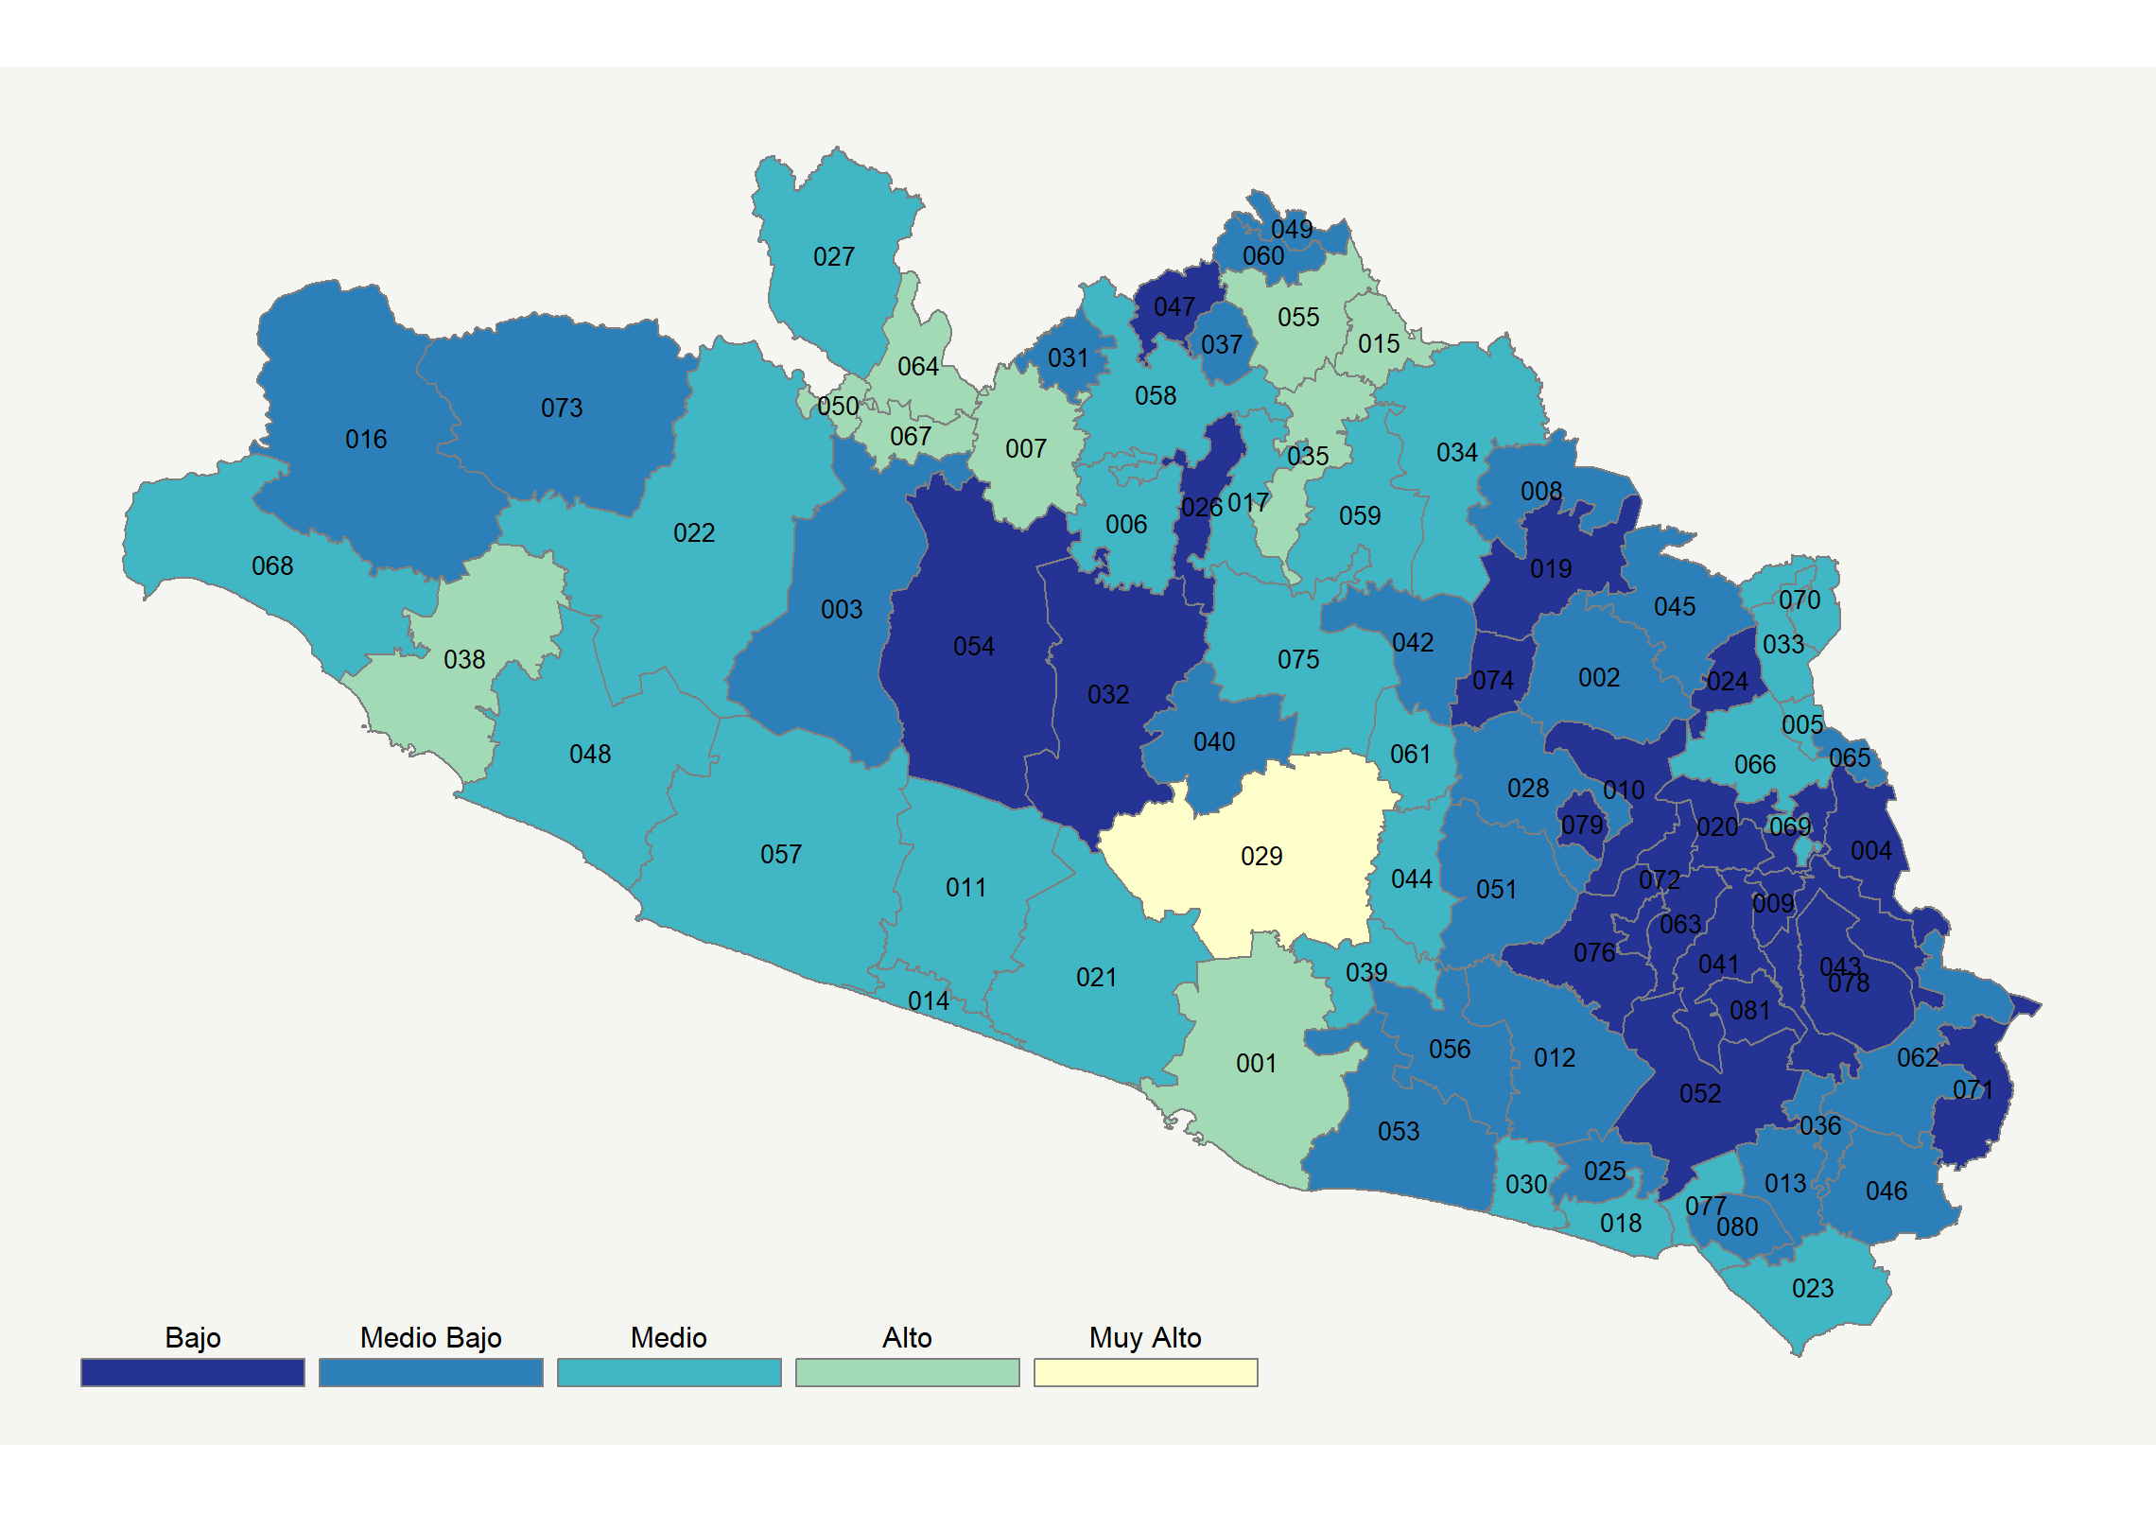

|  |  |  |  |  |  |  |  |  |  |  |  |  |  |
| --- | --- | --- | --- | --- | --- | --- | --- | --- | --- | --- | --- | --- | --- |
| **Clave del Municipio** | **Municipio** | **Telefonía fija a** | **Telefonía Celular a** | **Internet a** | **Televisión de paga a** | **Población Total a** | **Hasta 2 Salarios Mínimos b** | **Índice de Marginación** | **índice** | **Índice Escala 0-100** | **Lugar Nacional** | **Lugar Estatal** | **Estrato** |
| 001 | Acapulco de Juárez | 36.8 | 80.1 | 29.3 | 32.7 | 810669 | 50.0 | -0.77 | 0.93 | 48.3 | 319 | 3 | Alto |
| 002 | Ahuacuotzingo | 19.4 | 36.4 | 3.0 | 18.4 | 26858 | 77.8 | 2.14 | -0.58 | 18.5 | 1819 | 56 | Medio Bajo |
| 003 | Ajuchitlán del Progreso | 21.7 | 42.6 | 4.7 | 27.0 | 38134 | 60.9 | 1.32 | -0.35 | 23.1 | 1553 | 45 | Medio Bajo |
| 004 | Alcozauca de Guerrero * | 20.3 | 14.1 | 0.8 | 15.5 | 19368 | 76.3 | 2.55 | -0.87 | 12.7 | 2079 | 69 | Bajo |
| 005 | Alpoyeca | 32.0 | 55.2 | 6.9 | 22.7 | 6657 | 75.0 | 0.56 | -0.05 | 29.0 | 1191 | 33 | Medio |
| 006 | Apaxtla | 29.5 | 42.2 | 15.8 | 24.5 | 11159 | 48.8 | 0.15 | 0.02 | 30.3 | 1126 | 28 | Medio |
| 007 | Arcelia | 32.5 | 54.6 | 19.1 | 52.6 | 31406 | 45.6 | -0.14 | 0.59 | 41.5 | 536 | 9 | Alto |
| 008 | Atenango del Río | 26.3 | 40.9 | 7.1 | 27.5 | 8731 | 72.4 | 1.35 | -0.22 | 25.5 | 1415 | 41 | Medio Bajo |
| 009 | Atlamajalcingo del Monte * | 3.9 | 3.7 | 0.0 | 2.2 | 5476 | 46.8 | 2.17 | -1.41 | 2.0 | 2413 | 78 | Bajo |
| 010 | Atlixtac * | 6.0 | 3.7 | 0.2 | 8.8 | 27212 | 67.2 | 2.30 | -1.30 | 4.3 | 2350 | 75 | Bajo |
| 011 | Atoyac de Álvarez | 21.0 | 61.5 | 9.1 | 28.0 | 60382 | 59.7 | 0.21 | -0.05 | 28.9 | 1198 | 34 | Medio |
| 012 | Ayutla de los Libres | 14.5 | 40.8 | 4.9 | 28.2 | 69716 | 69.9 | 2.08 | -0.46 | 20.8 | 1693 | 51 | Medio Bajo |
| 013 | Azoyú * | 28.5 | 41.2 | 4.3 | 30.5 | 14865 | 61.2 | 1.07 | -0.22 | 25.6 | 1406 | 40 | Medio Bajo |
| 014 | Benito Juárez | 32.3 | 63.2 | 11.4 | 39.2 | 15318 | 50.5 | -0.24 | 0.33 | 36.5 | 789 | 13 | Medio |
| 015 | Buenavista de Cuéllar | 45.6 | 59.6 | 13.8 | 42.6 | 13286 | 56.5 | -0.53 | 0.61 | 42.0 | 516 | 7 | Alto |
| 016 | Coahuayutla de José María Izazaga * | 16.3 | 22.6 | 2.1 | 58.8 | 12725 | 65.1 | 2.20 | -0.34 | 23.2 | 1548 | 44 | Medio Bajo |
| 017 | Cocula | 31.4 | 59.6 | 9.6 | 33.8 | 13457 | 50.2 | 0.16 | 0.18 | 33.4 | 955 | 20 | Medio |
| 018 | Copala * | 22.2 | 56.8 | 10.2 | 43.7 | 14304 | 59.5 | 0.35 | 0.12 | 32.3 | 1007 | 21 | Medio |
| 019 | Copalillo * | 2.5 | 31.9 | 1.1 | 17.0 | 14866 | 73.7 | 2.70 | -0.97 | 10.8 | 2147 | 70 | Bajo |
| 020 | Copanatoyac * | 9.2 | 27.3 | 0.9 | 7.0 | 20192 | 62.1 | 2.57 | -1.02 | 9.8 | 2190 | 71 | Bajo |
| 021 | Coyuca de Benítez | 17.3 | 63.5 | 8.2 | 29.7 | 76306 | 59.1 | 0.56 | -0.10 | 28.0 | 1253 | 35 | Medio |
| 022 | Coyuca de Catalán | 25.5 | 37.7 | 8.6 | 46.7 | 39002 | 44.8 | 1.32 | -0.02 | 29.6 | 1158 | 30 | Medio |
| 023 | Cuajinicuilapa * | 32.8 | 45.6 | 8.8 | 33.1 | 27266 | 61.3 | 0.58 | 0.04 | 30.6 | 1109 | 26 | Medio |
| 024 | Cualác | 18.3 | 16.2 | 0.6 | 27.6 | 7649 | 70.1 | 1.12 | -0.75 | 15.0 | 1982 | 64 | Bajo |
| 025 | Cuautepec * | 14.0 | 31.7 | 1.0 | 33.9 | 16415 | 71.7 | 1.37 | -0.59 | 18.2 | 1830 | 58 | Medio Bajo |
| 026 | Cuetzala del Progreso | 21.6 | 21.0 | 4.4 | 13.7 | 8559 | 64.7 | 1.37 | -0.71 | 15.8 | 1936 | 60 | Bajo |
| 027 | Cutzamala de Pinzón | 29.8 | 32.7 | 6.1 | 49.1 | 19746 | 58.6 | 1.02 | -0.03 | 29.3 | 1176 | 32 | Medio |
| 028 | Chilapa de Álvarez | 11.8 | 54.5 | 5.9 | 14.7 | 129867 | 69.7 | 1.79 | -0.50 | 20.1 | 1730 | 52 | Medio Bajo |
| 029 | Chilpancingo de los Bravo | 38.8 | 81.9 | 36.6 | 47.1 | 273106 | 34.4 | -0.73 | 1.32 | 56.0 | 170 | 1 | Muy Alto |
| 030 | Florencio Villarreal * | 20.3 | 56.9 | 10.4 | 40.2 | 20855 | 55.8 | 0.45 | 0.06 | 31.1 | 1088 | 25 | Medio |
| 031 | General Canuto A. Neri | 26.2 | 30.0 | 1.5 | 20.1 | 5780 | 69.4 | 1.20 | -0.55 | 19.1 | 1786 | 54 | Medio Bajo |
| 032 | General Heliodoro Castillo | 9.7 | 29.2 | 2.5 | 25.1 | 37340 | 59.6 | 1.81 | -0.75 | 15.1 | 1979 | 63 | Bajo |
| 033 | Huamuxtitlán | 36.5 | 45.9 | 11.2 | 35.1 | 15287 | 65.7 | 0.13 | 0.18 | 33.5 | 946 | 18 | Medio |
| 034 | Huitzuco de los Figueroa | 40.8 | 51.2 | 12.7 | 26.6 | 37094 | 64.4 | 0.42 | 0.24 | 34.8 | 871 | 16 | Medio |
| 035 | Iguala de la Independencia | 42.8 | 80.6 | 33.1 | 34.7 | 151660 | 45.4 | -0.58 | 1.15 | 52.6 | 237 | 2 | Alto |
| 036 | Igualapa * | 17.5 | 33.9 | 1.8 | 37.4 | 11383 | 67.4 | 1.28 | -0.45 | 21.0 | 1681 | 50 | Medio Bajo |
| 037 | Ixcateopan de Cuauhtémoc | 31.3 | 25.0 | 6.8 | 15.0 | 6179 | 69.4 | 0.86 | -0.44 | 21.2 | 1668 | 49 | Medio Bajo |
| 038 | Zihuatanejo de Azueta | 27.6 | 83.9 | 25.7 | 39.6 | 124824 | 41.2 | -0.64 | 0.81 | 45.9 | 392 | 4 | Alto |
| 039 | Juan R. Escudero | 30.3 | 57.7 | 11.5 | 32.9 | 24890 | 59.1 | 0.08 | 0.18 | 33.4 | 950 | 19 | Medio |
| 040 | Leonardo Bravo | 15.2 | 39.4 | 4.8 | 34.9 | 26342 | 69.2 | 0.92 | -0.39 | 22.2 | 1607 | 46 | Medio Bajo |
| 041 | Malinaltepec * | 4.3 | 8.8 | 0.3 | 9.5 | 25584 | 62.6 | 1.67 | -1.27 | 4.9 | 2333 | 73 | Bajo |
| 042 | Mártir de Cuilapan | 13.6 | 41.5 | 4.1 | 26.4 | 18526 | 74.0 | 1.74 | -0.51 | 19.9 | 1744 | 53 | Medio Bajo |
| 043 | Metlatónoc * | 1.8 | 3.4 | 0.3 | 4.9 | 19456 | 60.1 | 2.91 | -1.41 | 2.0 | 2414 | 79 | Bajo |
| 044 | Mochitlán | 24.8 | 55.3 | 11.2 | 26.1 | 12752 | 55.7 | 0.18 | -0.02 | 29.5 | 1167 | 31 | Medio |
| 045 | Olinalá | 18.2 | 44.4 | 6.9 | 19.6 | 25483 | 73.4 | 2.01 | -0.41 | 21.8 | 1630 | 48 | Medio Bajo |
| 046 | Ometepec | 21.4 | 51.1 | 10.4 | 21.7 | 67641 | 54.3 | 0.77 | -0.19 | 26.2 | 1371 | 38 | Medio Bajo |
| 047 | Pedro Ascencio Alquisiras * | 13.5 | 44.3 | 0.3 | 7.7 | 6883 | 89.5 | 2.49 | -0.79 | 14.4 | 2009 | 67 | Bajo |
| 048 | Petatlán | 21.4 | 69.9 | 17.2 | 43.6 | 44263 | 48.2 | -0.14 | 0.41 | 38.0 | 714 | 11 | Medio |
| 049 | Pilcaya | 19.5 | 59.2 | 9.5 | 27.3 | 12900 | 68.4 | -0.18 | -0.10 | 28.0 | 1257 | 36 | Medio Bajo |
| 050 | Pungarabato | 35.3 | 67.5 | 23.0 | 45.9 | 37494 | 46.7 | -0.38 | 0.78 | 45.3 | 410 | 5 | Alto |
| 051 | Quechultenango | 20.0 | 40.5 | 5.2 | 24.8 | 35926 | 59.0 | 1.26 | -0.41 | 21.9 | 1625 | 47 | Medio Bajo |
| 052 | San Luis Acatlán | 8.9 | 33.2 | 3.4 | 20.6 | 43671 | 61.6 | 2.07 | -0.75 | 15.1 | 1975 | 62 | Bajo |
| 053 | San Marcos | 26.8 | 46.9 | 8.2 | 18.0 | 49449 | 62.8 | 0.92 | -0.23 | 25.3 | 1427 | 42 | Medio Bajo |
| 054 | San Miguel Totolapan * | 11.1 | 26.5 | 1.1 | 31.4 | 27853 | 64.9 | 2.58 | -0.72 | 15.8 | 1938 | 61 | Bajo |
| 055 | Taxco de Alarcón | 38.1 | 64.8 | 22.2 | 30.1 | 108416 | 62.5 | -0.29 | 0.60 | 41.8 | 522 | 8 | Alto |
| 056 | Tecoanapa | 15.8 | 38.6 | 1.1 | 25.0 | 46812 | 58.4 | 0.96 | -0.59 | 18.3 | 1827 | 57 | Medio Bajo |
| 057 | Técpan de Galeana | 34.2 | 55.7 | 15.2 | 39.5 | 64577 | 44.3 | 0.10 | 0.38 | 37.5 | 731 | 12 | Medio |
| 058 | Teloloapan | 28.3 | 51.3 | 12.6 | 32.0 | 57377 | 62.5 | 0.60 | 0.10 | 31.9 | 1036 | 23 | Medio |
| 059 | Tepecoacuilco de Trujano | 42.0 | 45.0 | 12.9 | 29.1 | 31599 | 67.1 | 0.58 | 0.23 | 34.6 | 883 | 17 | Medio |
| 060 | Tetipac | 18.7 | 52.6 | 2.8 | 6.7 | 14658 | 76.1 | 0.80 | -0.57 | 18.7 | 1803 | 55 | Medio Bajo |
| 061 | Tixtla de Guerrero | 25.5 | 65.6 | 17.2 | 28.5 | 42653 | 49.4 | 0.16 | 0.27 | 35.2 | 852 | 14 | Medio |
| 062 | Tlacoachistlahuaca * | 11.8 | 27.5 | 2.9 | 33.4 | 22771 | 67.0 | 2.77 | -0.63 | 17.5 | 1872 | 59 | Medio Bajo |
| 063 | Tlacoapa * | 0.9 | 1.2 | 0.3 | 12.7 | 9753 | 44.5 | 2.20 | -1.36 | 3.0 | 2386 | 77 | Bajo |
| 064 | Tlalchapa | 41.8 | 45.1 | 14.7 | 62.4 | 12404 | 57.4 | 0.20 | 0.65 | 42.7 | 490 | 6 | Alto |
| 065 | Tlalixtaquilla de Maldonado | 35.4 | 34.7 | 5.0 | 26.1 | 7407 | 75.5 | 1.27 | -0.20 | 26.0 | 1377 | 39 | Medio Bajo |
| 066 | Tlapa de Comonfort | 23.1 | 63.6 | 13.2 | 21.4 | 87967 | 58.4 | 0.62 | 0.03 | 30.5 | 1117 | 27 | Medio |
| 067 | Tlapehuala | 29.2 | 61.2 | 16.2 | 42.3 | 21995 | 54.6 | 0.31 | 0.41 | 38.0 | 708 | 10 | Alto |
| 068 | La Unión de Isidoro Montes de Oca | 10.5 | 72.2 | 8.5 | 45.7 | 26432 | 41.5 | 0.44 | 0.06 | 31.1 | 1083 | 24 | Medio |
| 069 | Xalpatláhuac * | 16.2 | 30.2 | 0.5 | 14.9 | 11726 | 65.7 | 2.22 | -0.79 | 14.3 | 2018 | 68 | Bajo |
| 070 | Xochihuehuetlán | 44.2 | 34.0 | 5.9 | 28.3 | 7201 | 71.4 | 0.94 | -0.01 | 29.7 | 1157 | 29 | Medio |
| 071 | Xochistlahuaca * | 7.8 | 45.2 | 3.9 | 10.2 | 28839 | 74.4 | 2.39 | -0.76 | 15.0 | 1985 | 65 | Bajo |
| 072 | Zapotitlán Tablas * | 2.5 | 12.0 | 0.5 | 6.6 | 11221 | 69.0 | 2.14 | -1.29 | 4.4 | 2345 | 74 | Bajo |
| 073 | Zirándaro | 19.3 | 27.0 | 6.4 | 42.5 | 18206 | 58.5 | 1.40 | -0.32 | 23.5 | 1531 | 43 | Medio Bajo |
| 074 | Zitlala | 8.9 | 48.0 | 2.5 | 7.2 | 22721 | 82.9 | 1.86 | -0.78 | 14.6 | 1998 | 66 | Bajo |
| 075 | Eduardo Neri | 22.8 | 65.7 | 13.9 | 39.7 | 51316 | 49.1 | 0.21 | 0.27 | 35.2 | 853 | 15 | Medio |
| 076 | Acatepec | 1.1 | 2.2 | 0.2 | 6.4 | 36449 | 70.6 | 2.63 | -1.42 | 1.8 | 2418 | 80 | Bajo |
| 077 | Marquelia | 22.7 | 54.1 | 9.9 | 44.8 | 13730 | 60.8 | 0.47 | 0.11 | 32.1 | 1024 | 22 | Medio |
| 078 | Cochoapa el Grande | 1.2 | 5.5 | 0.1 | 2.7 | 18458 | 76.9 | 4.74 | -1.43 | 1.6 | 2426 | 81 | Bajo |
| 079 | José Joaquín de Herrera | 5.6 | 4.5 | 0.1 | 4.2 | 17661 | 75.1 | 3.32 | -1.35 | 3.3 | 2382 | 76 | Bajo |
| 080 | Juchitán | 30.8 | 45.8 | 5.0 | 25.5 | 7576 | 54.6 | 0.98 | -0.17 | 26.5 | 1346 | 37 | Medio Bajo |
| 081 | Iliatenco | 6.1 | 9.8 | 0.6 | 18.8 | 11114 | 64.1 | 1.32 | -1.12 | 7.9 | 2250 | 72 | Bajo |
| a Porcentaje de viviendas que cuentas con el servicio  b Ingreso por trabajo de la población ocupada en porcentaje  Fuente: Elaboración propia con datos de Encuesta Intercensal 2015 de INEGI y CONAPO | | | | | | | | | | | | | |

**Hidalgo**

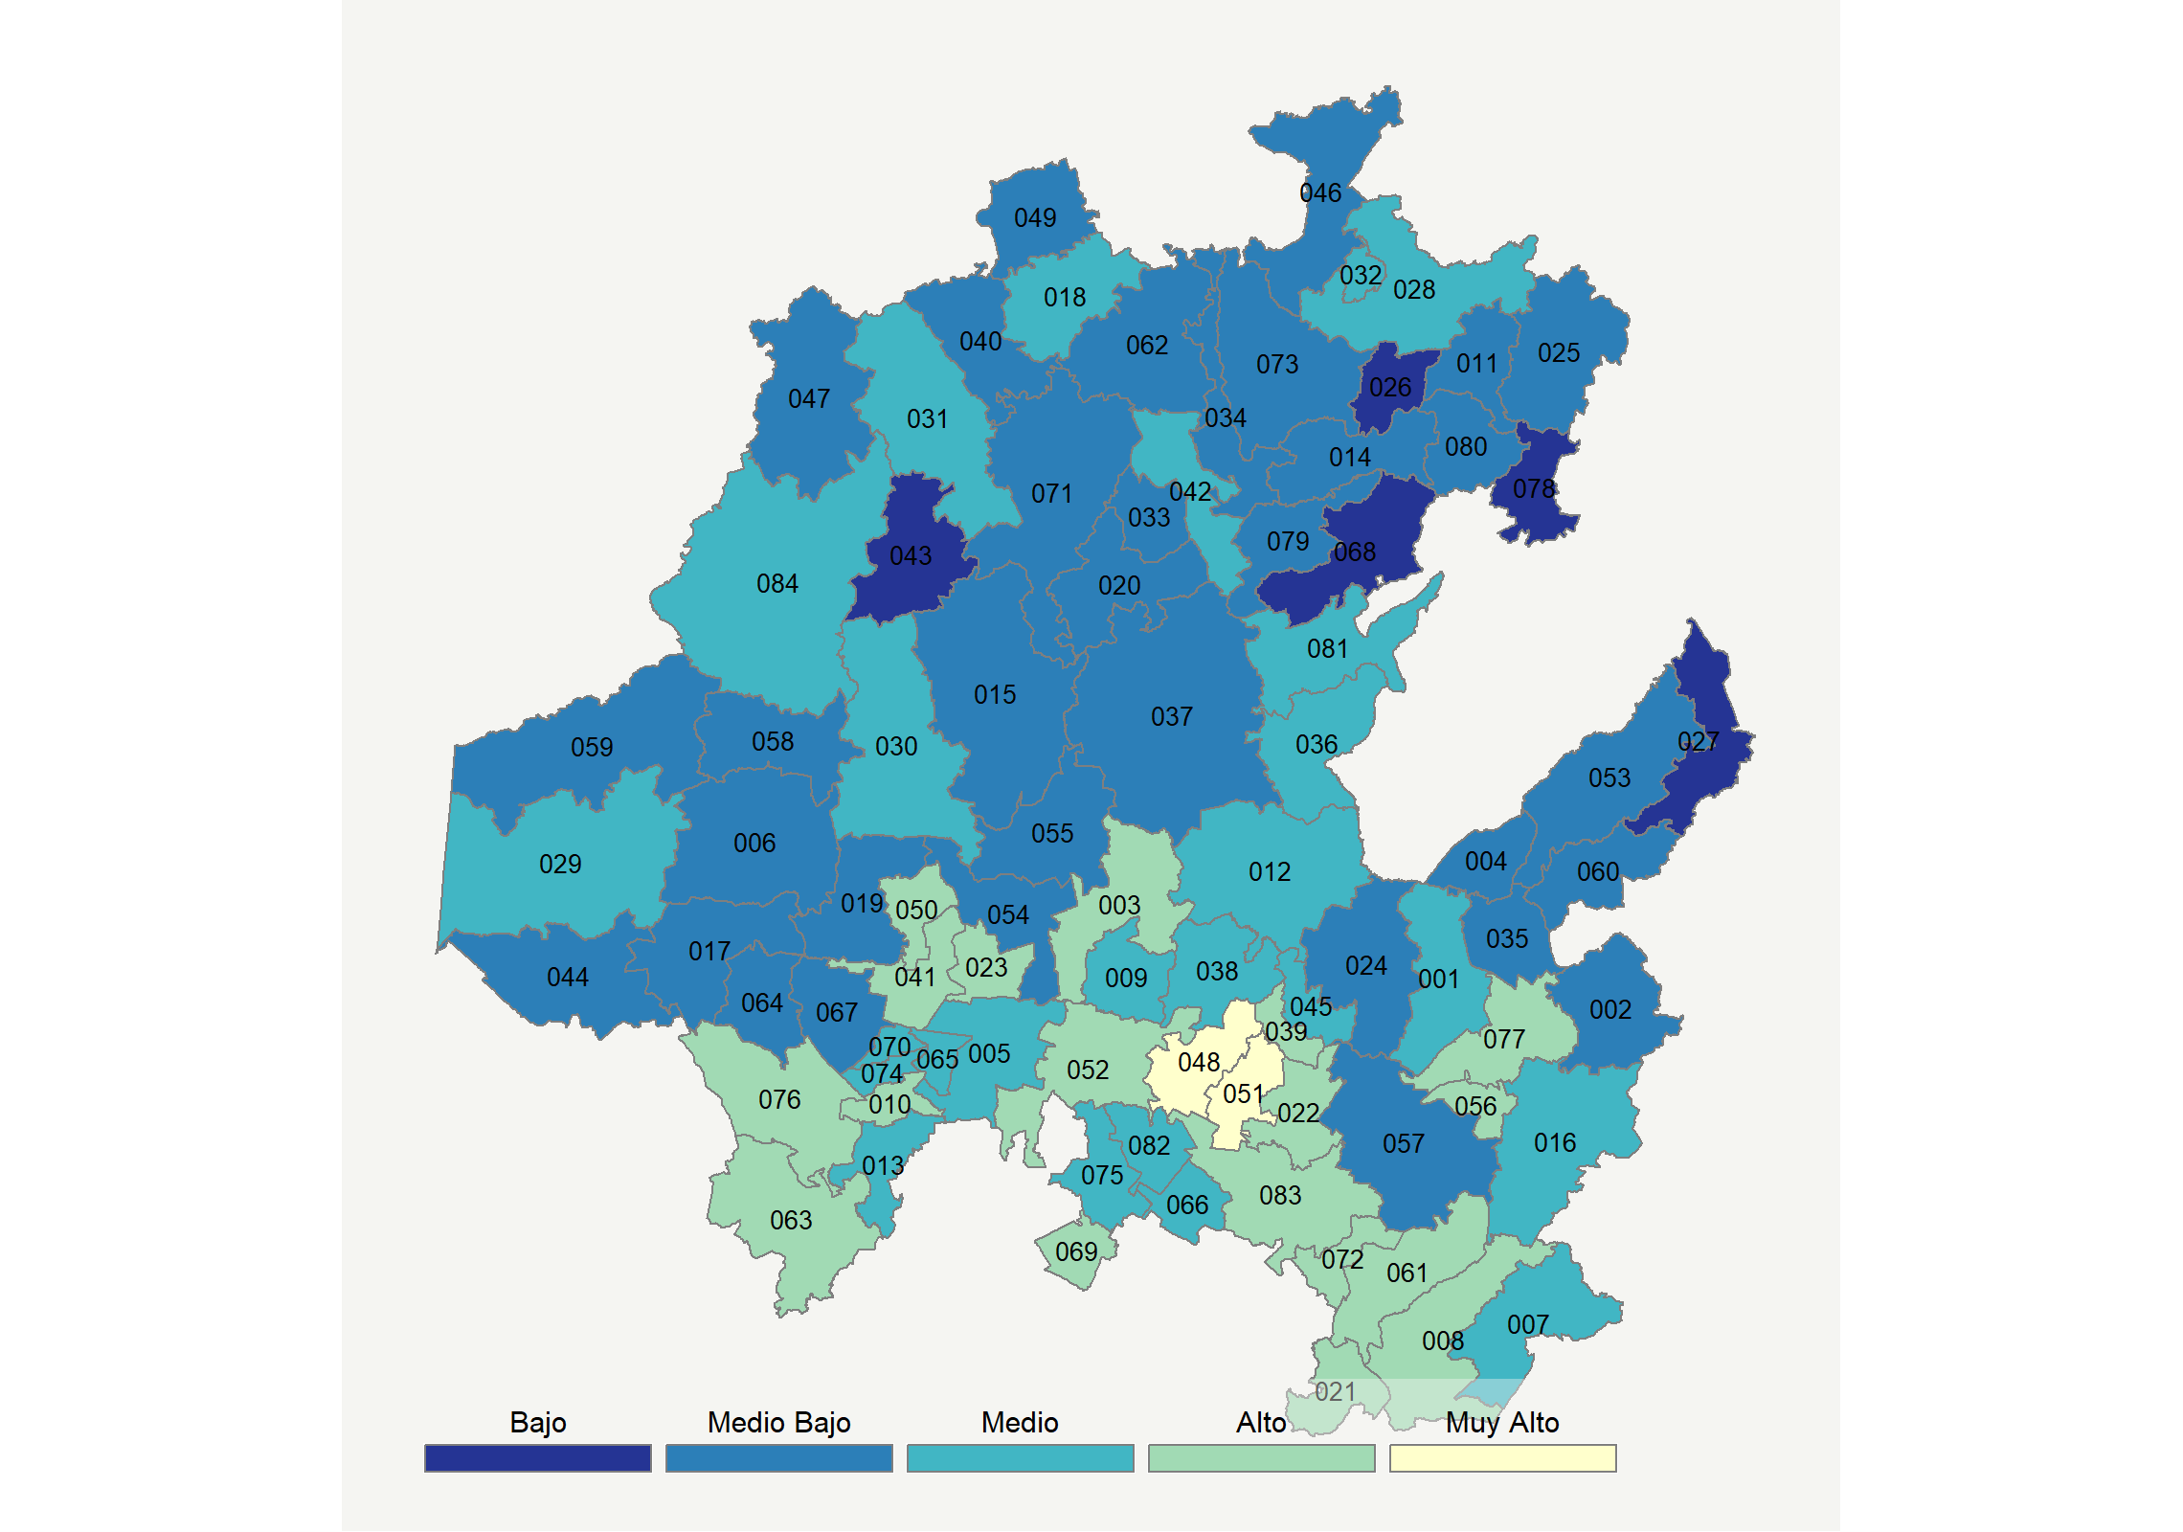

|  |  |  |  |  |  |  |  |  |  |  |  |  |  |
| --- | --- | --- | --- | --- | --- | --- | --- | --- | --- | --- | --- | --- | --- |
| **Clave del Municipio** | **Municipio** | **Telefonía fija a** | **Telefonía Celular a** | **Internet a** | **Televisión de paga a** | **Población Total a** | **Hasta 2 Salarios Mínimos b** | **Índice de Marginación** | **índice** | **Índice Escala 0-100** | **Lugar Nacional** | **Lugar Estatal** | **Estrato** |
| 001 | Acatlán | 18.4 | 77.2 | 9.0 | 32.0 | 21044 | 49.5 | 0.08 | 0.10 | 31.9 | 1033 | 34 | Medio |
| 002 | Acaxochitlán | 8.8 | 61.4 | 3.5 | 24.8 | 43774 | 68.2 | 0.67 | -0.43 | 21.5 | 1646 | 66 | Medio Bajo |
| 003 | Actopan | 28.8 | 72.3 | 20.3 | 35.1 | 56429 | 49.5 | -0.99 | 0.53 | 40.4 | 580 | 15 | Alto |
| 004 | Agua Blanca de Iturbide | 6.1 | 63.5 | 4.4 | 19.4 | 9116 | 57.1 | 0.14 | -0.49 | 20.3 | 1717 | 72 | Medio Bajo |
| 005 | Ajacuba | 13.0 | 76.5 | 7.8 | 40.9 | 18320 | 42.8 | -0.88 | 0.08 | 31.4 | 1060 | 35 | Medio |
| 006 | Alfajayucan | 7.3 | 71.1 | 4.2 | 17.1 | 20332 | 70.4 | 0.05 | -0.42 | 21.6 | 1641 | 65 | Medio Bajo |
| 007 | Almoloya | 14.0 | 66.6 | 8.7 | 39.8 | 12410 | 52.2 | -0.33 | 0.00 | 30.0 | 1142 | 41 | Medio |
| 008 | Apan | 26.3 | 75.9 | 19.1 | 46.9 | 44576 | 49.6 | -1.04 | 0.63 | 42.4 | 502 | 13 | Alto |
| 009 | El Arenal | 11.5 | 73.0 | 12.3 | 43.3 | 18807 | 47.6 | -0.65 | 0.15 | 32.9 | 971 | 32 | Medio |
| 010 | Atitalaquia | 26.6 | 82.4 | 24.4 | 47.7 | 29683 | 25.8 | -1.45 | 0.84 | 46.4 | 375 | 10 | Alto |
| 011 | Atlapexco | 15.5 | 45.6 | 5.4 | 36.2 | 19902 | 71.2 | 0.48 | -0.30 | 24.1 | 1498 | 60 | Medio Bajo |
| 012 | Atotonilco el Grande | 13.6 | 76.2 | 10.7 | 46.2 | 27433 | 60.6 | -0.22 | 0.21 | 34.1 | 907 | 28 | Medio |
| 013 | Atotonilco de Tula | 10.8 | 81.8 | 10.7 | 36.7 | 38564 | 27.9 | -1.25 | 0.12 | 32.2 | 1013 | 33 | Medio |
| 014 | Calnali | 11.0 | 55.3 | 1.5 | 26.9 | 17163 | 65.3 | 0.39 | -0.48 | 20.5 | 1705 | 69 | Medio Bajo |
| 015 | Cardonal | 12.1 | 62.6 | 5.4 | 19.2 | 18347 | 54.6 | -0.23 | -0.38 | 22.5 | 1590 | 63 | Medio Bajo |
| 016 | Cuautepec de Hinojosa | 23.2 | 73.5 | 11.9 | 36.4 | 58301 | 56.8 | -0.30 | 0.26 | 35.1 | 857 | 26 | Medio |
| 017 | Chapantongo | 9.0 | 65.4 | 2.9 | 16.3 | 13789 | 74.7 | 0.27 | -0.49 | 20.2 | 1725 | 73 | Medio Bajo |
| 018 | Chapulhuacán | 22.8 | 56.5 | 3.5 | 38.0 | 23961 | 64.0 | 0.29 | -0.10 | 28.0 | 1252 | 45 | Medio |
| 019 | Chilcuautla | 11.8 | 63.5 | 4.2 | 24.7 | 18169 | 58.6 | -0.30 | -0.34 | 23.2 | 1549 | 62 | Medio Bajo |
| 020 | Eloxochitlán * | 19.1 | 51.2 | 2.1 | 37.0 | 2667 | 70.5 | 0.06 | -0.26 | 24.9 | 1455 | 57 | Medio Bajo |
| 021 | Emiliano Zapata | 30.4 | 76.5 | 17.0 | 63.6 | 14825 | 38.1 | -1.28 | 0.84 | 46.5 | 369 | 9 | Alto |
| 022 | Epazoyucan | 27.2 | 78.3 | 17.0 | 30.1 | 14693 | 41.9 | -0.88 | 0.43 | 38.4 | 689 | 19 | Alto |
| 023 | Francisco I. Madero | 20.4 | 74.6 | 19.1 | 45.2 | 35872 | 46.6 | -1.07 | 0.50 | 39.8 | 606 | 18 | Alto |
| 024 | Huasca de Ocampo | 10.9 | 76.6 | 6.2 | 29.5 | 17728 | 52.0 | -0.21 | -0.12 | 27.5 | 1287 | 48 | Medio Bajo |
| 025 | Huautla | 6.8 | 47.0 | 3.0 | 27.3 | 21244 | 60.9 | 0.39 | -0.59 | 18.4 | 1824 | 77 | Medio Bajo |
| 026 | Huazalingo | 7.6 | 42.9 | 2.3 | 20.1 | 13986 | 67.1 | 0.45 | -0.71 | 15.9 | 1932 | 80 | Bajo |
| 027 | Huehuetla | 11.1 | 23.7 | 1.5 | 21.7 | 25989 | 64.2 | 1.49 | -0.84 | 13.3 | 2050 | 82 | Bajo |
| 028 | Huejutla de Reyes | 18.0 | 60.4 | 11.9 | 50.8 | 129919 | 62.1 | -0.07 | 0.21 | 34.1 | 906 | 27 | Medio |
| 029 | Huichapan | 23.3 | 71.2 | 13.5 | 29.2 | 45959 | 48.1 | -0.66 | 0.20 | 33.9 | 921 | 29 | Medio |
| 030 | Ixmiquilpan | 23.6 | 70.8 | 16.1 | 34.1 | 93502 | 58.2 | -0.70 | 0.32 | 36.2 | 795 | 22 | Medio |
| 031 | Jacala de Ledezma | 25.6 | 57.8 | 7.0 | 50.4 | 13399 | 59.2 | 0.11 | 0.18 | 33.6 | 941 | 30 | Medio |
| 032 | Jaltocán | 11.5 | 64.3 | 2.2 | 53.7 | 11818 | 72.6 | 0.04 | -0.06 | 28.7 | 1215 | 44 | Medio |
| 033 | Juárez Hidalgo * | 7.8 | 58.2 | 2.1 | 26.9 | 3108 | 59.2 | -0.03 | -0.49 | 20.3 | 1714 | 71 | Medio Bajo |
| 034 | Lolotla | 14.7 | 47.6 | 1.1 | 34.0 | 9461 | 60.2 | 0.56 | -0.42 | 21.6 | 1639 | 64 | Medio Bajo |
| 035 | Metepec | 12.8 | 76.8 | 4.9 | 31.3 | 11801 | 57.1 | -0.28 | -0.10 | 27.9 | 1262 | 46 | Medio Bajo |
| 036 | San Agustín Metzquititlán | 17.8 | 62.3 | 7.0 | 38.1 | 9437 | 73.2 | -0.05 | -0.04 | 29.2 | 1180 | 43 | Medio |
| 037 | Metztitlán | 13.9 | 56.7 | 3.0 | 42.5 | 20111 | 74.1 | 0.31 | -0.20 | 25.9 | 1386 | 55 | Medio Bajo |
| 038 | Mineral del Chico | 11.6 | 72.8 | 7.7 | 39.9 | 9028 | 53.9 | 0.09 | 0.00 | 30.0 | 1145 | 42 | Medio |
| 039 | Mineral del Monte | 32.2 | 79.8 | 30.4 | 58.7 | 14640 | 43.3 | -1.20 | 1.17 | 53.0 | 232 | 3 | Alto |
| 040 | La Misión | 23.8 | 40.4 | 4.2 | 28.9 | 10139 | 61.1 | 1.04 | -0.32 | 23.6 | 1525 | 61 | Medio Bajo |
| 041 | Mixquiahuala de Juárez | 27.0 | 73.6 | 18.8 | 29.2 | 46224 | 48.3 | -1.09 | 0.42 | 38.1 | 702 | 20 | Alto |
| 042 | Molango de Escamilla | 11.8 | 68.4 | 6.2 | 50.0 | 11587 | 59.5 | -0.04 | 0.04 | 30.7 | 1105 | 38 | Medio |
| 043 | Nicolás Flores | 7.8 | 18.6 | 1.6 | 23.3 | 7031 | 69.6 | 0.32 | -0.93 | 11.6 | 2116 | 84 | Bajo |
| 044 | Nopala de Villagrán | 12.6 | 68.6 | 5.8 | 20.9 | 16896 | 59.6 | -0.14 | -0.28 | 24.4 | 1473 | 59 | Medio Bajo |
| 045 | Omitlán de Juárez | 7.6 | 75.3 | 6.6 | 47.6 | 9636 | 55.1 | -0.15 | 0.02 | 30.3 | 1125 | 40 | Medio |
| 046 | San Felipe Orizatlán | 11.5 | 56.1 | 2.5 | 52.5 | 38952 | 68.2 | 0.16 | -0.15 | 27.0 | 1313 | 51 | Medio Bajo |
| 047 | Pacula | 12.6 | 21.5 | 0.5 | 47.7 | 5139 | 54.7 | 0.38 | -0.57 | 18.6 | 1810 | 75 | Medio Bajo |
| 048 | Pachuca de Soto | 47.2 | 90.6 | 46.5 | 51.8 | 277375 | 33.4 | -1.68 | 1.84 | 66.1 | 58 | 1 | Muy Alto |
| 049 | Pisaflores | 12.2 | 40.9 | 1.6 | 37.9 | 17379 | 66.7 | 0.70 | -0.47 | 20.6 | 1700 | 68 | Medio Bajo |
| 050 | Progreso de Obregón | 33.0 | 79.3 | 26.9 | 33.7 | 23451 | 42.5 | -1.28 | 0.82 | 46.0 | 386 | 11 | Alto |
| 051 | Mineral de la Reforma | 39.4 | 92.8 | 43.0 | 52.7 | 150176 | 28.5 | -1.52 | 1.66 | 62.6 | 88 | 2 | Muy Alto |
| 052 | San Agustín Tlaxiaca | 19.0 | 79.9 | 18.3 | 49.3 | 36079 | 36.8 | -0.86 | 0.56 | 40.9 | 559 | 14 | Alto |
| 053 | San Bartolo Tutotepec | 6.8 | 40.3 | 5.0 | 25.6 | 18986 | 60.5 | 1.20 | -0.62 | 17.7 | 1863 | 79 | Medio Bajo |
| 054 | San Salvador | 9.0 | 65.4 | 9.0 | 37.4 | 35547 | 56.9 | -0.64 | -0.11 | 27.7 | 1273 | 47 | Medio Bajo |
| 055 | Santiago de Anaya | 11.1 | 67.7 | 6.8 | 33.3 | 17032 | 61.6 | -0.44 | -0.15 | 26.9 | 1318 | 53 | Medio Bajo |
| 056 | Santiago Tulantepec de Lugo Guerrero | 33.5 | 82.0 | 22.9 | 44.7 | 37292 | 42.0 | -1.06 | 0.87 | 47.2 | 348 | 8 | Alto |
| 057 | Singuilucan | 11.0 | 72.1 | 7.2 | 29.5 | 16235 | 51.5 | -0.11 | -0.14 | 27.1 | 1308 | 50 | Medio Bajo |
| 058 | Tasquillo | 19.6 | 57.4 | 6.5 | 27.2 | 16403 | 63.1 | -0.22 | -0.19 | 26.2 | 1369 | 54 | Medio Bajo |
| 059 | Tecozautla | 13.7 | 65.4 | 5.5 | 29.2 | 37674 | 66.7 | -0.03 | -0.21 | 25.8 | 1395 | 56 | Medio Bajo |
| 060 | Tenango de Doria | 17.6 | 56.0 | 6.8 | 36.5 | 18766 | 59.7 | 0.35 | -0.13 | 27.4 | 1290 | 49 | Medio Bajo |
| 061 | Tepeapulco | 41.7 | 82.7 | 29.5 | 41.3 | 54373 | 36.6 | -1.49 | 1.14 | 52.4 | 241 | 4 | Alto |
| 062 | Tepehuacán de Guerrero | 13.4 | 33.9 | 1.6 | 32.2 | 30750 | 62.5 | 1.23 | -0.58 | 18.4 | 1822 | 76 | Medio Bajo |
| 063 | Tepeji del Río de Ocampo | 19.0 | 80.6 | 19.2 | 42.7 | 87442 | 30.8 | -1.09 | 0.51 | 40.0 | 599 | 17 | Alto |
| 064 | Tepetitlán | 12.0 | 72.4 | 8.0 | 25.3 | 10932 | 37.9 | -0.75 | -0.15 | 26.9 | 1317 | 52 | Medio Bajo |
| 065 | Tetepango | 11.8 | 75.4 | 7.7 | 43.8 | 11624 | 40.5 | -1.18 | 0.08 | 31.4 | 1061 | 36 | Medio |
| 066 | Villa de Tezontepec | 20.7 | 79.0 | 15.7 | 27.1 | 12413 | 42.0 | -0.98 | 0.26 | 35.1 | 854 | 24 | Medio |
| 067 | Tezontepec de Aldama | 10.3 | 72.4 | 8.1 | 17.1 | 53009 | 53.8 | -0.60 | -0.27 | 24.7 | 1465 | 58 | Medio Bajo |
| 068 | Tianguistengo | 4.5 | 51.5 | 0.8 | 19.0 | 15122 | 68.6 | 0.95 | -0.72 | 15.6 | 1945 | 81 | Bajo |
| 069 | Tizayuca | 17.6 | 89.7 | 25.9 | 38.6 | 119442 | 32.5 | -1.47 | 0.69 | 43.6 | 459 | 12 | Alto |
| 070 | Tlahuelilpan | 20.2 | 79.5 | 18.1 | 24.2 | 19389 | 50.2 | -0.91 | 0.29 | 35.6 | 832 | 23 | Medio |
| 071 | Tlahuiltepa | 10.9 | 56.4 | 0.6 | 27.3 | 10376 | 51.9 | 0.34 | -0.48 | 20.4 | 1711 | 70 | Medio Bajo |
| 072 | Tlanalapa | 39.1 | 80.2 | 27.7 | 41.3 | 10342 | 37.6 | -1.44 | 1.03 | 50.2 | 280 | 7 | Alto |
| 073 | Tlanchinol | 8.2 | 53.6 | 2.1 | 23.8 | 39772 | 66.0 | 0.59 | -0.56 | 18.9 | 1797 | 74 | Medio Bajo |
| 074 | Tlaxcoapan | 13.4 | 76.2 | 11.0 | 30.8 | 28490 | 39.9 | -1.17 | 0.04 | 30.8 | 1102 | 37 | Medio |
| 075 | Tolcayuca | 13.9 | 85.8 | 13.5 | 28.2 | 16733 | 47.6 | -1.09 | 0.18 | 33.5 | 947 | 31 | Medio |
| 076 | Tula de Allende | 30.3 | 85.1 | 29.8 | 55.0 | 109093 | 31.5 | -1.38 | 1.13 | 52.3 | 244 | 5 | Alto |
| 077 | Tulancingo de Bravo | 35.6 | 82.3 | 27.5 | 49.2 | 161069 | 45.4 | -1.12 | 1.08 | 51.2 | 265 | 6 | Alto |
| 078 | Xochiatipan * | 3.2 | 40.6 | 0.7 | 17.9 | 19752 | 59.4 | 1.30 | -0.87 | 12.8 | 2075 | 83 | Bajo |
| 079 | Xochicoatlán | 8.9 | 60.4 | 1.6 | 27.6 | 7706 | 69.2 | 0.08 | -0.45 | 21.1 | 1675 | 67 | Medio Bajo |
| 080 | Yahualica | 11.4 | 44.4 | 2.3 | 21.9 | 24173 | 70.0 | 1.37 | -0.61 | 17.9 | 1853 | 78 | Medio Bajo |
| 081 | Zacualtipán de Ángeles | 18.5 | 78.1 | 11.2 | 53.1 | 34720 | 57.6 | -0.66 | 0.40 | 37.8 | 719 | 21 | Medio |
| 082 | Zapotlán de Juárez | 19.4 | 80.3 | 17.9 | 23.0 | 18748 | 51.7 | -0.95 | 0.26 | 35.1 | 856 | 25 | Medio |
| 083 | Zempoala | 22.8 | 81.0 | 20.3 | 35.1 | 45382 | 41.2 | -1.02 | 0.52 | 40.2 | 591 | 16 | Alto |
| 084 | Zimapán | 14.9 | 69.7 | 9.9 | 35.8 | 40201 | 52.2 | -0.45 | 0.03 | 30.6 | 1113 | 39 | Medio |
| a Porcentaje de viviendas que cuentas con el servicio  b Ingreso por trabajo de la población ocupada en porcentaje  Fuente: Elaboración propia con datos de Encuesta Intercensal 2015 de INEGI y CONAPO | | | | | | | | | | | | | |

**Jalisco**

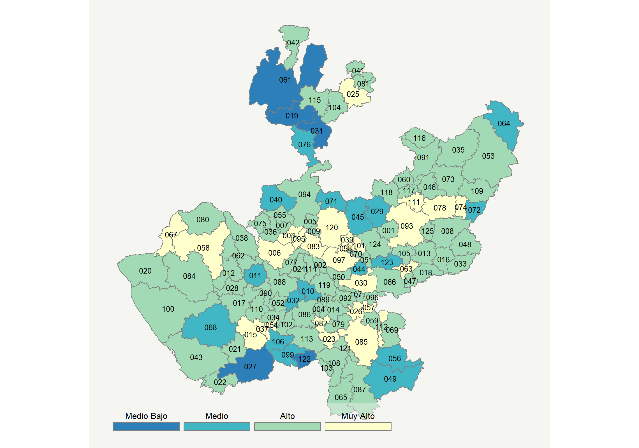

|  |  |  |  |  |  |  |  |  |  |  |  |  |  |
| --- | --- | --- | --- | --- | --- | --- | --- | --- | --- | --- | --- | --- | --- |
| **Clave del Municipio** | **Municipio** | **Telefonía fija a** | **Telefonía Celular a** | **Internet a** | **Televisión de paga a** | **Población Total a** | **Hasta 2 Salarios Mínimos b** | **Índice de Marginación** | **índice** | **Índice Escala 0-100** | **Lugar Nacional** | **Lugar Estatal** | **Estrato** |
| 001 | Acatic | 30.3 | 82.8 | 25.2 | 41.9 | 21530 | 31.6 | -0.82 | 0.86 | 46.8 | 359 | 55 | Alto |
| 002 | Acatlán de Juárez | 27.0 | 85.8 | 25.1 | 69.3 | 22261 | 26.3 | -1.39 | 1.13 | 52.3 | 245 | 32 | Alto |
| 003 | Ahualulco de Mercado | 41.3 | 83.0 | 33.3 | 60.1 | 23362 | 33.4 | -1.33 | 1.44 | 58.3 | 136 | 15 | Muy Alto |
| 004 | Amacueca | 41.3 | 67.8 | 19.0 | 65.0 | 5385 | 40.4 | -0.77 | 1.00 | 49.6 | 293 | 46 | Alto |
| 005 | Amatitán | 28.3 | 78.8 | 23.9 | 51.8 | 15344 | 39.3 | -1.12 | 0.86 | 46.9 | 358 | 54 | Alto |
| 006 | Ameca | 45.6 | 76.2 | 29.0 | 65.8 | 60951 | 34.0 | -1.18 | 1.40 | 57.6 | 144 | 18 | Muy Alto |
| 007 | San Juanito de Escobedo | 35.5 | 75.8 | 20.6 | 43.1 | 9420 | 38.9 | -1.02 | 0.77 | 45.2 | 414 | 72 | Alto |
| 008 | Arandas | 28.8 | 83.4 | 26.5 | 60.2 | 77116 | 34.0 | -1.10 | 1.07 | 51.1 | 270 | 39 | Alto |
| 009 | El Arenal | 25.4 | 81.9 | 20.9 | 55.2 | 19900 | 29.3 | -1.27 | 0.81 | 45.9 | 389 | 64 | Alto |
| 010 | Atemajac de Brizuela | 20.6 | 71.7 | 11.0 | 41.5 | 6717 | 38.1 | -0.62 | 0.24 | 34.6 | 881 | 114 | Medio |
| 011 | Atengo | 32.1 | 58.7 | 6.5 | 46.1 | 5475 | 49.6 | -0.22 | 0.24 | 34.7 | 876 | 113 | Medio |
| 012 | Atenguillo * | 39.6 | 74.2 | 11.2 | 53.3 | 3899 | 30.8 | -0.88 | 0.71 | 44.0 | 446 | 76 | Alto |
| 013 | Atotonilco el Alto | 31.9 | 78.9 | 20.9 | 50.9 | 60480 | 25.6 | -1.17 | 0.84 | 46.5 | 371 | 60 | Alto |
| 014 | Atoyac | 36.6 | 53.4 | 15.6 | 57.8 | 8264 | 48.0 | -0.54 | 0.61 | 42.1 | 513 | 87 | Alto |
| 015 | Autlán de Navarro | 45.8 | 84.1 | 35.3 | 48.9 | 60572 | 30.8 | -1.29 | 1.45 | 58.5 | 134 | 14 | Muy Alto |
| 016 | Ayotlán | 31.3 | 69.4 | 17.9 | 46.9 | 37963 | 43.9 | -0.69 | 0.62 | 42.1 | 510 | 85 | Alto |
| 017 | Ayutla | 35.5 | 68.1 | 18.7 | 38.8 | 12453 | 46.0 | -0.84 | 0.61 | 41.9 | 521 | 90 | Alto |
| 018 | La Barca | 38.9 | 71.5 | 24.5 | 55.6 | 65055 | 37.2 | -1.07 | 1.02 | 50.1 | 283 | 43 | Alto |
| 019 | Bolaños | 10.5 | 52.5 | 7.7 | 35.1 | 7341 | 26.2 | 2.70 | -0.27 | 24.6 | 1468 | 123 | Medio Bajo |
| 020 | Cabo Corrientes | 19.5 | 74.4 | 11.9 | 58.9 | 10303 | 35.7 | -0.38 | 0.46 | 39.0 | 648 | 102 | Alto |
| 021 | Casimiro Castillo | 38.3 | 71.6 | 22.8 | 41.1 | 21584 | 36.1 | -0.84 | 0.81 | 45.9 | 391 | 66 | Alto |
| 022 | Cihuatlán | 30.2 | 76.0 | 25.4 | 66.9 | 41300 | 34.3 | -0.84 | 1.07 | 51.1 | 269 | 38 | Alto |
| 023 | Zapotlán el Grande | 49.7 | 86.7 | 44.1 | 52.4 | 105423 | 31.3 | -1.60 | 1.79 | 65.2 | 64 | 4 | Muy Alto |
| 024 | Cocula | 42.4 | 73.8 | 18.0 | 50.6 | 26687 | 38.4 | -1.03 | 0.89 | 47.5 | 343 | 52 | Alto |
| 025 | Colotlán | 45.6 | 79.5 | 34.7 | 45.7 | 17865 | 42.5 | -1.18 | 1.35 | 56.5 | 162 | 20 | Muy Alto |
| 026 | Concepción de Buenos Aires | 34.0 | 77.7 | 26.9 | 76.5 | 6088 | 31.3 | -0.67 | 1.29 | 55.5 | 183 | 23 | Muy Alto |
| 027 | Cuautitlán de García Barragán | 17.7 | 29.0 | 8.6 | 28.6 | 18138 | 44.5 | 0.82 | -0.43 | 21.4 | 1656 | 124 | Medio Bajo |
| 028 | Cuautla * | 38.0 | 73.0 | 20.0 | 49.3 | 2120 | 33.2 | -0.63 | 0.84 | 46.6 | 365 | 59 | Alto |
| 029 | Cuquío | 23.5 | 78.9 | 8.3 | 25.8 | 17980 | 46.2 | -0.33 | 0.12 | 32.2 | 1010 | 117 | Medio |
| 030 | Chapala | 44.2 | 84.2 | 39.6 | 50.1 | 50738 | 33.8 | -1.34 | 1.54 | 60.2 | 112 | 9 | Muy Alto |
| 031 | Chimaltitán * | 11.6 | 60.8 | 2.6 | 38.6 | 3383 | 50.1 | 0.97 | -0.25 | 24.9 | 1452 | 122 | Medio Bajo |
| 032 | Chiquilistlán | 22.6 | 65.7 | 7.5 | 62.1 | 6102 | 54.6 | -0.29 | 0.36 | 37.0 | 760 | 108 | Medio |
| 033 | Degollado | 38.2 | 69.9 | 19.9 | 49.6 | 21479 | 36.3 | -0.81 | 0.82 | 46.1 | 384 | 63 | Alto |
| 034 | Ejutla * | 45.4 | 66.2 | 20.3 | 39.6 | 1862 | 40.0 | -0.76 | 0.80 | 45.7 | 397 | 69 | Alto |
| 035 | Encarnación de Díaz | 31.4 | 78.3 | 18.2 | 47.0 | 53555 | 41.9 | -0.82 | 0.72 | 44.1 | 444 | 75 | Alto |
| 036 | Etzatlán | 46.2 | 74.4 | 30.0 | 46.0 | 19847 | 35.6 | -1.26 | 1.20 | 53.5 | 220 | 28 | Alto |
| 037 | El Grullo | 47.4 | 81.2 | 34.1 | 54.9 | 24312 | 31.7 | -1.36 | 1.48 | 59.2 | 129 | 12 | Muy Alto |
| 038 | Guachinango * | 40.7 | 63.4 | 18.1 | 46.2 | 4184 | 41.6 | -0.56 | 0.71 | 44.0 | 449 | 77 | Alto |
| 039 | Guadalajara | 62.7 | 88.4 | 52.9 | 46.7 | 1460148 | 26.1 | -1.86 | 2.17 | 72.7 | 28 | 2 | Muy Alto |
| 040 | Hostotipaquillo | 18.8 | 74.6 | 9.3 | 52.2 | 9761 | 49.4 | -0.27 | 0.32 | 36.1 | 798 | 109 | Medio |
| 041 | Huejúcar | 46.3 | 62.5 | 17.2 | 45.8 | 5633 | 55.7 | -0.50 | 0.77 | 45.1 | 417 | 74 | Alto |
| 042 | Huejuquilla el Alto | 26.8 | 70.1 | 15.5 | 49.9 | 8787 | 46.0 | 0.08 | 0.53 | 40.3 | 586 | 96 | Alto |
| 043 | La Huerta | 34.3 | 69.8 | 24.8 | 67.9 | 24563 | 35.8 | -0.71 | 1.07 | 51.1 | 267 | 37 | Alto |
| 044 | Ixtlahuacán de los Membrillos | 16.0 | 88.6 | 15.9 | 29.4 | 53045 | 26.1 | -1.20 | 0.31 | 36.1 | 803 | 110 | Medio |
| 045 | Ixtlahuacán del Río | 32.3 | 79.3 | 15.5 | 21.1 | 19070 | 37.8 | -0.62 | 0.39 | 37.6 | 730 | 105 | Medio |
| 046 | Jalostotitlán | 33.6 | 78.1 | 25.7 | 60.4 | 33777 | 40.0 | -1.06 | 1.08 | 51.3 | 263 | 36 | Alto |
| 047 | Jamay | 38.5 | 76.5 | 26.7 | 59.1 | 24753 | 42.0 | -0.99 | 1.16 | 52.8 | 234 | 31 | Alto |
| 048 | Jesús María | 33.3 | 80.5 | 23.1 | 54.1 | 19469 | 43.5 | -0.68 | 0.97 | 49.0 | 308 | 48 | Alto |
| 049 | Jilotlán de los Dolores | 18.5 | 66.7 | 5.5 | 65.5 | 9917 | 27.6 | -0.09 | 0.29 | 35.6 | 830 | 112 | Medio |
| 050 | Jocotepec | 29.1 | 84.3 | 23.7 | 60.4 | 46521 | 25.7 | -1.02 | 1.02 | 50.0 | 285 | 44 | Alto |
| 051 | Juanacatlán | 26.4 | 86.1 | 20.5 | 36.1 | 17955 | 30.3 | -1.36 | 0.64 | 42.6 | 494 | 82 | Alto |
| 052 | Juchitlán | 36.6 | 71.7 | 18.1 | 57.0 | 5638 | 45.3 | -0.55 | 0.85 | 46.6 | 362 | 56 | Alto |
| 053 | Lagos de Moreno | 32.7 | 80.6 | 28.5 | 51.2 | 164981 | 44.1 | -0.94 | 1.06 | 50.8 | 273 | 40 | Alto |
| 054 | El Limón | 54.0 | 65.6 | 25.4 | 57.6 | 5379 | 43.2 | -0.82 | 1.26 | 54.7 | 201 | 26 | Muy Alto |
| 055 | Magdalena | 31.5 | 79.4 | 19.2 | 54.4 | 22643 | 39.0 | -1.04 | 0.84 | 46.4 | 374 | 62 | Alto |
| 056 | Santa María del Oro * | 35.3 | 31.7 | 5.2 | 52.9 | 2028 | 41.3 | 0.58 | 0.07 | 31.4 | 1063 | 119 | Medio |
| 057 | La Manzanilla de la Paz | 36.0 | 73.7 | 30.9 | 80.1 | 3688 | 38.6 | -0.91 | 1.42 | 58.0 | 139 | 16 | Muy Alto |
| 058 | Mascota | 44.5 | 74.7 | 29.8 | 77.4 | 14477 | 30.7 | -1.14 | 1.52 | 59.9 | 116 | 10 | Muy Alto |
| 059 | Mazamitla | 27.1 | 77.6 | 26.2 | 70.7 | 13799 | 33.7 | -0.95 | 1.10 | 51.5 | 259 | 35 | Alto |
| 060 | Mexticacán | 27.4 | 77.8 | 10.6 | 44.3 | 5088 | 44.4 | -0.59 | 0.43 | 38.5 | 684 | 103 | Alto |
| 061 | Mezquitic * | 10.3 | 44.0 | 4.8 | 20.0 | 19452 | 51.3 | 3.03 | -0.60 | 18.2 | 1833 | 125 | Medio Bajo |
| 062 | Mixtlán * | 45.1 | 57.7 | 6.1 | 57.8 | 3526 | 45.4 | -0.52 | 0.57 | 41.2 | 551 | 93 | Alto |
| 063 | Ocotlán | 38.8 | 83.2 | 36.9 | 69.7 | 99461 | 34.7 | -1.36 | 1.59 | 61.3 | 103 | 7 | Muy Alto |
| 064 | Ojuelos de Jalisco | 20.9 | 74.4 | 9.4 | 56.3 | 32357 | 45.8 | -0.54 | 0.40 | 37.7 | 722 | 104 | Medio |
| 065 | Pihuamo | 38.1 | 61.6 | 12.3 | 44.2 | 11192 | 34.9 | -0.57 | 0.49 | 39.6 | 615 | 100 | Alto |
| 066 | Poncitlán | 27.5 | 73.0 | 18.8 | 47.0 | 51944 | 44.1 | -0.66 | 0.62 | 42.1 | 512 | 86 | Alto |
| 067 | Puerto Vallarta | 42.7 | 92.2 | 49.9 | 59.1 | 275640 | 24.6 | -1.64 | 1.94 | 68.2 | 46 | 3 | Muy Alto |
| 068 | Villa Purificación | 22.3 | 56.9 | 13.8 | 57.0 | 10704 | 36.7 | -0.44 | 0.36 | 37.0 | 755 | 107 | Medio |
| 069 | Quitupan | 36.0 | 54.9 | 9.7 | 61.8 | 8379 | 43.0 | -0.11 | 0.52 | 40.3 | 588 | 97 | Alto |
| 070 | El Salto | 30.3 | 85.3 | 20.9 | 24.4 | 183437 | 31.0 | -1.24 | 0.58 | 41.4 | 542 | 91 | Alto |
| 071 | San Cristóbal de la Barranca * | 15.9 | 79.7 | 1.5 | 48.9 | 3117 | 40.8 | -0.33 | 0.09 | 31.7 | 1042 | 118 | Medio |
| 072 | San Diego de Alejandría | 27.9 | 77.2 | 17.3 | 24.4 | 7349 | 38.7 | -0.80 | 0.37 | 37.3 | 740 | 106 | Medio |
| 073 | San Juan de los Lagos | 33.7 | 82.1 | 28.9 | 45.5 | 69725 | 35.3 | -1.12 | 1.03 | 50.3 | 278 | 41 | Alto |
| 074 | San Julián | 44.8 | 84.0 | 34.3 | 57.7 | 15890 | 36.6 | -1.20 | 1.50 | 59.6 | 121 | 11 | Muy Alto |
| 075 | San Marcos * | 37.4 | 80.5 | 23.9 | 35.3 | 3783 | 33.0 | -0.85 | 0.85 | 46.6 | 363 | 57 | Alto |
| 076 | San Martín de Bolaños * | 14.8 | 84.5 | 5.7 | 49.2 | 3122 | 24.6 | -0.50 | 0.23 | 34.4 | 893 | 115 | Medio |
| 077 | San Martín Hidalgo | 46.5 | 64.8 | 18.9 | 40.1 | 27777 | 35.4 | -0.98 | 0.77 | 45.2 | 416 | 73 | Alto |
| 078 | San Miguel el Alto | 39.9 | 80.4 | 28.5 | 60.9 | 32960 | 40.3 | -1.06 | 1.28 | 55.2 | 187 | 25 | Muy Alto |
| 079 | Gómez Farías | 35.0 | 68.7 | 18.8 | 35.9 | 14278 | 37.6 | -0.94 | 0.57 | 41.2 | 550 | 92 | Alto |
| 080 | San Sebastián del Oeste | 29.2 | 50.7 | 15.0 | 63.8 | 5643 | 42.8 | -0.47 | 0.52 | 40.1 | 592 | 98 | Alto |
| 081 | Santa María de los Ángeles * | 44.9 | 47.0 | 10.2 | 56.7 | 3033 | 58.6 | -0.22 | 0.55 | 40.7 | 569 | 95 | Alto |
| 082 | Sayula | 41.6 | 80.9 | 36.6 | 75.6 | 36778 | 39.6 | -1.26 | 1.68 | 63.0 | 81 | 6 | Muy Alto |
| 083 | Tala | 31.6 | 83.8 | 30.8 | 69.4 | 80365 | 31.6 | -1.24 | 1.33 | 56.2 | 168 | 21 | Muy Alto |
| 084 | Talpa de Allende | 30.2 | 67.9 | 20.7 | 69.2 | 15126 | 40.5 | -0.86 | 0.90 | 47.7 | 338 | 51 | Alto |
| 085 | Tamazula de Gordiano | 45.8 | 70.2 | 33.0 | 75.0 | 38396 | 31.3 | -1.04 | 1.55 | 60.4 | 111 | 8 | Muy Alto |
| 086 | Tapalpa | 22.6 | 70.7 | 16.5 | 62.3 | 19506 | 29.0 | -0.58 | 0.62 | 42.2 | 507 | 84 | Alto |
| 087 | Tecalitlán | 39.8 | 69.7 | 24.8 | 44.8 | 16579 | 38.6 | -0.87 | 0.91 | 47.8 | 337 | 50 | Alto |
| 088 | Tecolotlán | 33.4 | 77.5 | 17.5 | 54.5 | 17257 | 41.2 | -1.01 | 0.81 | 45.9 | 390 | 65 | Alto |
| 089 | Techaluta de Montenegro * | 41.2 | 63.2 | 14.9 | 48.1 | 3703 | 51.2 | -0.62 | 0.66 | 43.0 | 481 | 79 | Alto |
| 090 | Tenamaxtlán | 39.8 | 69.0 | 19.2 | 46.8 | 7005 | 39.6 | -0.83 | 0.79 | 45.5 | 403 | 70 | Alto |
| 091 | Teocaltiche | 35.7 | 66.2 | 18.6 | 45.1 | 41278 | 45.7 | -0.79 | 0.66 | 42.9 | 484 | 80 | Alto |
| 092 | Teocuitatlán de Corona | 28.3 | 68.9 | 12.8 | 57.0 | 10317 | 49.2 | -0.43 | 0.56 | 40.9 | 560 | 94 | Alto |
| 093 | Tepatitlán de Morelos | 40.9 | 88.1 | 37.8 | 73.2 | 141322 | 28.8 | -1.37 | 1.74 | 64.2 | 72 | 5 | Muy Alto |
| 094 | Tequila | 32.9 | 82.8 | 26.9 | 59.0 | 42009 | 39.3 | -1.09 | 1.13 | 52.2 | 247 | 33 | Alto |
| 095 | Teuchitlán | 51.9 | 66.4 | 28.1 | 56.7 | 9608 | 40.3 | -0.84 | 1.29 | 55.3 | 185 | 24 | Muy Alto |
| 096 | Tizapán el Alto | 28.8 | 74.1 | 25.2 | 60.4 | 20961 | 56.2 | -0.71 | 0.95 | 48.6 | 312 | 49 | Alto |
| 097 | Tlajomulco de Zúñiga | 33.0 | 92.9 | 36.0 | 41.3 | 549442 | 25.6 | -1.55 | 1.25 | 54.7 | 203 | 27 | Muy Alto |
| 098 | San Pedro Tlaquepaque | 44.4 | 89.2 | 39.9 | 31.0 | 664193 | 30.6 | -1.50 | 1.39 | 57.3 | 151 | 19 | Muy Alto |
| 099 | Tolimán | 29.8 | 59.4 | 5.8 | 48.0 | 10310 | 51.5 | -0.05 | 0.22 | 34.2 | 899 | 116 | Medio |
| 100 | Tomatlán | 26.1 | 69.8 | 13.7 | 67.4 | 35824 | 25.6 | -0.55 | 0.66 | 43.0 | 479 | 78 | Alto |
| 101 | Tonalá | 38.9 | 89.2 | 37.6 | 36.7 | 536111 | 31.4 | -1.46 | 1.30 | 55.6 | 180 | 22 | Muy Alto |
| 102 | Tonaya | 38.8 | 81.8 | 21.4 | 67.5 | 5960 | 43.2 | -0.77 | 1.18 | 53.2 | 227 | 30 | Alto |
| 103 | Tonila | 37.6 | 72.4 | 20.5 | 44.3 | 7919 | 33.3 | -0.79 | 0.79 | 45.4 | 404 | 71 | Alto |
| 104 | Totatiche | 46.7 | 68.0 | 20.6 | 39.6 | 4412 | 52.8 | -0.48 | 0.84 | 46.6 | 364 | 58 | Alto |
| 105 | Tototlán | 31.4 | 81.9 | 15.5 | 57.3 | 23171 | 31.4 | -0.93 | 0.80 | 45.7 | 394 | 68 | Alto |
| 106 | Tuxcacuesco * | 18.0 | 67.7 | 2.6 | 44.7 | 4229 | 49.7 | -0.04 | -0.01 | 29.7 | 1155 | 120 | Medio |
| 107 | Tuxcueca | 29.7 | 75.1 | 19.0 | 58.4 | 6156 | 34.1 | -0.81 | 0.80 | 45.8 | 393 | 67 | Alto |
| 108 | Tuxpan | 33.0 | 81.1 | 24.2 | 43.9 | 34535 | 42.4 | -1.06 | 0.88 | 47.3 | 344 | 53 | Alto |
| 109 | Unión de San Antonio | 26.7 | 76.8 | 15.1 | 40.3 | 17915 | 41.1 | -0.61 | 0.48 | 39.3 | 632 | 101 | Alto |
| 110 | Unión de Tula | 47.9 | 66.3 | 27.6 | 54.8 | 13446 | 37.6 | -1.16 | 1.19 | 53.3 | 224 | 29 | Alto |
| 111 | Valle de Guadalupe | 30.4 | 86.7 | 29.7 | 78.4 | 6924 | 23.8 | -1.02 | 1.41 | 57.8 | 140 | 17 | Muy Alto |
| 112 | Valle de Juárez | 44.7 | 72.3 | 30.7 | 73.0 | 5389 | 36.1 | -0.75 | 1.47 | 58.9 | 131 | 13 | Muy Alto |
| 113 | San Gabriel | 28.2 | 75.3 | 10.0 | 53.4 | 16105 | 41.6 | -0.49 | 0.51 | 40.0 | 601 | 99 | Alto |
| 114 | Villa Corona | 34.4 | 78.4 | 21.2 | 59.8 | 17824 | 38.8 | -0.90 | 0.98 | 49.3 | 301 | 47 | Alto |
| 115 | Villa Guerrero | 33.7 | 70.8 | 19.0 | 38.7 | 5417 | 43.5 | 0.21 | 0.61 | 41.9 | 519 | 89 | Alto |
| 116 | Villa Hidalgo | 45.7 | 72.1 | 29.0 | 43.0 | 20257 | 38.0 | -1.13 | 1.11 | 51.8 | 255 | 34 | Alto |
| 117 | Cañadas de Obregón * | 29.9 | 76.4 | 13.3 | 55.3 | 4110 | 34.4 | -0.59 | 0.65 | 42.7 | 491 | 81 | Alto |
| 118 | Yahualica de González Gallo | 31.4 | 76.9 | 16.8 | 41.9 | 22586 | 41.7 | -0.88 | 0.61 | 42.0 | 515 | 88 | Alto |
| 119 | Zacoalco de Torres | 34.2 | 76.0 | 22.0 | 62.2 | 28205 | 44.3 | -0.90 | 1.00 | 49.7 | 292 | 45 | Alto |
| 120 | Zapopan | 59.7 | 91.4 | 54.7 | 48.4 | 1332272 | 21.9 | -1.80 | 2.21 | 73.5 | 25 | 1 | Muy Alto |
| 121 | Zapotiltic | 42.5 | 74.2 | 25.2 | 47.2 | 29190 | 38.1 | -1.18 | 1.03 | 50.2 | 279 | 42 | Alto |
| 122 | Zapotitlán de Vadillo | 22.5 | 58.5 | 8.6 | 24.8 | 7027 | 58.9 | 0.13 | -0.10 | 27.9 | 1264 | 121 | Medio Bajo |
| 123 | Zapotlán del Rey | 23.0 | 71.8 | 10.1 | 45.9 | 17893 | 43.3 | -0.48 | 0.31 | 36.0 | 812 | 111 | Medio |
| 124 | Zapotlanejo | 26.7 | 87.3 | 22.6 | 29.2 | 68519 | 29.2 | -0.97 | 0.64 | 42.5 | 500 | 83 | Alto |
| 125 | San Ignacio Cerro Gordo | 27.4 | 81.3 | 19.3 | 58.7 | 18952 | 31.9 | -0.81 | 0.84 | 46.4 | 373 | 61 | Alto |
| a Porcentaje de viviendas que cuentas con el servicio  b Ingreso por trabajo de la población ocupada en porcentaje  Fuente: Elaboración propia con datos de Encuesta Intercensal 2015 de INEGI y CONAPO | | | | | | | | | | | | | |

**Estado de México**

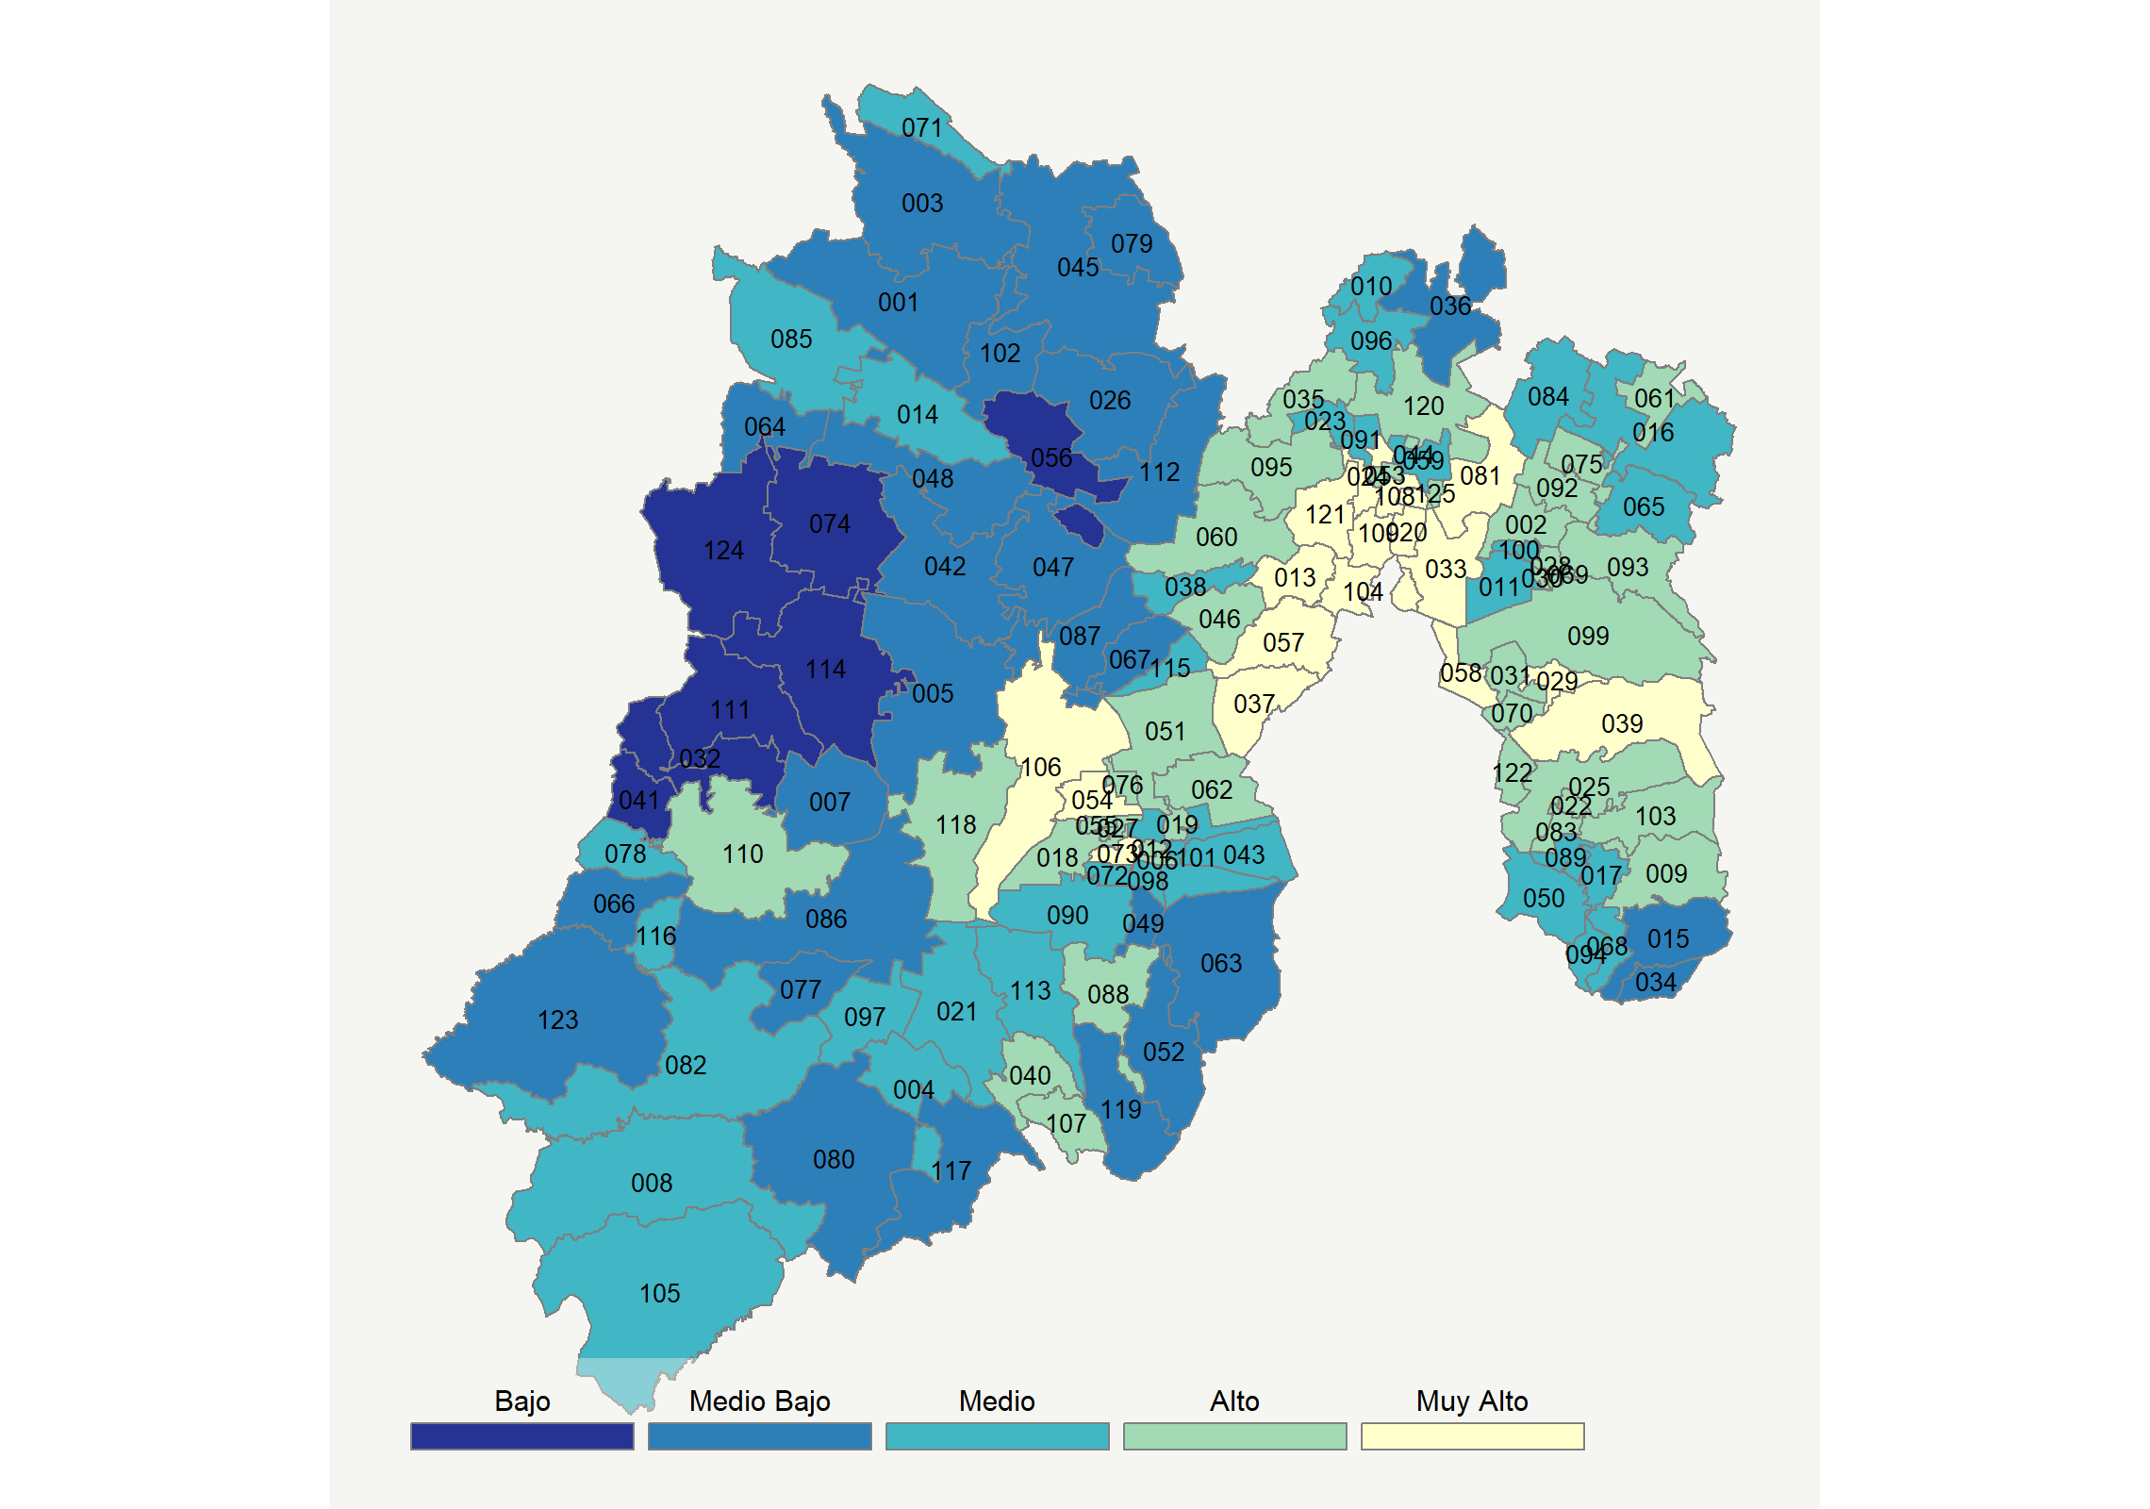

|  |  |  |  |  |  |  |  |  |  |  |  |  |  |
| --- | --- | --- | --- | --- | --- | --- | --- | --- | --- | --- | --- | --- | --- |
| **Clave del Municipio** | **Municipio** | **Telefonía fija a** | **Telefonía Celular a** | **Internet a** | **Televisión de paga a** | **Población Total a** | **Hasta 2 Salarios Mínimos b** | **Índice de Marginación** | **índice** | **Índice Escala 0-100** | **Lugar Nacional** | **Lugar Estatal** | **Estrato** |
| 001 | Acambay de Ruíz Castañeda | 14.2 | 56.0 | 6.5 | 8.8 | 66034 | 61.0 | 0.38 | -0.50 | 20.1 | 1729 | 114 | Medio Bajo |
| 002 | Acolman | 32.5 | 83.1 | 21.9 | 20.3 | 152506 | 35.9 | -1.15 | 0.57 | 41.2 | 548 | 44 | Alto |
| 003 | Aculco | 6.4 | 67.2 | 4.0 | 16.5 | 49026 | 55.5 | 0.20 | -0.49 | 20.3 | 1718 | 113 | Medio Bajo |
| 004 | Almoloya de Alquisiras | 12.9 | 71.1 | 9.9 | 41.7 | 14846 | 62.8 | 0.16 | 0.08 | 31.5 | 1053 | 79 | Medio |
| 005 | Almoloya de Juárez | 11.1 | 67.5 | 11.3 | 15.1 | 176237 | 37.8 | -0.40 | -0.25 | 25.1 | 1444 | 99 | Medio Bajo |
| 006 | Almoloya del Río | 35.5 | 67.9 | 29.1 | 33.4 | 11126 | 45.0 | -1.05 | 0.79 | 45.5 | 401 | 31 | Alto |
| 007 | Amanalco | 6.8 | 47.2 | 3.9 | 28.2 | 24669 | 49.3 | -0.07 | -0.55 | 19.1 | 1787 | 117 | Medio Bajo |
| 008 | Amatepec | 21.0 | 71.5 | 8.2 | 39.3 | 26610 | 55.2 | 0.33 | 0.15 | 32.9 | 974 | 75 | Medio |
| 009 | Amecameca | 29.9 | 80.0 | 22.9 | 25.0 | 50904 | 46.9 | -1.08 | 0.58 | 41.3 | 546 | 43 | Alto |
| 010 | Apaxco | 23.3 | 71.9 | 17.6 | 25.6 | 29347 | 34.0 | -1.21 | 0.27 | 35.2 | 845 | 63 | Medio |
| 011 | Atenco | 17.6 | 84.5 | 13.7 | 11.6 | 62392 | 44.4 | -1.01 | 0.05 | 30.8 | 1101 | 82 | Medio |
| 012 | Atizapán | 34.0 | 71.6 | 27.8 | 25.9 | 11875 | 46.3 | -1.09 | 0.69 | 43.5 | 461 | 37 | Alto |
| 013 | Atizapán de Zaragoza | 62.4 | 85.1 | 47.5 | 36.3 | 523296 | 27.7 | -1.73 | 1.88 | 67.1 | 50 | 7 | Muy Alto |
| 014 | Atlacomulco | 22.8 | 70.5 | 19.5 | 18.6 | 100675 | 42.5 | -0.73 | 0.21 | 34.1 | 904 | 70 | Medio |
| 015 | Atlautla | 17.7 | 69.5 | 11.5 | 15.7 | 30945 | 61.4 | -0.48 | -0.11 | 27.8 | 1265 | 91 | Medio Bajo |
| 016 | Axapusco | 15.5 | 72.6 | 11.8 | 19.0 | 27709 | 44.3 | -0.67 | -0.07 | 28.5 | 1223 | 89 | Medio |
| 017 | Ayapango | 21.3 | 80.4 | 17.2 | 19.8 | 9863 | 47.1 | -0.79 | 0.24 | 34.7 | 874 | 68 | Medio |
| 018 | Calimaya | 27.1 | 81.3 | 27.7 | 35.3 | 56574 | 34.2 | -1.32 | 0.77 | 45.2 | 415 | 33 | Alto |
| 019 | Capulhuac | 31.9 | 74.5 | 26.9 | 37.9 | 35495 | 40.8 | -1.26 | 0.80 | 45.6 | 399 | 30 | Alto |
| 020 | Coacalco de Berriozábal | 68.4 | 87.1 | 55.9 | 50.8 | 284462 | 22.9 | -2.01 | 2.37 | 76.6 | 16 | 1 | Muy Alto |
| 021 | Coatepec Harinas | 14.4 | 72.7 | 10.3 | 44.6 | 39897 | 60.8 | 0.02 | 0.16 | 33.1 | 961 | 73 | Medio |
| 022 | Cocotitlán | 42.0 | 80.1 | 27.4 | 20.3 | 14414 | 42.9 | -1.06 | 0.83 | 46.4 | 377 | 28 | Alto |
| 023 | Coyotepec | 20.7 | 77.4 | 21.2 | 15.0 | 41810 | 38.4 | -1.22 | 0.25 | 34.8 | 868 | 67 | Medio |
| 024 | Cuautitlán | 59.3 | 88.8 | 53.2 | 38.0 | 149550 | 26.0 | -1.85 | 2.03 | 69.9 | 40 | 5 | Muy Alto |
| 025 | Chalco | 37.8 | 78.0 | 24.1 | 21.9 | 343701 | 42.0 | -1.11 | 0.68 | 43.4 | 465 | 38 | Alto |
| 026 | Chapa de Mota | 4.8 | 71.5 | 3.6 | 10.6 | 28289 | 57.6 | 0.01 | -0.55 | 19.1 | 1783 | 116 | Medio Bajo |
| 027 | Chapultepec | 36.1 | 84.7 | 35.5 | 41.3 | 11764 | 23.8 | -1.49 | 1.21 | 53.8 | 216 | 19 | Alto |
| 028 | Chiautla | 32.7 | 81.6 | 27.6 | 15.3 | 29159 | 43.4 | -1.04 | 0.64 | 42.6 | 493 | 39 | Alto |
| 029 | Chicoloapan | 49.5 | 85.0 | 38.6 | 26.9 | 204107 | 34.4 | -1.46 | 1.35 | 56.6 | 160 | 15 | Muy Alto |
| 030 | Chiconcuac | 33.1 | 77.0 | 23.8 | 11.2 | 25543 | 49.5 | -1.25 | 0.47 | 39.2 | 641 | 52 | Alto |
| 031 | Chimalhuacán | 37.4 | 74.8 | 23.4 | 13.7 | 679811 | 42.3 | -1.07 | 0.54 | 40.5 | 575 | 47 | Alto |
| 032 | Donato Guerra | 3.1 | 48.2 | 1.9 | 14.4 | 34000 | 49.5 | 0.79 | -0.81 | 14.0 | 2026 | 123 | Bajo |
| 033 | Ecatepec de Morelos | 60.8 | 81.8 | 41.0 | 28.9 | 1677678 | 36.6 | -1.59 | 1.59 | 61.2 | 106 | 11 | Muy Alto |
| 034 | Ecatzingo | 12.9 | 66.3 | 8.3 | 15.4 | 9414 | 54.8 | -0.51 | -0.30 | 24.1 | 1497 | 102 | Medio Bajo |
| 035 | Huehuetoca | 14.8 | 88.7 | 24.7 | 33.0 | 128486 | 29.2 | -1.40 | 0.55 | 40.7 | 568 | 46 | Alto |
| 036 | Hueypoxtla | 13.8 | 68.5 | 10.2 | 14.7 | 43784 | 41.5 | -0.82 | -0.22 | 25.5 | 1416 | 97 | Medio Bajo |
| 037 | Huixquilucan | 66.4 | 86.5 | 57.0 | 51.3 | 267858 | 16.5 | -1.75 | 2.36 | 76.5 | 17 | 2 | Muy Alto |
| 038 | Isidro Fabela | 30.1 | 75.5 | 22.3 | 13.0 | 11726 | 41.8 | -0.64 | 0.39 | 37.6 | 727 | 57 | Medio |
| 039 | Ixtapaluca | 48.2 | 82.2 | 36.7 | 35.9 | 495563 | 34.0 | -1.39 | 1.36 | 56.7 | 158 | 14 | Muy Alto |
| 040 | Ixtapan de la Sal | 24.6 | 80.4 | 18.5 | 43.6 | 35552 | 48.7 | -0.52 | 0.60 | 41.7 | 529 | 42 | Alto |
| 041 | Ixtapan del Oro | 4.1 | 36.5 | 1.2 | 17.6 | 6791 | 63.7 | 0.76 | -0.89 | 12.5 | 2084 | 124 | Bajo |
| 042 | Ixtlahuaca | 8.8 | 66.8 | 7.5 | 6.7 | 153184 | 56.5 | -0.25 | -0.48 | 20.5 | 1707 | 112 | Medio Bajo |
| 043 | Xalatlaco | 17.5 | 61.9 | 12.8 | 27.7 | 29572 | 48.3 | -0.69 | -0.02 | 29.5 | 1165 | 87 | Medio |
| 044 | Jaltenco | 47.1 | 82.5 | 35.6 | 27.0 | 27825 | 35.4 | -1.63 | 1.22 | 53.9 | 215 | 18 | Alto |
| 045 | Jilotepec | 8.6 | 71.3 | 6.9 | 17.1 | 87927 | 51.6 | -0.27 | -0.33 | 23.3 | 1541 | 105 | Medio Bajo |
| 046 | Jilotzingo | 40.0 | 73.3 | 24.8 | 26.0 | 19013 | 32.5 | -0.83 | 0.73 | 44.4 | 438 | 36 | Alto |
| 047 | Jiquipilco | 8.7 | 60.5 | 6.5 | 6.9 | 74314 | 48.6 | -0.31 | -0.56 | 18.8 | 1799 | 118 | Medio Bajo |
| 048 | Jocotitlán | 13.8 | 63.9 | 10.7 | 10.5 | 65291 | 53.7 | -0.62 | -0.31 | 23.9 | 1509 | 104 | Medio Bajo |
| 049 | Joquicingo | 11.8 | 52.6 | 6.8 | 20.2 | 13857 | 64.1 | -0.25 | -0.44 | 21.3 | 1658 | 109 | Medio Bajo |
| 050 | Juchitepec | 17.0 | 75.8 | 13.0 | 18.1 | 25436 | 52.9 | -0.79 | 0.01 | 30.0 | 1138 | 84 | Medio |
| 051 | Lerma | 23.6 | 77.5 | 20.5 | 32.0 | 146654 | 29.9 | -1.18 | 0.47 | 39.2 | 642 | 53 | Alto |
| 052 | Malinalco | 17.4 | 56.2 | 10.9 | 28.9 | 27482 | 51.8 | -0.38 | -0.11 | 27.8 | 1269 | 92 | Medio Bajo |
| 053 | Melchor Ocampo | 42.0 | 76.6 | 31.0 | 25.4 | 57152 | 31.0 | -1.35 | 0.94 | 48.5 | 315 | 25 | Alto |
| 054 | Metepec | 56.6 | 87.2 | 56.9 | 61.2 | 227827 | 21.9 | -1.84 | 2.31 | 75.6 | 20 | 3 | Muy Alto |
| 055 | Mexicaltzingo | 32.3 | 78.9 | 30.0 | 36.8 | 12796 | 35.4 | -1.37 | 0.91 | 47.8 | 336 | 26 | Alto |
| 056 | Morelos | 8.7 | 51.1 | 4.4 | 5.3 | 29862 | 63.3 | 0.42 | -0.72 | 15.7 | 1944 | 120 | Bajo |
| 057 | Naucalpan de Juárez | 59.9 | 83.5 | 46.1 | 37.9 | 844219 | 29.3 | -1.58 | 1.81 | 65.7 | 61 | 8 | Muy Alto |
| 058 | Nezahualcóyotl | 60.9 | 78.7 | 44.2 | 25.1 | 1039867 | 32.1 | -1.58 | 1.59 | 61.4 | 101 | 10 | Muy Alto |
| 059 | Nextlalpan | 16.7 | 83.9 | 14.5 | 24.6 | 39666 | 39.3 | -0.98 | 0.19 | 33.7 | 935 | 71 | Medio |
| 060 | Nicolás Romero | 49.4 | 79.0 | 32.4 | 21.4 | 410118 | 34.9 | -1.32 | 1.08 | 51.2 | 264 | 21 | Alto |
| 061 | Nopaltepec | 22.5 | 79.4 | 19.4 | 29.7 | 8960 | 43.6 | -0.81 | 0.42 | 38.2 | 698 | 55 | Alto |
| 062 | Ocoyoacac | 25.7 | 80.7 | 25.3 | 41.1 | 66190 | 37.8 | -1.23 | 0.75 | 44.8 | 429 | 35 | Alto |
| 063 | Ocuilan | 15.4 | 56.2 | 6.8 | 26.3 | 34485 | 61.2 | -0.05 | -0.27 | 24.6 | 1469 | 101 | Medio Bajo |
| 064 | El Oro | 16.4 | 64.6 | 12.0 | 19.7 | 37343 | 49.8 | -0.37 | -0.12 | 27.6 | 1281 | 93 | Medio Bajo |
| 065 | Otumba | 17.3 | 75.8 | 17.6 | 11.9 | 35274 | 38.6 | -1.01 | 0.05 | 31.0 | 1095 | 81 | Medio |
| 066 | Otzoloapan * | 11.6 | 50.4 | 4.4 | 32.1 | 3872 | 58.0 | 0.25 | -0.38 | 22.3 | 1598 | 108 | Medio Bajo |
| 067 | Otzolotepec | 10.1 | 70.0 | 13.3 | 20.1 | 84519 | 46.5 | -0.60 | -0.14 | 27.2 | 1299 | 94 | Medio Bajo |
| 068 | Ozumba | 27.0 | 74.4 | 17.8 | 21.8 | 29114 | 55.4 | -0.81 | 0.32 | 36.1 | 799 | 62 | Medio |
| 069 | Papalotla * | 35.2 | 85.7 | 27.3 | 20.4 | 3963 | 31.6 | -1.21 | 0.78 | 45.2 | 412 | 32 | Alto |
| 070 | La Paz | 44.4 | 78.7 | 26.8 | 18.8 | 293725 | 37.9 | -1.03 | 0.83 | 46.3 | 380 | 29 | Alto |
| 071 | Polotitlán | 15.0 | 73.6 | 10.0 | 23.5 | 13851 | 51.8 | -0.49 | -0.06 | 28.7 | 1211 | 88 | Medio |
| 072 | Rayón | 19.5 | 72.5 | 21.2 | 31.0 | 13261 | 34.1 | -1.30 | 0.36 | 36.9 | 762 | 60 | Medio |
| 073 | San Antonio la Isla | 25.8 | 87.6 | 41.2 | 47.8 | 27230 | 29.3 | -1.67 | 1.28 | 55.2 | 191 | 16 | Muy Alto |
| 074 | San Felipe del Progreso | 6.9 | 54.0 | 4.4 | 3.3 | 134143 | 40.5 | 0.28 | -0.75 | 15.1 | 1974 | 121 | Bajo |
| 075 | San Martín de las Pirámides | 20.8 | 85.2 | 22.6 | 19.9 | 26960 | 33.5 | -1.22 | 0.41 | 38.1 | 704 | 56 | Alto |
| 076 | San Mateo Atenco | 27.0 | 81.9 | 32.9 | 41.5 | 75511 | 39.0 | -1.43 | 0.97 | 49.1 | 306 | 24 | Alto |
| 077 | San Simón de Guerrero | 5.6 | 69.3 | 5.0 | 35.6 | 6010 | 49.4 | -0.09 | -0.24 | 25.1 | 1440 | 98 | Medio Bajo |
| 078 | Santo Tomás | 16.8 | 66.4 | 12.3 | 50.9 | 9682 | 47.2 | -0.30 | 0.26 | 35.0 | 861 | 66 | Medio |
| 079 | Soyaniquilpan de Juárez | 5.9 | 70.6 | 5.9 | 20.3 | 13290 | 54.6 | -0.37 | -0.37 | 22.5 | 1586 | 107 | Medio Bajo |
| 080 | Sultepec | 10.7 | 63.0 | 6.3 | 25.3 | 26832 | 47.3 | 0.51 | -0.31 | 23.9 | 1508 | 103 | Medio Bajo |
| 081 | Tecámac | 45.3 | 88.0 | 41.5 | 38.0 | 446008 | 26.7 | -1.66 | 1.51 | 59.6 | 119 | 12 | Muy Alto |
| 082 | Tejupilco | 21.9 | 75.0 | 13.5 | 26.8 | 77799 | 44.5 | -0.10 | 0.19 | 33.7 | 936 | 72 | Medio |
| 083 | Temamatla | 31.4 | 83.2 | 24.5 | 19.9 | 12984 | 32.7 | -1.18 | 0.61 | 42.0 | 514 | 41 | Alto |
| 084 | Temascalapa | 14.6 | 78.6 | 13.1 | 17.4 | 38622 | 45.5 | -0.88 | -0.01 | 29.7 | 1153 | 85 | Medio |
| 085 | Temascalcingo | 22.4 | 57.0 | 11.0 | 23.3 | 63721 | 59.0 | -0.09 | -0.08 | 28.3 | 1233 | 90 | Medio |
| 086 | Temascaltepec | 5.9 | 55.1 | 3.3 | 26.8 | 31631 | 59.5 | 0.29 | -0.52 | 19.7 | 1755 | 115 | Medio Bajo |
| 087 | Temoaya | 5.5 | 62.5 | 9.8 | 12.5 | 103834 | 52.9 | -0.17 | -0.45 | 21.0 | 1683 | 110 | Medio Bajo |
| 088 | Tenancingo | 24.1 | 65.1 | 19.3 | 45.6 | 97891 | 49.6 | -0.41 | 0.48 | 39.3 | 631 | 51 | Alto |
| 089 | Tenango del Aire | 22.5 | 81.7 | 16.2 | 11.8 | 12470 | 42.1 | -1.03 | 0.16 | 33.1 | 962 | 74 | Medio |
| 090 | Tenango del Valle | 20.6 | 63.4 | 16.7 | 34.5 | 86380 | 53.2 | -0.71 | 0.22 | 34.2 | 897 | 69 | Medio |
| 091 | Teoloyucan | 25.0 | 80.8 | 21.1 | 15.7 | 66518 | 40.9 | -1.39 | 0.36 | 37.0 | 759 | 59 | Medio |
| 092 | Teotihuacán | 25.1 | 85.6 | 21.7 | 18.1 | 56993 | 37.5 | -1.29 | 0.45 | 38.7 | 668 | 54 | Alto |
| 093 | Tepetlaoxtoc | 32.0 | 77.9 | 20.1 | 20.9 | 30680 | 35.7 | -1.02 | 0.48 | 39.4 | 630 | 50 | Alto |
| 094 | Tepetlixpa | 22.1 | 74.5 | 13.1 | 18.8 | 19843 | 58.3 | -0.71 | 0.09 | 31.7 | 1046 | 78 | Medio |
| 095 | Tepotzotlán | 43.6 | 82.4 | 33.5 | 17.0 | 94198 | 27.7 | -1.43 | 0.99 | 49.5 | 295 | 22 | Alto |
| 096 | Tequixquiac | 19.8 | 80.9 | 14.3 | 29.6 | 36902 | 33.9 | -1.25 | 0.26 | 35.1 | 855 | 65 | Medio |
| 097 | Texcaltitlán | 10.6 | 66.7 | 6.9 | 46.7 | 19206 | 63.9 | 0.14 | -0.02 | 29.6 | 1162 | 86 | Medio |
| 098 | Texcalyacac * | 16.0 | 68.9 | 18.6 | 22.2 | 5246 | 51.9 | -0.78 | 0.10 | 32.0 | 1031 | 77 | Medio |
| 099 | Texcoco | 43.9 | 80.7 | 37.4 | 23.0 | 240749 | 32.7 | -1.49 | 1.15 | 52.5 | 238 | 20 | Alto |
| 100 | Tezoyuca | 18.7 | 82.0 | 16.5 | 13.4 | 41333 | 38.5 | -0.84 | 0.13 | 32.4 | 997 | 76 | Medio |
| 101 | Tianguistenco | 24.0 | 64.8 | 20.1 | 25.4 | 77147 | 48.5 | -0.88 | 0.27 | 35.2 | 849 | 64 | Medio |
| 102 | Timilpan | 16.5 | 63.1 | 8.4 | 16.3 | 15664 | 47.1 | -0.56 | -0.26 | 24.8 | 1459 | 100 | Medio Bajo |
| 103 | Tlalmanalco | 36.8 | 81.2 | 29.6 | 35.9 | 47390 | 37.9 | -1.33 | 0.99 | 49.4 | 297 | 23 | Alto |
| 104 | Tlalnepantla de Baz | 63.9 | 81.8 | 49.9 | 39.9 | 700734 | 28.8 | -1.71 | 1.98 | 68.9 | 42 | 6 | Muy Alto |
| 105 | Tlatlaya | 16.5 | 66.8 | 4.5 | 50.5 | 34937 | 52.7 | 0.32 | 0.07 | 31.2 | 1075 | 80 | Medio |
| 106 | Toluca | 38.8 | 81.2 | 35.8 | 43.4 | 873536 | 30.7 | -1.48 | 1.26 | 54.7 | 202 | 17 | Muy Alto |
| 107 | Tonatico | 33.6 | 78.2 | 21.0 | 41.1 | 12324 | 47.5 | -0.93 | 0.76 | 44.8 | 426 | 34 | Alto |
| 108 | Tultepec | 51.4 | 84.1 | 39.6 | 30.0 | 150182 | 28.7 | -1.64 | 1.43 | 58.2 | 137 | 13 | Muy Alto |
| 109 | Tultitlán | 57.9 | 82.7 | 43.2 | 34.6 | 520557 | 35.4 | -1.67 | 1.66 | 62.8 | 83 | 9 | Muy Alto |
| 110 | Valle de Bravo | 23.0 | 75.9 | 20.9 | 40.6 | 65703 | 34.6 | -0.79 | 0.55 | 40.8 | 565 | 45 | Alto |
| 111 | Villa de Allende | 3.1 | 59.4 | 2.1 | 12.4 | 52641 | 46.4 | 0.31 | -0.71 | 15.9 | 1934 | 119 | Bajo |
| 112 | Villa del Carbón | 11.2 | 61.1 | 8.6 | 6.6 | 47151 | 47.0 | -0.07 | -0.47 | 20.7 | 1698 | 111 | Medio Bajo |
| 113 | Villa Guerrero | 14.9 | 69.6 | 9.5 | 35.4 | 67929 | 59.1 | -0.07 | 0.02 | 30.3 | 1128 | 83 | Medio |
| 114 | Villa Victoria | 2.6 | 55.5 | 1.9 | 8.8 | 104612 | 33.8 | 0.68 | -0.80 | 14.1 | 2024 | 122 | Bajo |
| 115 | Xonacatlán | 16.5 | 75.0 | 20.7 | 35.9 | 51646 | 35.6 | -1.17 | 0.38 | 37.3 | 738 | 58 | Medio |
| 116 | Zacazonapan * | 19.1 | 68.3 | 14.2 | 47.7 | 4137 | 45.5 | -0.43 | 0.33 | 36.4 | 793 | 61 | Medio |
| 117 | Zacualpan | 15.6 | 68.1 | 9.1 | 16.5 | 14958 | 53.0 | 0.75 | -0.21 | 25.9 | 1390 | 95 | Medio Bajo |
| 118 | Zinacantepec | 30.3 | 74.6 | 25.9 | 27.9 | 188927 | 33.1 | -1.19 | 0.63 | 42.4 | 501 | 40 | Alto |
| 119 | Zumpahuacán * | 15.1 | 49.3 | 4.6 | 31.0 | 16927 | 72.6 | 0.54 | -0.35 | 23.1 | 1552 | 106 | Medio Bajo |
| 120 | Zumpango | 21.1 | 84.9 | 22.1 | 31.4 | 199069 | 34.9 | -1.25 | 0.53 | 40.4 | 582 | 48 | Alto |
| 121 | Cuautitlán Izcalli | 68.8 | 87.0 | 54.5 | 37.2 | 531041 | 27.4 | -1.89 | 2.19 | 73.1 | 26 | 4 | Muy Alto |
| 122 | Valle de Chalco Solidaridad | 42.7 | 75.9 | 29.1 | 20.8 | 396157 | 44.0 | -1.05 | 0.85 | 46.7 | 360 | 27 | Alto |
| 123 | Luvianos | 18.9 | 60.8 | 5.9 | 24.2 | 27860 | 48.5 | 0.38 | -0.21 | 25.7 | 1400 | 96 | Medio Bajo |
| 124 | San José del Rincón | 2.4 | 52.2 | 0.9 | 2.4 | 93878 | 48.8 | 0.54 | -0.94 | 11.5 | 2123 | 125 | Bajo |
| 125 | Tonanitla | 31.7 | 79.1 | 21.2 | 18.6 | 9728 | 41.7 | -1.07 | 0.49 | 39.5 | 619 | 49 | Alto |
| a Porcentaje de viviendas que cuentas con el servicio  b Ingreso por trabajo de la población ocupada en porcentaje  Fuente: Elaboración propia con datos de Encuesta Intercensal 2015 de INEGI y CONAPO | | | | | | | | | | | | | |

**Michoacán**

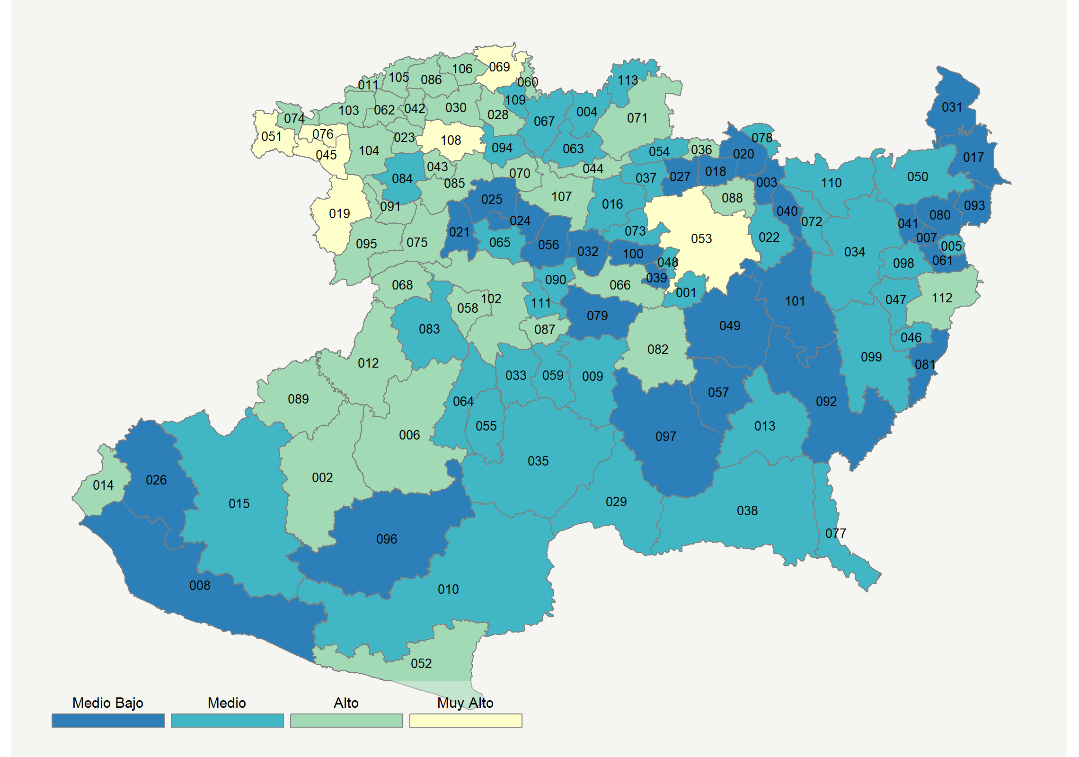

|  |  |  |  |  |  |  |  |  |  |  |  |  |  |
| --- | --- | --- | --- | --- | --- | --- | --- | --- | --- | --- | --- | --- | --- |
| **Clave del Municipio** | **Municipio** | **Telefonía fija a** | **Telefonía Celular a** | **Internet a** | **Televisión de paga a** | **Población Total a** | **Hasta 2 Salarios Mínimos b** | **Índice de Marginación** | **índice** | **Índice Escala 0-100** | **Lugar Nacional** | **Lugar Estatal** | **Estrato** |
| 001 | Acuitzio | 14.8 | 71.8 | 10.9 | 22.2 | 11425 | 58.6 | -0.22 | -0.07 | 28.5 | 1226 | 83 | Medio |
| 002 | Aguililla | 22.8 | 72.3 | 8.5 | 61.2 | 15241 | 47.5 | 0.04 | 0.44 | 38.6 | 676 | 41 | Alto |
| 003 | Álvaro Obregón | 12.3 | 77.3 | 9.0 | 13.5 | 21651 | 59.4 | -0.49 | -0.21 | 25.9 | 1389 | 97 | Medio Bajo |
| 004 | Angamacutiro | 24.9 | 61.1 | 6.4 | 30.1 | 15193 | 65.1 | -0.31 | -0.03 | 29.3 | 1179 | 80 | Medio |
| 005 | Angangueo | 16.2 | 66.2 | 10.3 | 30.7 | 11120 | 48.1 | -0.21 | -0.03 | 29.4 | 1174 | 79 | Medio |
| 006 | Apatzingán | 28.4 | 84.4 | 24.3 | 46.6 | 128250 | 47.5 | -0.58 | 0.87 | 47.1 | 352 | 17 | Alto |
| 007 | Aporo * | 18.6 | 60.7 | 7.5 | 30.7 | 3218 | 66.6 | 0.21 | -0.11 | 27.8 | 1268 | 85 | Medio Bajo |
| 008 | Aquila | 9.3 | 27.5 | 4.8 | 38.6 | 24864 | 31.9 | 1.55 | -0.57 | 18.7 | 1805 | 111 | Medio Bajo |
| 009 | Ario | 14.2 | 71.0 | 11.1 | 50.4 | 36549 | 36.5 | -0.42 | 0.23 | 34.4 | 895 | 60 | Medio |
| 010 | Arteaga | 19.5 | 71.2 | 10.9 | 56.5 | 22138 | 42.6 | -0.05 | 0.38 | 37.4 | 736 | 47 | Medio |
| 011 | Briseñas | 39.3 | 60.4 | 20.4 | 52.5 | 11328 | 44.4 | -0.59 | 0.79 | 45.4 | 405 | 21 | Alto |
| 012 | Buenavista | 16.8 | 84.9 | 12.2 | 53.2 | 47498 | 42.6 | -0.13 | 0.47 | 39.1 | 644 | 37 | Alto |
| 013 | Carácuaro | 20.0 | 68.4 | 10.0 | 47.0 | 9485 | 53.7 | 0.66 | 0.23 | 34.5 | 884 | 57 | Medio |
| 014 | Coahuayana | 29.5 | 64.9 | 17.4 | 68.2 | 14392 | 32.9 | -0.47 | 0.77 | 45.1 | 418 | 22 | Alto |
| 015 | Coalcomán de Vázquez Pallares | 18.5 | 67.6 | 13.0 | 47.0 | 18444 | 39.5 | -0.06 | 0.27 | 35.3 | 840 | 55 | Medio |
| 016 | Coeneo | 21.9 | 71.3 | 6.8 | 38.4 | 20749 | 69.8 | 0.05 | 0.12 | 32.3 | 1008 | 69 | Medio |
| 017 | Contepec | 11.3 | 68.1 | 5.9 | 13.5 | 34193 | 65.4 | 0.10 | -0.39 | 22.3 | 1604 | 108 | Medio Bajo |
| 018 | Copándaro | 18.6 | 75.4 | 5.4 | 16.0 | 9151 | 56.4 | -0.37 | -0.18 | 26.4 | 1357 | 96 | Medio Bajo |
| 019 | Cotija | 47.0 | 72.9 | 25.6 | 73.6 | 19018 | 40.6 | -0.67 | 1.40 | 57.5 | 146 | 5 | Muy Alto |
| 020 | Cuitzeo | 20.7 | 55.5 | 8.0 | 14.4 | 29681 | 57.5 | -0.29 | -0.30 | 24.1 | 1496 | 102 | Medio Bajo |
| 021 | Charapan | 11.9 | 51.6 | 1.9 | 32.6 | 12373 | 71.9 | 0.84 | -0.42 | 21.6 | 1643 | 109 | Medio Bajo |
| 022 | Charo | 19.2 | 74.7 | 11.0 | 29.2 | 21784 | 43.6 | -0.55 | 0.11 | 32.1 | 1022 | 71 | Medio |
| 023 | Chavinda | 36.6 | 66.2 | 17.6 | 55.0 | 10258 | 51.6 | -0.50 | 0.76 | 44.9 | 423 | 23 | Alto |
| 024 | Cherán | 11.4 | 58.2 | 6.1 | 45.7 | 19081 | 66.5 | 0.13 | -0.12 | 27.6 | 1277 | 86 | Medio Bajo |
| 025 | Chilchota | 12.8 | 50.4 | 8.2 | 35.0 | 39035 | 68.9 | 0.19 | -0.24 | 25.2 | 1438 | 99 | Medio Bajo |
| 026 | Chinicuila * | 11.5 | 39.9 | 10.7 | 42.8 | 5032 | 52.6 | 0.46 | -0.22 | 25.6 | 1411 | 98 | Medio Bajo |
| 027 | Chucándiro | 28.7 | 68.1 | 3.2 | 13.8 | 4559 | 58.6 | 0.19 | -0.16 | 26.8 | 1329 | 91 | Medio Bajo |
| 028 | Churintzio | 51.8 | 57.6 | 20.5 | 49.0 | 5016 | 58.9 | -0.45 | 0.93 | 48.2 | 323 | 14 | Alto |
| 029 | Churumuco | 18.0 | 48.7 | 5.1 | 55.0 | 15455 | 58.2 | 1.09 | -0.02 | 29.4 | 1172 | 78 | Medio |
| 030 | Ecuandureo | 51.5 | 48.8 | 18.3 | 54.0 | 12788 | 47.5 | -0.36 | 0.84 | 46.5 | 368 | 19 | Alto |
| 031 | Epitacio Huerta | 8.6 | 63.9 | 1.1 | 7.6 | 16622 | 64.9 | 0.09 | -0.66 | 17.0 | 1888 | 113 | Medio Bajo |
| 032 | Erongarícuaro | 17.4 | 61.0 | 5.6 | 13.6 | 15291 | 64.0 | -0.05 | -0.36 | 22.8 | 1574 | 106 | Medio Bajo |
| 033 | Gabriel Zamora | 13.2 | 79.1 | 9.3 | 46.1 | 22707 | 51.1 | -0.23 | 0.20 | 33.8 | 927 | 62 | Medio |
| 034 | Hidalgo | 26.8 | 70.5 | 14.4 | 39.0 | 122619 | 59.0 | -0.26 | 0.38 | 37.5 | 732 | 46 | Medio |
| 035 | La Huacana | 16.4 | 66.8 | 6.5 | 53.0 | 34243 | 55.6 | 0.26 | 0.14 | 32.7 | 985 | 68 | Medio |
| 036 | Huandacareo | 23.7 | 78.8 | 17.0 | 40.1 | 11723 | 59.4 | -0.47 | 0.49 | 39.5 | 618 | 35 | Alto |
| 037 | Huaniqueo | 17.9 | 72.2 | 6.1 | 32.6 | 8093 | 67.1 | 0.01 | -0.02 | 29.5 | 1164 | 77 | Medio |
| 038 | Huetamo | 31.4 | 56.8 | 14.5 | 41.3 | 40818 | 46.4 | 0.37 | 0.35 | 36.9 | 767 | 48 | Medio |
| 039 | Huiramba | 16.9 | 63.8 | 4.3 | 16.1 | 8838 | 44.5 | -0.40 | -0.35 | 23.1 | 1557 | 105 | Medio Bajo |
| 040 | Indaparapeo | 16.2 | 69.1 | 9.3 | 17.6 | 16990 | 63.5 | -0.17 | -0.17 | 26.6 | 1337 | 93 | Medio Bajo |
| 041 | Irimbo | 16.5 | 67.3 | 5.0 | 29.2 | 15215 | 66.2 | 0.09 | -0.16 | 26.9 | 1326 | 90 | Medio Bajo |
| 042 | Ixtlán | 36.9 | 62.3 | 15.0 | 58.6 | 12720 | 59.6 | -0.10 | 0.70 | 43.8 | 457 | 26 | Alto |
| 043 | Jacona | 38.0 | 74.1 | 31.9 | 46.1 | 69744 | 41.5 | -0.93 | 1.11 | 51.7 | 256 | 10 | Alto |
| 044 | Jiménez | 31.9 | 69.9 | 11.5 | 41.2 | 12426 | 63.2 | -0.22 | 0.42 | 38.1 | 701 | 44 | Alto |
| 045 | Jiquilpan | 48.5 | 69.0 | 31.9 | 65.4 | 32950 | 47.0 | -0.91 | 1.45 | 58.4 | 135 | 4 | Muy Alto |
| 046 | Juárez | 21.3 | 72.4 | 8.0 | 37.7 | 14387 | 61.5 | -0.10 | 0.14 | 32.7 | 983 | 67 | Medio |
| 047 | Jungapeo | 14.3 | 73.1 | 9.6 | 48.4 | 21548 | 65.0 | -0.08 | 0.19 | 33.7 | 931 | 63 | Medio |
| 048 | Lagunillas | 22.7 | 68.0 | 7.7 | 22.2 | 5571 | 49.5 | -0.44 | -0.06 | 28.8 | 1207 | 81 | Medio |
| 049 | Madero | 13.3 | 62.8 | 3.9 | 42.8 | 18030 | 59.6 | 0.72 | -0.13 | 27.4 | 1292 | 88 | Medio Bajo |
| 050 | Maravatío | 18.6 | 68.6 | 9.7 | 21.3 | 88535 | 63.2 | -0.18 | -0.08 | 28.3 | 1234 | 84 | Medio |
| 051 | Marcos Castellanos | 39.1 | 76.8 | 35.0 | 69.3 | 13750 | 35.3 | -1.19 | 1.48 | 59.2 | 127 | 2 | Muy Alto |
| 052 | Lázaro Cárdenas | 30.1 | 89.6 | 30.7 | 48.3 | 183185 | 23.4 | -1.26 | 1.12 | 52.1 | 252 | 9 | Alto |
| 053 | Morelia | 44.7 | 87.8 | 40.7 | 45.7 | 784776 | 33.7 | -1.47 | 1.56 | 60.7 | 108 | 1 | Muy Alto |
| 054 | Morelos | 23.2 | 69.7 | 4.1 | 27.2 | 7806 | 65.1 | -0.14 | -0.06 | 28.7 | 1217 | 82 | Medio |
| 055 | Múgica | 17.4 | 81.4 | 11.4 | 50.3 | 45484 | 50.7 | -0.30 | 0.39 | 37.6 | 729 | 45 | Medio |
| 056 | Nahuatzen | 6.9 | 49.2 | 3.5 | 45.9 | 28074 | 65.8 | 0.78 | -0.34 | 23.1 | 1551 | 104 | Medio Bajo |
| 057 | Nocupétaro | 13.3 | 64.0 | 3.4 | 43.1 | 8195 | 44.8 | 0.86 | -0.12 | 27.5 | 1289 | 87 | Medio Bajo |
| 058 | Nuevo Parangaricutiro | 18.8 | 83.1 | 11.3 | 63.2 | 19595 | 41.5 | -0.84 | 0.57 | 41.2 | 553 | 31 | Alto |
| 059 | Nuevo Urecho | 13.6 | 79.7 | 2.3 | 68.5 | 7988 | 54.0 | -0.11 | 0.29 | 35.7 | 827 | 54 | Medio |
| 060 | Numarán | 36.2 | 61.7 | 14.6 | 40.4 | 9794 | 51.3 | -0.47 | 0.47 | 39.2 | 636 | 36 | Alto |
| 061 | Ocampo | 5.6 | 66.5 | 3.3 | 17.7 | 24424 | 51.6 | 0.21 | -0.51 | 19.8 | 1749 | 110 | Medio Bajo |
| 062 | Pajacuarán | 30.9 | 63.2 | 17.9 | 56.8 | 19440 | 60.0 | -0.29 | 0.66 | 43.0 | 480 | 27 | Alto |
| 063 | Panindícuaro | 23.2 | 67.0 | 9.5 | 43.6 | 15705 | 62.3 | -0.19 | 0.22 | 34.3 | 896 | 61 | Medio |
| 064 | Parácuaro | 15.6 | 76.8 | 9.2 | 43.3 | 26789 | 56.9 | 0.28 | 0.18 | 33.5 | 945 | 65 | Medio |
| 065 | Paracho | 18.9 | 63.6 | 12.7 | 46.7 | 37464 | 56.7 | -0.05 | 0.23 | 34.4 | 891 | 59 | Medio |
| 066 | Pátzcuaro | 27.3 | 76.4 | 23.6 | 36.1 | 93265 | 53.8 | -0.64 | 0.64 | 42.5 | 497 | 29 | Alto |
| 067 | Penjamillo | 42.1 | 49.5 | 7.5 | 36.1 | 16920 | 69.1 | -0.08 | 0.23 | 34.5 | 888 | 58 | Medio |
| 068 | Peribán | 31.4 | 78.7 | 19.8 | 62.3 | 27832 | 21.9 | -0.87 | 0.93 | 48.2 | 324 | 15 | Alto |
| 069 | La Piedad | 48.4 | 74.3 | 32.6 | 54.3 | 103702 | 41.1 | -1.22 | 1.39 | 57.3 | 150 | 6 | Muy Alto |
| 070 | Purépero | 35.4 | 72.5 | 14.9 | 26.4 | 15255 | 50.0 | -1.01 | 0.42 | 38.1 | 700 | 43 | Alto |
| 071 | Puruándiro | 32.2 | 69.1 | 14.9 | 36.4 | 67644 | 59.0 | -0.39 | 0.44 | 38.6 | 675 | 40 | Alto |
| 072 | Queréndaro | 23.5 | 69.5 | 10.9 | 23.2 | 13836 | 63.8 | -0.47 | 0.06 | 31.0 | 1091 | 74 | Medio |
| 073 | Quiroga | 19.8 | 66.3 | 14.8 | 34.6 | 27862 | 67.0 | -0.27 | 0.19 | 33.6 | 938 | 64 | Medio |
| 074 | Cojumatlán de Régules | 26.0 | 72.1 | 16.0 | 48.6 | 10450 | 53.4 | -0.45 | 0.53 | 40.4 | 578 | 33 | Alto |
| 075 | Los Reyes | 34.2 | 71.3 | 25.4 | 51.7 | 69723 | 37.0 | -0.57 | 0.92 | 48.1 | 328 | 16 | Alto |
| 076 | Sahuayo | 40.5 | 77.2 | 35.9 | 63.7 | 76587 | 43.1 | -1.10 | 1.47 | 58.9 | 130 | 3 | Muy Alto |
| 077 | San Lucas | 26.7 | 66.2 | 10.1 | 45.2 | 17845 | 58.3 | 0.61 | 0.31 | 35.9 | 815 | 52 | Medio |
| 078 | Santa Ana Maya | 33.9 | 63.0 | 11.9 | 19.4 | 12466 | 60.4 | -0.36 | 0.15 | 32.9 | 978 | 66 | Medio |
| 079 | Salvador Escalante | 18.4 | 63.5 | 6.9 | 23.8 | 49588 | 59.7 | -0.01 | -0.18 | 26.5 | 1351 | 95 | Medio Bajo |
| 080 | Senguio | 14.1 | 71.9 | 3.9 | 18.7 | 19146 | 50.9 | -0.03 | -0.30 | 24.1 | 1495 | 101 | Medio Bajo |
| 081 | Susupuato | 11.5 | 49.6 | 1.5 | 19.0 | 8804 | 65.6 | 0.98 | -0.61 | 17.9 | 1851 | 112 | Medio Bajo |
| 082 | Tacámbaro | 16.4 | 83.1 | 12.5 | 53.9 | 76661 | 41.2 | -0.57 | 0.46 | 38.9 | 656 | 38 | Alto |
| 083 | Tancítaro | 8.2 | 65.3 | 7.9 | 56.1 | 31100 | 22.7 | -0.32 | 0.06 | 31.1 | 1086 | 73 | Medio |
| 084 | Tangamandapio | 18.8 | 54.8 | 11.3 | 43.2 | 29268 | 57.7 | 0.17 | 0.07 | 31.3 | 1068 | 72 | Medio |
| 085 | Tangancícuaro | 30.0 | 67.5 | 14.7 | 48.2 | 33621 | 52.8 | -0.30 | 0.52 | 40.1 | 593 | 34 | Alto |
| 086 | Tanhuato | 38.7 | 60.4 | 17.2 | 54.8 | 15352 | 52.2 | -0.72 | 0.72 | 44.2 | 442 | 25 | Alto |
| 087 | Taretan | 16.4 | 84.8 | 6.8 | 64.4 | 14819 | 39.4 | -0.63 | 0.45 | 38.8 | 664 | 39 | Alto |
| 088 | Tarímbaro | 23.1 | 84.8 | 22.4 | 38.3 | 105400 | 39.2 | -0.92 | 0.65 | 42.7 | 488 | 28 | Alto |
| 089 | Tepalcatepec | 28.2 | 75.7 | 12.6 | 51.2 | 23842 | 42.1 | -0.44 | 0.55 | 40.8 | 564 | 32 | Alto |
| 090 | Tingambato | 6.6 | 72.5 | 7.3 | 58.3 | 15010 | 42.9 | -0.34 | 0.11 | 32.1 | 1019 | 70 | Medio |
| 091 | Tingüindín | 39.8 | 64.6 | 18.1 | 58.1 | 14532 | 41.1 | -0.61 | 0.84 | 46.6 | 366 | 18 | Alto |
| 092 | Tiquicheo de Nicolás Romero | 17.1 | 59.2 | 3.1 | 37.7 | 13731 | 54.9 | 1.24 | -0.17 | 26.5 | 1348 | 94 | Medio Bajo |
| 093 | Tlalpujahua | 14.8 | 63.3 | 5.2 | 15.3 | 27788 | 66.7 | 0.28 | -0.37 | 22.6 | 1585 | 107 | Medio Bajo |
| 094 | Tlazazalca | 22.6 | 70.4 | 12.8 | 41.9 | 6202 | 58.8 | -0.10 | 0.31 | 36.0 | 810 | 51 | Medio |
| 095 | Tocumbo | 41.0 | 69.4 | 21.2 | 59.9 | 11994 | 34.9 | -0.81 | 1.01 | 49.8 | 288 | 12 | Alto |
| 096 | Tumbiscatío | 17.1 | 45.0 | 3.6 | 52.8 | 6947 | 41.6 | 0.79 | -0.14 | 27.2 | 1302 | 89 | Medio Bajo |
| 097 | Turicato | 10.8 | 68.2 | 3.2 | 40.1 | 31849 | 55.0 | 0.68 | -0.16 | 26.7 | 1330 | 92 | Medio Bajo |
| 098 | Tuxpan | 17.6 | 68.4 | 15.1 | 45.6 | 27371 | 60.3 | -0.24 | 0.30 | 35.8 | 822 | 53 | Medio |
| 099 | Tuzantla | 20.1 | 56.1 | 4.4 | 52.0 | 15383 | 64.6 | 0.69 | 0.03 | 30.6 | 1111 | 75 | Medio |
| 100 | Tzintzuntzan | 12.9 | 68.3 | 6.2 | 17.3 | 14432 | 61.7 | -0.12 | -0.31 | 23.8 | 1512 | 103 | Medio Bajo |
| 101 | Tzitzio | 8.6 | 58.4 | 1.0 | 46.8 | 8966 | 66.3 | 1.34 | -0.28 | 24.5 | 1471 | 100 | Medio Bajo |
| 102 | Uruapan | 28.9 | 85.3 | 32.2 | 55.5 | 334749 | 39.4 | -1.11 | 1.18 | 53.1 | 228 | 8 | Alto |
| 103 | Venustiano Carranza | 42.9 | 66.8 | 25.3 | 52.2 | 24708 | 52.4 | -0.58 | 1.02 | 50.1 | 284 | 11 | Alto |
| 104 | Villamar | 40.4 | 57.8 | 14.9 | 45.9 | 17166 | 58.3 | -0.17 | 0.57 | 41.2 | 549 | 30 | Alto |
| 105 | Vista Hermosa | 28.9 | 72.2 | 15.2 | 65.4 | 20624 | 37.1 | -0.72 | 0.75 | 44.7 | 432 | 24 | Alto |
| 106 | Yurécuaro | 35.5 | 66.3 | 21.7 | 51.4 | 31404 | 54.2 | -0.80 | 0.80 | 45.7 | 396 | 20 | Alto |
| 107 | Zacapu | 36.4 | 74.5 | 21.6 | 59.5 | 75632 | 52.4 | -1.00 | 0.98 | 49.3 | 300 | 13 | Alto |
| 108 | Zamora | 41.3 | 75.8 | 36.9 | 49.7 | 196208 | 43.6 | -0.97 | 1.34 | 56.3 | 166 | 7 | Muy Alto |
| 109 | Zináparo * | 36.0 | 53.1 | 18.4 | 25.9 | 3200 | 48.5 | -0.43 | 0.31 | 36.1 | 802 | 50 | Medio |
| 110 | Zinapécuaro | 26.2 | 70.1 | 11.7 | 32.9 | 47327 | 63.5 | -0.34 | 0.24 | 34.6 | 882 | 56 | Medio |
| 111 | Ziracuaretiro | 7.1 | 79.3 | 12.1 | 62.5 | 17394 | 44.2 | -0.11 | 0.35 | 36.8 | 769 | 49 | Medio |
| 112 | Zitácuaro | 18.7 | 79.3 | 19.7 | 36.3 | 164144 | 46.9 | -0.63 | 0.43 | 38.5 | 683 | 42 | Alto |
| 113 | José Sixto Verduzco | 28.5 | 61.2 | 8.0 | 25.4 | 26214 | 66.9 | -0.41 | 0.01 | 30.2 | 1131 | 76 | Medio |
| a Porcentaje de viviendas que cuentas con el servicio  b Ingreso por trabajo de la población ocupada en porcentaje  Fuente: Elaboración propia con datos de Encuesta Intercensal 2015 de INEGI y CONAPO | | | | | | | | | | | | | |

**Morelos**

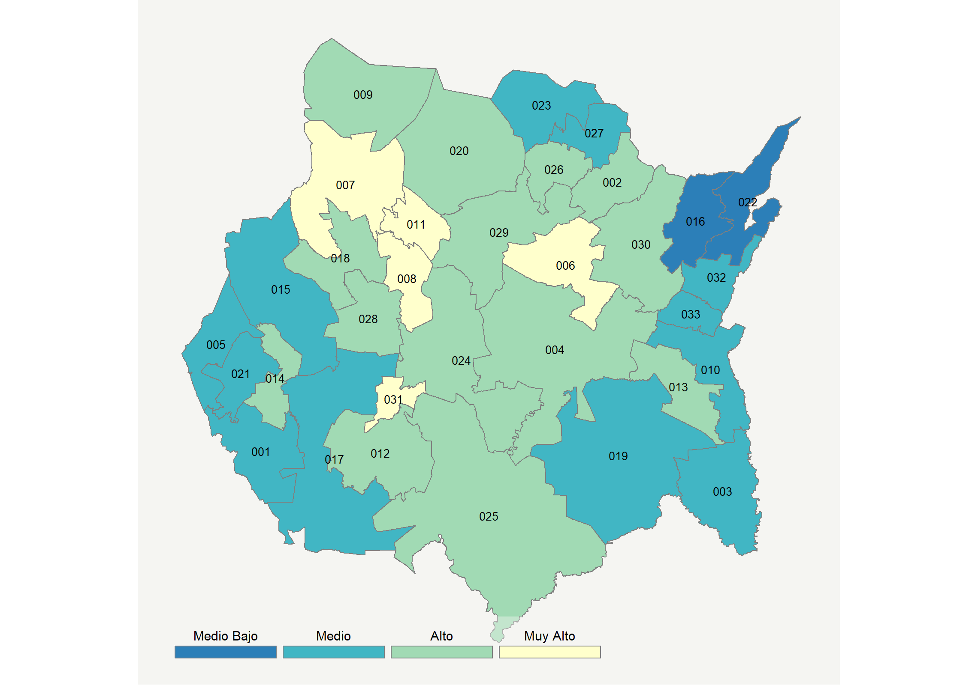

|  |  |  |  |  |  |  |  |  |  |  |  |  |  |
| --- | --- | --- | --- | --- | --- | --- | --- | --- | --- | --- | --- | --- | --- |
| **Clave del Municipio** | **Municipio** | **Telefonía fija a** | **Telefonía Celular a** | **Internet a** | **Televisión de paga a** | **Población Total a** | **Hasta 2 Salarios Mínimos b** | **Índice de Marginación** | **índice** | **Índice Escala 0-100** | **Lugar Nacional** | **Lugar Estatal** | **Estrato** |
| 001 | Amacuzac | 32.4 | 64.1 | 17.6 | 27.6 | 17772 | 48.6 | -0.53 | 0.36 | 37.1 | 751 | 21 | Medio |
| 002 | Atlatlahucan | 31.6 | 80.1 | 24.2 | 24.1 | 22079 | 46.4 | -0.42 | 0.63 | 42.3 | 505 | 15 | Alto |
| 003 | Axochiapan | 31.2 | 69.7 | 18.2 | 20.8 | 35689 | 69.6 | -0.06 | 0.34 | 36.6 | 785 | 25 | Medio |
| 004 | Ayala | 36.7 | 74.2 | 23.7 | 23.0 | 85521 | 51.1 | -0.64 | 0.63 | 42.3 | 504 | 14 | Alto |
| 005 | Coatlán del Río | 33.0 | 57.7 | 14.2 | 24.4 | 9768 | 59.5 | -0.21 | 0.19 | 33.7 | 933 | 28 | Medio |
| 006 | Cuautla | 42.7 | 83.1 | 38.1 | 33.6 | 194786 | 44.9 | -1.15 | 1.28 | 55.2 | 188 | 4 | Muy Alto |
| 007 | Cuernavaca | 61.4 | 85.4 | 54.6 | 52.8 | 366321 | 28.3 | -1.67 | 2.23 | 73.8 | 22 | 1 | Muy Alto |
| 008 | Emiliano Zapata | 39.7 | 84.5 | 35.7 | 37.8 | 99493 | 40.4 | -1.14 | 1.24 | 54.3 | 208 | 5 | Muy Alto |
| 009 | Huitzilac | 29.3 | 79.8 | 24.7 | 30.4 | 19231 | 42.5 | -0.75 | 0.67 | 43.1 | 472 | 12 | Alto |
| 010 | Jantetelco | 29.6 | 77.8 | 18.4 | 17.6 | 17238 | 54.1 | -0.54 | 0.36 | 37.0 | 758 | 22 | Medio |
| 011 | Jiutepec | 48.0 | 85.1 | 44.3 | 43.8 | 214137 | 37.4 | -1.46 | 1.65 | 62.5 | 89 | 2 | Muy Alto |
| 012 | Jojutla | 45.7 | 77.0 | 33.3 | 36.2 | 57121 | 44.1 | -1.08 | 1.19 | 53.3 | 225 | 6 | Alto |
| 013 | Jonacatepec | 39.5 | 70.6 | 22.8 | 23.5 | 15690 | 50.3 | -0.76 | 0.63 | 42.3 | 506 | 16 | Alto |
| 014 | Mazatepec | 38.0 | 61.7 | 23.1 | 21.3 | 9967 | 54.7 | -0.53 | 0.49 | 39.7 | 611 | 19 | Alto |
| 015 | Miacatlán | 33.5 | 65.5 | 21.0 | 18.1 | 26713 | 56.3 | -0.40 | 0.37 | 37.2 | 742 | 20 | Medio |
| 016 | Ocuituco | 26.2 | 62.4 | 12.5 | 7.2 | 18580 | 70.8 | -0.14 | -0.11 | 27.8 | 1267 | 33 | Medio Bajo |
| 017 | Puente de Ixtla | 25.3 | 64.1 | 17.4 | 17.1 | 66435 | 43.8 | -0.69 | 0.12 | 32.4 | 1004 | 29 | Medio |
| 018 | Temixco | 39.2 | 79.8 | 31.7 | 28.9 | 116143 | 42.7 | -1.04 | 0.98 | 49.3 | 302 | 8 | Alto |
| 019 | Tepalcingo | 30.7 | 69.3 | 14.8 | 17.1 | 27187 | 60.6 | -0.34 | 0.20 | 33.9 | 919 | 27 | Medio |
| 020 | Tepoztlán | 43.4 | 72.6 | 30.8 | 34.1 | 46946 | 41.2 | -0.60 | 1.02 | 50.0 | 286 | 7 | Alto |
| 021 | Tetecala | 30.9 | 68.2 | 20.4 | 19.5 | 7772 | 48.8 | -0.46 | 0.36 | 37.0 | 761 | 23 | Medio |
| 022 | Tetela del Volcán | 23.3 | 66.3 | 9.9 | 14.2 | 20698 | 67.3 | -0.61 | -0.10 | 27.9 | 1260 | 32 | Medio Bajo |
| 023 | Tlalnepantla | 19.6 | 65.7 | 10.2 | 27.3 | 7166 | 58.8 | 0.18 | -0.02 | 29.6 | 1160 | 30 | Medio |
| 024 | Tlaltizapán de Zapata | 35.1 | 71.1 | 24.5 | 28.8 | 52110 | 49.8 | -0.73 | 0.66 | 42.9 | 486 | 13 | Alto |
| 025 | Tlaquiltenango | 37.6 | 66.1 | 26.3 | 31.3 | 33844 | 50.0 | -0.75 | 0.72 | 44.1 | 443 | 11 | Alto |
| 026 | Tlayacapan | 30.8 | 76.7 | 20.6 | 29.4 | 17714 | 51.3 | -0.56 | 0.55 | 40.8 | 562 | 17 | Alto |
| 027 | Totolapan | 19.1 | 79.8 | 14.5 | 38.0 | 11992 | 58.2 | -0.20 | 0.34 | 36.6 | 781 | 24 | Medio |
| 028 | Xochitepec | 34.6 | 80.9 | 29.2 | 29.6 | 68984 | 44.0 | -0.87 | 0.87 | 47.0 | 355 | 10 | Alto |
| 029 | Yautepec | 38.2 | 80.6 | 30.2 | 28.1 | 102690 | 42.2 | -1.02 | 0.93 | 48.3 | 320 | 9 | Alto |
| 030 | Yecapixtla | 31.6 | 78.0 | 22.8 | 18.8 | 52651 | 50.9 | -0.67 | 0.51 | 40.1 | 596 | 18 | Alto |
| 031 | Zacatepec | 47.3 | 77.8 | 39.6 | 38.5 | 36159 | 38.7 | -1.42 | 1.40 | 57.5 | 147 | 3 | Muy Alto |
| 032 | Zacualpan de Amilpas | 38.7 | 54.4 | 19.2 | 12.4 | 9370 | 60.4 | -0.76 | 0.24 | 34.6 | 880 | 26 | Medio |
| 033 | Temoac | 26.3 | 60.2 | 15.4 | 9.6 | 15844 | 63.1 | -0.44 | -0.03 | 29.3 | 1177 | 31 | Medio |
| a Porcentaje de viviendas que cuentas con el servicio  b Ingreso por trabajo de la población ocupada en porcentaje  Fuente: Elaboración propia con datos de Encuesta Intercensal 2015 de INEGI y CONAPO | | | | | | | | | | | | | |

**Nayarit**

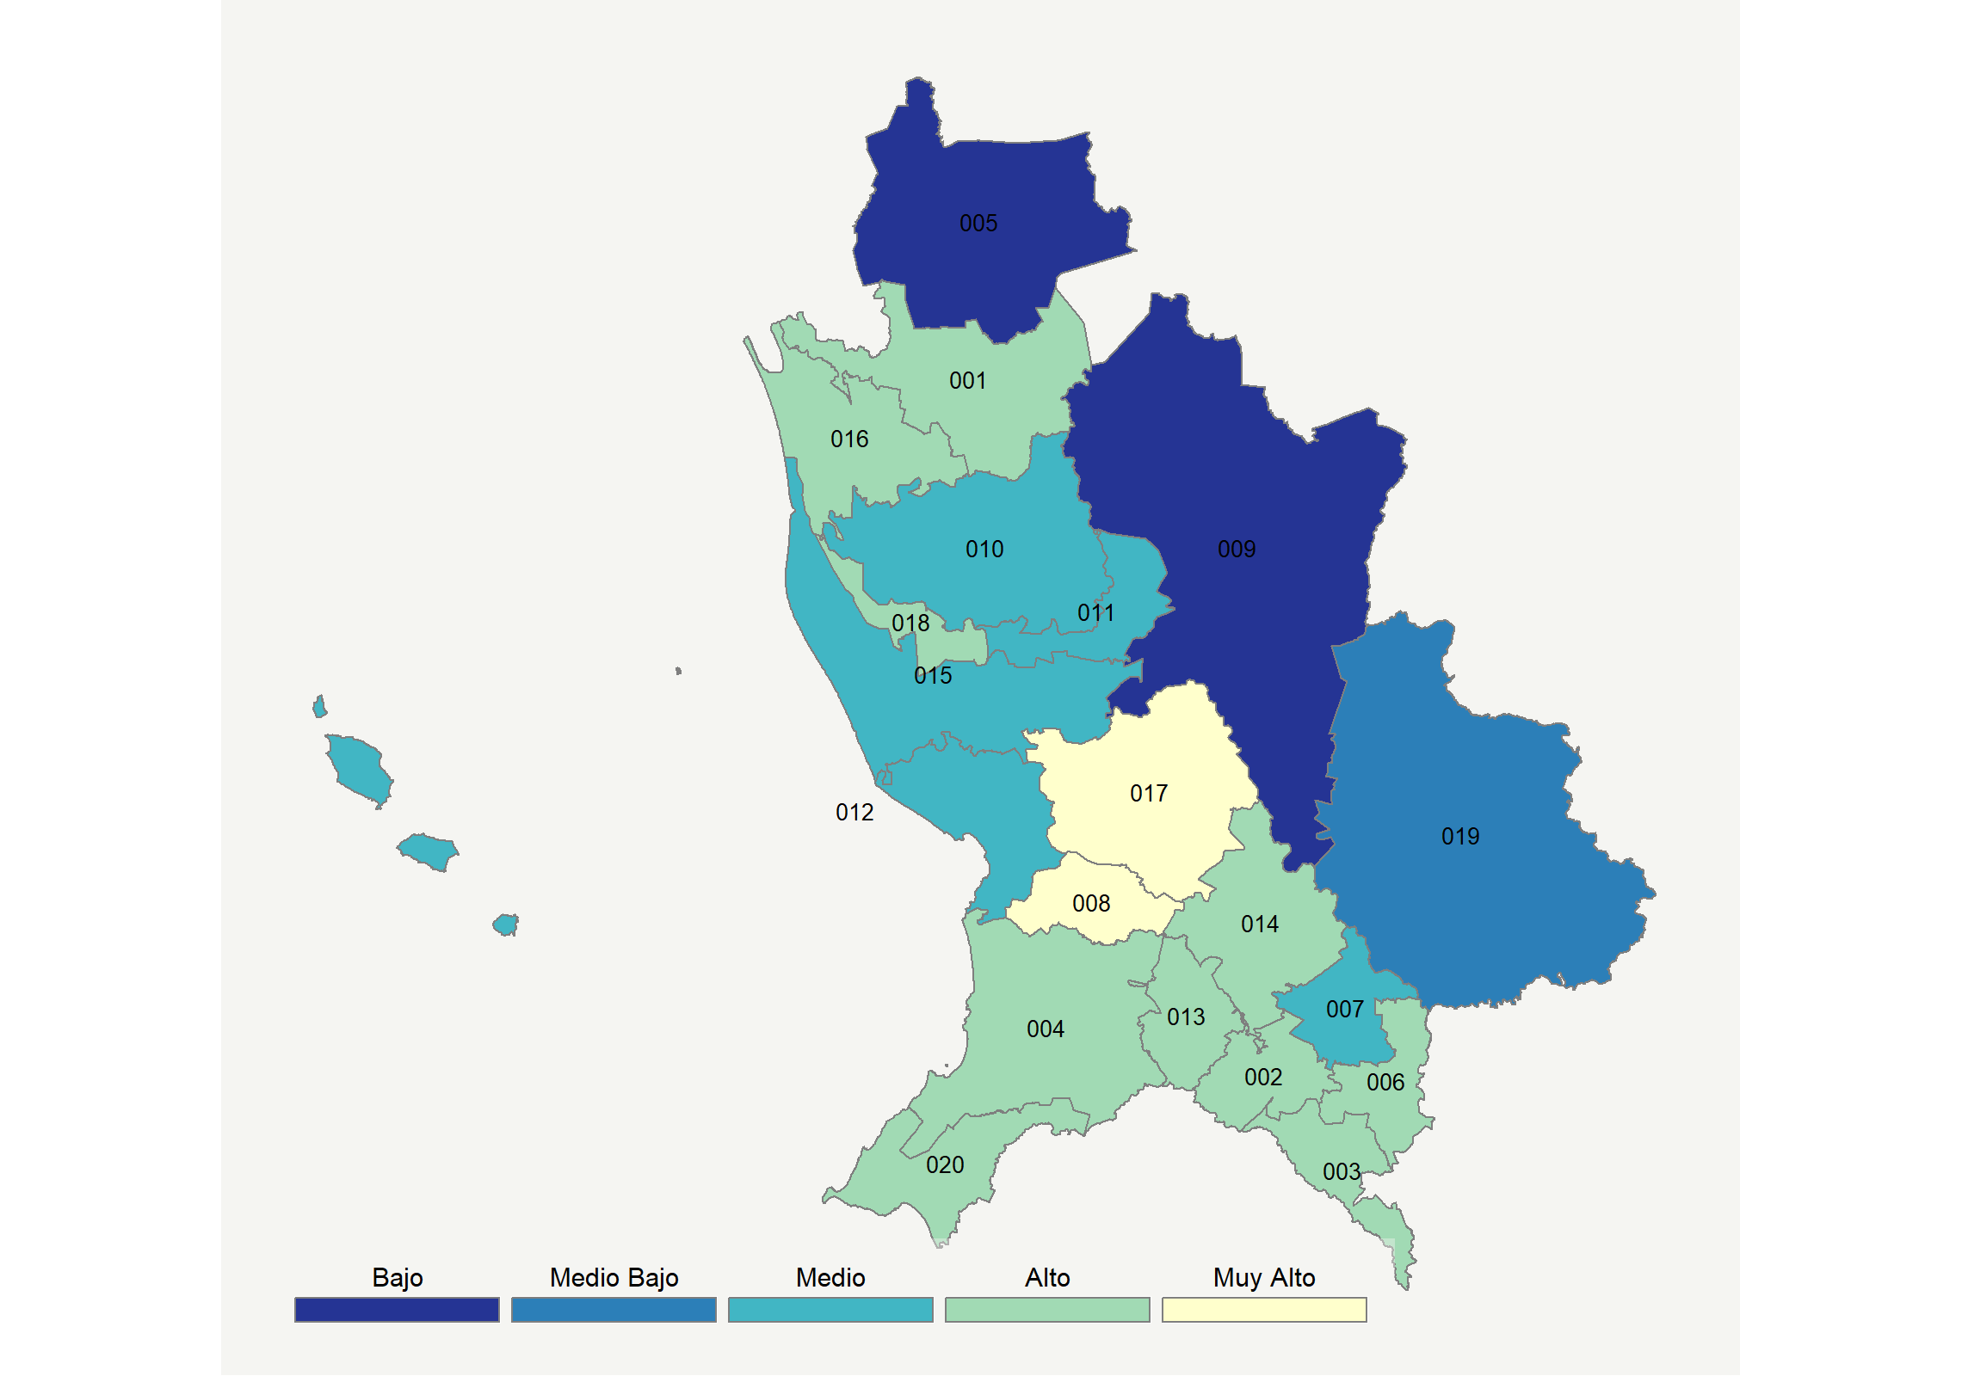

|  |  |  |  |  |  |  |  |  |  |  |  |  |  |
| --- | --- | --- | --- | --- | --- | --- | --- | --- | --- | --- | --- | --- | --- |
| **Clave del Municipio** | **Municipio** | **Telefonía fija a** | **Telefonía Celular a** | **Internet a** | **Televisión de paga a** | **Población Total a** | **Hasta 2 Salarios Mínimos b** | **Índice de Marginación** | **índice** | **Índice Escala 0-100** | **Lugar Nacional** | **Lugar Estatal** | **Estrato** |
| 001 | Acaponeta | 26.6 | 74.9 | 18.2 | 37.0 | 37309 | 51.4 | -0.60 | 0.49 | 39.7 | 612 | 11 | Alto |
| 002 | Ahuacatlán | 34.5 | 76.2 | 17.9 | 47.2 | 15953 | 48.7 | -0.94 | 0.74 | 44.6 | 434 | 7 | Alto |
| 003 | Amatlán de Cañas | 39.3 | 65.9 | 18.6 | 51.2 | 11851 | 42.1 | -0.65 | 0.78 | 45.4 | 407 | 6 | Alto |
| 004 | Compostela | 29.2 | 81.4 | 21.0 | 60.9 | 75520 | 34.8 | -0.95 | 0.93 | 48.3 | 317 | 5 | Alto |
| 005 | Huajicori | 5.3 | 48.4 | 2.4 | 15.1 | 12614 | 63.9 | 2.05 | -0.75 | 15.2 | 1970 | 19 | Bajo |
| 006 | Ixtlán del Río | 38.3 | 80.9 | 27.8 | 37.5 | 29416 | 39.7 | -1.22 | 0.98 | 49.3 | 303 | 4 | Alto |
| 007 | Jala | 24.1 | 65.8 | 13.1 | 27.2 | 18580 | 57.9 | -0.31 | 0.13 | 32.5 | 991 | 15 | Medio |
| 008 | Xalisco | 35.2 | 90.5 | 40.4 | 59.1 | 57418 | 33.1 | -1.46 | 1.57 | 60.9 | 107 | 2 | Muy Alto |
| 009 | Del Nayar * | 3.2 | 19.9 | 0.4 | 12.8 | 42514 | 57.3 | 4.41 | -1.14 | 7.5 | 2263 | 20 | Bajo |
| 010 | Rosamorada | 26.5 | 64.9 | 10.4 | 25.1 | 33901 | 57.9 | -0.20 | 0.07 | 31.4 | 1065 | 17 | Medio |
| 011 | Ruíz | 24.3 | 66.9 | 14.5 | 21.4 | 24743 | 59.4 | -0.13 | 0.11 | 32.1 | 1021 | 16 | Medio |
| 012 | San Blas | 22.1 | 77.1 | 13.5 | 44.1 | 43979 | 49.8 | -0.57 | 0.40 | 37.9 | 716 | 13 | Medio |
| 013 | San Pedro Lagunillas | 39.3 | 69.0 | 16.1 | 49.7 | 7499 | 45.1 | -0.66 | 0.73 | 44.4 | 437 | 8 | Alto |
| 014 | Santa María del Oro | 26.2 | 77.3 | 9.6 | 52.7 | 23477 | 45.7 | -0.32 | 0.48 | 39.4 | 629 | 12 | Alto |
| 015 | Santiago Ixcuintla | 30.8 | 70.5 | 15.8 | 27.4 | 97820 | 53.0 | -0.54 | 0.35 | 36.9 | 768 | 14 | Medio |
| 016 | Tecuala | 37.2 | 70.3 | 18.2 | 37.0 | 39718 | 49.8 | -0.71 | 0.62 | 42.2 | 508 | 9 | Alto |
| 017 | Tepic | 42.4 | 89.5 | 47.9 | 48.8 | 413608 | 32.1 | -1.60 | 1.75 | 64.4 | 71 | 1 | Muy Alto |
| 018 | Tuxpan | 32.7 | 72.4 | 19.7 | 27.4 | 30565 | 50.6 | -0.91 | 0.50 | 39.7 | 608 | 10 | Alto |
| 019 | La Yesca | 7.4 | 39.2 | 0.3 | 32.3 | 14315 | 46.4 | 1.91 | -0.66 | 16.9 | 1896 | 18 | Medio Bajo |
| 020 | Bahía de Banderas | 24.4 | 91.5 | 33.8 | 54.6 | 150250 | 25.8 | -1.31 | 1.19 | 53.5 | 221 | 3 | Alto |
| a Porcentaje de viviendas que cuentas con el servicio  b Ingreso por trabajo de la población ocupada en porcentaje  Fuente: Elaboración propia con datos de Encuesta Intercensal 2015 de INEGI y CONAPO | | | | | | | | | | | | | |

**Nuevo León**

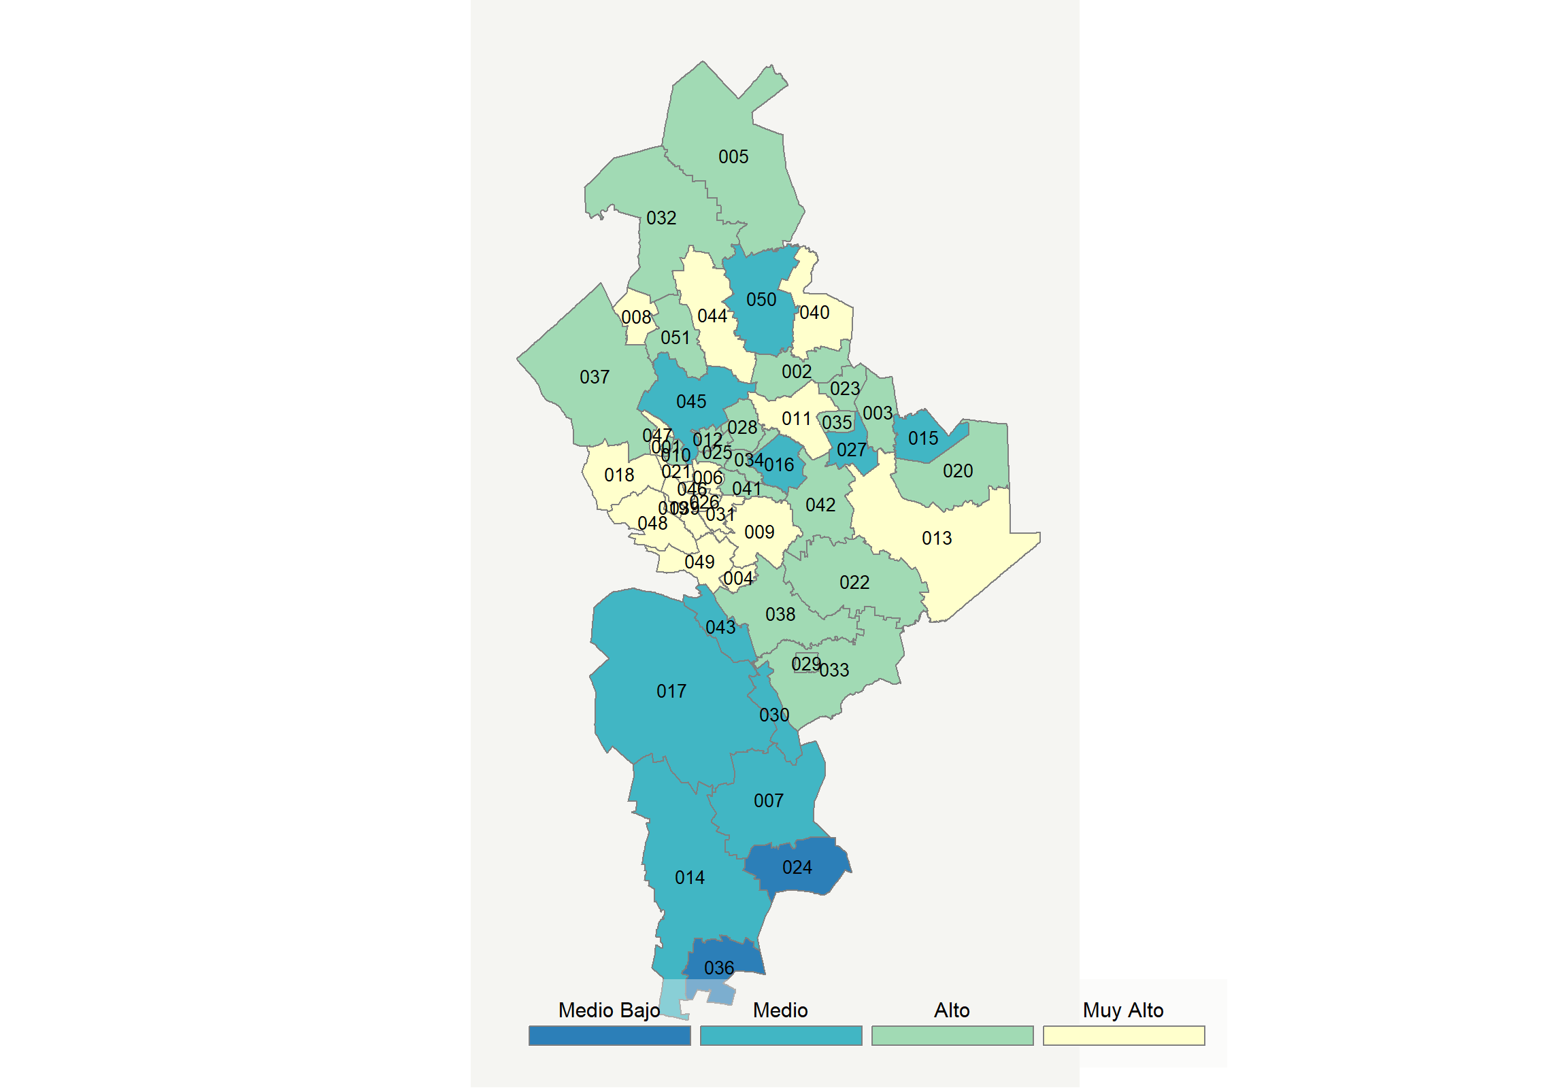

|  |  |  |  |  |  |  |  |  |  |  |  |  |  |
| --- | --- | --- | --- | --- | --- | --- | --- | --- | --- | --- | --- | --- | --- |
| **Clave del Municipio** | **Municipio** | **Telefonía fija a** | **Telefonía Celular a** | **Internet a** | **Televisión de paga a** | **Población Total a** | **Hasta 2 Salarios Mínimos b** | **Índice de Marginación** | **índice** | **Índice Escala 0-100** | **Lugar Nacional** | **Lugar Estatal** | **Estrato** |
| 001 | Abasolo * | 12.9 | 87.3 | 17.9 | 45.9 | 2639 | 17.7 | -1.13 | 0.48 | 39.4 | 627 | 37 | Alto |
| 002 | Agualeguas * | 37.0 | 74.0 | 20.9 | 55.7 | 2439 | 29.4 | -0.99 | 0.93 | 48.3 | 322 | 30 | Alto |
| 003 | Los Aldamas * | 40.1 | 84.2 | 15.4 | 23.0 | 1292 | 42.4 | -0.78 | 0.58 | 41.4 | 537 | 34 | Alto |
| 004 | Allende | 37.1 | 86.4 | 39.8 | 65.9 | 34353 | 11.4 | -1.62 | 1.62 | 61.9 | 96 | 9 | Muy Alto |
| 005 | Anáhuac | 36.1 | 83.4 | 27.9 | 55.4 | 18194 | 43.8 | -1.10 | 1.17 | 53.1 | 230 | 20 | Alto |
| 006 | Apodaca | 52.9 | 91.7 | 58.5 | 47.4 | 597207 | 14.5 | -1.89 | 2.18 | 72.9 | 27 | 5 | Muy Alto |
| 007 | Aramberri | 13.7 | 52.9 | 6.7 | 53.1 | 16152 | 52.1 | 0.17 | -0.04 | 29.2 | 1183 | 47 | Medio |
| 008 | Bustamante * | 40.0 | 78.7 | 25.8 | 68.3 | 3977 | 43.0 | -0.88 | 1.28 | 55.3 | 186 | 13 | Muy Alto |
| 009 | Cadereyta Jiménez | 32.6 | 85.9 | 35.9 | 45.8 | 95534 | 14.4 | -1.56 | 1.23 | 54.1 | 210 | 18 | Muy Alto |
| 010 | El Carmen | 10.7 | 93.5 | 23.5 | 48.4 | 38306 | 13.6 | -1.44 | 0.67 | 43.1 | 475 | 33 | Alto |
| 011 | Cerralvo | 37.0 | 85.4 | 31.3 | 54.7 | 7757 | 28.4 | -1.31 | 1.28 | 55.2 | 189 | 14 | Muy Alto |
| 012 | Ciénega de Flores | 11.1 | 93.7 | 22.6 | 42.0 | 42715 | 16.2 | -1.55 | 0.58 | 41.4 | 539 | 35 | Alto |
| 013 | China | 42.9 | 80.8 | 31.5 | 45.5 | 10835 | 17.5 | -1.26 | 1.24 | 54.3 | 207 | 17 | Muy Alto |
| 014 | Doctor Arroyo | 16.1 | 47.8 | 9.3 | 47.3 | 34110 | 55.6 | 0.04 | -0.05 | 29.0 | 1194 | 49 | Medio |
| 015 | Doctor Coss * | 16.6 | 81.5 | 5.6 | 25.2 | 1632 | 38.5 | -0.61 | -0.04 | 29.1 | 1189 | 48 | Medio |
| 016 | Doctor González * | 15.9 | 85.6 | 17.6 | 35.4 | 2861 | 19.0 | -0.85 | 0.39 | 37.6 | 728 | 40 | Medio |
| 017 | Galeana | 14.1 | 52.7 | 6.7 | 66.9 | 41130 | 49.8 | -0.19 | 0.12 | 32.3 | 1006 | 45 | Medio |
| 018 | García | 24.5 | 91.9 | 39.0 | 57.3 | 247370 | 13.5 | -1.62 | 1.35 | 56.6 | 159 | 12 | Muy Alto |
| 019 | San Pedro Garza García | 84.0 | 91.5 | 81.1 | 75.2 | 123156 | 8.2 | -2.22 | 3.55 | 100.0 | 1 | 1 | Muy Alto |
| 020 | General Bravo | 37.0 | 85.2 | 26.5 | 53.4 | 5479 | 16.3 | -1.03 | 1.15 | 52.6 | 236 | 22 | Alto |
| 021 | General Escobedo | 40.4 | 89.9 | 41.5 | 46.1 | 425148 | 15.9 | -1.75 | 1.53 | 60.2 | 113 | 10 | Muy Alto |
| 022 | General Terán | 25.6 | 79.3 | 20.3 | 38.1 | 14795 | 29.9 | -0.93 | 0.58 | 41.4 | 541 | 36 | Alto |
| 023 | General Treviño * | 42.0 | 80.7 | 23.2 | 50.4 | 1044 | 37.8 | -0.68 | 1.08 | 51.1 | 266 | 25 | Alto |
| 024 | General Zaragoza | 7.6 | 60.6 | 4.4 | 42.1 | 6011 | 55.2 | 0.60 | -0.24 | 25.2 | 1436 | 50 | Medio Bajo |
| 025 | General Zuazua | 14.2 | 93.4 | 26.4 | 43.7 | 67294 | 15.7 | -1.61 | 0.74 | 44.6 | 433 | 32 | Alto |
| 026 | Guadalupe | 63.3 | 87.8 | 58.4 | 50.4 | 682880 | 16.2 | -1.92 | 2.35 | 76.2 | 18 | 4 | Muy Alto |
| 027 | Los Herreras * | 30.1 | 68.8 | 12.9 | 29.7 | 1764 | 38.3 | -0.76 | 0.28 | 35.4 | 837 | 42 | Medio |
| 028 | Higueras * | 29.4 | 90.0 | 23.2 | 47.0 | 1511 | 28.6 | -0.82 | 0.92 | 48.1 | 330 | 31 | Alto |
| 029 | Hualahuises | 37.1 | 78.1 | 34.4 | 54.1 | 6921 | 31.0 | -1.26 | 1.28 | 55.2 | 190 | 15 | Muy Alto |
| 030 | Iturbide * | 16.4 | 53.2 | 8.9 | 61.1 | 3571 | 44.4 | -0.03 | 0.15 | 32.9 | 969 | 44 | Medio |
| 031 | Juárez | 29.9 | 91.6 | 36.6 | 46.4 | 333481 | 17.3 | -1.62 | 1.26 | 54.8 | 197 | 16 | Muy Alto |
| 032 | Lampazos de Naranjo | 33.0 | 84.1 | 22.7 | 58.9 | 5238 | 32.0 | -1.26 | 1.04 | 50.5 | 277 | 26 | Alto |
| 033 | Linares | 26.0 | 82.1 | 33.7 | 55.0 | 79853 | 37.6 | -1.17 | 1.13 | 52.2 | 248 | 23 | Alto |
| 034 | Marín | 29.7 | 88.4 | 31.9 | 38.3 | 5630 | 16.0 | -1.13 | 1.02 | 50.1 | 282 | 27 | Alto |
| 035 | Melchor Ocampo * | 44.8 | 78.7 | 23.8 | 38.7 | 955 | 31.5 | -1.14 | 0.99 | 49.4 | 296 | 28 | Alto |
| 036 | Mier y Noriega | 14.4 | 32.9 | 0.4 | 52.2 | 6996 | 55.2 | 0.42 | -0.38 | 22.3 | 1599 | 51 | Medio Bajo |
| 037 | Mina | 14.6 | 84.6 | 20.1 | 81.6 | 5326 | 16.1 | -0.85 | 0.93 | 48.3 | 318 | 29 | Alto |
| 038 | Montemorelos | 31.8 | 83.5 | 32.2 | 52.2 | 60829 | 21.7 | -1.43 | 1.17 | 53.0 | 231 | 21 | Alto |
| 039 | Monterrey | 65.6 | 86.2 | 59.6 | 52.6 | 1109171 | 15.5 | -1.90 | 2.42 | 77.7 | 11 | 3 | Muy Alto |
| 040 | Parás * | 50.3 | 64.1 | 29.1 | 53.1 | 971 | 25.4 | -0.95 | 1.22 | 54.0 | 211 | 19 | Muy Alto |
| 041 | Pesquería | 12.1 | 92.2 | 20.4 | 36.7 | 87168 | 13.1 | -1.43 | 0.47 | 39.2 | 638 | 38 | Alto |
| 042 | Los Ramones | 27.5 | 67.8 | 22.6 | 28.1 | 4469 | 25.5 | -0.88 | 0.44 | 38.7 | 671 | 39 | Alto |
| 043 | Rayones * | 14.9 | 41.4 | 8.4 | 67.7 | 2640 | 49.4 | 0.10 | 0.07 | 31.4 | 1064 | 46 | Medio |
| 044 | Sabinas Hidalgo | 50.1 | 82.3 | 37.8 | 63.0 | 35456 | 32.6 | -1.56 | 1.72 | 63.8 | 75 | 8 | Muy Alto |
| 045 | Salinas Victoria | 10.3 | 88.1 | 11.9 | 35.8 | 54192 | 13.3 | -1.33 | 0.19 | 33.6 | 937 | 43 | Medio |
| 046 | San Nicolás de los Garza | 74.8 | 86.5 | 65.2 | 54.0 | 430143 | 13.1 | -2.10 | 2.73 | 83.8 | 5 | 2 | Muy Alto |
| 047 | Hidalgo | 30.2 | 85.8 | 37.7 | 68.7 | 13836 | 13.3 | -1.68 | 1.48 | 59.2 | 128 | 11 | Muy Alto |
| 048 | Santa Catarina | 57.1 | 86.7 | 54.0 | 44.9 | 296954 | 13.9 | -1.85 | 2.07 | 70.7 | 38 | 6 | Muy Alto |
| 049 | Santiago | 48.1 | 83.9 | 46.9 | 56.4 | 42407 | 18.6 | -1.63 | 1.84 | 66.3 | 57 | 7 | Muy Alto |
| 050 | Vallecillo * | 21.1 | 72.9 | 9.6 | 51.4 | 1632 | 38.0 | -0.67 | 0.34 | 36.5 | 786 | 41 | Medio |
| 051 | Villaldama | 45.8 | 66.6 | 26.2 | 55.3 | 4080 | 43.3 | -0.83 | 1.13 | 52.1 | 250 | 24 | Alto |
| a Porcentaje de viviendas que cuentas con el servicio  b Ingreso por trabajo de la población ocupada en porcentaje  Fuente: Elaboración propia con datos de Encuesta Intercensal 2015 de INEGI y CONAPO | | | | | | | | | | | | | |

**Oaxaca**

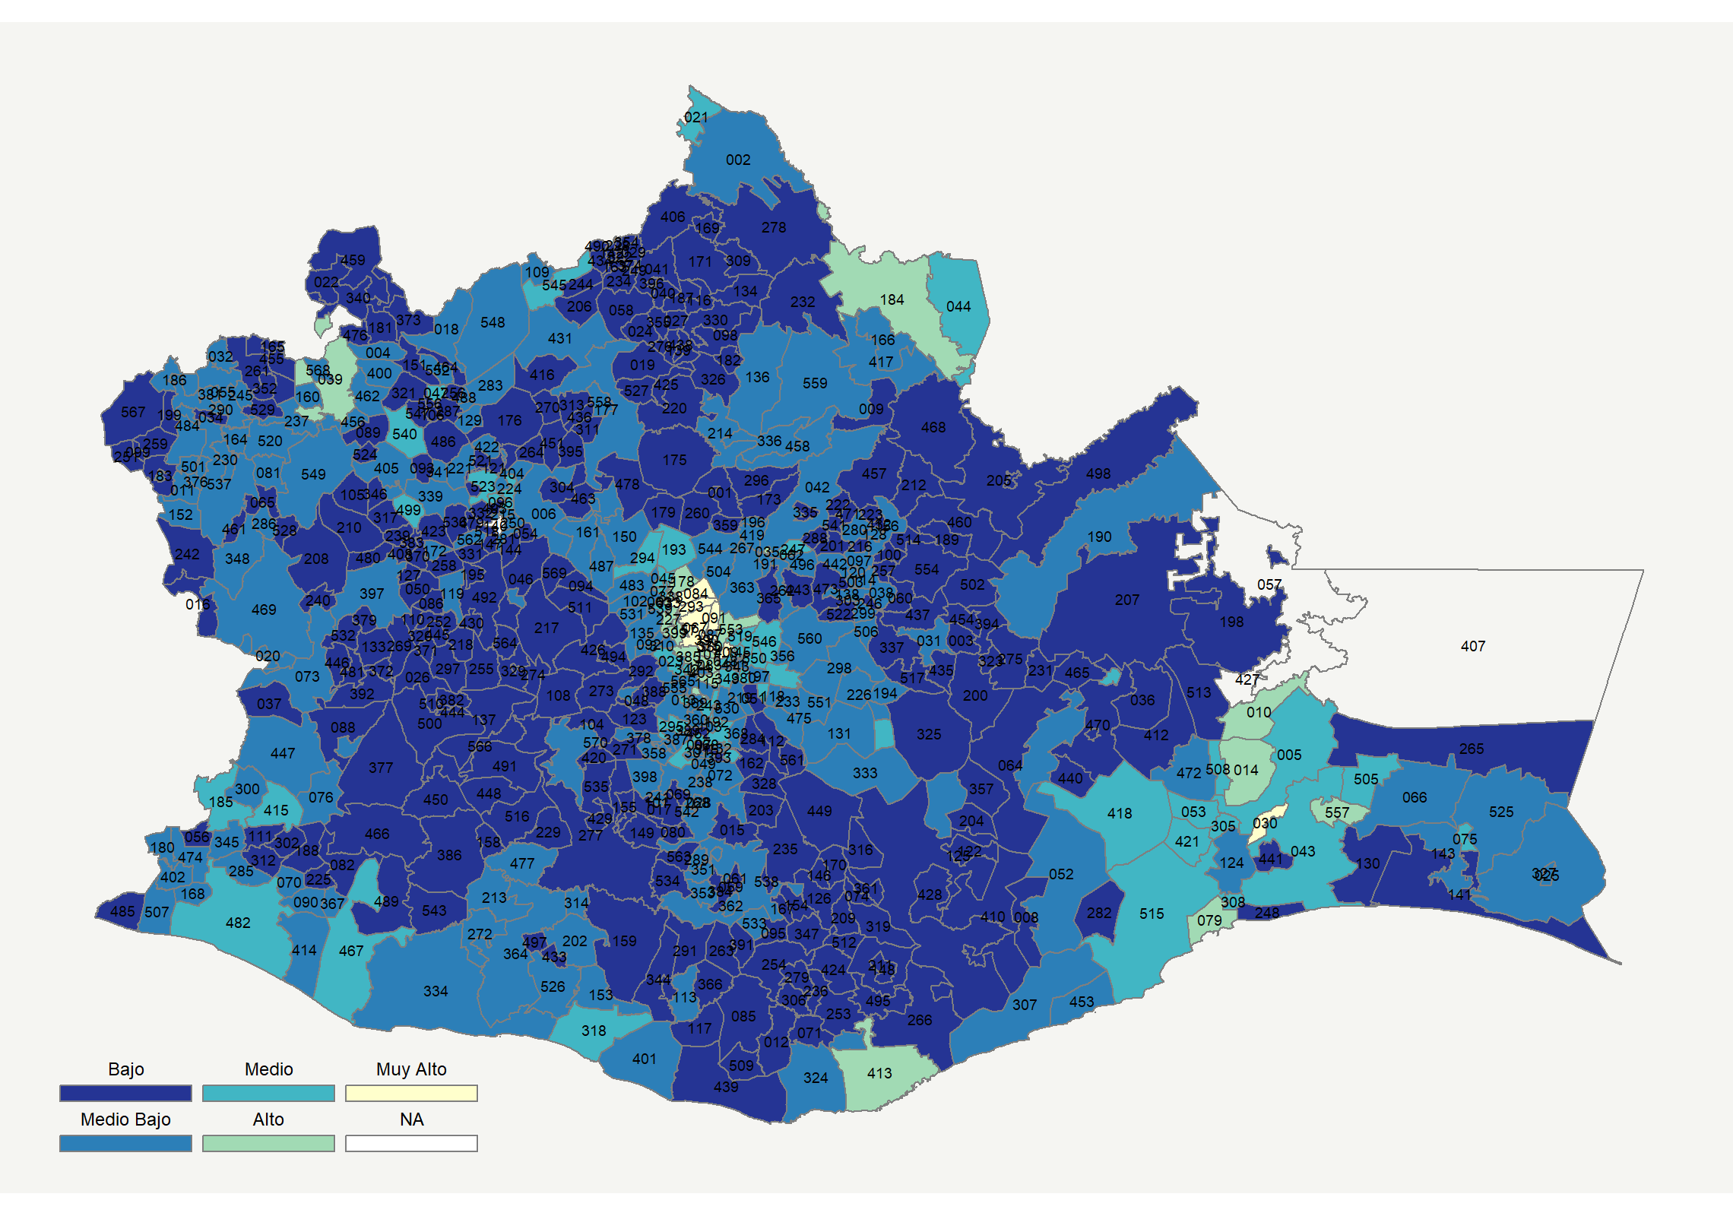

|  |  |  |  |  |  |  |  |  |  |  |  |  |  |  |
| --- | --- | --- | --- | --- | --- | --- | --- | --- | --- | --- | --- | --- | --- | --- |
| **Clave del Municipio** | **Municipio** | **Telefonía fija a** | **Telefonía Celular a** | **Internet a** | **Televisión de paga a** | **Población Total a** | **Hasta 2 Salarios Mínimos b** | **Índice de Marginación** | **índice** | **Índice Escala 0-100** | **Lugar Nacional** | **Lugar Estatal** | **Estrato** | |
| 001 | Abejones * | 13.5 | 11.7 | 0.4 | 10.8 | 882 | 86.8 | 1.08 | -1.07 | 8.8 | 2227 | 409 | Bajo | |
| 002 | Acatlán de Pérez Figueroa | 15.0 | 60.6 | 8.1 | 16.8 | 45883 | 65.3 | 0.34 | -0.31 | 23.8 | 1515 | 137 | Medio Bajo | |
| 003 | Asunción Cacalotepec * | 2.9 | 1.2 | 0.3 | 11.6 | 2027 | 65.5 | 0.91 | -1.34 | 3.4 | 2374 | 507 | Bajo | |
| 004 | Asunción Cuyotepeji * | 38.6 | 12.0 | 4.4 | 47.4 | 930 | 56.3 | -0.17 | -0.15 | 27.0 | 1312 | 86 | Medio Bajo | |
| 005 | Asunción Ixtaltepec | 21.6 | 63.6 | 11.9 | 29.5 | 15105 | 44.4 | -0.52 | 0.06 | 31.1 | 1082 | 60 | Medio | |
| 006 | Asunción Nochixtlán | 11.8 | 67.8 | 8.0 | 18.1 | 18525 | 53.3 | -0.21 | -0.28 | 24.4 | 1475 | 123 | Medio Bajo | |
| 007 | Asunción Ocotlán * | 12.8 | 41.5 | 2.5 | 0.5 | 2550 | 55.3 | 1.54 | -0.85 | 13.1 | 2062 | 317 | Bajo | |
| 008 | Asunción Tlacolulita * | 6.3 | 35.3 | 0.8 | 10.2 | 758 | 20.2 | -0.20 | -0.95 | 11.1 | 2138 | 357 | Bajo | |
| 009 | Ayotzintepec | 6.3 | 38.7 | 1.8 | 22.7 | 7102 | 70.2 | 0.38 | -0.76 | 15.0 | 1984 | 272 | Bajo | |
| 010 | El Barrio de la Soledad | 24.6 | 78.4 | 18.6 | 34.9 | 14277 | 36.0 | -0.81 | 0.48 | 39.4 | 626 | 26 | Alto | |
| 011 | Calihualá * | 35.2 | 5.6 | 1.0 | 39.5 | 1182 | 71.6 | 1.06 | -0.44 | 21.3 | 1661 | 170 | Medio Bajo | |
| 012 | Candelaria Loxicha * | 5.1 | 48.3 | 1.1 | 15.1 | 10497 | 67.6 | 1.86 | -0.78 | 14.5 | 2003 | 284 | Bajo | |
| 013 | Ciénega de Zimatlán * | 39.6 | 53.1 | 7.2 | 8.3 | 2953 | 57.3 | -0.24 | -0.09 | 28.1 | 1250 | 77 | Medio | |
| 014 | Ciudad Ixtepec | 23.5 | 84.1 | 26.6 | 40.0 | 28637 | 38.9 | -1.07 | 0.77 | 45.1 | 419 | 17 | Alto | |
| 015 | Coatecas Altas * | 19.6 | 17.2 | 0.3 | 3.5 | 4823 | 55.7 | 1.72 | -1.00 | 10.2 | 2173 | 374 | Bajo | |
| 016 | Coicoyán de las Flores * | 2.9 | 1.7 | 0.2 | 1.2 | 9936 | 85.4 | 3.05 | -1.46 | 1.2 | 2436 | 556 | Bajo | |
| 017 | La Compañía * | 22.9 | 20.1 | 0.9 | 5.1 | 3365 | 72.1 | 1.03 | -0.88 | 12.5 | 2082 | 326 | Bajo | |
| 018 | Concepción Buenavista * | 16.9 | 36.0 | 0.8 | 25.2 | 803 | 84.1 | 0.63 | -0.60 | 18.0 | 1842 | 220 | Medio Bajo | |
| 019 | Concepción Pápalo * | 23.0 | 7.2 | 0.7 | 7.5 | 2934 | 71.4 | 0.87 | -0.99 | 10.5 | 2163 | 368 | Bajo | |
| 020 | Constancia del Rosario * | 12.6 | 54.8 | 6.4 | 13.9 | 3947 | 59.8 | 1.45 | -0.48 | 20.4 | 1709 | 185 | Medio Bajo | |
| 021 | Cosolapa | 15.2 | 71.1 | 19.1 | 41.2 | 15866 | 65.3 | 0.04 | 0.33 | 36.5 | 787 | 36 | Medio | |
| 022 | Cosoltepec * | 10.5 | 24.6 | 0.7 | 5.8 | 716 | 84.4 | 0.14 | -1.04 | 9.4 | 2205 | 397 | Bajo | |
| 023 | Cuilápam de Guerrero | 14.3 | 80.4 | 10.3 | 18.3 | 21597 | 38.3 | -0.54 | -0.06 | 28.8 | 1202 | 70 | Medio | |
| 024 | Cuyamecalco Villa de Zaragoza * | 13.2 | 3.1 | 1.6 | 11.1 | 3643 | 58.8 | 1.44 | -1.13 | 7.7 | 2258 | 432 | Bajo | |
| 025 | Chahuites | 14.3 | 72.9 | 13.0 | 48.0 | 11413 | 49.4 | -0.24 | 0.27 | 35.2 | 848 | 43 | Medio | |
| 026 | Chalcatongo de Hidalgo | 6.8 | 40.1 | 1.4 | 14.1 | 9066 | 67.1 | 0.43 | -0.84 | 13.4 | 2047 | 308 | Bajo | |
| 027 | Chiquihuitlán de Benito Juárez * | 21.7 | 2.9 | 1.3 | 10.1 | 2251 | 84.8 | 1.59 | -1.01 | 10.1 | 2180 | 378 | Bajo | |
| 028 | Heroica Ciudad de Ejutla de Crespo | 14.2 | 55.9 | 5.1 | 14.1 | 20915 | 60.1 | 0.44 | -0.47 | 20.6 | 1701 | 180 | Medio Bajo | |
| 029 | Eloxochitlán de Flores Magón * | 1.4 | 7.7 | 0.9 | 6.7 | 4135 | 71.1 | 1.91 | -1.34 | 3.4 | 2375 | 508 | Bajo | |
| 030 | El Espinal | 40.2 | 82.7 | 35.9 | 47.6 | 8575 | 25.6 | -1.33 | 1.34 | 56.3 | 165 | 9 | Muy Alto | |
| 031 | Tamazulápam del Espíritu Santo | 8.5 | 46.3 | 1.1 | 21.0 | 7102 | 54.1 | 0.86 | -0.68 | 16.5 | 1906 | 245 | Medio Bajo | |
| 032 | Fresnillo de Trujano * | 31.7 | 5.5 | 0.0 | 51.9 | 996 | 71.8 | 1.10 | -0.38 | 22.4 | 1596 | 156 | Medio Bajo | |
| 033 | Guadalupe Etla * | 33.6 | 78.7 | 25.8 | 16.1 | 2637 | 33.2 | -0.85 | 0.60 | 41.7 | 528 | 23 | Alto | |
| 034 | Guadalupe de Ramírez * | 27.2 | 14.6 | 0.0 | 17.3 | 1172 | 69.8 | 0.36 | -0.75 | 15.1 | 1976 | 268 | Bajo | |
| 035 | Guelatao de Juárez * | 39.2 | 82.4 | 24.3 | 48.0 | 531 | 37.8 | -1.11 | 1.05 | 50.5 | 276 | 13 | Alto | |
| 036 | Guevea de Humboldt | 0.6 | 11.5 | 3.4 | 21.4 | 5409 | 67.4 | 0.77 | -1.10 | 8.3 | 2239 | 418 | Bajo | |
| 037 | Mesones Hidalgo * | 18.2 | 17.9 | 1.4 | 16.3 | 4380 | 80.8 | 1.38 | -0.85 | 13.2 | 2054 | 311 | Bajo | |
| 038 | Villa Hidalgo * | 44.3 | 14.0 | 3.3 | 31.8 | 1917 | 80.7 | 1.00 | -0.24 | 25.3 | 1430 | 109 | Medio Bajo | |
| 039 | Heroica Ciudad de Huajuapan de León | 29.4 | 72.9 | 21.3 | 26.1 | 77547 | 44.9 | -0.70 | 0.47 | 39.2 | 637 | 27 | Alto | |
| 040 | Huautepec * | 1.9 | 3.8 | 0.2 | 3.8 | 6299 | 86.5 | 2.95 | -1.42 | 1.8 | 2419 | 541 | Bajo | |
| 041 | Huautla de Jiménez | 7.6 | 31.7 | 5.5 | 17.6 | 31551 | 71.1 | 1.71 | -0.77 | 14.7 | 1995 | 278 | Bajo | |
| 042 | Ixtlán de Juárez | 11.8 | 41.7 | 11.1 | 27.4 | 8268 | 44.3 | -0.17 | -0.36 | 22.9 | 1570 | 152 | Medio Bajo | |
| 043 | Heroica Ciudad de Juchitán de Zaragoza | 19.9 | 70.4 | 19.8 | 36.0 | 98043 | 39.9 | -0.65 | 0.37 | 37.1 | 749 | 33 | Medio | |
| 044 | Loma Bonita | 23.0 | 71.8 | 15.3 | 20.8 | 42884 | 61.5 | -0.28 | 0.15 | 32.9 | 972 | 50 | Medio | |
| 045 | Magdalena Apasco | 18.9 | 89.2 | 17.8 | 24.0 | 8303 | 35.6 | -1.01 | 0.35 | 36.9 | 766 | 34 | Medio | |
| 046 | Magdalena Jaltepec * | 23.0 | 19.3 | 1.1 | 16.7 | 3149 | 62.5 | 0.80 | -0.76 | 15.0 | 1983 | 271 | Bajo | |
| 047 | Santa Magdalena Jicotlán * | 29.0 | 38.7 | 0.0 | 54.8 | 87 | 36.4 | -0.59 | -0.06 | 28.6 | 1218 | 72 | Medio | |
| 048 | Magdalena Mixtepec * | 21.4 | 21.0 | 0.0 | 10.5 | 1375 | 71.3 | 1.60 | -0.86 | 13.0 | 2067 | 319 | Bajo | |
| 049 | Magdalena Ocotlán * | 20.7 | 62.2 | 2.4 | 2.7 | 1146 | 58.4 | 0.29 | -0.49 | 20.2 | 1722 | 189 | Medio Bajo | |
| 050 | Magdalena Peñasco * | 1.1 | 1.7 | 0.3 | 3.6 | 3381 | 76.5 | 1.81 | -1.46 | 1.2 | 2437 | 557 | Bajo | |
| 051 | Magdalena Teitipac * | 3.9 | 51.9 | 0.5 | 1.2 | 4563 | 88.6 | 2.39 | -0.94 | 11.4 | 2124 | 348 | Bajo | |
| 052 | Magdalena Tequisistlán | 10.0 | 57.6 | 5.5 | 19.3 | 6038 | 51.0 | 0.01 | -0.46 | 20.9 | 1684 | 174 | Medio Bajo | |
| 053 | Magdalena Tlacotepec * | 9.3 | 70.4 | 10.0 | 34.1 | 1220 | 49.2 | -0.15 | -0.07 | 28.6 | 1220 | 73 | Medio | |
| 054 | Magdalena Zahuatlán * | 10.6 | 45.8 | 0.0 | 11.3 | 415 | 51.6 | -0.11 | -0.79 | 14.4 | 2010 | 290 | Bajo | |
| 055 | Mariscala de Juárez * | 26.3 | 41.8 | 4.1 | 33.6 | 3486 | 66.8 | 0.15 | -0.22 | 25.6 | 1405 | 105 | Medio Bajo | |
| 056 | Mártires de Tacubaya * | 19.5 | 8.5 | 1.7 | 6.7 | 1424 | 62.1 | 0.68 | -1.02 | 9.9 | 2188 | 385 | Bajo | |
| 058 | Mazatlán Villa de Flores * | 4.7 | 2.0 | 0.5 | 10.5 | 13097 | 68.0 | 1.87 | -1.31 | 4.0 | 2354 | 491 | Bajo | |
| 059 | Miahuatlán de Porfirio Díaz | 9.9 | 72.2 | 10.6 | 15.2 | 42312 | 47.7 | 0.06 | -0.24 | 25.2 | 1435 | 112 | Medio Bajo | |
| 060 | Mixistlán de la Reforma * | 13.2 | 21.2 | 0.3 | 2.4 | 2585 | 89.2 | 1.19 | -1.08 | 8.7 | 2230 | 412 | Bajo | |
| 061 | Monjas * | 4.0 | 57.5 | 0.9 | 6.2 | 2722 | 69.3 | 1.07 | -0.82 | 13.8 | 2036 | 302 | Bajo | |
| 062 | Natividad * | 48.2 | 28.4 | 7.1 | 46.8 | 475 | 50.0 | -0.61 | 0.23 | 34.5 | 887 | 44 | Medio | |
| 063 | Nazareno Etla * | 24.5 | 82.4 | 24.6 | 23.1 | 3910 | 41.0 | -1.02 | 0.53 | 40.4 | 581 | 25 | Alto | |
| 064 | Nejapa de Madero | 13.1 | 49.2 | 4.8 | 23.4 | 7385 | 72.8 | 0.48 | -0.46 | 20.9 | 1687 | 175 | Medio Bajo | |
| 065 | Ixpantepec Nieves * | 23.9 | 31.8 | 0.8 | 6.6 | 1209 | 69.4 | 1.25 | -0.74 | 15.4 | 1958 | 262 | Bajo | |
| 066 | Santiago Niltepec | 11.3 | 64.3 | 6.2 | 30.1 | 5327 | 58.9 | 0.07 | -0.23 | 25.4 | 1423 | 108 | Medio Bajo | |
| 067 | Oaxaca de Juárez | 48.9 | 86.9 | 46.9 | 36.8 | 264251 | 26.7 | -1.52 | 1.67 | 62.9 | 82 | 3 | Muy Alto | |
| 068 | Ocotlán de Morelos | 20.7 | 70.0 | 16.8 | 14.8 | 21676 | 48.1 | 0.05 | 0.06 | 31.2 | 1077 | 59 | Medio | |
| 069 | La Pe * | 19.8 | 17.0 | 0.0 | 2.6 | 2632 | 77.8 | 1.38 | -1.01 | 9.9 | 2183 | 381 | Bajo | |
| 070 | Pinotepa de Don Luis | 10.8 | 56.8 | 6.0 | 16.3 | 6893 | 57.9 | 0.67 | -0.47 | 20.6 | 1703 | 181 | Medio Bajo | |
| 071 | Pluma Hidalgo * | 10.7 | 23.6 | 2.1 | 18.8 | 2871 | 68.8 | 1.47 | -0.87 | 12.8 | 2076 | 324 | Bajo | |
| 072 | San José del Progreso | 11.1 | 50.3 | 2.5 | 9.1 | 6822 | 40.7 | 1.07 | -0.70 | 16.2 | 1920 | 249 | Medio Bajo | |
| 073 | Putla Villa de Guerrero | 16.6 | 44.5 | 8.3 | 20.4 | 32640 | 56.8 | 0.11 | -0.40 | 22.1 | 1616 | 162 | Medio Bajo | |
| 074 | Santa Catarina Quioquitani * | 11.8 | 6.3 | 0.0 | 2.4 | 482 | 74.0 | 0.32 | -1.26 | 5.2 | 2325 | 474 | Bajo | |
| 075 | Reforma de Pineda * | 13.4 | 74.1 | 9.5 | 39.4 | 2723 | 59.0 | -0.10 | 0.08 | 31.6 | 1049 | 56 | Medio | |
| 076 | La Reforma * | 19.7 | 6.0 | 5.5 | 33.3 | 3256 | 73.6 | 0.27 | -0.65 | 17.1 | 1886 | 238 | Medio Bajo | |
| 077 | Reyes Etla * | 22.4 | 75.2 | 14.5 | 13.3 | 3757 | 49.1 | -0.24 | 0.07 | 31.3 | 1067 | 57 | Medio | |
| 078 | Rojas de Cuauhtémoc * | 10.8 | 81.6 | 9.8 | 46.5 | 1095 | 41.9 | -0.84 | 0.20 | 33.9 | 923 | 45 | Medio | |
| 079 | Salina Cruz | 28.2 | 87.9 | 33.3 | 49.7 | 89211 | 32.4 | -1.13 | 1.15 | 52.7 | 235 | 11 | Alto | |
| 080 | San Agustín Amatengo * | 10.8 | 12.1 | 1.3 | 13.5 | 1459 | 67.2 | 0.57 | -1.06 | 9.0 | 2216 | 404 | Bajo | |
| 081 | San Agustín Atenango * | 41.0 | 23.7 | 6.7 | 15.9 | 1760 | 52.2 | 0.77 | -0.29 | 24.2 | 1491 | 130 | Medio Bajo | |
| 082 | San Agustín Chayuco * | 22.8 | 21.5 | 0.9 | 15.1 | 4099 | 50.0 | 0.46 | -0.76 | 14.9 | 1988 | 275 | Bajo | |
| 083 | San Agustín de las Juntas | 34.3 | 88.9 | 27.8 | 12.1 | 9342 | 39.8 | -0.90 | 0.71 | 44.0 | 448 | 18 | Alto | |
| 084 | San Agustín Etla * | 44.6 | 75.9 | 34.6 | 53.7 | 3984 | 28.0 | -1.10 | 1.38 | 57.2 | 154 | 8 | Muy Alto | |
| 085 | San Agustín Loxicha * | 7.3 | 36.6 | 0.6 | 4.6 | 24467 | 71.3 | 2.41 | -0.99 | 10.4 | 2167 | 371 | Bajo | |
| 086 | San Agustín Tlacotepec * | 3.1 | 11.7 | 1.5 | 18.1 | 929 | 59.7 | 0.35 | -1.14 | 7.5 | 2261 | 433 | Bajo | |
| 087 | San Agustín Yatareni * | 28.1 | 58.9 | 12.3 | 6.2 | 4334 | 49.4 | 0.07 | -0.13 | 27.4 | 1293 | 84 | Medio Bajo | |
| 088 | San Andrés Cabecera Nueva * | 2.0 | 3.7 | 0.9 | 9.3 | 2819 | 76.8 | 1.54 | -1.34 | 3.4 | 2378 | 511 | Bajo | |
| 089 | San Andrés Dinicuiti * | 21.8 | 12.2 | 0.4 | 5.9 | 2112 | 58.2 | 0.21 | -0.98 | 10.5 | 2159 | 366 | Bajo | |
| 090 | San Andrés Huaxpaltepec | 9.9 | 68.7 | 4.1 | 14.7 | 6168 | 51.9 | 0.19 | -0.43 | 21.4 | 1653 | 168 | Medio Bajo | |
| 091 | San Andrés Huayápam * | 49.3 | 89.2 | 51.9 | 46.3 | 5336 | 24.4 | -1.14 | 1.93 | 67.9 | 48 | 2 | Muy Alto | |
| 092 | San Andrés Ixtlahuaca * | 17.1 | 67.1 | 7.0 | 8.3 | 1604 | 41.5 | -0.28 | -0.33 | 23.4 | 1539 | 143 | Medio Bajo | |
| 093 | San Andrés Lagunas * | 10.2 | 9.6 | 0.0 | 9.0 | 483 | 80.9 | -0.09 | -1.18 | 6.7 | 2292 | 453 | Bajo | |
| 094 | San Andrés Nuxiño * | 3.8 | 27.4 | 0.4 | 14.4 | 1756 | 67.3 | 0.00 | -1.04 | 9.5 | 2200 | 393 | Bajo | |
| 095 | San Andrés Paxtlán * | 2.7 | 8.4 | 1.0 | 7.9 | 4295 | 74.4 | 1.65 | -1.30 | 4.3 | 2349 | 488 | Bajo | |
| 096 | San Andrés Sinaxtla * | 26.5 | 67.5 | 1.5 | 27.5 | 716 | 47.8 | -0.66 | -0.09 | 28.1 | 1245 | 76 | Medio | |
| 097 | San Andrés Solaga * | 31.5 | 26.6 | 1.6 | 16.1 | 1671 | 83.1 | 0.61 | -0.54 | 19.3 | 1771 | 203 | Medio Bajo | |
| 098 | San Andrés Teotilálpam * | 15.1 | 5.5 | 0.3 | 10.4 | 4425 | 72.2 | 1.15 | -1.11 | 8.0 | 2246 | 424 | Bajo | |
| 099 | San Andrés Tepetlapa * | 24.8 | 4.1 | 0.0 | 6.6 | 472 | 92.3 | 1.32 | -1.01 | 9.9 | 2185 | 382 | Bajo | |
| 100 | San Andrés Yaá * | 32.0 | 13.7 | 1.1 | 11.4 | 422 | 62.7 | 0.93 | -0.72 | 15.7 | 1942 | 256 | Bajo | |
| 101 | San Andrés Zabache * | 41.8 | 11.2 | 0.0 | 11.2 | 739 | 71.9 | 0.94 | -0.61 | 17.9 | 1850 | 225 | Medio Bajo | |
| 102 | San Andrés Zautla * | 9.6 | 74.3 | 10.7 | 13.7 | 4409 | 46.2 | -0.02 | -0.24 | 25.3 | 1432 | 110 | Medio Bajo | |
| 103 | San Antonino Castillo Velasco | 14.2 | 72.3 | 8.5 | 7.8 | 6009 | 49.4 | 0.76 | -0.30 | 24.1 | 1499 | 132 | Medio Bajo | |
| 104 | San Antonino el Alto * | 6.8 | 7.2 | 1.7 | 17.9 | 2606 | 54.8 | 0.76 | -1.12 | 7.9 | 2249 | 427 | Bajo | |
| 105 | San Antonino Monte Verde | 21.8 | 15.5 | 0.6 | 0.6 | 7305 | 66.3 | 0.41 | -1.01 | 10.1 | 2178 | 376 | Bajo | |
| 106 | San Antonio Acutla * | 0.0 | 15.0 | 0.0 | 0.0 | 249 | 85.0 | 0.52 | -1.39 | 2.5 | 2393 | 520 | Bajo | |
| 107 | San Antonio de la Cal | 34.2 | 86.9 | 31.0 | 17.9 | 23038 | 38.6 | -0.93 | 0.83 | 46.4 | 376 | 14 | Alto | |
| 108 | San Antonio Huitepec * | 14.0 | 3.4 | 0.3 | 13.3 | 4421 | 76.3 | 1.15 | -1.12 | 7.8 | 2251 | 428 | Bajo | |
| 109 | San Antonio Nanahuatípam * | 10.8 | 68.7 | 5.9 | 32.2 | 1227 | 62.7 | -0.26 | -0.18 | 26.4 | 1360 | 95 | Medio Bajo | |
| 110 | San Antonio Sinicahua * | 0.5 | 8.7 | 0.2 | 1.2 | 1484 | 65.5 | 1.39 | -1.43 | 1.8 | 2423 | 544 | Bajo | |
| 111 | San Antonio Tepetlapa * | 15.4 | 30.9 | 0.5 | 10.4 | 4245 | 51.1 | 1.06 | -0.85 | 13.2 | 2058 | 314 | Bajo | |
| 112 | San Baltazar Chichicápam * | 5.9 | 60.3 | 0.6 | 6.1 | 2494 | 62.4 | 0.66 | -0.76 | 14.9 | 1991 | 276 | Bajo | |
| 113 | San Baltazar Loxicha * | 10.2 | 56.0 | 0.4 | 21.4 | 2996 | 45.2 | 0.26 | -0.57 | 18.7 | 1808 | 212 | Medio Bajo | |
| 114 | San Baltazar Yatzachi el Bajo * | 49.3 | 21.0 | 1.8 | 25.1 | 641 | 89.0 | 0.57 | -0.19 | 26.1 | 1374 | 98 | Medio Bajo | |
| 115 | San Bartolo Coyotepec | 31.9 | 90.6 | 24.7 | 26.6 | 9105 | 31.7 | -0.90 | 0.78 | 45.2 | 411 | 16 | Alto | |
| 116 | San Bartolomé Ayautla * | 2.6 | 2.0 | 0.3 | 13.2 | 4415 | 63.8 | 1.73 | -1.32 | 3.8 | 2360 | 495 | Bajo | |
| 117 | San Bartolomé Loxicha * | 15.4 | 18.3 | 0.0 | 13.9 | 2337 | 53.0 | 1.36 | -0.95 | 11.2 | 2132 | 353 | Bajo | |
| 118 | San Bartolomé Quialana * | 36.8 | 49.0 | 4.0 | 1.9 | 2476 | 73.3 | 1.18 | -0.33 | 23.5 | 1534 | 141 | Medio Bajo | |
| 119 | San Bartolomé Yucuañe * | 34.6 | 8.1 | 0.7 | 25.0 | 386 | 88.4 | 1.03 | -0.59 | 18.3 | 1828 | 215 | Medio Bajo | |
| 120 | San Bartolomé Zoogocho * | 38.3 | 45.0 | 0.8 | 24.2 | 334 | 78.3 | 0.30 | -0.17 | 26.6 | 1341 | 89 | Medio Bajo | |
| 121 | San Bartolo Soyaltepec * | 10.7 | 33.0 | 0.5 | 9.3 | 654 | 65.9 | 0.36 | -0.92 | 11.8 | 2108 | 341 | Bajo | |
| 122 | San Bartolo Yautepec * | 0.0 | 4.0 | 0.5 | 11.1 | 636 | 82.6 | -0.34 | -1.36 | 3.0 | 2385 | 515 | Bajo | |
| 123 | San Bernardo Mixtepec * | 18.1 | 20.7 | 2.1 | 14.4 | 2741 | 63.3 | 0.74 | -0.83 | 13.7 | 2042 | 305 | Bajo | |
| 124 | San Blas Atempa | 8.7 | 49.8 | 9.7 | 16.3 | 18406 | 60.4 | 1.35 | -0.49 | 20.3 | 1716 | 188 | Medio Bajo | |
| 125 | San Carlos Yautepec | 6.4 | 10.7 | 0.6 | 16.6 | 12101 | 77.7 | 0.70 | -1.13 | 7.7 | 2257 | 431 | Bajo | |
| 126 | San Cristóbal Amatlán * | 1.5 | 6.1 | 0.1 | 1.5 | 5148 | 74.0 | 1.51 | -1.44 | 1.6 | 2428 | 548 | Bajo | |
| 127 | San Cristóbal Amoltepec * | 0.7 | 4.0 | 0.0 | 7.1 | 1004 | 87.1 | 1.56 | -1.41 | 2.1 | 2410 | 535 | Bajo | |
| 128 | San Cristóbal Lachirioag * | 28.2 | 7.4 | 4.2 | 25.4 | 1206 | 49.8 | 0.07 | -0.62 | 17.8 | 1858 | 227 | Medio Bajo | |
| 129 | San Cristóbal Suchixtlahuaca * | 5.0 | 74.2 | 2.5 | 48.3 | 360 | 75.8 | -0.31 | -0.12 | 27.5 | 1288 | 83 | Medio Bajo | |
| 130 | San Dionisio del Mar | 21.3 | 9.6 | 1.7 | 10.5 | 5127 | 68.0 | 0.93 | -0.93 | 11.5 | 2121 | 347 | Bajo | |
| 131 | San Dionisio Ocotepec | 7.4 | 62.8 | 2.6 | 5.4 | 10628 | 65.4 | 0.53 | -0.67 | 16.6 | 1905 | 244 | Medio Bajo | |
| 132 | San Dionisio Ocotlán * | 17.5 | 68.7 | 6.2 | 12.4 | 1077 | 42.1 | -0.21 | -0.28 | 24.3 | 1486 | 127 | Medio Bajo | |
| 133 | San Esteban Atatlahuca * | 0.6 | 10.9 | 0.5 | 6.1 | 3596 | 79.2 | 1.19 | -1.34 | 3.4 | 2377 | 510 | Bajo | |
| 134 | San Felipe Jalapa de Díaz * | 4.0 | 48.2 | 4.5 | 15.4 | 27979 | 66.4 | 1.62 | -0.72 | 15.8 | 1940 | 254 | Bajo | |
| 135 | San Felipe Tejalápam | 8.8 | 48.8 | 4.3 | 15.5 | 7862 | 53.7 | -0.08 | -0.64 | 17.4 | 1874 | 233 | Medio Bajo | |
| 136 | San Felipe Usila * | 8.5 | 48.0 | 3.4 | 22.2 | 11604 | 33.9 | 0.31 | -0.59 | 18.2 | 1832 | 216 | Medio Bajo | |
| 137 | San Francisco Cahuacuá * | 4.6 | 0.7 | 0.2 | 13.1 | 3379 | 34.1 | 0.66 | -1.30 | 4.2 | 2352 | 489 | Bajo | |
| 138 | San Francisco Cajonos * | 43.6 | 12.7 | 1.8 | 35.2 | 440 | 82.0 | 0.49 | -0.26 | 24.9 | 1454 | 115 | Medio Bajo | |
| 139 | San Francisco Chapulapa * | 6.5 | 2.1 | 0.4 | 9.9 | 2045 | 31.2 | 1.37 | -1.29 | 4.4 | 2344 | 485 | Bajo | |
| 141 | San Francisco del Mar | 2.7 | 40.2 | 1.3 | 18.3 | 7650 | 72.8 | 0.65 | -0.86 | 12.9 | 2068 | 320 | Bajo | |
| 142 | San Francisco Huehuetlán * | 11.1 | 0.6 | 0.0 | 19.0 | 991 | 73.8 | 1.22 | -1.14 | 7.5 | 2264 | 435 | Bajo | |
| 143 | San Francisco Ixhuatán | 11.4 | 53.2 | 5.8 | 27.1 | 8980 | 70.8 | 0.10 | -0.38 | 22.4 | 1597 | 157 | Medio Bajo | |
| 144 | San Francisco Jaltepetongo * | 3.2 | 38.2 | 1.6 | 2.9 | 949 | 84.1 | 0.55 | -1.04 | 9.4 | 2204 | 396 | Bajo | |
| 145 | San Francisco Lachigoló * | 6.6 | 91.2 | 15.7 | 27.7 | 3854 | 31.1 | -0.55 | 0.16 | 33.0 | 966 | 48 | Medio | |
| 146 | San Francisco Logueche * | 11.8 | 34.2 | 0.2 | 4.7 | 2787 | 62.6 | 1.09 | -0.95 | 11.2 | 2134 | 354 | Bajo | |
| 147 | San Francisco Nuxaño * | 10.8 | 25.2 | 0.9 | 13.5 | 367 | 80.0 | 0.49 | -0.94 | 11.4 | 2125 | 349 | Bajo | |
| 148 | San Francisco Ozolotepec * | 1.8 | 4.6 | 0.2 | 10.1 | 1940 | 76.2 | 1.25 | -1.35 | 3.4 | 2380 | 512 | Bajo | |
| 149 | San Francisco Sola * | 4.0 | 59.1 | 0.5 | 8.6 | 1731 | 54.3 | 1.27 | -0.78 | 14.5 | 2002 | 283 | Bajo | |
| 150 | San Francisco Telixtlahuaca | 7.6 | 80.3 | 6.1 | 18.0 | 12894 | 37.1 | -0.81 | -0.27 | 24.6 | 1470 | 121 | Medio Bajo | |
| 151 | San Francisco Teopan * | 30.5 | 20.0 | 0.0 | 3.2 | 323 | 41.8 | 0.41 | -0.80 | 14.1 | 2021 | 294 | Bajo | |
| 152 | San Francisco Tlapancingo * | 35.8 | 10.4 | 0.5 | 33.4 | 2109 | 56.1 | 1.72 | -0.46 | 20.8 | 1689 | 177 | Medio Bajo | |
| 153 | San Gabriel Mixtepec * | 7.5 | 63.2 | 4.2 | 34.6 | 4836 | 63.6 | 0.49 | -0.30 | 24.0 | 1505 | 135 | Medio Bajo | |
| 154 | San Ildefonso Amatlán * | 4.5 | 33.4 | 0.2 | 5.8 | 2407 | 50.5 | 0.54 | -1.07 | 8.9 | 2223 | 407 | Bajo | |
| 155 | San Ildefonso Sola * | 0.5 | 44.8 | 0.5 | 5.0 | 985 | 67.9 | 1.55 | -1.02 | 9.7 | 2192 | 388 | Bajo | |
| 156 | San Ildefonso Villa Alta * | 21.6 | 22.4 | 3.9 | 22.0 | 3316 | 55.1 | -0.09 | -0.62 | 17.6 | 1864 | 229 | Medio Bajo | |
| 157 | San Jacinto Amilpas | 41.6 | 92.1 | 44.8 | 33.8 | 15720 | 29.7 | -1.59 | 1.52 | 59.9 | 117 | 6 | Muy Alto | |
| 158 | San Jacinto Tlacotepec * | 14.8 | 7.9 | 0.5 | 14.0 | 2258 | 75.5 | 1.03 | -1.05 | 9.3 | 2212 | 402 | Bajo | |
| 159 | San Jerónimo Coatlán * | 13.0 | 9.6 | 1.0 | 17.8 | 5019 | 79.5 | 1.27 | -1.01 | 10.1 | 2179 | 377 | Bajo | |
| 160 | San Jerónimo Silacayoapilla * | 22.0 | 22.0 | 0.2 | 34.3 | 1391 | 66.2 | 0.18 | -0.57 | 18.7 | 1806 | 211 | Medio Bajo | |
| 161 | San Jerónimo Sosola * | 14.9 | 50.4 | 0.3 | 7.4 | 2517 | 73.6 | 0.76 | -0.71 | 16.0 | 1927 | 253 | Medio Bajo | |
| 162 | San Jerónimo Taviche * | 10.0 | 11.8 | 0.2 | 11.8 | 1934 | 57.6 | 1.43 | -1.12 | 7.8 | 2253 | 430 | Bajo | |
| 163 | San Jerónimo Tecóatl * | 4.7 | 29.8 | 2.4 | 19.1 | 1590 | 77.2 | 1.30 | -0.90 | 12.2 | 2093 | 330 | Bajo | |
| 164 | San Jorge Nuchita * | 15.5 | 52.1 | 0.1 | 25.1 | 2772 | 81.1 | 0.87 | -0.49 | 20.3 | 1715 | 187 | Medio Bajo | |
| 165 | San José Ayuquila * | 18.6 | 24.4 | 0.3 | 3.8 | 1512 | 77.9 | 0.74 | -0.94 | 11.3 | 2126 | 350 | Bajo | |
| 166 | San José Chiltepec | 13.0 | 58.1 | 5.2 | 22.2 | 12098 | 67.6 | 0.01 | -0.38 | 22.5 | 1589 | 155 | Medio Bajo | |
| 167 | San José del Peñasco * | 6.1 | 38.4 | 0.4 | 2.8 | 2035 | 53.5 | 1.28 | -1.02 | 9.8 | 2189 | 386 | Bajo | |
| 168 | San José Estancia Grande * | 37.9 | 27.5 | 0.4 | 16.4 | 1059 | 62.0 | 0.64 | -0.45 | 21.1 | 1677 | 173 | Medio Bajo | |
| 169 | San José Independencia * | 18.3 | 18.8 | 0.6 | 3.7 | 3867 | 60.4 | 2.75 | -1.00 | 10.3 | 2170 | 372 | Bajo | |
| 170 | San José Lachiguiri * | 2.2 | 11.4 | 0.4 | 0.5 | 3251 | 57.1 | 2.22 | -1.38 | 2.8 | 2389 | 517 | Bajo | |
| 171 | San José Tenango * | 1.5 | 4.4 | 0.6 | 4.8 | 18316 | 74.7 | 3.81 | -1.40 | 2.3 | 2402 | 529 | Bajo | |
| 172 | San Juan Achiutla * | 23.1 | 11.6 | 0.0 | 42.9 | 376 | 79.6 | 0.10 | -0.56 | 18.8 | 1801 | 209 | Medio Bajo | |
| 173 | San Juan Atepec * | 13.0 | 6.1 | 0.2 | 9.0 | 1462 | 79.7 | 0.54 | -1.16 | 7.1 | 2278 | 443 | Bajo | |
| 174 | Ánimas Trujano * | 25.9 | 87.1 | 24.0 | 20.7 | 3917 | 34.0 | -0.95 | 0.56 | 41.0 | 555 | 24 | Alto | |
| 175 | San Juan Bautista Atatlahuca * | 1.7 | 0.5 | 0.0 | 9.9 | 1583 | 74.6 | 0.65 | -1.40 | 2.4 | 2395 | 522 | Bajo | |
| 176 | San Juan Bautista Coixtlahuaca * | 13.2 | 31.2 | 0.8 | 14.0 | 2687 | 67.1 | 0.81 | -0.84 | 13.4 | 2045 | 306 | Bajo | |
| 177 | San Juan Bautista Cuicatlán | 10.6 | 56.0 | 5.6 | 37.3 | 9945 | 62.9 | 0.25 | -0.26 | 24.8 | 1460 | 118 | Medio Bajo | |
| 178 | San Juan Bautista Guelache | 32.1 | 72.5 | 22.8 | 37.4 | 6874 | 36.9 | -0.65 | 0.68 | 43.3 | 469 | 20 | Alto | |
| 179 | San Juan Bautista Jayacatlán * | 1.5 | 3.1 | 0.3 | 14.9 | 1456 | 76.7 | 0.55 | -1.31 | 4.1 | 2353 | 490 | Bajo | |
| 180 | San Juan Bautista Lo de Soto * | 37.5 | 33.7 | 1.6 | 32.0 | 2593 | 55.4 | 0.24 | -0.19 | 26.2 | 1372 | 97 | Medio Bajo | |
| 181 | San Juan Bautista Suchitepec * | 0.7 | 5.3 | 0.0 | 15.9 | 440 | 77.5 | 0.53 | -1.30 | 4.3 | 2348 | 487 | Bajo | |
| 182 | San Juan Bautista Tlacoatzintepec * | 4.0 | 14.4 | 0.2 | 16.0 | 2178 | 56.0 | 0.93 | -1.15 | 7.3 | 2271 | 439 | Bajo | |
| 183 | San Juan Bautista Tlachichilco * | 12.3 | 10.3 | 0.6 | 40.8 | 1383 | 86.4 | 1.27 | -0.77 | 14.8 | 1992 | 277 | Bajo | |
| 184 | San Juan Bautista Tuxtepec | 21.6 | 77.5 | 20.7 | 33.4 | 162511 | 47.6 | -0.61 | 0.45 | 38.9 | 659 | 28 | Alto | |
| 185 | San Juan Cacahuatepec | 31.7 | 38.6 | 12.0 | 26.0 | 8855 | 54.8 | 0.17 | -0.05 | 28.9 | 1199 | 69 | Medio | |
| 186 | San Juan Cieneguilla * | 18.0 | 35.4 | 1.9 | 28.0 | 547 | 55.2 | 0.23 | -0.54 | 19.4 | 1768 | 201 | Medio Bajo | |
| 187 | San Juan Coatzóspam * | 3.1 | 2.0 | 0.8 | 11.2 | 1808 | 90.3 | 1.52 | -1.32 | 3.8 | 2361 | 496 | Bajo | |
| 188 | San Juan Colorado | 10.8 | 36.8 | 2.6 | 10.7 | 10030 | 61.6 | 1.10 | -0.82 | 13.8 | 2034 | 300 | Bajo | |
| 189 | San Juan Comaltepec * | 9.8 | 3.6 | 0.2 | 9.0 | 2870 | 60.1 | 1.55 | -1.24 | 5.5 | 2320 | 471 | Bajo | |
| 190 | San Juan Cotzocón | 11.2 | 31.2 | 3.5 | 30.3 | 23686 | 63.5 | 0.78 | -0.62 | 17.6 | 1868 | 232 | Medio Bajo | |
| 191 | San Juan Chicomezúchil * | 0.0 | 82.0 | 0.0 | 46.0 | 330 | 43.4 | -0.13 | -0.22 | 25.7 | 1403 | 103 | Medio Bajo | |
| 192 | San Juan Chilateca * | 34.5 | 72.5 | 12.9 | 22.1 | 1494 | 46.9 | -0.83 | 0.31 | 36.0 | 813 | 38 | Medio | |
| 193 | San Juan del Estado * | 22.8 | 65.5 | 3.1 | 36.3 | 2592 | 38.0 | -0.18 | -0.04 | 29.2 | 1182 | 68 | Medio | |
| 194 | San Juan del Río * | 55.2 | 7.1 | 0.2 | 3.9 | 1237 | 88.5 | 0.26 | -0.51 | 19.9 | 1742 | 193 | Medio Bajo | |
| 195 | San Juan Diuxi * | 11.2 | 9.0 | 0.0 | 4.6 | 1071 | 43.2 | 1.34 | -1.21 | 6.0 | 2312 | 465 | Bajo | |
| 196 | San Juan Evangelista Analco * | 17.2 | 18.8 | 0.0 | 48.4 | 413 | 64.7 | -0.24 | -0.53 | 19.5 | 1765 | 200 | Medio Bajo | |
| 197 | San Juan Guelavía * | 13.6 | 66.0 | 2.2 | 7.2 | 3212 | 51.6 | 0.44 | -0.53 | 19.5 | 1763 | 198 | Medio Bajo | |
| 198 | San Juan Guichicovi | 8.3 | 34.5 | 0.4 | 11.4 | 29364 | 65.5 | 1.22 | -0.93 | 11.7 | 2111 | 342 | Bajo | |
| 199 | San Juan Ihualtepec * | 5.2 | 5.2 | 0.0 | 20.0 | 580 | 50.0 | 1.20 | -1.18 | 6.6 | 2295 | 456 | Bajo | |
| 200 | San Juan Juquila Mixes * | 11.2 | 8.1 | 0.9 | 17.6 | 3726 | 64.3 | 0.97 | -1.05 | 9.1 | 2214 | 403 | Bajo | |
| 201 | San Juan Juquila Vijanos * | 11.1 | 25.6 | 0.4 | 8.5 | 1953 | 69.4 | 0.85 | -1.00 | 10.2 | 2175 | 375 | Bajo | |
| 202 | San Juan Lachao * | 17.1 | 18.9 | 0.6 | 32.5 | 4677 | 76.7 | 0.96 | -0.69 | 16.3 | 1917 | 247 | Medio Bajo | |
| 203 | San Juan Lachigalla * | 20.9 | 32.3 | 0.0 | 3.0 | 3277 | 66.0 | 1.18 | -0.84 | 13.3 | 2048 | 309 | Bajo | |
| 204 | San Juan Lajarcia * | 0.0 | 0.5 | 0.0 | 12.6 | 607 | 94.1 | 0.09 | -1.39 | 2.4 | 2394 | 521 | Bajo | |
| 205 | San Juan Lalana * | 19.0 | 7.3 | 0.6 | 16.0 | 16972 | 68.8 | 1.18 | -0.96 | 11.0 | 2141 | 358 | Bajo | |
| 206 | San Juan de los Cués * | 19.5 | 18.8 | 2.9 | 13.1 | 2444 | 61.5 | 0.39 | -0.82 | 13.8 | 2037 | 303 | Bajo | |
| 207 | San Juan Mazatlán | 7.6 | 8.6 | 0.8 | 25.4 | 19163 | 69.0 | 1.14 | -1.03 | 9.7 | 2193 | 389 | Bajo | |
| 208 | San Juan Mixtepec | 4.0 | 20.3 | 0.6 | 7.2 | 6680 | 40.0 | 1.09 | -1.18 | 6.7 | 2293 | 454 | Bajo | |
| 209 | San Juan Mixtepec * | 1.0 | 2.0 | 0.0 | 0.0 | 660 | 70.1 | 1.40 | -1.50 | 0.3 | 2444 | 564 | Bajo | |
| 210 | San Juan Ñumí | 5.3 | 9.9 | 0.5 | 4.2 | 5747 | 64.8 | 0.67 | -1.29 | 4.4 | 2347 | 486 | Bajo | |
| 211 | San Juan Ozolotepec * | 1.4 | 3.4 | 0.3 | 6.6 | 2664 | 50.6 | 1.62 | -1.40 | 2.3 | 2401 | 528 | Bajo | |
| 212 | San Juan Petlapa * | 0.4 | 2.4 | 0.0 | 2.0 | 2919 | 51.0 | 1.56 | -1.49 | 0.6 | 2442 | 562 | Bajo | |
| 213 | San Juan Quiahije * | 10.2 | 84.5 | 0.5 | 9.8 | 4286 | 72.8 | 0.96 | -0.41 | 21.8 | 1631 | 164 | Medio Bajo | |
| 214 | San Juan Quiotepec * | 22.4 | 44.3 | 0.6 | 14.7 | 1979 | 89.2 | 1.27 | -0.55 | 19.0 | 1788 | 206 | Medio Bajo | |
| 215 | San Juan Sayultepec * | 12.9 | 68.3 | 2.2 | 17.4 | 788 | 52.9 | -0.37 | -0.40 | 22.0 | 1620 | 163 | Medio Bajo | |
| 216 | San Juan Tabaá * | 10.2 | 2.6 | 0.9 | 13.7 | 1280 | 46.1 | 0.27 | -1.17 | 6.8 | 2289 | 451 | Bajo | |
| 217 | San Juan Tamazola * | 2.9 | 8.6 | 0.5 | 5.9 | 2877 | 65.3 | 1.95 | -1.33 | 3.7 | 2364 | 498 | Bajo | |
| 218 | San Juan Teita * | 1.3 | 0.0 | 0.0 | 6.6 | 531 | 58.4 | 0.88 | -1.44 | 1.4 | 2432 | 552 | Bajo | |
| 219 | San Juan Teitipac * | 16.9 | 40.4 | 4.2 | 9.2 | 2619 | 58.0 | 0.88 | -0.66 | 17.0 | 1889 | 239 | Medio Bajo | |
| 220 | San Juan Tepeuxila * | 10.7 | 4.7 | 0.2 | 13.5 | 2639 | 82.3 | 0.47 | -1.16 | 7.1 | 2277 | 442 | Bajo | |
| 221 | San Juan Teposcolula * | 8.8 | 56.1 | 0.5 | 11.5 | 1228 | 72.4 | 0.20 | -0.70 | 16.2 | 1919 | 248 | Medio Bajo | |
| 222 | San Juan Yaeé * | 12.1 | 19.8 | 1.7 | 8.4 | 1481 | 41.3 | 0.05 | -1.01 | 10.0 | 2181 | 379 | Bajo | |
| 223 | San Juan Yatzona * | 15.4 | 0.8 | 1.5 | 13.8 | 474 | 15.4 | -0.69 | -1.09 | 8.5 | 2235 | 415 | Bajo | |
| 224 | San Juan Yucuita * | 43.8 | 43.2 | 4.1 | 27.8 | 567 | 55.2 | -0.36 | 0.02 | 30.4 | 1121 | 62 | Medio | |
| 225 | San Lorenzo | 12.2 | 8.9 | 1.0 | 14.3 | 6101 | 60.5 | 1.45 | -1.07 | 8.9 | 2224 | 408 | Bajo | |
| 226 | San Lorenzo Albarradas * | 24.5 | 49.5 | 0.7 | 25.6 | 2723 | 73.0 | 0.40 | -0.34 | 23.2 | 1550 | 145 | Medio Bajo | |
| 227 | San Lorenzo Cacaotepec | 27.3 | 85.3 | 24.5 | 23.8 | 15735 | 36.4 | -1.15 | 0.61 | 42.0 | 517 | 22 | Alto | |
| 228 | San Lorenzo Cuaunecuiltitla * | 4.2 | 1.6 | 0.0 | 1.1 | 807 | 79.5 | 1.40 | -1.44 | 1.5 | 2430 | 550 | Bajo | |
| 229 | San Lorenzo Texmelúcan * | 7.7 | 11.1 | 1.4 | 4.0 | 8323 | 82.4 | 1.99 | -1.23 | 5.8 | 2318 | 469 | Bajo | |
| 230 | San Lorenzo Victoria * | 25.0 | 48.9 | 0.7 | 23.5 | 942 | 73.5 | 0.23 | -0.36 | 22.8 | 1576 | 153 | Medio Bajo | |
| 231 | San Lucas Camotlán * | 0.3 | 2.1 | 0.3 | 6.4 | 2961 | 35.5 | 1.53 | -1.44 | 1.6 | 2427 | 547 | Bajo | |
| 232 | San Lucas Ojitlán * | 4.6 | 50.2 | 1.8 | 6.7 | 20085 | 72.7 | 1.25 | -0.85 | 13.2 | 2057 | 313 | Bajo | |
| 233 | San Lucas Quiaviní * | 37.4 | 43.5 | 1.4 | 2.7 | 1736 | 77.8 | 1.36 | -0.43 | 21.5 | 1649 | 167 | Medio Bajo | |
| 234 | San Lucas Zoquiápam * | 3.2 | 11.1 | 0.5 | 3.0 | 7250 | 79.3 | 2.00 | -1.33 | 3.6 | 2368 | 501 | Bajo | |
| 235 | San Luis Amatlán * | 12.8 | 24.3 | 0.2 | 4.1 | 3642 | 57.9 | 1.07 | -1.04 | 9.5 | 2202 | 395 | Bajo | |
| 236 | San Marcial Ozolotepec * | 2.9 | 5.8 | 0.3 | 6.9 | 1557 | 60.1 | 2.01 | -1.35 | 3.3 | 2381 | 513 | Bajo | |
| 237 | San Marcos Arteaga * | 24.2 | 21.8 | 1.5 | 56.7 | 1422 | 58.5 | -0.06 | -0.26 | 24.9 | 1456 | 116 | Medio Bajo | |
| 238 | San Martín de los Cansecos * | 15.5 | 70.8 | 2.7 | 11.0 | 851 | 49.4 | 0.10 | -0.40 | 22.1 | 1613 | 160 | Medio Bajo | |
| 239 | San Martín Huamelúlpam * | 10.8 | 35.4 | 1.0 | 18.8 | 1010 | 69.9 | 0.30 | -0.78 | 14.6 | 1999 | 280 | Bajo | |
| 240 | San Martín Itunyoso * | 6.0 | 12.6 | 0.2 | 6.2 | 2298 | 70.5 | 2.35 | -1.24 | 5.4 | 2322 | 472 | Bajo | |
| 241 | San Martín Lachilá * | 28.2 | 40.4 | 1.9 | 11.0 | 1087 | 67.3 | 0.53 | -0.51 | 20.0 | 1740 | 192 | Medio Bajo | |
| 242 | San Martín Peras * | 10.9 | 39.8 | 1.1 | 6.1 | 12246 | 77.8 | 2.71 | -0.87 | 12.7 | 2077 | 325 | Bajo | |
| 243 | San Martín Tilcajete * | 42.3 | 57.7 | 10.1 | 8.1 | 1821 | 48.2 | -0.20 | 0.07 | 31.2 | 1073 | 58 | Medio | |
| 244 | San Martín Toxpalan * | 7.3 | 31.5 | 2.1 | 9.9 | 3787 | 80.3 | 0.53 | -0.95 | 11.3 | 2130 | 352 | Bajo | |
| 245 | San Martín Zacatepec * | 14.8 | 41.1 | 0.3 | 21.0 | 1265 | 73.7 | 1.05 | -0.65 | 17.2 | 1881 | 236 | Medio Bajo | |
| 246 | San Mateo Cajonos * | 34.0 | 1.6 | 0.0 | 13.8 | 616 | 89.0 | 1.16 | -0.81 | 14.0 | 2027 | 296 | Bajo | |
| 247 | Capulálpam de Méndez * | 34.2 | 51.8 | 13.5 | 39.3 | 1549 | 40.8 | -0.99 | 0.30 | 35.9 | 818 | 40 | Medio | |
| 248 | San Mateo del Mar * | 5.3 | 30.3 | 1.8 | 2.5 | 14835 | 68.7 | 3.17 | -1.08 | 8.6 | 2231 | 413 | Bajo | |
| 249 | San Mateo Yoloxochitlán * | 5.0 | 50.3 | 2.1 | 15.4 | 3614 | 73.2 | 0.97 | -0.74 | 15.4 | 1960 | 263 | Bajo | |
| 250 | San Mateo Etlatongo * | 2.8 | 65.3 | 3.8 | 10.1 | 1107 | 78.4 | 0.16 | -0.64 | 17.2 | 1879 | 235 | Medio Bajo | |
| 251 | San Mateo Nejápam * | 13.2 | 3.8 | 0.8 | 16.5 | 1144 | 90.0 | 1.33 | -1.08 | 8.6 | 2232 | 414 | Bajo | |
| 252 | San Mateo Peñasco * | 6.7 | 4.7 | 1.0 | 9.2 | 2062 | 84.0 | 1.42 | -1.26 | 5.1 | 2326 | 475 | Bajo | |
| 253 | San Mateo Piñas * | 2.9 | 25.6 | 0.7 | 7.3 | 2084 | 42.9 | 1.43 | -1.14 | 7.4 | 2267 | 436 | Bajo | |
| 254 | San Mateo Río Hondo * | 7.8 | 10.7 | 1.1 | 14.6 | 3133 | 61.4 | 0.85 | -1.11 | 7.9 | 2247 | 425 | Bajo | |
| 255 | San Mateo Sindihui * | 14.0 | 2.1 | 0.4 | 1.1 | 2019 | 77.2 | 1.26 | -1.27 | 4.9 | 2331 | 477 | Bajo | |
| 256 | San Mateo Tlapiltepec * | 12.9 | 24.2 | 0.0 | 27.4 | 224 | 80.4 | 0.14 | -0.78 | 14.5 | 2001 | 282 | Bajo | |
| 257 | San Melchor Betaza * | 21.9 | 14.2 | 1.7 | 12.9 | 986 | 69.4 | 0.94 | -0.85 | 13.1 | 2060 | 316 | Bajo | |
| 258 | San Miguel Achiutla * | 3.4 | 3.0 | 0.0 | 15.3 | 712 | 75.8 | 0.15 | -1.28 | 4.6 | 2339 | 480 | Bajo | |
| 259 | San Miguel Ahuehuetitlán * | 15.7 | 2.0 | 0.0 | 5.2 | 2360 | 72.7 | 1.76 | -1.20 | 6.2 | 2307 | 462 | Bajo | |
| 260 | San Miguel Aloápam * | 9.9 | 42.8 | 2.1 | 7.6 | 2172 | 52.8 | 0.66 | -0.82 | 13.8 | 2035 | 301 | Bajo | |
| 261 | San Miguel Amatitlán | 15.7 | 13.9 | 0.2 | 15.3 | 7549 | 82.1 | 1.18 | -0.97 | 10.8 | 2148 | 361 | Bajo | |
| 262 | San Miguel Amatlán * | 29.1 | 35.1 | 0.4 | 15.8 | 993 | 66.1 | -0.22 | -0.53 | 19.5 | 1761 | 197 | Medio Bajo | |
| 263 | San Miguel Coatlán * | 8.5 | 33.0 | 0.6 | 22.1 | 3178 | 52.0 | 1.52 | -0.81 | 13.9 | 2031 | 298 | Bajo | |
| 264 | San Miguel Chicahua * | 9.5 | 1.4 | 0.2 | 2.9 | 2097 | 51.1 | 1.22 | -1.33 | 3.6 | 2370 | 503 | Bajo | |
| 265 | San Miguel Chimalapa | 14.6 | 11.7 | 0.4 | 16.8 | 6817 | 57.3 | 1.12 | -0.99 | 10.5 | 2161 | 367 | Bajo | |
| 266 | San Miguel del Puerto | 10.4 | 19.0 | 3.4 | 28.1 | 8362 | 47.2 | 0.76 | -0.78 | 14.5 | 2005 | 286 | Bajo | |
| 267 | San Miguel del Río * | 31.6 | 19.0 | 0.0 | 25.3 | 244 | 53.1 | -0.26 | -0.55 | 19.2 | 1780 | 205 | Medio Bajo | |
| 268 | San Miguel Ejutla * | 5.4 | 84.2 | 6.2 | 12.4 | 1014 | 58.1 | 0.40 | -0.33 | 23.4 | 1535 | 142 | Medio Bajo | |
| 269 | San Miguel el Grande * | 6.3 | 46.5 | 2.6 | 17.6 | 4109 | 57.4 | 0.15 | -0.72 | 15.7 | 1941 | 255 | Bajo | |
| 270 | San Miguel Huautla * | 4.1 | 9.6 | 0.3 | 3.2 | 1094 | 62.1 | 1.60 | -1.33 | 3.6 | 2369 | 502 | Bajo | |
| 271 | San Miguel Mixtepec * | 22.1 | 18.7 | 0.8 | 2.2 | 2644 | 71.2 | 1.61 | -0.95 | 11.3 | 2128 | 351 | Bajo | |
| 272 | San Miguel Panixtlahuaca * | 4.3 | 81.9 | 0.4 | 19.0 | 6422 | 62.0 | 0.58 | -0.44 | 21.3 | 1660 | 169 | Medio Bajo | |
| 273 | San Miguel Peras * | 5.1 | 4.6 | 0.1 | 8.1 | 3287 | 63.1 | 1.61 | -1.32 | 4.0 | 2356 | 492 | Bajo | |
| 274 | San Miguel Piedras * | 1.3 | 3.3 | 0.0 | 3.3 | 1271 | 83.8 | 1.29 | -1.45 | 1.3 | 2434 | 554 | Bajo | |
| 275 | San Miguel Quetzaltepec | 5.7 | 4.0 | 0.3 | 6.0 | 8119 | 49.6 | 1.10 | -1.33 | 3.7 | 2366 | 500 | Bajo | |
| 276 | San Miguel Santa Flor * | 13.0 | 3.0 | 0.0 | 13.5 | 702 | 9.6 | 1.33 | -1.14 | 7.4 | 2268 | 437 | Bajo | |
| 277 | Villa Sola de Vega | 10.1 | 31.7 | 0.8 | 16.9 | 12425 | 73.3 | 1.48 | -0.85 | 13.1 | 2059 | 315 | Bajo | |
| 278 | San Miguel Soyaltepec | 12.1 | 30.9 | 2.9 | 13.4 | 39680 | 69.4 | 1.18 | -0.82 | 13.8 | 2033 | 299 | Bajo | |
| 279 | San Miguel Suchixtepec * | 20.0 | 15.8 | 1.2 | 22.7 | 2665 | 52.0 | 0.68 | -0.77 | 14.7 | 1997 | 279 | Bajo | |
| 280 | Villa Talea de Castro * | 12.0 | 34.1 | 3.5 | 19.6 | 2279 | 72.4 | 0.04 | -0.70 | 16.1 | 1921 | 250 | Medio Bajo | |
| 281 | San Miguel Tecomatlán * | 13.8 | 69.1 | 2.1 | 20.2 | 266 | 84.9 | -0.04 | -0.35 | 23.0 | 1564 | 150 | Medio Bajo | |
| 282 | San Miguel Tenango * | 1.4 | 43.8 | 0.0 | 1.9 | 729 | 79.0 | 0.75 | -1.06 | 9.0 | 2218 | 405 | Bajo | |
| 283 | San Miguel Tequixtepec * | 9.5 | 53.5 | 3.3 | 40.7 | 997 | 74.4 | 0.13 | -0.32 | 23.6 | 1526 | 140 | Medio Bajo | |
| 284 | San Miguel Tilquiápam * | 3.9 | 51.5 | 0.3 | 12.7 | 3149 | 85.2 | 2.19 | -0.82 | 13.8 | 2039 | 304 | Bajo | |
| 285 | San Miguel Tlacamama * | 20.1 | 65.2 | 1.4 | 20.3 | 3662 | 56.5 | 0.71 | -0.30 | 24.0 | 1503 | 133 | Medio Bajo | |
| 286 | San Miguel Tlacotepec * | 17.7 | 46.8 | 1.5 | 12.6 | 3164 | 58.5 | 0.79 | -0.61 | 17.9 | 1845 | 222 | Medio Bajo | |
| 287 | San Miguel Tulancingo * | 21.8 | 14.9 | 1.0 | 24.8 | 296 | 79.5 | 0.31 | -0.73 | 15.5 | 1950 | 259 | Bajo | |
| 288 | San Miguel Yotao * | 0.5 | 29.9 | 0.0 | 1.6 | 593 | 84.5 | 0.87 | -1.22 | 5.9 | 2316 | 468 | Bajo | |
| 289 | San Nicolás * | 32.1 | 31.8 | 0.6 | 5.4 | 1135 | 48.5 | 0.46 | -0.62 | 17.7 | 1862 | 228 | Medio Bajo | |
| 290 | San Nicolás Hidalgo * | 46.6 | 20.3 | 0.9 | 33.6 | 975 | 75.2 | 0.24 | -0.17 | 26.5 | 1344 | 90 | Medio Bajo | |
| 291 | San Pablo Coatlán * | 10.7 | 18.6 | 0.4 | 22.4 | 4245 | 67.2 | 0.52 | -0.92 | 11.8 | 2107 | 340 | Bajo | |
| 292 | San Pablo Cuatro Venados * | 3.1 | 27.9 | 1.4 | 0.7 | 1411 | 66.2 | 1.10 | -1.17 | 6.8 | 2290 | 452 | Bajo | |
| 293 | San Pablo Etla | 39.7 | 90.8 | 41.8 | 38.6 | 15993 | 27.3 | -1.46 | 1.45 | 58.6 | 133 | 7 | Muy Alto | |
| 294 | San Pablo Huitzo | 21.2 | 75.5 | 14.2 | 25.2 | 7024 | 42.8 | -0.98 | 0.18 | 33.5 | 948 | 47 | Medio | |
| 295 | San Pablo Huixtepec | 17.7 | 78.4 | 14.7 | 11.2 | 9313 | 46.6 | -0.62 | 0.01 | 30.1 | 1137 | 65 | Medio | |
| 296 | San Pablo Macuiltianguis * | 22.5 | 14.0 | 0.0 | 11.4 | 890 | 80.0 | 0.49 | -0.90 | 12.2 | 2096 | 333 | Bajo | |
| 297 | San Pablo Tijaltepec * | 0.2 | 1.3 | 0.0 | 0.6 | 2504 | 84.4 | 1.33 | -1.52 | 0.0 | 2446 | 566 | Bajo | |
| 298 | San Pablo Villa de Mitla | 13.4 | 70.7 | 6.1 | 10.8 | 12511 | 66.3 | 0.08 | -0.35 | 23.0 | 1561 | 148 | Medio Bajo | |
| 299 | San Pablo Yaganiza * | 36.7 | 5.6 | 1.0 | 30.1 | 1063 | 86.9 | 0.34 | -0.52 | 19.7 | 1752 | 195 | Medio Bajo | |
| 300 | San Pedro Amuzgos | 16.0 | 53.7 | 11.6 | 20.3 | 6664 | 72.7 | 0.72 | -0.24 | 25.2 | 1434 | 111 | Medio Bajo | |
| 301 | San Pedro Apóstol * | 33.9 | 52.4 | 3.5 | 7.9 | 1505 | 48.6 | 0.34 | -0.29 | 24.2 | 1490 | 129 | Medio Bajo | |
| 302 | San Pedro Atoyac * | 18.3 | 30.2 | 0.2 | 13.2 | 4539 | 75.5 | 1.31 | -0.79 | 14.4 | 2008 | 289 | Bajo | |
| 303 | San Pedro Cajonos * | 32.7 | 16.2 | 2.1 | 28.3 | 1089 | 80.1 | 0.37 | -0.47 | 20.6 | 1699 | 179 | Medio Bajo | |
| 304 | San Pedro Coxcaltepec Cántaros * | 4.7 | 2.5 | 0.0 | 3.0 | 735 | 84.3 | 1.65 | -1.40 | 2.2 | 2404 | 530 | Bajo | |
| 305 | San Pedro Comitancillo * | 15.1 | 76.1 | 23.2 | 33.1 | 4234 | 37.7 | -0.85 | 0.39 | 37.6 | 725 | 31 | Medio | |
| 306 | San Pedro el Alto * | 18.2 | 21.6 | 0.5 | 3.0 | 3551 | 48.6 | 1.52 | -0.98 | 10.6 | 2155 | 363 | Bajo | |
| 307 | San Pedro Huamelula | 4.7 | 55.9 | 12.4 | 39.2 | 10014 | 57.1 | 0.32 | -0.18 | 26.5 | 1350 | 92 | Medio Bajo | |
| 308 | San Pedro Huilotepec * | 12.8 | 74.5 | 12.4 | 28.3 | 3146 | 44.8 | 0.59 | 0.02 | 30.4 | 1122 | 63 | Medio | |
| 309 | San Pedro Ixcatlán | 7.9 | 24.6 | 3.2 | 4.8 | 11653 | 80.5 | 2.00 | -1.04 | 9.5 | 2201 | 394 | Bajo | |
| 310 | San Pedro Ixtlahuaca | 6.1 | 82.9 | 4.9 | 12.5 | 8561 | 42.7 | 0.70 | -0.36 | 22.7 | 1578 | 154 | Medio Bajo | |
| 311 | San Pedro Jaltepetongo * | 16.0 | 29.4 | 0.0 | 4.9 | 545 | 62.0 | 1.25 | -0.93 | 11.6 | 2118 | 345 | Bajo | |
| 312 | San Pedro Jicayán | 6.1 | 39.9 | 1.6 | 12.7 | 12387 | 53.6 | 1.45 | -0.86 | 12.9 | 2071 | 322 | Bajo | |
| 313 | San Pedro Jocotipac * | 3.8 | 4.1 | 0.3 | 1.4 | 779 | 75.4 | 0.91 | -1.41 | 2.0 | 2412 | 537 | Bajo | |
| 314 | San Pedro Juchatengo * | 17.4 | 5.3 | 0.0 | 50.0 | 1561 | 63.1 | 0.01 | -0.64 | 17.3 | 1877 | 234 | Medio Bajo | |
| 315 | San Pedro Mártir * | 8.0 | 50.8 | 1.5 | 0.6 | 1694 | 54.2 | 2.07 | -0.86 | 12.9 | 2069 | 321 | Bajo | |
| 316 | San Pedro Mártir Quiechapa * | 9.0 | 2.0 | 0.0 | 4.5 | 693 | 37.1 | 0.22 | -1.32 | 3.9 | 2359 | 494 | Bajo | |
| 317 | San Pedro Mártir Yucuxaco * | 11.5 | 33.4 | 1.0 | 9.3 | 1239 | 75.0 | 0.41 | -0.89 | 12.4 | 2088 | 327 | Bajo | |
| 318 | San Pedro Mixtepec | 18.5 | 73.9 | 20.2 | 32.0 | 48336 | 36.8 | -0.56 | 0.34 | 36.7 | 778 | 35 | Medio | |
| 319 | San Pedro Mixtepec * | 0.0 | 0.3 | 0.0 | 4.9 | 1074 | 60.5 | 0.81 | -1.48 | 0.7 | 2441 | 561 | Bajo | |
| 320 | San Pedro Molinos * | 2.3 | 10.4 | 1.4 | 15.8 | 668 | 70.9 | 0.60 | -1.19 | 6.5 | 2302 | 461 | Bajo | |
| 321 | San Pedro Nopala * | 2.9 | 31.1 | 0.0 | 0.5 | 720 | 81.5 | 0.71 | -1.18 | 6.7 | 2294 | 455 | Bajo | |
| 322 | San Pedro Ocopetatillo * | 12.8 | 6.6 | 1.3 | 11.9 | 790 | 80.1 | 1.50 | -1.10 | 8.3 | 2240 | 419 | Bajo | |
| 323 | San Pedro Ocotepec * | 11.4 | 7.2 | 1.2 | 14.6 | 2098 | 46.5 | 0.65 | -1.09 | 8.5 | 2236 | 416 | Bajo | |
| 324 | San Pedro Pochutla | 11.5 | 63.2 | 10.7 | 31.8 | 47476 | 47.8 | 0.45 | -0.11 | 27.7 | 1274 | 80 | Medio Bajo | |
| 325 | San Pedro Quiatoni * | 7.3 | 58.2 | 0.6 | 4.5 | 10810 | 78.1 | 1.14 | -0.78 | 14.5 | 2000 | 281 | Bajo | |
| 326 | San Pedro Sochiápam * | 9.1 | 2.2 | 0.5 | 10.4 | 5134 | 82.2 | 1.48 | -1.24 | 5.5 | 2319 | 470 | Bajo | |
| 327 | San Pedro Tapanatepec | 13.2 | 61.1 | 6.0 | 37.8 | 15152 | 63.2 | 0.21 | -0.15 | 26.9 | 1319 | 87 | Medio Bajo | |
| 328 | San Pedro Taviche * | 4.0 | 3.3 | 0.0 | 1.7 | 1208 | 91.5 | 1.64 | -1.42 | 1.9 | 2417 | 540 | Bajo | |
| 329 | San Pedro Teozacoalco * | 1.4 | 1.7 | 0.6 | 8.9 | 1225 | 91.4 | 1.10 | -1.39 | 2.6 | 2391 | 519 | Bajo | |
| 330 | San Pedro Teutila * | 18.1 | 11.9 | 0.9 | 12.1 | 4232 | 74.5 | 0.76 | -0.97 | 10.9 | 2145 | 360 | Bajo | |
| 331 | San Pedro Tidaá * | 6.0 | 7.9 | 0.6 | 16.7 | 873 | 83.0 | 0.80 | -1.16 | 7.0 | 2281 | 445 | Bajo | |
| 332 | San Pedro Topiltepec * | 5.5 | 45.5 | 0.0 | 8.2 | 343 | 86.0 | 0.26 | -0.91 | 12.0 | 2100 | 335 | Bajo | |
| 333 | San Pedro Totolápam * | 11.6 | 66.0 | 3.9 | 41.5 | 2626 | 35.3 | -0.27 | -0.14 | 27.2 | 1306 | 85 | Medio Bajo | |
| 334 | Villa de Tututepec de Melchor Ocampo | 17.1 | 54.6 | 6.9 | 30.0 | 46152 | 54.4 | 0.33 | -0.22 | 25.7 | 1402 | 102 | Medio Bajo | |
| 335 | San Pedro Yaneri * | 7.3 | 1.1 | 0.0 | 4.0 | 910 | 45.5 | 0.50 | -1.36 | 3.0 | 2384 | 514 | Bajo | |
| 336 | San Pedro Yólox * | 26.1 | 3.4 | 1.6 | 45.5 | 1698 | 80.1 | 1.03 | -0.53 | 19.5 | 1764 | 199 | Medio Bajo | |
| 337 | San Pedro y San Pablo Ayutla * | 8.6 | 29.2 | 3.2 | 11.9 | 4813 | 65.2 | 1.70 | -0.90 | 12.2 | 2094 | 331 | Bajo | |
| 338 | Villa de Etla | 29.1 | 88.6 | 26.3 | 29.2 | 10737 | 41.5 | -0.94 | 0.78 | 45.3 | 409 | 15 | Alto | |
| 339 | San Pedro y San Pablo Teposcolula * | 15.6 | 55.0 | 6.8 | 28.4 | 4016 | 54.5 | -0.25 | -0.26 | 24.9 | 1457 | 117 | Medio Bajo | |
| 340 | San Pedro y San Pablo Tequixtepec * | 9.1 | 24.6 | 0.2 | 6.4 | 1680 | 83.1 | 0.39 | -1.07 | 8.8 | 2228 | 410 | Bajo | |
| 341 | San Pedro Yucunama * | 5.7 | 70.0 | 0.0 | 44.3 | 236 | 69.5 | -0.30 | -0.26 | 24.8 | 1462 | 120 | Medio Bajo | |
| 342 | San Raymundo Jalpan * | 7.0 | 88.8 | 13.1 | 30.9 | 3336 | 28.4 | -0.97 | 0.11 | 32.2 | 1017 | 55 | Medio | |
| 343 | San Sebastián Abasolo * | 29.2 | 61.1 | 4.9 | 13.2 | 1933 | 72.2 | 0.14 | -0.19 | 26.3 | 1365 | 96 | Medio Bajo | |
| 344 | San Sebastián Coatlán * | 7.9 | 13.2 | 0.3 | 5.1 | 2678 | 46.1 | 0.22 | -1.21 | 6.0 | 2314 | 467 | Bajo | |
| 345 | San Sebastián Ixcapa * | 31.3 | 35.3 | 0.5 | 18.0 | 4072 | 56.2 | 0.45 | -0.46 | 20.9 | 1688 | 176 | Medio Bajo | |
| 346 | San Sebastián Nicananduta * | 35.6 | 11.0 | 0.0 | 8.9 | 1441 | 87.5 | 0.82 | -0.74 | 15.3 | 1966 | 264 | Bajo | |
| 347 | San Sebastián Río Hondo * | 6.8 | 14.7 | 1.2 | 12.8 | 3587 | 51.1 | 0.41 | -1.11 | 8.0 | 2245 | 423 | Bajo | |
| 348 | San Sebastián Tecomaxtlahuaca | 14.3 | 44.7 | 1.5 | 19.4 | 8352 | 57.8 | 0.83 | -0.61 | 17.9 | 1848 | 223 | Medio Bajo | |
| 349 | San Sebastián Teitipac * | 25.1 | 47.4 | 8.3 | 32.1 | 1967 | 55.7 | 0.62 | -0.10 | 28.0 | 1254 | 78 | Medio | |
| 350 | San Sebastián Tutla | 61.8 | 91.9 | 63.8 | 41.2 | 18195 | 22.4 | -1.79 | 2.39 | 77.1 | 15 | 1 | Muy Alto | |
| 351 | San Simón Almolongas * | 30.3 | 36.4 | 1.3 | 3.8 | 2820 | 72.8 | 0.74 | -0.60 | 18.0 | 1843 | 221 | Medio Bajo | |
| 352 | San Simón Zahuatlán * | 4.7 | 38.7 | 0.9 | 19.6 | 3526 | 78.0 | 2.16 | -0.84 | 13.4 | 2046 | 307 | Bajo | |
| 353 | Santa Ana * | 30.7 | 30.1 | 1.3 | 9.0 | 2153 | 36.5 | 0.10 | -0.60 | 18.1 | 1838 | 218 | Medio Bajo | |
| 354 | Santa Ana Ateixtlahuaca * | 2.0 | 11.4 | 2.0 | 0.7 | 516 | 81.3 | 1.82 | -1.34 | 3.5 | 2371 | 504 | Bajo | |
| 355 | Santa Ana Cuauhtémoc * | 9.3 | 0.0 | 0.0 | 9.3 | 727 | 86.2 | 1.32 | -1.28 | 4.6 | 2340 | 481 | Bajo | |
| 356 | Santa Ana del Valle * | 26.2 | 65.4 | 5.1 | 4.9 | 2067 | 71.9 | 0.07 | -0.28 | 24.4 | 1479 | 125 | Medio Bajo | |
| 357 | Santa Ana Tavela * | 1.5 | 44.2 | 0.4 | 7.8 | 762 | 45.6 | -0.02 | -0.98 | 10.6 | 2156 | 364 | Bajo | |
| 358 | Santa Ana Tlapacoyan * | 13.3 | 59.9 | 1.6 | 21.8 | 1950 | 40.1 | 0.20 | -0.44 | 21.2 | 1669 | 171 | Medio Bajo | |
| 359 | Santa Ana Yareni * | 25.3 | 10.7 | 0.8 | 9.5 | 918 | 74.3 | 0.73 | -0.89 | 12.4 | 2089 | 328 | Bajo | |
| 360 | Santa Ana Zegache * | 14.4 | 48.5 | 5.3 | 6.4 | 3773 | 55.5 | 0.61 | -0.62 | 17.6 | 1866 | 230 | Medio Bajo | |
| 361 | Santa Catalina Quierí * | 3.8 | 10.0 | 0.0 | 3.1 | 871 | 57.2 | 0.70 | -1.34 | 3.4 | 2373 | 506 | Bajo | |
| 362 | Santa Catarina Cuixtla * | 21.1 | 46.3 | 2.0 | 16.7 | 1427 | 54.8 | 0.43 | -0.50 | 20.1 | 1734 | 190 | Medio Bajo | |
| 363 | Santa Catarina Ixtepeji * | 21.6 | 45.7 | 2.3 | 35.3 | 2572 | 63.4 | 0.00 | -0.28 | 24.4 | 1478 | 124 | Medio Bajo | |
| 364 | Santa Catarina Juquila | 9.5 | 53.6 | 4.9 | 19.8 | 15987 | 54.9 | 0.43 | -0.51 | 19.8 | 1745 | 194 | Medio Bajo | |
| 365 | Santa Catarina Lachatao * | 9.2 | 41.0 | 0.8 | 8.7 | 1068 | 66.9 | 0.10 | -0.86 | 12.9 | 2072 | 323 | Bajo | |
| 366 | Santa Catarina Loxicha * | 10.2 | 39.8 | 0.5 | 10.6 | 3905 | 69.6 | 1.15 | -0.85 | 13.3 | 2052 | 310 | Bajo | |
| 367 | Santa Catarina Mechoacán * | 6.3 | 61.4 | 2.3 | 9.9 | 4460 | 58.8 | 1.25 | -0.66 | 16.9 | 1895 | 241 | Medio Bajo | |
| 368 | Santa Catarina Minas * | 13.7 | 74.5 | 3.8 | 18.0 | 1930 | 63.2 | 0.24 | -0.28 | 24.3 | 1482 | 126 | Medio Bajo | |
| 369 | Santa Catarina Quiané * | 21.9 | 52.7 | 7.0 | 5.6 | 1931 | 49.2 | -0.12 | -0.42 | 21.6 | 1645 | 165 | Medio Bajo | |
| 370 | Santa Catarina Tayata * | 0.5 | 12.4 | 0.5 | 31.4 | 663 | 75.6 | -0.11 | -1.05 | 9.3 | 2211 | 401 | Bajo | |
| 371 | Santa Catarina Ticuá * | 10.5 | 8.9 | 0.5 | 22.4 | 1031 | 79.2 | 0.73 | -1.02 | 9.9 | 2187 | 384 | Bajo | |
| 372 | Santa Catarina Yosonotú * | 0.6 | 6.0 | 0.4 | 4.7 | 1556 | 59.5 | 1.52 | -1.41 | 2.1 | 2408 | 533 | Bajo | |
| 373 | Santa Catarina Zapoquila * | 5.1 | 0.0 | 0.0 | 0.9 | 366 | 82.5 | 0.69 | -1.45 | 1.4 | 2433 | 553 | Bajo | |
| 374 | Santa Cruz Acatepec * | 0.3 | 32.4 | 2.3 | 7.5 | 1548 | 74.8 | 2.17 | -1.08 | 8.7 | 2229 | 411 | Bajo | |
| 375 | Santa Cruz Amilpas | 39.5 | 90.5 | 41.2 | 24.4 | 12814 | 36.4 | -1.22 | 1.27 | 55.1 | 194 | 10 | Muy Alto | |
| 376 | Santa Cruz de Bravo * | 47.6 | 31.4 | 0.0 | 21.0 | 356 | 69.0 | 0.76 | -0.21 | 25.8 | 1392 | 101 | Medio Bajo | |
| 377 | Santa Cruz Itundujia | 5.8 | 7.4 | 0.9 | 13.1 | 11616 | 64.1 | 1.14 | -1.20 | 6.2 | 2308 | 463 | Bajo | |
| 378 | Santa Cruz Mixtepec * | 25.1 | 34.7 | 2.3 | 15.5 | 3425 | 71.4 | 0.48 | -0.55 | 19.0 | 1789 | 207 | Medio Bajo | |
| 379 | Santa Cruz Nundaco * | 2.2 | 20.1 | 0.8 | 13.4 | 2921 | 83.0 | 1.32 | -1.14 | 7.5 | 2262 | 434 | Bajo | |
| 380 | Santa Cruz Papalutla * | 20.1 | 65.2 | 13.4 | 16.4 | 2127 | 66.4 | 0.51 | -0.06 | 28.8 | 1205 | 71 | Medio | |
| 381 | Santa Cruz Tacache de Mina * | 27.1 | 50.9 | 1.4 | 38.7 | 2675 | 62.0 | -0.18 | -0.12 | 27.5 | 1285 | 82 | Medio Bajo | |
| 382 | Santa Cruz Tacahua * | 2.1 | 7.1 | 2.1 | 10.7 | 1116 | 70.5 | 1.45 | -1.26 | 5.0 | 2329 | 476 | Bajo | |
| 383 | Santa Cruz Tayata * | 9.1 | 9.7 | 0.0 | 12.7 | 583 | 80.0 | 0.71 | -1.15 | 7.2 | 2273 | 440 | Bajo | |
| 384 | Santa Cruz Xitla * | 5.5 | 62.2 | 1.1 | 1.6 | 4754 | 78.8 | 1.46 | -0.79 | 14.3 | 2013 | 291 | Bajo | |
| 385 | Santa Cruz Xoxocotlán | 36.3 | 88.5 | 35.0 | 29.1 | 93188 | 34.0 | -0.98 | 1.11 | 51.7 | 257 | 12 | Alto | |
| 386 | Santa Cruz Zenzontepec * | 3.5 | 1.1 | 0.3 | 4.3 | 18512 | 64.2 | 2.06 | -1.42 | 2.0 | 2415 | 538 | Bajo | |
| 387 | Santa Gertrudis * | 21.1 | 65.7 | 5.7 | 9.3 | 2914 | 55.4 | 0.20 | -0.30 | 24.0 | 1504 | 134 | Medio Bajo | |
| 388 | Santa Inés del Monte * | 3.3 | 54.1 | 0.3 | 1.0 | 2372 | 63.8 | 1.21 | -0.93 | 11.5 | 2119 | 346 | Bajo | |
| 389 | Santa Inés Yatzeche * | 22.2 | 22.7 | 1.4 | 0.5 | 952 | 73.9 | 1.43 | -0.91 | 12.0 | 2099 | 334 | Bajo | |
| 390 | Santa Lucía del Camino | 47.0 | 88.9 | 45.1 | 28.8 | 49459 | 28.3 | -1.56 | 1.53 | 60.0 | 115 | 5 | Muy Alto | |
| 391 | Santa Lucía Miahuatlán * | 3.6 | 43.4 | 0.8 | 7.1 | 3361 | 67.5 | 2.33 | -0.95 | 11.1 | 2137 | 356 | Bajo | |
| 392 | Santa Lucía Monteverde * | 1.7 | 2.9 | 0.3 | 3.7 | 6398 | 74.4 | 2.02 | -1.43 | 1.7 | 2425 | 546 | Bajo | |
| 393 | Santa Lucía Ocotlán * | 10.7 | 50.8 | 1.7 | 1.7 | 3855 | 44.6 | 0.81 | -0.80 | 14.2 | 2020 | 293 | Bajo | |
| 394 | Santa María Alotepec * | 8.7 | 5.5 | 0.3 | 14.9 | 2766 | 50.2 | 0.37 | -1.17 | 6.9 | 2286 | 448 | Bajo | |
| 395 | Santa María Apazco * | 5.2 | 3.7 | 0.0 | 4.3 | 1720 | 23.0 | 1.65 | -1.37 | 2.9 | 2388 | 516 | Bajo | |
| 396 | Santa María la Asunción * | 2.3 | 4.2 | 0.2 | 4.2 | 3237 | 91.5 | 2.37 | -1.41 | 2.1 | 2409 | 534 | Bajo | |
| 397 | Heroica Ciudad de Tlaxiaco | 9.7 | 67.3 | 9.6 | 23.1 | 39945 | 47.1 | -0.18 | -0.23 | 25.5 | 1419 | 107 | Medio Bajo | |
| 398 | Ayoquezco de Aldama * | 15.3 | 57.3 | 3.8 | 13.6 | 4418 | 61.3 | 0.67 | -0.47 | 20.6 | 1704 | 182 | Medio Bajo | |
| 399 | Santa María Atzompa | 19.8 | 89.2 | 23.3 | 19.1 | 34115 | 33.9 | -0.90 | 0.45 | 38.7 | 669 | 29 | Alto | |
| 400 | Santa María Camotlán * | 46.5 | 7.0 | 1.5 | 8.7 | 1568 | 73.8 | 0.33 | -0.57 | 18.7 | 1802 | 210 | Medio Bajo | |
| 401 | Santa María Colotepec | 9.6 | 66.0 | 10.2 | 23.6 | 24076 | 45.3 | -0.17 | -0.22 | 25.6 | 1410 | 106 | Medio Bajo | |
| 402 | Santa María Cortijo * | 36.1 | 41.4 | 1.7 | 19.2 | 1075 | 62.8 | 0.43 | -0.28 | 24.4 | 1474 | 122 | Medio Bajo | |
| 403 | Santa María Coyotepec * | 6.5 | 87.5 | 7.8 | 14.6 | 2971 | 37.4 | -0.53 | -0.22 | 25.6 | 1404 | 104 | Medio Bajo | |
| 404 | Santa María Chachoápam * | 41.1 | 36.2 | 0.0 | 23.2 | 733 | 67.7 | -0.32 | -0.24 | 25.1 | 1439 | 113 | Medio Bajo | |
| 405 | Villa de Chilapa de Díaz * | 32.6 | 28.1 | 1.0 | 7.3 | 2110 | 66.4 | 0.23 | -0.62 | 17.8 | 1857 | 226 | Medio Bajo | |
| 406 | Santa María Chilchotla * | 3.4 | 9.0 | 1.3 | 2.9 | 20328 | 82.7 | 3.13 | -1.33 | 3.7 | 2365 | 499 | Bajo | |
| 408 | Santa María del Rosario * | 4.3 | 30.9 | 0.7 | 20.9 | 482 | 62.7 | 0.06 | -0.91 | 11.9 | 2102 | 337 | Bajo | |
| 409 | Santa María del Tule | 50.1 | 87.9 | 42.7 | 35.9 | 8918 | 24.2 | -1.61 | 1.59 | 61.3 | 104 | 4 | Muy Alto | |
| 410 | Santa María Ecatepec * | 11.3 | 6.4 | 0.7 | 9.2 | 3353 | 62.3 | 0.14 | -1.17 | 6.8 | 2288 | 450 | Bajo | |
| 411 | Santa María Guelacé * | 18.9 | 73.8 | 6.0 | 21.0 | 813 | 53.3 | -0.34 | -0.12 | 27.6 | 1279 | 81 | Medio Bajo | |
| 412 | Santa María Guienagati * | 0.4 | 12.6 | 2.1 | 28.3 | 3168 | 70.8 | 1.74 | -1.04 | 9.3 | 2208 | 399 | Bajo | |
| 413 | Santa María Huatulco | 20.4 | 83.2 | 24.6 | 44.2 | 45680 | 36.0 | -0.69 | 0.71 | 43.9 | 453 | 19 | Alto | |
| 414 | Santa María Huazolotitlán * | 21.1 | 59.2 | 2.0 | 15.3 | 11400 | 61.1 | 0.62 | -0.39 | 22.3 | 1601 | 158 | Medio Bajo | |
| 415 | Santa María Ipalapa * | 23.1 | 62.6 | 2.6 | 43.1 | 4990 | 79.8 | 0.51 | 0.00 | 30.0 | 1140 | 66 | Medio | |
| 416 | Santa María Ixcatlán * | 6.5 | 4.1 | 0.0 | 4.7 | 488 | 64.9 | 0.92 | -1.34 | 3.5 | 2372 | 505 | Bajo | |
| 417 | Santa María Jacatepec | 26.1 | 15.0 | 2.2 | 30.8 | 9474 | 72.5 | 0.38 | -0.56 | 18.8 | 1800 | 208 | Medio Bajo | |
| 418 | Santa María Jalapa del Marqués | 15.6 | 72.1 | 14.9 | 31.0 | 13148 | 51.4 | -0.29 | 0.13 | 32.6 | 989 | 52 | Medio | |
| 419 | Santa María Jaltianguis * | 38.5 | 20.5 | 0.0 | 31.4 | 499 | 60.3 | -0.37 | -0.35 | 23.0 | 1562 | 149 | Medio Bajo | |
| 420 | Santa María Lachixío * | 3.7 | 9.0 | 0.2 | 8.4 | 1844 | 70.9 | 1.18 | -1.29 | 4.5 | 2343 | 484 | Bajo | |
| 421 | Santa María Mixtequilla * | 14.5 | 63.2 | 11.9 | 38.8 | 4555 | 42.3 | -0.28 | 0.04 | 30.8 | 1103 | 61 | Medio | |
| 422 | Santa María Nativitas * | 26.8 | 19.2 | 0.5 | 26.3 | 585 | 73.7 | 0.32 | -0.60 | 18.1 | 1839 | 219 | Medio Bajo | |
| 423 | Santa María Nduayaco * | 4.2 | 9.8 | 0.7 | 21.7 | 466 | 72.1 | 0.51 | -1.11 | 7.9 | 2248 | 426 | Bajo | |
| 424 | Santa María Ozolotepec * | 3.1 | 4.3 | 0.1 | 3.9 | 3894 | 64.4 | 1.11 | -1.40 | 2.3 | 2399 | 526 | Bajo | |
| 425 | Santa María Pápalo * | 11.4 | 1.7 | 0.0 | 5.4 | 2086 | 47.6 | 0.60 | -1.27 | 4.8 | 2336 | 479 | Bajo | |
| 426 | Santa María Peñoles * | 1.1 | 4.1 | 0.3 | 2.9 | 8593 | 58.0 | 1.53 | -1.44 | 1.4 | 2431 | 551 | Bajo | |
| 428 | Santa María Quiegolani * | 0.9 | 1.9 | 0.2 | 2.4 | 1924 | 85.4 | 1.28 | -1.47 | 0.8 | 2440 | 560 | Bajo | |
| 429 | Santa María Sola * | 7.0 | 25.8 | 0.0 | 21.5 | 1471 | 90.4 | 1.28 | -0.93 | 11.6 | 2117 | 344 | Bajo | |
| 430 | Santa María Tataltepec * | 0.9 | 4.3 | 0.0 | 5.2 | 360 | 65.4 | 1.43 | -1.43 | 1.8 | 2422 | 543 | Bajo | |
| 431 | Santa María Tecomavaca * | 20.5 | 7.8 | 10.3 | 30.4 | 1692 | 78.0 | 0.41 | -0.54 | 19.3 | 1770 | 202 | Medio Bajo | |
| 432 | Santa María Temaxcalapa * | 15.0 | 8.4 | 1.4 | 22.3 | 901 | 28.1 | -0.53 | -0.93 | 11.6 | 2113 | 343 | Bajo | |
| 433 | Santa María Temaxcaltepec * | 17.4 | 16.2 | 0.3 | 17.1 | 2571 | 82.0 | 2.06 | -0.89 | 12.3 | 2090 | 329 | Bajo | |
| 434 | Santa María Teopoxco * | 7.3 | 3.5 | 0.0 | 5.0 | 4214 | 81.1 | 1.17 | -1.33 | 3.7 | 2362 | 497 | Bajo | |
| 435 | Santa María Tepantlali * | 8.6 | 14.5 | 1.1 | 16.2 | 3465 | 72.0 | 1.87 | -1.05 | 9.3 | 2210 | 400 | Bajo | |
| 436 | Santa María Texcatitlán * | 11.3 | 7.2 | 0.3 | 15.1 | 981 | 46.4 | 1.68 | -1.10 | 8.2 | 2244 | 422 | Bajo | |
| 437 | Santa María Tlahuitoltepec * | 6.8 | 42.5 | 4.9 | 9.3 | 8922 | 48.8 | 0.86 | -0.78 | 14.4 | 2007 | 288 | Bajo | |
| 438 | Santa María Tlalixtac * | 11.6 | 1.0 | 0.2 | 10.6 | 1635 | 67.4 | 1.34 | -1.21 | 6.0 | 2313 | 466 | Bajo | |
| 439 | Santa María Tonameca | 11.4 | 31.5 | 2.0 | 24.1 | 25130 | 50.2 | 1.17 | -0.72 | 15.7 | 1943 | 257 | Bajo | |
| 440 | Santa María Totolapilla * | 0.4 | 14.1 | 0.7 | 18.7 | 839 | 67.6 | 0.51 | -1.17 | 6.9 | 2287 | 449 | Bajo | |
| 441 | Santa María Xadani | 2.4 | 52.7 | 5.5 | 9.0 | 8795 | 50.9 | 0.37 | -0.75 | 15.2 | 1971 | 267 | Bajo | |
| 442 | Santa María Yalina * | 43.4 | 22.4 | 1.3 | 25.0 | 267 | 22.2 | -0.44 | -0.29 | 24.2 | 1493 | 131 | Medio Bajo | |
| 443 | Santa María Yavesía * | 26.1 | 6.5 | 1.4 | 13.8 | 472 | 70.2 | -0.30 | -0.85 | 13.1 | 2064 | 318 | Bajo | |
| 444 | Santa María Yolotepec * | 3.3 | 2.5 | 0.8 | 14.0 | 411 | 71.6 | 0.32 | -1.28 | 4.6 | 2342 | 483 | Bajo | |
| 445 | Santa María Yosoyúa * | 1.7 | 0.9 | 0.0 | 3.2 | 1514 | 52.4 | 0.84 | -1.47 | 1.0 | 2439 | 559 | Bajo | |
| 446 | Santa María Yucuhiti | 1.9 | 5.7 | 0.0 | 1.4 | 6048 | 83.5 | 1.39 | -1.44 | 1.6 | 2429 | 549 | Bajo | |
| 447 | Santa María Zacatepec | 22.5 | 30.3 | 3.0 | 33.1 | 16340 | 65.0 | 0.72 | -0.43 | 21.5 | 1648 | 166 | Medio Bajo | |
| 448 | Santa María Zaniza * | 0.3 | 0.3 | 0.0 | 2.6 | 2234 | 89.0 | 1.72 | -1.50 | 0.3 | 2445 | 565 | Bajo | |
| 449 | Santa María Zoquitlán * | 16.1 | 1.6 | 1.5 | 5.3 | 2939 | 58.1 | 0.40 | -1.16 | 7.0 | 2279 | 444 | Bajo | |
| 450 | Santiago Amoltepec * | 1.0 | 1.4 | 0.3 | 7.2 | 12683 | 36.1 | 2.15 | -1.42 | 1.9 | 2416 | 539 | Bajo | |
| 451 | Santiago Apoala * | 0.0 | 2.4 | 0.3 | 1.7 | 875 | 89.0 | 2.24 | -1.49 | 0.6 | 2443 | 563 | Bajo | |
| 452 | Santiago Apóstol * | 5.0 | 47.1 | 2.9 | 1.1 | 3995 | 59.5 | 1.55 | -0.91 | 12.0 | 2101 | 336 | Bajo | |
| 453 | Santiago Astata * | 6.6 | 46.7 | 13.5 | 39.6 | 3708 | 52.3 | 0.04 | -0.20 | 25.9 | 1382 | 99 | Medio Bajo | |
| 454 | Santiago Atitlán * | 0.9 | 2.3 | 0.3 | 8.1 | 2920 | 68.2 | 1.14 | -1.41 | 2.2 | 2406 | 532 | Bajo | |
| 455 | Santiago Ayuquililla * | 14.5 | 19.9 | 1.1 | 5.6 | 2583 | 71.2 | 1.15 | -1.01 | 9.9 | 2186 | 383 | Bajo | |
| 456 | Santiago Cacaloxtepec * | 24.6 | 28.8 | 3.4 | 10.1 | 1441 | 68.7 | 0.61 | -0.65 | 17.1 | 1885 | 237 | Medio Bajo | |
| 457 | Santiago Camotlán * | 2.8 | 3.5 | 0.2 | 4.8 | 3082 | 76.0 | 0.96 | -1.40 | 2.3 | 2398 | 525 | Bajo | |
| 458 | Santiago Comaltepec * | 33.1 | 2.4 | 1.0 | 22.9 | 967 | 71.1 | 0.11 | -0.69 | 16.4 | 1913 | 246 | Medio Bajo | |
| 459 | Santiago Chazumba | 12.5 | 35.8 | 3.2 | 10.7 | 4371 | 69.9 | -0.10 | -0.78 | 14.5 | 2004 | 285 | Bajo | |
| 460 | Santiago Choápam * | 13.8 | 5.4 | 0.2 | 19.8 | 4983 | 71.8 | 1.12 | -1.03 | 9.5 | 2199 | 392 | Bajo | |
| 461 | Santiago del Río * | 13.2 | 6.8 | 0.5 | 5.3 | 518 | 82.6 | 1.56 | -1.18 | 6.6 | 2296 | 457 | Bajo | |
| 462 | Santiago Huajolotitlán * | 23.3 | 33.9 | 2.8 | 24.4 | 4083 | 57.6 | -0.13 | -0.48 | 20.5 | 1706 | 183 | Medio Bajo | |
| 463 | Santiago Huauclilla * | 10.5 | 6.6 | 0.6 | 8.8 | 529 | 80.8 | 0.63 | -1.19 | 6.5 | 2301 | 460 | Bajo | |
| 464 | Santiago Ihuitlán Plumas * | 20.8 | 15.2 | 0.0 | 17.6 | 351 | 76.8 | 0.71 | -0.85 | 13.2 | 2056 | 312 | Bajo | |
| 465 | Santiago Ixcuintepec * | 0.5 | 2.1 | 0.0 | 4.7 | 1598 | 29.6 | 0.69 | -1.46 | 1.2 | 2438 | 558 | Bajo | |
| 466 | Santiago Ixtayutla * | 6.9 | 1.7 | 0.1 | 7.9 | 13041 | 73.8 | 2.81 | -1.32 | 3.9 | 2357 | 493 | Bajo | |
| 467 | Santiago Jamiltepec | 21.6 | 54.0 | 10.1 | 29.2 | 19201 | 54.7 | 0.16 | -0.08 | 28.4 | 1230 | 75 | Medio | |
| 468 | Santiago Jocotepec | 17.7 | 8.4 | 0.4 | 22.8 | 14135 | 70.8 | 1.03 | -0.90 | 12.2 | 2095 | 332 | Bajo | |
| 469 | Santiago Juxtlahuaca | 14.8 | 40.0 | 6.1 | 15.3 | 36275 | 63.3 | 0.98 | -0.58 | 18.5 | 1815 | 213 | Medio Bajo | |
| 470 | Santiago Lachiguiri | 1.1 | 18.8 | 2.7 | 21.7 | 4886 | 50.8 | 0.59 | -1.03 | 9.6 | 2197 | 391 | Bajo | |
| 471 | Santiago Lalopa * | 4.3 | 9.8 | 1.8 | 7.3 | 498 | 43.9 | -0.02 | -1.25 | 5.3 | 2324 | 473 | Bajo | |
| 472 | Santiago Laollaga * | 13.7 | 69.6 | 6.2 | 26.8 | 3326 | 53.4 | -0.14 | -0.18 | 26.4 | 1355 | 93 | Medio Bajo | |
| 473 | Santiago Laxopa * | 27.4 | 5.8 | 1.2 | 23.9 | 1292 | 23.2 | -0.32 | -0.73 | 15.4 | 1955 | 261 | Bajo | |
| 474 | Santiago Llano Grande * | 39.5 | 22.2 | 1.5 | 21.8 | 3284 | 52.0 | 0.25 | -0.39 | 22.3 | 1603 | 159 | Medio Bajo | |
| 475 | Santiago Matatlán | 10.1 | 83.2 | 2.4 | 14.1 | 9681 | 67.8 | 0.83 | -0.34 | 23.3 | 1544 | 144 | Medio Bajo | |
| 476 | Santiago Miltepec * | 0.0 | 8.8 | 0.0 | 39.5 | 393 | 88.2 | -0.01 | -1.01 | 9.9 | 2182 | 380 | Bajo | |
| 477 | Santiago Minas * | 43.2 | 10.5 | 0.8 | 46.9 | 1445 | 52.4 | 0.81 | -0.18 | 26.4 | 1358 | 94 | Medio Bajo | |
| 478 | Santiago Nacaltepec * | 7.9 | 14.4 | 0.0 | 26.8 | 1785 | 83.0 | 0.42 | -0.97 | 10.8 | 2149 | 362 | Bajo | |
| 479 | Santiago Nejapilla * | 1.4 | 32.4 | 1.4 | 6.8 | 202 | 90.2 | 0.14 | -1.09 | 8.4 | 2238 | 417 | Bajo | |
| 480 | Santiago Nundiche * | 0.7 | 6.5 | 0.0 | 3.2 | 877 | 88.9 | 0.97 | -1.43 | 1.8 | 2424 | 545 | Bajo | |
| 481 | Santiago Nuyoó * | 1.3 | 0.2 | 0.0 | 5.4 | 1820 | 87.6 | 1.74 | -1.46 | 1.2 | 2435 | 555 | Bajo | |
| 482 | Santiago Pinotepa Nacional | 26.5 | 66.9 | 15.6 | 19.3 | 53148 | 51.4 | 0.23 | 0.15 | 32.9 | 973 | 51 | Medio | |
| 483 | Santiago Suchilquitongo | 5.0 | 76.4 | 3.3 | 12.4 | 10397 | 46.1 | -0.40 | -0.49 | 20.4 | 1713 | 186 | Medio Bajo | |
| 484 | Santiago Tamazola * | 20.2 | 36.5 | 0.9 | 26.8 | 4250 | 69.7 | 0.60 | -0.52 | 19.6 | 1758 | 196 | Medio Bajo | |
| 485 | Santiago Tapextla * | 27.2 | 11.1 | 0.4 | 15.8 | 3208 | 67.5 | 1.47 | -0.80 | 14.2 | 2019 | 292 | Bajo | |
| 486 | Villa Tejúpam de la Unión * | 8.1 | 48.7 | 1.5 | 11.8 | 2403 | 71.8 | 0.38 | -0.76 | 15.0 | 1987 | 274 | Bajo | |
| 487 | Santiago Tenango * | 2.1 | 73.3 | 0.5 | 6.1 | 1995 | 54.4 | 0.12 | -0.70 | 16.1 | 1922 | 251 | Medio Bajo | |
| 488 | Santiago Tepetlapa * | 10.5 | 60.5 | 5.3 | 31.6 | 114 | 81.0 | 0.00 | -0.29 | 24.2 | 1488 | 128 | Medio Bajo | |
| 489 | Santiago Tetepec * | 21.9 | 6.8 | 0.7 | 15.8 | 4994 | 43.3 | 0.68 | -0.92 | 11.8 | 2105 | 339 | Bajo | |
| 490 | Santiago Texcalcingo * | 5.4 | 3.6 | 0.0 | 0.8 | 3098 | 50.2 | 1.03 | -1.41 | 2.2 | 2405 | 531 | Bajo | |
| 491 | Santiago Textitlán * | 3.4 | 1.4 | 0.4 | 24.6 | 4404 | 51.1 | 0.50 | -1.19 | 6.5 | 2298 | 458 | Bajo | |
| 492 | Santiago Tilantongo * | 11.1 | 9.9 | 0.9 | 12.2 | 2956 | 63.3 | 1.19 | -1.10 | 8.2 | 2241 | 420 | Bajo | |
| 493 | Santiago Tillo * | 7.5 | 53.2 | 2.3 | 6.9 | 523 | 67.0 | -0.21 | -0.76 | 15.0 | 1986 | 273 | Bajo | |
| 494 | Santiago Tlazoyaltepec * | 1.2 | 10.2 | 0.2 | 1.2 | 4662 | 71.5 | 1.65 | -1.40 | 2.3 | 2400 | 527 | Bajo | |
| 495 | Santiago Xanica * | 2.0 | 4.3 | 0.1 | 5.5 | 3101 | 62.1 | 1.66 | -1.40 | 2.3 | 2397 | 524 | Bajo | |
| 496 | Santiago Xiacuí * | 44.8 | 16.1 | 1.6 | 40.1 | 1736 | 51.9 | -0.66 | -0.15 | 26.9 | 1322 | 88 | Medio Bajo | |
| 497 | Santiago Yaitepec * | 12.9 | 19.3 | 0.6 | 12.3 | 4352 | 67.0 | 1.76 | -0.98 | 10.6 | 2158 | 365 | Bajo | |
| 498 | Santiago Yaveo | 9.7 | 37.1 | 0.4 | 24.5 | 6885 | 73.0 | 1.45 | -0.73 | 15.5 | 1949 | 258 | Bajo | |
| 499 | Santiago Yolomécatl * | 20.7 | 74.9 | 2.0 | 37.5 | 2090 | 47.9 | -0.62 | 0.01 | 30.1 | 1133 | 64 | Medio | |
| 500 | Santiago Yosondúa | 8.8 | 17.9 | 0.9 | 15.2 | 8330 | 63.6 | 0.51 | -1.03 | 9.7 | 2194 | 390 | Bajo | |
| 501 | Santiago Yucuyachi * | 45.0 | 18.6 | 1.4 | 29.6 | 936 | 70.9 | 0.27 | -0.25 | 25.0 | 1445 | 114 | Medio Bajo | |
| 502 | Santiago Zacatepec * | 6.6 | 50.2 | 3.1 | 10.3 | 5187 | 67.9 | 2.08 | -0.74 | 15.3 | 1967 | 265 | Bajo | |
| 503 | Santiago Zoochila * | 34.6 | 3.7 | 0.0 | 38.3 | 402 | 10.3 | -0.52 | -0.50 | 20.0 | 1737 | 191 | Medio Bajo | |
| 504 | Nuevo Zoquiápam * | 26.2 | 13.6 | 0.8 | 33.0 | 1654 | 77.2 | 0.43 | -0.59 | 18.4 | 1823 | 214 | Medio Bajo | |
| 505 | Santo Domingo Ingenio | 13.3 | 70.9 | 7.3 | 49.9 | 7965 | 39.8 | -0.62 | 0.11 | 32.2 | 1016 | 54 | Medio | |
| 506 | Santo Domingo Albarradas * | 25.6 | 25.6 | 7.9 | 24.7 | 755 | 76.7 | 0.41 | -0.40 | 22.1 | 1615 | 161 | Medio Bajo | |
| 507 | Santo Domingo Armenta * | 38.1 | 15.6 | 1.5 | 21.4 | 3469 | 60.2 | 0.89 | -0.48 | 20.4 | 1708 | 184 | Medio Bajo | |
| 508 | Santo Domingo Chihuitán * | 18.8 | 74.8 | 6.9 | 28.8 | 1486 | 50.5 | -0.47 | 0.00 | 29.9 | 1149 | 67 | Medio | |
| 509 | Santo Domingo de Morelos * | 14.1 | 13.5 | 0.8 | 14.6 | 10738 | 67.5 | 1.69 | -0.99 | 10.4 | 2165 | 369 | Bajo | |
| 510 | Santo Domingo Ixcatlán * | 7.1 | 6.1 | 1.0 | 15.3 | 652 | 77.1 | 0.73 | -1.17 | 6.9 | 2284 | 446 | Bajo | |
| 511 | Santo Domingo Nuxaá * | 1.6 | 19.6 | 0.1 | 9.9 | 3124 | 71.5 | 1.13 | -1.21 | 6.1 | 2310 | 464 | Bajo | |
| 512 | Santo Domingo Ozolotepec * | 11.8 | 1.6 | 0.0 | 14.4 | 870 | 68.7 | 0.89 | -1.17 | 6.9 | 2285 | 447 | Bajo | |
| 513 | Santo Domingo Petapa | 5.5 | 31.7 | 0.5 | 7.3 | 9157 | 68.3 | 0.29 | -1.04 | 9.3 | 2207 | 398 | Bajo | |
| 514 | Santo Domingo Roayaga * | 3.9 | 0.4 | 0.0 | 4.2 | 1020 | 79.7 | 1.70 | -1.42 | 1.8 | 2421 | 542 | Bajo | |
| 515 | Santo Domingo Tehuantepec | 16.6 | 74.5 | 18.7 | 34.3 | 64639 | 44.8 | -0.34 | 0.30 | 35.9 | 816 | 39 | Medio | |
| 516 | Santo Domingo Teojomulco * | 21.5 | 22.2 | 0.8 | 12.1 | 5093 | 69.8 | 0.91 | -0.81 | 13.9 | 2028 | 297 | Bajo | |
| 517 | Santo Domingo Tepuxtepec * | 3.9 | 18.3 | 0.8 | 7.8 | 4815 | 59.5 | 1.97 | -1.19 | 6.5 | 2300 | 459 | Bajo | |
| 518 | Santo Domingo Tlatayápam * | 4.5 | 43.2 | 0.0 | 6.8 | 132 | 88.6 | -0.07 | -0.96 | 11.0 | 2143 | 359 | Bajo | |
| 519 | Santo Domingo Tomaltepec * | 32.8 | 70.0 | 13.5 | 12.1 | 2988 | 55.1 | -0.07 | 0.15 | 33.0 | 968 | 49 | Medio | |
| 520 | Santo Domingo Tonalá | 24.2 | 59.0 | 8.9 | 21.7 | 6921 | 64.9 | 0.25 | -0.10 | 27.9 | 1259 | 79 | Medio Bajo | |
| 521 | Santo Domingo Tonaltepec * | 8.1 | 14.9 | 1.4 | 9.5 | 235 | 87.0 | 1.07 | -1.12 | 7.8 | 2252 | 429 | Bajo | |
| 522 | Santo Domingo Xagacía * | 13.7 | 7.7 | 0.7 | 14.0 | 1030 | 69.0 | 0.91 | -1.06 | 8.9 | 2221 | 406 | Bajo | |
| 523 | Santo Domingo Yanhuitlán * | 32.0 | 49.3 | 16.2 | 28.0 | 1503 | 60.7 | -0.12 | 0.18 | 33.5 | 943 | 46 | Medio | |
| 524 | Santo Domingo Yodohino * | 25.7 | 6.9 | 0.0 | 2.0 | 314 | 49.5 | -0.16 | -1.02 | 9.7 | 2191 | 387 | Bajo | |
| 525 | Santo Domingo Zanatepec | 12.4 | 56.8 | 4.8 | 30.0 | 12161 | 65.3 | 0.05 | -0.32 | 23.6 | 1524 | 139 | Medio Bajo | |
| 526 | Santos Reyes Nopala | 11.5 | 47.0 | 3.3 | 23.8 | 17583 | 69.3 | 0.76 | -0.54 | 19.3 | 1773 | 204 | Medio Bajo | |
| 527 | Santos Reyes Pápalo * | 4.9 | 4.9 | 0.0 | 1.0 | 2600 | 68.2 | 0.99 | -1.40 | 2.3 | 2396 | 523 | Bajo | |
| 528 | Santos Reyes Tepejillo * | 5.8 | 24.4 | 0.3 | 3.8 | 980 | 82.0 | 1.20 | -1.15 | 7.2 | 2274 | 441 | Bajo | |
| 529 | Santos Reyes Yucuná * | 0.5 | 31.7 | 0.0 | 6.4 | 1380 | 76.8 | 2.36 | -1.15 | 7.3 | 2270 | 438 | Bajo | |
| 530 | Santo Tomás Jalieza * | 23.6 | 45.6 | 6.2 | 17.1 | 3617 | 77.0 | 0.64 | -0.36 | 22.9 | 1569 | 151 | Medio Bajo | |
| 531 | Santo Tomás Mazaltepec * | 16.8 | 45.6 | 6.5 | 27.3 | 2632 | 64.1 | -0.26 | -0.35 | 23.0 | 1559 | 147 | Medio Bajo | |
| 532 | Santo Tomás Ocotepec * | 1.4 | 6.7 | 0.2 | 6.1 | 3705 | 83.0 | 1.17 | -1.38 | 2.8 | 2390 | 518 | Bajo | |
| 533 | Santo Tomás Tamazulapan * | 7.5 | 60.5 | 7.3 | 15.7 | 2132 | 52.1 | 0.37 | -0.47 | 20.7 | 1694 | 178 | Medio Bajo | |
| 534 | San Vicente Coatlán * | 9.1 | 2.8 | 0.2 | 6.5 | 3923 | 75.6 | 1.52 | -1.28 | 4.6 | 2341 | 482 | Bajo | |
| 535 | San Vicente Lachixío * | 9.7 | 6.2 | 0.2 | 4.2 | 2961 | 70.8 | 1.25 | -1.27 | 4.9 | 2332 | 478 | Bajo | |
| 536 | San Vicente Nuñú * | 14.1 | 40.1 | 0.0 | 14.8 | 413 | 55.6 | 0.06 | -0.75 | 15.2 | 1968 | 266 | Bajo | |
| 537 | Silacayoápam | 21.5 | 49.6 | 3.5 | 27.5 | 6495 | 62.6 | 0.39 | -0.30 | 23.9 | 1506 | 136 | Medio Bajo | |
| 538 | Sitio de Xitlapehua * | 7.1 | 38.2 | 1.2 | 1.8 | 669 | 50.0 | 0.52 | -1.00 | 10.3 | 2171 | 373 | Bajo | |
| 539 | Soledad Etla * | 17.2 | 86.2 | 19.4 | 19.4 | 5591 | 42.0 | -0.70 | 0.28 | 35.5 | 836 | 41 | Medio | |
| 540 | Villa de Tamazulápam del Progreso | 22.4 | 69.6 | 16.1 | 18.8 | 7707 | 52.9 | -0.69 | 0.12 | 32.2 | 1011 | 53 | Medio | |
| 541 | Tanetze de Zaragoza * | 1.5 | 36.4 | 1.8 | 14.4 | 1622 | 79.2 | 0.29 | -0.95 | 11.2 | 2136 | 355 | Bajo | |
| 542 | Taniche * | 8.7 | 66.5 | 1.3 | 3.9 | 825 | 72.7 | 0.69 | -0.66 | 16.8 | 1898 | 242 | Medio Bajo | |
| 543 | Tataltepec de Valdés * | 11.4 | 31.0 | 8.8 | 8.8 | 5869 | 66.6 | 1.26 | -0.73 | 15.5 | 1951 | 260 | Bajo | |
| 544 | Teococuilco de Marcos Pérez * | 51.2 | 8.9 | 0.7 | 37.1 | 1016 | 72.7 | 0.32 | -0.17 | 26.5 | 1345 | 91 | Medio Bajo | |
| 545 | Teotitlán de Flores Magón | 23.2 | 74.4 | 19.0 | 24.6 | 9876 | 51.3 | -0.68 | 0.31 | 36.1 | 805 | 37 | Medio | |
| 546 | Teotitlán del Valle | 41.5 | 55.5 | 17.5 | 13.6 | 5784 | 62.5 | 0.55 | 0.27 | 35.2 | 842 | 42 | Medio | |
| 547 | Teotongo * | 29.8 | 22.8 | 0.0 | 6.0 | 931 | 68.2 | -0.05 | -0.75 | 15.1 | 1981 | 270 | Bajo | |
| 548 | Tepelmeme Villa de Morelos * | 16.2 | 52.2 | 4.5 | 29.9 | 1607 | 60.0 | 0.74 | -0.31 | 23.8 | 1519 | 138 | Medio Bajo | |
| 549 | Heroica Villa Tezoatlán de Segura y Luna, Cuna de la Independencia de Oaxaca | 28.7 | 24.6 | 5.0 | 8.1 | 11034 | 62.4 | 0.50 | -0.61 | 17.9 | 1849 | 224 | Medio Bajo | |
| 550 | San Jerónimo Tlacochahuaya | 23.4 | 70.9 | 10.0 | 11.9 | 5491 | 53.8 | 0.22 | -0.08 | 28.4 | 1228 | 74 | Medio | |
| 551 | Tlacolula de Matamoros | 22.6 | 80.7 | 17.9 | 28.5 | 22545 | 41.4 | -0.57 | 0.38 | 37.4 | 735 | 32 | Medio | |
| 552 | Tlacotepec Plumas * | 19.7 | 22.6 | 0.7 | 27.0 | 438 | 63.3 | 0.13 | -0.67 | 16.7 | 1903 | 243 | Medio Bajo | |
| 553 | Tlalixtac de Cabrera | 36.3 | 78.6 | 25.7 | 16.0 | 10208 | 37.1 | -0.72 | 0.64 | 42.5 | 499 | 21 | Alto | |
| 554 | Totontepec Villa de Morelos * | 6.9 | 13.9 | 0.2 | 16.3 | 5361 | 72.9 | 0.98 | -1.10 | 8.2 | 2242 | 421 | Bajo | |
| 555 | Trinidad Zaachila * | 13.5 | 57.9 | 2.3 | 5.9 | 3032 | 41.6 | 0.21 | -0.62 | 17.6 | 1867 | 231 | Medio Bajo | |
| 556 | La Trinidad Vista Hermosa * | 3.9 | 39.0 | 1.3 | 13.0 | 260 | 65.0 | 0.05 | -0.91 | 11.9 | 2104 | 338 | Bajo | |
| 557 | Unión Hidalgo | 24.2 | 75.7 | 19.2 | 31.8 | 15347 | 43.5 | -0.82 | 0.43 | 38.3 | 692 | 30 | Alto | |
| 558 | Valerio Trujano * | 0.8 | 68.3 | 0.8 | 43.8 | 1371 | 80.9 | 0.49 | -0.35 | 23.1 | 1554 | 146 | Medio Bajo | |
| 559 | San Juan Bautista Valle Nacional | 15.1 | 29.2 | 5.8 | 37.2 | 22699 | 55.6 | 0.15 | -0.45 | 21.1 | 1672 | 172 | Medio Bajo | |
| 560 | Villa Díaz Ordaz | 20.2 | 33.5 | 1.9 | 14.9 | 6646 | 72.1 | 0.68 | -0.66 | 16.9 | 1894 | 240 | Medio Bajo | |
| 561 | Yaxe * | 13.7 | 42.7 | 1.5 | 6.3 | 2789 | 79.5 | 1.17 | -0.78 | 14.5 | 2006 | 287 | Bajo | |
| 562 | Magdalena Yodocono de Porfirio Díaz * | 16.9 | 28.7 | 3.6 | 16.9 | 1554 | 56.1 | -0.10 | -0.70 | 16.1 | 1924 | 252 | Medio Bajo | |
| 563 | Yogana * | 28.6 | 12.0 | 0.6 | 11.7 | 1264 | 59.3 | 1.55 | -0.80 | 14.1 | 2025 | 295 | Bajo | |
| 564 | Yutanduchi de Guerrero * | 5.7 | 1.1 | 0.0 | 2.0 | 1129 | 92.6 | 0.93 | -1.41 | 2.1 | 2411 | 536 | Bajo | |
| 565 | Villa de Zaachila | 7.6 | 84.2 | 8.6 | 15.3 | 43279 | 37.4 | -0.14 | -0.20 | 25.9 | 1388 | 100 | Medio Bajo | |
| 566 | San Mateo Yucutindoo * | 5.1 | 1.7 | 0.6 | 7.2 | 3010 | 54.4 | 1.19 | -1.34 | 3.4 | 2376 | 509 | Bajo | |
| 567 | Zapotitlán Lagunas * | 31.9 | 2.4 | 0.6 | 19.9 | 3142 | 80.2 | 1.71 | -0.75 | 15.1 | 1977 | 269 | Bajo | |
| 568 | Zapotitlán Palmas * | 33.6 | 38.7 | 0.0 | 0.3 | 1431 | 66.9 | 0.32 | -0.60 | 18.1 | 1835 | 217 | Medio Bajo | |
| 569 | Santa Inés de Zaragoza * | 6.7 | 31.3 | 0.4 | 10.7 | 1616 | 70.6 | 0.52 | -0.99 | 10.4 | 2166 | 370 | Bajo | |
| 570 | Zimatlán de Álvarez | 16.6 | 62.3 | 10.5 | 12.2 | 19849 | 52.6 | 0.01 | -0.26 | 24.8 | 1461 | 119 | Medio Bajo | |
| a Porcentaje de viviendas que cuentas con el servicio  b Ingreso por trabajo de la población ocupada en porcentaje  Fuente: Elaboración propia con datos de Encuesta Intercensal 2015 de INEGI y CONAPO | | | | | | | | | | | | | |

**Puebla**

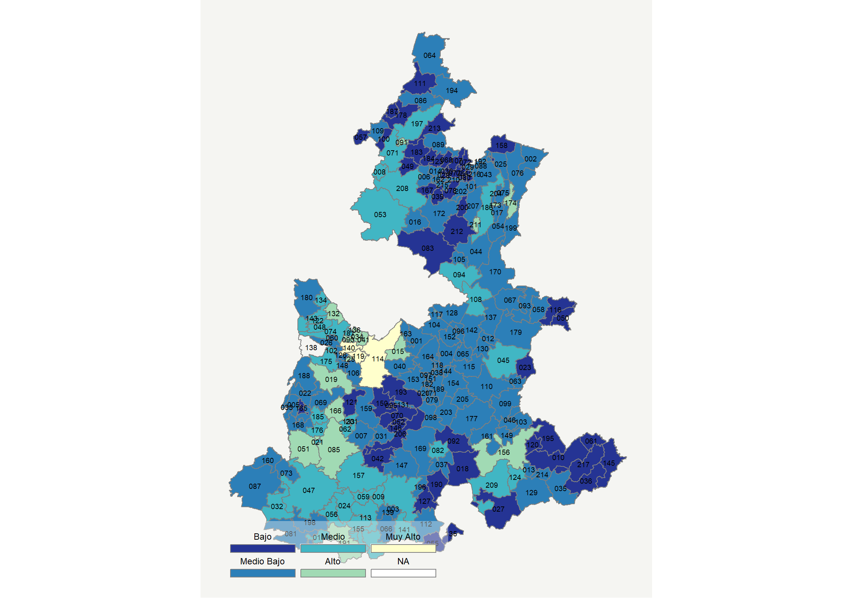

|  |  |  |  |  |  |  |  |  |  |  |  |  |  |
| --- | --- | --- | --- | --- | --- | --- | --- | --- | --- | --- | --- | --- | --- |
| **Clave del Municipio** | **Municipio** | **Telefonía fija a** | **Telefonía Celular a** | **Internet a** | **Televisión de paga a** | **Población Total a** | **Hasta 2 Salarios Mínimos b** | **Índice de Marginación** | **índice** | **Índice Escala 0-100** | **Lugar Nacional** | **Lugar Estatal** | **Estrato** |
| 001 | Acajete | 16.6 | 66.1 | 11.0 | 14.9 | 65048 | 51.6 | -0.29 | -0.18 | 26.4 | 1362 | 73 | Medio Bajo |
| 002 | Acateno | 8.6 | 62.5 | 1.7 | 13.8 | 9095 | 74.9 | 0.74 | -0.58 | 18.4 | 1821 | 138 | Medio Bajo |
| 003 | Acatlán | 25.8 | 62.4 | 12.0 | 31.2 | 35764 | 61.7 | -0.23 | 0.14 | 32.7 | 984 | 32 | Medio |
| 004 | Acatzingo | 9.7 | 60.0 | 8.8 | 16.9 | 59077 | 61.0 | -0.23 | -0.39 | 22.3 | 1600 | 96 | Medio Bajo |
| 005 | Acteopan * | 31.3 | 28.8 | 0.5 | 1.8 | 2989 | 87.7 | 1.76 | -0.70 | 16.0 | 1925 | 163 | Medio Bajo |
| 006 | Ahuacatlán | 13.4 | 45.2 | 5.7 | 14.1 | 15637 | 67.9 | 1.44 | -0.58 | 18.6 | 1811 | 136 | Medio Bajo |
| 007 | Ahuatlán * | 35.8 | 12.4 | 0.2 | 24.7 | 3186 | 77.1 | 0.81 | -0.54 | 19.2 | 1777 | 129 | Medio Bajo |
| 008 | Ahuazotepec | 15.0 | 74.2 | 5.3 | 43.2 | 11269 | 57.2 | -0.28 | 0.05 | 30.9 | 1096 | 42 | Medio |
| 009 | Ahuehuetitla * | 31.9 | 39.9 | 2.6 | 44.6 | 1803 | 64.2 | 0.39 | -0.06 | 28.8 | 1206 | 53 | Medio |
| 010 | Ajalpan | 7.8 | 43.2 | 5.7 | 9.8 | 65854 | 76.3 | 1.24 | -0.74 | 15.4 | 1962 | 170 | Bajo |
| 011 | Albino Zertuche * | 56.0 | 7.1 | 19.0 | 30.8 | 1790 | 71.5 | 0.40 | 0.26 | 35.0 | 860 | 26 | Medio |
| 012 | Aljojuca | 22.3 | 59.6 | 2.9 | 10.2 | 6521 | 71.3 | 0.05 | -0.40 | 22.1 | 1617 | 101 | Medio Bajo |
| 013 | Altepexi | 8.6 | 68.1 | 10.4 | 31.6 | 21100 | 71.9 | 0.01 | -0.12 | 27.5 | 1283 | 61 | Medio Bajo |
| 014 | Amixtlán * | 15.8 | 45.6 | 10.1 | 13.4 | 4832 | 74.1 | 1.18 | -0.43 | 21.4 | 1655 | 110 | Medio Bajo |
| 015 | Amozoc | 25.8 | 81.3 | 21.3 | 21.2 | 117244 | 41.6 | -0.86 | 0.44 | 38.6 | 677 | 20 | Alto |
| 016 | Aquixtla | 12.2 | 39.1 | 8.4 | 17.2 | 8768 | 69.0 | 0.33 | -0.56 | 18.9 | 1796 | 134 | Medio Bajo |
| 017 | Atempan | 8.5 | 64.7 | 6.9 | 23.4 | 28306 | 71.9 | 0.36 | -0.33 | 23.4 | 1538 | 91 | Medio Bajo |
| 018 | Atexcal * | 12.0 | 14.4 | 0.8 | 13.7 | 3679 | 69.9 | 0.43 | -1.03 | 9.7 | 2195 | 201 | Bajo |
| 019 | Atlixco | 43.2 | 69.6 | 26.8 | 34.8 | 134364 | 52.6 | -0.71 | 0.90 | 47.6 | 339 | 7 | Alto |
| 020 | Atoyatempan | 12.5 | 72.3 | 8.7 | 9.6 | 7039 | 73.4 | -0.19 | -0.30 | 24.0 | 1501 | 88 | Medio Bajo |
| 021 | Atzala * | 53.9 | 45.6 | 2.3 | 43.0 | 1326 | 69.5 | 0.00 | 0.34 | 36.6 | 784 | 23 | Medio |
| 022 | Atzitzihuacán | 34.6 | 36.2 | 7.2 | 9.5 | 12230 | 68.6 | 0.28 | -0.33 | 23.4 | 1537 | 90 | Medio Bajo |
| 023 | Atzitzintla | 12.9 | 30.4 | 0.7 | 17.6 | 9344 | 77.8 | 0.82 | -0.81 | 13.9 | 2032 | 176 | Bajo |
| 024 | Axutla * | 56.5 | 12.3 | 1.5 | 65.1 | 902 | 58.6 | 0.30 | 0.28 | 35.4 | 838 | 25 | Medio |
| 025 | Ayotoxco de Guerrero | 14.9 | 64.0 | 7.5 | 11.9 | 8558 | 75.9 | 0.51 | -0.35 | 23.1 | 1555 | 92 | Medio Bajo |
| 026 | Calpan | 34.6 | 42.2 | 11.3 | 3.8 | 14440 | 58.3 | -0.14 | -0.23 | 25.3 | 1428 | 79 | Medio Bajo |
| 027 | Caltepec * | 17.3 | 8.9 | 1.1 | 13.6 | 3886 | 86.8 | 0.73 | -0.99 | 10.5 | 2162 | 197 | Bajo |
| 028 | Camocuautla * | 3.5 | 15.4 | 0.9 | 2.4 | 2624 | 83.0 | 1.45 | -1.28 | 4.7 | 2337 | 213 | Bajo |
| 029 | Caxhuacan * | 13.6 | 28.3 | 4.6 | 27.1 | 3637 | 69.7 | 0.65 | -0.62 | 17.6 | 1865 | 147 | Medio Bajo |
| 030 | Coatepec * | 10.9 | 36.3 | 1.5 | 7.5 | 756 | 59.9 | 0.70 | -0.88 | 12.6 | 2080 | 183 | Bajo |
| 031 | Coatzingo * | 33.0 | 57.6 | 2.7 | 16.5 | 2951 | 77.9 | 0.69 | -0.17 | 26.5 | 1349 | 68 | Medio Bajo |
| 032 | Cohetzala * | 48.6 | 14.0 | 0.5 | 59.7 | 1379 | 77.7 | 0.71 | 0.08 | 31.5 | 1052 | 36 | Medio |
| 033 | Cohuecan * | 24.3 | 46.6 | 2.2 | 2.8 | 4885 | 65.8 | 0.24 | -0.59 | 18.2 | 1831 | 140 | Medio Bajo |
| 034 | Coronango | 43.2 | 65.8 | 22.7 | 15.0 | 40949 | 48.0 | -0.74 | 0.54 | 40.6 | 572 | 13 | Alto |
| 035 | Coxcatlán | 14.5 | 61.7 | 9.5 | 20.2 | 20459 | 61.1 | 0.17 | -0.24 | 25.3 | 1433 | 82 | Medio Bajo |
| 036 | Coyomeapan * | 8.0 | 11.3 | 0.8 | 8.3 | 13942 | 81.1 | 1.68 | -1.18 | 6.6 | 2297 | 210 | Bajo |
| 037 | Coyotepec * | 6.9 | 59.6 | 4.3 | 14.4 | 2221 | 58.4 | 0.02 | -0.57 | 18.7 | 1809 | 135 | Medio Bajo |
| 038 | Cuapiaxtla de Madero | 4.0 | 75.1 | 5.3 | 13.1 | 10101 | 59.7 | -0.17 | -0.46 | 20.9 | 1686 | 116 | Medio Bajo |
| 039 | Cuautempan | 10.3 | 45.5 | 0.7 | 16.6 | 9337 | 72.2 | 0.79 | -0.72 | 15.8 | 1939 | 166 | Bajo |
| 040 | Cuautinchán | 8.1 | 62.8 | 1.6 | 7.7 | 10179 | 46.9 | 0.26 | -0.66 | 16.9 | 1892 | 154 | Medio Bajo |
| 041 | Cuautlancingo | 36.7 | 88.1 | 34.3 | 32.7 | 112225 | 28.3 | -1.62 | 1.13 | 52.2 | 246 | 4 | Alto |
| 042 | Cuayuca de Andrade * | 13.2 | 7.7 | 2.1 | 30.1 | 3163 | 79.6 | 0.94 | -0.86 | 13.0 | 2066 | 181 | Bajo |
| 043 | Cuetzalan del Progreso | 9.1 | 58.9 | 5.6 | 16.0 | 47983 | 73.5 | 1.03 | -0.49 | 20.2 | 1720 | 120 | Medio Bajo |
| 044 | Cuyoaco | 16.6 | 60.4 | 5.6 | 10.9 | 15704 | 67.1 | -0.09 | -0.41 | 21.8 | 1632 | 106 | Medio Bajo |
| 045 | Chalchicomula de Sesma | 20.8 | 64.5 | 10.8 | 23.1 | 46778 | 66.1 | -0.33 | -0.04 | 29.1 | 1186 | 49 | Medio |
| 046 | Chapulco | 10.6 | 53.4 | 5.3 | 14.7 | 7752 | 70.5 | 0.07 | -0.55 | 19.2 | 1779 | 130 | Medio Bajo |
| 047 | Chiautla | 31.8 | 55.1 | 13.3 | 29.0 | 20155 | 61.0 | -0.16 | 0.18 | 33.4 | 952 | 30 | Medio |
| 048 | Chiautzingo | 26.6 | 61.0 | 9.1 | 18.3 | 20441 | 69.4 | -0.47 | -0.07 | 28.5 | 1225 | 55 | Medio |
| 049 | Chiconcuautla | 4.6 | 33.5 | 0.8 | 7.6 | 16569 | 75.7 | 1.58 | -1.03 | 9.6 | 2196 | 202 | Bajo |
| 050 | Chichiquila | 11.4 | 41.5 | 4.2 | 11.3 | 25978 | 61.1 | 1.16 | -0.71 | 15.9 | 1935 | 165 | Bajo |
| 051 | Chietla | 37.3 | 61.3 | 12.3 | 41.7 | 34415 | 61.9 | -0.27 | 0.44 | 38.7 | 670 | 18 | Alto |
| 052 | Chigmecatitlán * | 10.8 | 33.7 | 0.6 | 4.2 | 1137 | 80.2 | 0.95 | -0.97 | 10.8 | 2146 | 195 | Bajo |
| 053 | Chignahuapan | 13.8 | 67.4 | 11.5 | 42.3 | 62028 | 63.3 | -0.14 | 0.10 | 32.0 | 1030 | 33 | Medio |
| 054 | Chignautla | 7.8 | 69.6 | 7.1 | 33.5 | 34196 | 72.6 | 0.31 | -0.18 | 26.4 | 1354 | 71 | Medio Bajo |
| 055 | Chila * | 16.4 | 17.5 | 3.4 | 13.1 | 4515 | 77.6 | 0.58 | -0.87 | 12.8 | 2073 | 182 | Bajo |
| 056 | Chila de la Sal * | 33.3 | 9.4 | 12.3 | 45.2 | 1362 | 68.0 | 0.38 | -0.09 | 28.1 | 1249 | 59 | Medio |
| 057 | Honey | 8.8 | 44.2 | 1.9 | 16.6 | 7857 | 74.0 | 0.68 | -0.73 | 15.6 | 1947 | 167 | Bajo |
| 058 | Chilchotla | 9.7 | 39.8 | 1.1 | 24.5 | 20010 | 75.9 | 1.26 | -0.69 | 16.4 | 1911 | 159 | Medio Bajo |
| 059 | Chinantla * | 26.5 | 55.1 | 5.0 | 39.4 | 2221 | 60.1 | 0.36 | 0.00 | 30.0 | 1143 | 45 | Medio |
| 060 | Domingo Arenas | 16.8 | 43.5 | 7.7 | 1.7 | 7421 | 56.1 | -0.33 | -0.63 | 17.6 | 1869 | 148 | Medio Bajo |
| 061 | Eloxochitlán * | 2.3 | 4.1 | 0.2 | 4.2 | 12520 | 71.3 | 2.09 | -1.41 | 2.2 | 2407 | 216 | Bajo |
| 062 | Epatlán * | 33.1 | 63.3 | 9.9 | 46.8 | 4879 | 78.7 | 0.25 | 0.39 | 37.7 | 723 | 21 | Medio |
| 063 | Esperanza | 13.0 | 60.0 | 4.6 | 19.3 | 14974 | 67.6 | -0.22 | -0.40 | 21.9 | 1622 | 105 | Medio Bajo |
| 064 | Francisco Z. Mena | 16.9 | 36.0 | 7.6 | 22.5 | 16677 | 69.4 | 0.67 | -0.47 | 20.7 | 1697 | 119 | Medio Bajo |
| 065 | General Felipe Ángeles | 6.9 | 64.3 | 4.0 | 7.1 | 20511 | 55.6 | 0.07 | -0.61 | 17.8 | 1856 | 146 | Medio Bajo |
| 066 | Guadalupe | 28.1 | 49.8 | 4.7 | 25.9 | 5755 | 75.1 | 0.67 | -0.18 | 26.4 | 1359 | 72 | Medio Bajo |
| 067 | Guadalupe Victoria | 13.4 | 60.6 | 7.6 | 27.0 | 16923 | 69.4 | -0.09 | -0.24 | 25.3 | 1429 | 80 | Medio Bajo |
| 068 | Hermenegildo Galeana | 12.9 | 21.7 | 1.5 | 9.5 | 7611 | 79.6 | 1.40 | -0.97 | 10.8 | 2151 | 196 | Bajo |
| 069 | Huaquechula | 32.4 | 49.1 | 7.8 | 20.8 | 24787 | 71.0 | 0.28 | -0.10 | 28.0 | 1255 | 60 | Medio Bajo |
| 070 | Huatlatlauca | 9.1 | 35.4 | 0.9 | 1.9 | 6317 | 84.7 | 1.14 | -1.00 | 10.3 | 2169 | 198 | Bajo |
| 071 | Huauchinango | 21.8 | 68.7 | 17.5 | 39.2 | 103509 | 53.8 | -0.32 | 0.36 | 37.0 | 757 | 22 | Medio |
| 072 | Huehuetla | 5.0 | 30.2 | 2.3 | 9.2 | 18803 | 79.1 | 2.43 | -1.00 | 10.2 | 2177 | 199 | Bajo |
| 073 | Huehuetlán el Chico | 29.5 | 43.0 | 8.5 | 17.0 | 8443 | 76.3 | 0.23 | -0.23 | 25.4 | 1424 | 78 | Medio Bajo |
| 074 | Huejotzingo | 25.7 | 71.7 | 16.6 | 20.9 | 73771 | 49.5 | -0.97 | 0.23 | 34.4 | 892 | 27 | Medio |
| 075 | Hueyapan | 4.3 | 65.3 | 2.8 | 10.7 | 12897 | 79.0 | 0.44 | -0.64 | 17.3 | 1875 | 150 | Medio Bajo |
| 076 | Hueytamalco | 9.1 | 56.1 | 3.8 | 14.0 | 25981 | 77.8 | 0.53 | -0.59 | 18.3 | 1825 | 139 | Medio Bajo |
| 077 | Hueytlalpan * | 4.2 | 14.7 | 1.3 | 7.0 | 5186 | 89.5 | 2.09 | -1.22 | 5.9 | 2315 | 212 | Bajo |
| 078 | Huitzilan de Serdán | 2.5 | 46.9 | 0.7 | 15.2 | 15096 | 90.5 | 1.42 | -0.85 | 13.2 | 2055 | 179 | Bajo |
| 079 | Huitziltepec * | 14.4 | 61.4 | 8.6 | 10.4 | 5373 | 58.7 | -0.24 | -0.37 | 22.6 | 1584 | 94 | Medio Bajo |
| 080 | Atlequizayan * | 6.4 | 23.2 | 0.9 | 5.1 | 2562 | 73.0 | 0.85 | -1.13 | 7.7 | 2256 | 208 | Bajo |
| 081 | Ixcamilpa de Guerrero * | 20.6 | 11.7 | 0.5 | 36.7 | 3635 | 64.3 | 1.19 | -0.66 | 16.9 | 1891 | 153 | Medio Bajo |
| 082 | Ixcaquixtla | 23.6 | 69.4 | 15.6 | 16.1 | 8752 | 58.8 | -0.20 | 0.09 | 31.7 | 1043 | 35 | Medio |
| 083 | Ixtacamaxtitlán | 14.6 | 27.3 | 0.9 | 19.1 | 24512 | 66.5 | 0.56 | -0.79 | 14.3 | 2016 | 174 | Bajo |
| 084 | Ixtepec | 2.5 | 39.8 | 1.9 | 9.8 | 6975 | 72.8 | 1.34 | -0.95 | 11.2 | 2133 | 194 | Bajo |
| 085 | Izúcar de Matamoros | 41.8 | 65.3 | 23.2 | 42.0 | 77601 | 61.4 | -0.46 | 0.83 | 46.2 | 381 | 9 | Alto |
| 086 | Jalpan | 6.8 | 52.0 | 5.7 | 7.7 | 12077 | 77.7 | 1.09 | -0.69 | 16.3 | 1914 | 160 | Medio Bajo |
| 087 | Jolalpan | 21.6 | 38.3 | 3.9 | 28.3 | 13120 | 81.8 | 0.77 | -0.39 | 22.2 | 1609 | 99 | Medio Bajo |
| 088 | Jonotla * | 16.3 | 43.0 | 1.7 | 16.9 | 4504 | 75.5 | 1.04 | -0.61 | 17.8 | 1855 | 145 | Medio Bajo |
| 089 | Jopala | 11.6 | 56.1 | 0.9 | 19.8 | 12818 | 75.2 | 1.16 | -0.55 | 19.1 | 1784 | 131 | Medio Bajo |
| 090 | Juan C. Bonilla | 42.3 | 64.2 | 22.4 | 12.2 | 21253 | 54.3 | -0.85 | 0.47 | 39.2 | 635 | 16 | Alto |
| 091 | Juan Galindo | 32.0 | 77.4 | 23.9 | 49.1 | 10685 | 55.1 | -0.90 | 0.88 | 47.3 | 345 | 8 | Alto |
| 092 | Juan N. Méndez * | 25.1 | 15.5 | 0.5 | 5.7 | 5192 | 78.0 | 0.90 | -0.90 | 12.3 | 2091 | 187 | Bajo |
| 093 | Lafragua | 16.6 | 36.9 | 1.1 | 16.2 | 7817 | 86.2 | 0.41 | -0.69 | 16.3 | 1916 | 161 | Medio Bajo |
| 094 | Libres | 16.3 | 71.7 | 12.9 | 15.8 | 33784 | 65.6 | -0.32 | -0.07 | 28.5 | 1227 | 56 | Medio |
| 095 | La Magdalena Tlatlauquitepec * | 22.8 | 29.3 | 0.0 | 14.6 | 469 | 70.5 | -0.16 | -0.71 | 15.9 | 1930 | 164 | Bajo |
| 096 | Mazapiltepec de Juárez | 5.8 | 65.5 | 1.3 | 27.1 | 2826 | 67.3 | -0.17 | -0.46 | 20.8 | 1691 | 118 | Medio Bajo |
| 097 | Mixtla | 25.0 | 60.8 | 8.9 | 15.5 | 2333 | 55.6 | -0.48 | -0.14 | 27.2 | 1301 | 64 | Medio Bajo |
| 098 | Molcaxac | 10.2 | 53.4 | 4.3 | 10.2 | 6352 | 67.5 | 0.26 | -0.63 | 17.6 | 1870 | 149 | Medio Bajo |
| 099 | Cañada Morelos | 13.4 | 57.3 | 3.3 | 24.2 | 19174 | 75.0 | 0.56 | -0.40 | 22.0 | 1621 | 104 | Medio Bajo |
| 100 | Naupan | 16.4 | 21.9 | 0.3 | 13.8 | 9974 | 79.6 | 0.99 | -0.89 | 12.4 | 2087 | 186 | Bajo |
| 101 | Nauzontla * | 16.0 | 37.3 | 1.6 | 16.8 | 3294 | 71.1 | 0.33 | -0.68 | 16.5 | 1909 | 157 | Medio Bajo |
| 102 | Nealtican | 28.6 | 64.6 | 18.0 | 6.4 | 12442 | 61.8 | -0.54 | 0.08 | 31.5 | 1055 | 38 | Medio |
| 103 | Nicolás Bravo | 13.1 | 47.9 | 3.9 | 27.0 | 6259 | 72.9 | 0.50 | -0.45 | 21.0 | 1679 | 114 | Medio Bajo |
| 104 | Nopalucan | 9.1 | 58.9 | 5.1 | 21.8 | 30848 | 42.1 | -0.44 | -0.44 | 21.3 | 1663 | 111 | Medio Bajo |
| 105 | Ocotepec * | 23.4 | 62.5 | 12.0 | 10.6 | 4735 | 70.6 | 0.19 | -0.13 | 27.4 | 1295 | 62 | Medio Bajo |
| 106 | Ocoyucan | 29.0 | 52.7 | 11.3 | 8.1 | 28220 | 60.6 | 0.18 | -0.17 | 26.5 | 1347 | 67 | Medio Bajo |
| 107 | Olintla | 3.2 | 31.4 | 2.9 | 5.5 | 11517 | 77.6 | 2.39 | -1.05 | 9.3 | 2209 | 204 | Bajo |
| 108 | Oriental | 14.5 | 68.9 | 10.7 | 24.5 | 18239 | 62.8 | -0.33 | -0.09 | 28.2 | 1238 | 58 | Medio |
| 109 | Pahuatlán | 12.0 | 54.3 | 3.0 | 30.3 | 22002 | 72.9 | 0.76 | -0.39 | 22.2 | 1610 | 100 | Medio Bajo |
| 110 | Palmar de Bravo | 5.6 | 58.6 | 3.7 | 8.6 | 46233 | 74.5 | 0.44 | -0.68 | 16.4 | 1910 | 158 | Medio Bajo |
| 111 | Pantepec | 17.4 | 17.2 | 3.8 | 15.9 | 18102 | 66.2 | 0.93 | -0.81 | 13.9 | 2030 | 175 | Bajo |
| 112 | Petlalcingo | 19.1 | 39.1 | 4.9 | 18.1 | 9623 | 76.7 | 0.66 | -0.52 | 19.7 | 1756 | 126 | Medio Bajo |
| 113 | Piaxtla * | 34.0 | 28.8 | 3.6 | 53.2 | 4322 | 68.2 | 0.52 | -0.01 | 29.7 | 1156 | 46 | Medio |
| 114 | Puebla | 49.8 | 85.8 | 43.1 | 37.2 | 1576259 | 33.8 | -1.56 | 1.59 | 61.3 | 105 | 2 | Muy Alto |
| 115 | Quecholac | 8.4 | 63.6 | 6.0 | 7.8 | 50962 | 63.5 | 0.28 | -0.54 | 19.2 | 1775 | 128 | Medio Bajo |
| 116 | Quimixtlán | 10.7 | 43.0 | 2.6 | 11.4 | 22136 | 79.5 | 1.17 | -0.75 | 15.2 | 1972 | 172 | Bajo |
| 117 | Rafael Lara Grajales | 21.1 | 74.8 | 14.6 | 37.2 | 14159 | 44.0 | -0.93 | 0.32 | 36.2 | 797 | 24 | Medio |
| 118 | Los Reyes de Juárez | 8.4 | 65.3 | 7.3 | 16.9 | 27454 | 70.6 | -0.27 | -0.39 | 22.2 | 1606 | 97 | Medio Bajo |
| 119 | San Andrés Cholula | 55.1 | 89.8 | 59.3 | 48.0 | 137290 | 30.9 | -1.65 | 2.23 | 73.8 | 23 | 1 | Muy Alto |
| 120 | San Antonio Cañada * | 4.7 | 32.5 | 1.8 | 13.7 | 5590 | 77.0 | 1.21 | -0.94 | 11.3 | 2127 | 192 | Bajo |
| 121 | San Diego la Mesa Tochimiltzingo * | 4.1 | 12.4 | 0.3 | 5.4 | 1198 | 59.0 | 0.79 | -1.28 | 4.7 | 2338 | 214 | Bajo |
| 122 | San Felipe Teotlalcingo | 28.5 | 63.9 | 12.7 | 17.9 | 10456 | 66.5 | -0.65 | 0.07 | 31.3 | 1070 | 39 | Medio |
| 123 | San Felipe Tepatlán * | 6.1 | 37.2 | 0.8 | 10.8 | 3838 | 82.2 | 1.53 | -0.93 | 11.5 | 2120 | 190 | Bajo |
| 124 | San Gabriel Chilac | 22.1 | 71.0 | 14.2 | 15.5 | 15763 | 74.4 | 0.25 | 0.04 | 30.8 | 1104 | 43 | Medio |
| 125 | San Gregorio Atzompa | 49.7 | 72.0 | 30.2 | 24.9 | 8962 | 42.8 | -0.87 | 1.00 | 49.7 | 290 | 5 | Alto |
| 126 | San Jerónimo Tecuanipan * | 25.6 | 48.9 | 6.3 | 5.5 | 6265 | 68.8 | 0.07 | -0.42 | 21.7 | 1638 | 108 | Medio Bajo |
| 127 | San Jerónimo Xayacatlán * | 24.5 | 11.1 | 0.5 | 14.2 | 3441 | 68.5 | 0.45 | -0.85 | 13.1 | 2063 | 180 | Bajo |
| 128 | San José Chiapa | 7.2 | 67.0 | 5.5 | 29.1 | 8692 | 41.6 | -0.33 | -0.30 | 24.0 | 1500 | 87 | Medio Bajo |
| 129 | San José Miahuatlán | 10.4 | 65.3 | 5.5 | 7.0 | 13159 | 82.5 | 0.28 | -0.51 | 19.8 | 1748 | 125 | Medio Bajo |
| 130 | San Juan Atenco * | 17.6 | 58.7 | 2.2 | 10.9 | 3362 | 61.3 | 0.03 | -0.50 | 20.2 | 1727 | 121 | Medio Bajo |
| 131 | San Juan Atzompa * | 42.6 | 16.5 | 2.1 | 3.8 | 856 | 88.2 | 0.31 | -0.58 | 18.5 | 1813 | 137 | Medio Bajo |
| 132 | San Martín Texmelucan | 24.9 | 80.1 | 22.0 | 28.0 | 152051 | 49.6 | -1.17 | 0.51 | 39.9 | 602 | 14 | Alto |
| 133 | San Martín Totoltepec * | 34.4 | 63.3 | 7.8 | 32.2 | 699 | 76.3 | 0.26 | 0.20 | 33.9 | 918 | 29 | Medio |
| 134 | San Matías Tlalancaleca | 24.9 | 67.6 | 12.1 | 20.5 | 20175 | 66.8 | -0.59 | 0.06 | 31.1 | 1085 | 41 | Medio |
| 135 | San Miguel Ixitlán * | 17.4 | 7.6 | 0.0 | 3.5 | 477 | 74.7 | 0.60 | -1.14 | 7.5 | 2265 | 209 | Bajo |
| 136 | San Miguel Xoxtla | 37.7 | 80.0 | 33.7 | 22.3 | 12341 | 46.3 | -1.27 | 0.94 | 48.4 | 316 | 6 | Alto |
| 137 | San Nicolás Buenos Aires | 9.2 | 50.4 | 1.0 | 23.9 | 9972 | 73.8 | 0.45 | -0.60 | 18.1 | 1836 | 141 | Medio Bajo |
| 139 | San Pablo Anicano * | 20.6 | 49.5 | 5.4 | 26.4 | 3534 | 63.5 | 0.33 | -0.28 | 24.3 | 1484 | 86 | Medio Bajo |
| 140 | San Pedro Cholula | 48.1 | 76.0 | 38.5 | 27.1 | 129032 | 48.4 | -1.17 | 1.24 | 54.3 | 206 | 3 | Muy Alto |
| 141 | San Pedro Yeloixtlahuaca * | 26.5 | 58.0 | 6.7 | 27.4 | 3320 | 66.5 | 0.20 | -0.06 | 28.7 | 1216 | 54 | Medio |
| 142 | San Salvador el Seco | 7.1 | 71.5 | 12.4 | 17.6 | 30303 | 63.3 | -0.26 | -0.22 | 25.6 | 1413 | 77 | Medio Bajo |
| 143 | San Salvador el Verde | 19.6 | 68.5 | 12.8 | 18.7 | 31355 | 59.2 | -0.50 | -0.02 | 29.5 | 1168 | 48 | Medio |
| 144 | San Salvador Huixcolotla | 14.4 | 76.5 | 10.5 | 12.7 | 14810 | 63.1 | -0.44 | -0.15 | 27.0 | 1314 | 65 | Medio Bajo |
| 145 | San Sebastián Tlacotepec | 5.1 | 3.8 | 0.4 | 6.9 | 14092 | 81.3 | 1.92 | -1.33 | 3.7 | 2367 | 215 | Bajo |
| 146 | Santa Catarina Tlaltempan * | 10.0 | 34.3 | 2.0 | 4.8 | 756 | 78.7 | 0.83 | -0.94 | 11.5 | 2122 | 191 | Bajo |
| 147 | Santa Inés Ahuatempan | 13.7 | 44.9 | 5.0 | 5.0 | 6289 | 77.2 | 0.85 | -0.69 | 16.2 | 1918 | 162 | Medio Bajo |
| 148 | Santa Isabel Cholula | 21.7 | 57.5 | 6.1 | 5.7 | 9236 | 70.5 | 0.68 | -0.40 | 22.0 | 1619 | 103 | Medio Bajo |
| 149 | Santiago Miahuatlán | 12.9 | 72.1 | 10.6 | 11.0 | 25228 | 71.2 | 0.34 | -0.24 | 25.3 | 1431 | 81 | Medio Bajo |
| 150 | Huehuetlán el Grande | 8.8 | 26.7 | 0.9 | 8.4 | 7242 | 70.1 | 0.73 | -1.01 | 9.9 | 2184 | 200 | Bajo |
| 151 | Santo Tomás Hueyotlipan | 17.3 | 63.9 | 10.4 | 13.4 | 8511 | 66.8 | -0.58 | -0.22 | 25.6 | 1412 | 76 | Medio Bajo |
| 152 | Soltepec | 7.5 | 67.4 | 1.6 | 17.8 | 12226 | 68.6 | -0.11 | -0.51 | 19.9 | 1743 | 124 | Medio Bajo |
| 153 | Tecali de Herrera | 12.7 | 57.8 | 8.6 | 13.6 | 21992 | 51.2 | -0.52 | -0.40 | 22.0 | 1618 | 102 | Medio Bajo |
| 154 | Tecamachalco | 12.7 | 71.2 | 13.6 | 14.6 | 77061 | 56.1 | -0.50 | -0.13 | 27.3 | 1298 | 63 | Medio Bajo |
| 155 | Tecomatlán | 34.2 | 47.3 | 9.1 | 32.7 | 5461 | 48.2 | 0.13 | 0.08 | 31.5 | 1054 | 37 | Medio |
| 156 | Tehuacán | 29.2 | 79.3 | 30.7 | 26.8 | 319375 | 59.3 | -0.69 | 0.77 | 45.1 | 421 | 10 | Alto |
| 157 | Tehuitzingo | 25.8 | 46.9 | 6.9 | 46.1 | 11156 | 61.0 | 0.21 | 0.03 | 30.6 | 1114 | 44 | Medio |
| 158 | Tenampulco | 8.6 | 48.3 | 1.4 | 13.2 | 6975 | 79.1 | 0.80 | -0.74 | 15.3 | 1964 | 171 | Bajo |
| 159 | Teopantlán * | 24.6 | 29.3 | 2.7 | 8.6 | 3707 | 88.0 | 1.48 | -0.68 | 16.5 | 1908 | 156 | Medio Bajo |
| 160 | Teotlalco * | 26.0 | 50.4 | 6.9 | 16.5 | 3135 | 78.0 | 0.30 | -0.26 | 24.8 | 1463 | 85 | Medio Bajo |
| 161 | Tepanco de López | 14.4 | 69.7 | 11.1 | 11.4 | 20580 | 72.4 | -0.03 | -0.22 | 25.6 | 1407 | 75 | Medio Bajo |
| 162 | Tepango de Rodríguez * | 10.8 | 56.2 | 0.6 | 12.6 | 3947 | 77.9 | 1.52 | -0.65 | 17.1 | 1883 | 151 | Medio Bajo |
| 163 | Tepatlaxco de Hidalgo | 15.7 | 66.6 | 8.8 | 7.7 | 17472 | 40.2 | -0.65 | -0.32 | 23.5 | 1530 | 89 | Medio Bajo |
| 164 | Tepeaca | 13.6 | 68.4 | 12.4 | 15.7 | 80507 | 57.3 | -0.53 | -0.16 | 26.7 | 1331 | 66 | Medio Bajo |
| 165 | Tepemaxalco * | 15.6 | 43.8 | 0.9 | 3.6 | 1124 | 76.7 | 1.06 | -0.79 | 14.4 | 2011 | 173 | Bajo |
| 166 | Tepeojuma | 33.7 | 59.3 | 13.1 | 51.2 | 8492 | 71.3 | 0.21 | 0.49 | 39.6 | 613 | 15 | Alto |
| 167 | Tepetzintla | 10.0 | 22.2 | 0.5 | 9.0 | 11622 | 78.5 | 1.70 | -1.04 | 9.4 | 2206 | 203 | Bajo |
| 168 | Tepexco | 26.3 | 45.5 | 5.7 | 14.2 | 6793 | 68.9 | 1.17 | -0.36 | 22.8 | 1572 | 93 | Medio Bajo |
| 169 | Tepexi de Rodríguez | 19.8 | 47.5 | 7.2 | 10.0 | 20598 | 63.9 | 0.41 | -0.46 | 20.9 | 1685 | 115 | Medio Bajo |
| 170 | Tepeyahualco | 8.5 | 55.7 | 3.9 | 14.1 | 16892 | 66.5 | 0.14 | -0.60 | 18.1 | 1837 | 142 | Medio Bajo |
| 171 | Tepeyahualco de Cuauhtémoc * | 5.6 | 63.2 | 8.2 | 8.4 | 3534 | 65.6 | -0.40 | -0.53 | 19.5 | 1767 | 127 | Medio Bajo |
| 172 | Tetela de Ocampo | 13.0 | 48.4 | 5.8 | 25.1 | 28139 | 66.8 | 0.54 | -0.43 | 21.5 | 1647 | 109 | Medio Bajo |
| 173 | Teteles de Avila Castillo | 27.1 | 78.8 | 21.7 | 39.2 | 5869 | 51.4 | -0.66 | 0.65 | 42.7 | 489 | 12 | Alto |
| 174 | Teziutlán | 25.7 | 80.4 | 22.0 | 44.3 | 97590 | 61.4 | -0.76 | 0.70 | 43.8 | 456 | 11 | Alto |
| 175 | Tianguismanalco | 23.8 | 66.0 | 10.5 | 13.9 | 12783 | 71.1 | -0.20 | -0.08 | 28.3 | 1236 | 57 | Medio |
| 176 | Tilapa | 28.7 | 57.0 | 2.9 | 37.3 | 8547 | 69.6 | -0.01 | -0.02 | 29.6 | 1159 | 47 | Medio |
| 177 | Tlacotepec de Benito Juárez | 13.1 | 64.1 | 4.6 | 6.6 | 52508 | 76.6 | 0.77 | -0.51 | 20.0 | 1741 | 123 | Medio Bajo |
| 178 | Tlacuilotepec | 7.7 | 40.3 | 1.1 | 7.7 | 16496 | 79.1 | 0.91 | -0.90 | 12.1 | 2097 | 189 | Bajo |
| 179 | Tlachichuca | 8.0 | 58.1 | 4.3 | 10.9 | 28953 | 75.6 | 0.15 | -0.61 | 18.0 | 1844 | 143 | Medio Bajo |
| 180 | Tlahuapan | 16.0 | 66.2 | 9.3 | 19.8 | 40220 | 64.7 | -0.43 | -0.18 | 26.5 | 1353 | 70 | Medio Bajo |
| 181 | Tlaltenango | 34.8 | 59.7 | 13.7 | 9.9 | 7125 | 56.8 | -0.60 | 0.07 | 31.2 | 1071 | 40 | Medio |
| 182 | Tlanepantla * | 15.9 | 60.5 | 4.6 | 9.5 | 4957 | 72.2 | -0.08 | -0.46 | 20.8 | 1690 | 117 | Medio Bajo |
| 183 | Tlaola | 11.3 | 35.1 | 1.3 | 11.4 | 19982 | 80.1 | 1.40 | -0.85 | 13.2 | 2053 | 178 | Bajo |
| 184 | Tlapacoya | 6.3 | 32.7 | 1.4 | 11.6 | 6493 | 82.6 | 1.00 | -0.95 | 11.2 | 2131 | 193 | Bajo |
| 185 | Tlapanalá | 35.0 | 55.1 | 9.3 | 35.9 | 8444 | 69.6 | 0.19 | 0.21 | 34.0 | 909 | 28 | Medio |
| 186 | Tlatlauquitepec | 17.4 | 64.3 | 8.6 | 31.9 | 53498 | 64.7 | -0.08 | -0.05 | 28.9 | 1197 | 51 | Medio |
| 187 | Tlaxco | 11.5 | 13.0 | 1.6 | 10.1 | 5345 | 76.7 | 1.21 | -1.07 | 8.8 | 2226 | 207 | Bajo |
| 188 | Tochimilco | 31.6 | 44.4 | 4.3 | 8.3 | 17956 | 76.9 | 0.43 | -0.38 | 22.4 | 1595 | 95 | Medio Bajo |
| 189 | Tochtepec | 10.6 | 62.6 | 8.8 | 7.7 | 21229 | 59.4 | -0.40 | -0.45 | 21.1 | 1673 | 113 | Medio Bajo |
| 190 | Totoltepec de Guerrero * | 4.9 | 9.1 | 0.5 | 14.2 | 1180 | 84.1 | 0.04 | -1.20 | 6.3 | 2305 | 211 | Bajo |
| 191 | Tulcingo | 44.7 | 49.2 | 15.3 | 34.6 | 9150 | 64.4 | 0.33 | 0.44 | 38.6 | 672 | 19 | Alto |
| 192 | Tuzamapan de Galeana | 15.5 | 43.4 | 2.1 | 22.2 | 6314 | 71.4 | 0.47 | -0.56 | 19.0 | 1795 | 133 | Medio Bajo |
| 193 | Tzicatlacoyan | 11.0 | 24.6 | 0.1 | 4.0 | 7126 | 67.6 | 1.03 | -1.07 | 8.8 | 2225 | 206 | Bajo |
| 194 | Venustiano Carranza | 17.2 | 62.5 | 11.5 | 16.7 | 29090 | 49.1 | -0.14 | -0.18 | 26.5 | 1352 | 69 | Medio Bajo |
| 195 | Vicente Guerrero * | 16.0 | 25.6 | 0.7 | 9.7 | 24660 | 77.1 | 1.68 | -0.90 | 12.2 | 2092 | 188 | Bajo |
| 196 | Xayacatlán de Bravo * | 26.8 | 22.8 | 3.0 | 34.3 | 1513 | 66.0 | 0.15 | -0.42 | 21.7 | 1636 | 107 | Medio Bajo |
| 197 | Xicotepec | 16.5 | 64.8 | 12.0 | 25.8 | 81455 | 59.2 | -0.11 | -0.05 | 28.9 | 1195 | 50 | Medio |
| 198 | Xicotlán * | 25.8 | 10.3 | 0.7 | 49.5 | 1177 | 64.7 | 1.03 | -0.44 | 21.2 | 1667 | 112 | Medio Bajo |
| 199 | Xiutetelco | 5.8 | 65.5 | 5.4 | 9.9 | 39959 | 78.5 | 0.38 | -0.56 | 19.0 | 1793 | 132 | Medio Bajo |
| 200 | Xochiapulco * | 17.2 | 18.3 | 1.9 | 26.4 | 3357 | 76.5 | 0.47 | -0.73 | 15.4 | 1952 | 168 | Bajo |
| 201 | Xochiltepec * | 39.6 | 54.0 | 5.3 | 29.0 | 3301 | 73.0 | 0.48 | 0.10 | 31.9 | 1032 | 34 | Medio |
| 202 | Xochitlán de Vicente Suárez | 12.8 | 51.4 | 1.3 | 9.6 | 12740 | 79.7 | 1.15 | -0.68 | 16.5 | 1907 | 155 | Medio Bajo |
| 203 | Xochitlán Todos Santos | 10.0 | 56.7 | 5.5 | 6.3 | 6336 | 75.8 | 0.40 | -0.61 | 17.9 | 1846 | 144 | Medio Bajo |
| 204 | Yaonáhuac | 9.4 | 68.2 | 6.8 | 26.1 | 7943 | 68.4 | -0.05 | -0.25 | 24.9 | 1451 | 84 | Medio Bajo |
| 205 | Yehualtepec | 11.7 | 65.5 | 4.6 | 8.0 | 25057 | 63.2 | 0.02 | -0.50 | 20.1 | 1731 | 122 | Medio Bajo |
| 206 | Zacapala * | 20.4 | 28.8 | 2.3 | 11.3 | 4396 | 73.0 | 0.73 | -0.73 | 15.4 | 1953 | 169 | Bajo |
| 207 | Zacapoaxtla | 14.2 | 62.9 | 8.8 | 25.2 | 55299 | 64.9 | 0.12 | -0.19 | 26.2 | 1373 | 74 | Medio Bajo |
| 208 | Zacatlán | 20.7 | 74.0 | 14.1 | 24.9 | 82457 | 57.0 | -0.16 | 0.15 | 32.9 | 975 | 31 | Medio |
| 209 | Zapotitlán | 30.2 | 32.1 | 13.2 | 31.1 | 8495 | 69.2 | 0.40 | -0.06 | 28.8 | 1204 | 52 | Medio |
| 210 | Zapotitlán de Méndez * | 2.9 | 54.6 | 10.3 | 27.9 | 5469 | 77.7 | 0.66 | -0.39 | 22.2 | 1608 | 98 | Medio Bajo |
| 211 | Zaragoza | 24.5 | 77.3 | 17.5 | 35.4 | 16173 | 53.5 | -0.87 | 0.45 | 38.7 | 666 | 17 | Alto |
| 212 | Zautla | 8.5 | 32.9 | 1.7 | 13.4 | 19050 | 78.6 | 0.87 | -0.88 | 12.5 | 2083 | 185 | Bajo |
| 213 | Zihuateutla | 6.6 | 42.5 | 0.4 | 10.6 | 13320 | 76.4 | 1.10 | -0.88 | 12.5 | 2081 | 184 | Bajo |
| 214 | Zinacatepec | 8.2 | 70.5 | 11.1 | 16.8 | 16817 | 75.5 | 0.00 | -0.25 | 24.9 | 1448 | 83 | Medio Bajo |
| 215 | Zongozotla * | 4.1 | 59.5 | 2.2 | 15.8 | 4902 | 78.4 | 0.72 | -0.66 | 17.0 | 1887 | 152 | Medio Bajo |
| 216 | Zoquiapan * | 8.6 | 45.7 | 0.7 | 8.9 | 2442 | 74.8 | 1.13 | -0.83 | 13.6 | 2044 | 177 | Bajo |
| 217 | Zoquitlán * | 7.2 | 29.4 | 0.8 | 4.3 | 18278 | 83.0 | 2.07 | -1.06 | 9.0 | 2219 | 205 | Bajo |
| a Porcentaje de viviendas que cuentas con el servicio  b Ingreso por trabajo de la población ocupada en porcentaje  Fuente: Elaboración propia con datos de Encuesta Intercensal 2015 de INEGI y CONAPO | | | | | | | | | | | | | |

**Querétaro**

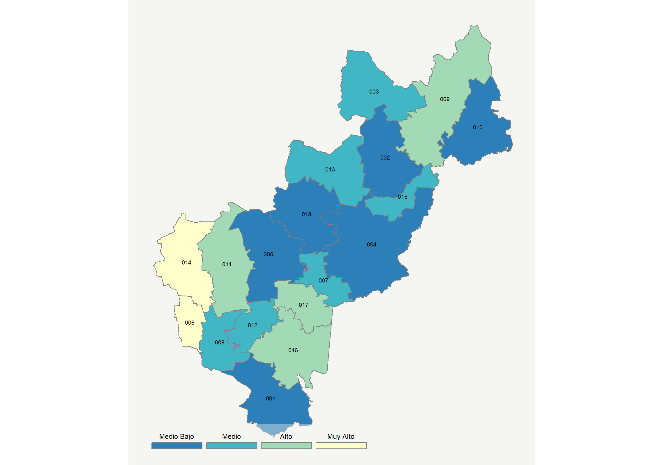

|  |  |  |  |  |  |  |  |  |  |  |  |  |  |
| --- | --- | --- | --- | --- | --- | --- | --- | --- | --- | --- | --- | --- | --- |
| **Clave del Municipio** | **Municipio** | **Telefonía fija a** | **Telefonía Celular a** | **Internet a** | **Televisión de paga a** | **Población Total a** | **Hasta 2 Salarios Mínimos b** | **Índice de Marginación** | **índice** | **Índice Escala 0-100** | **Lugar Nacional** | **Lugar Estatal** | **Estrato** |
| 001 | Amealco de Bonfil | 10.6 | 59.4 | 4.9 | 13.8 | 61259 | 54.7 | 0.10 | -0.51 | 20.0 | 1739 | 17 | Medio Bajo |
| 002 | Pinal de Amoles | 8.8 | 27.3 | 2.4 | 38.7 | 25623 | 50.5 | 0.51 | -0.64 | 17.4 | 1873 | 18 | Medio Bajo |
| 003 | Arroyo Seco | 18.7 | 59.6 | 8.0 | 64.9 | 13307 | 50.5 | -0.16 | 0.28 | 35.4 | 839 | 9 | Medio |
| 004 | Cadereyta de Montes | 16.4 | 62.5 | 8.2 | 27.7 | 69549 | 48.1 | -0.01 | -0.14 | 27.1 | 1310 | 13 | Medio Bajo |
| 005 | Colón | 7.9 | 73.8 | 7.5 | 31.0 | 62667 | 34.4 | -0.41 | -0.15 | 26.9 | 1321 | 14 | Medio Bajo |
| 006 | Corregidora | 58.8 | 92.4 | 62.2 | 66.6 | 181684 | 12.9 | -1.88 | 2.59 | 81.0 | 8 | 1 | Muy Alto |
| 007 | Ezequiel Montes | 20.2 | 77.3 | 15.2 | 33.3 | 40572 | 44.5 | -0.65 | 0.30 | 35.7 | 825 | 8 | Medio |
| 008 | Huimilpan | 16.3 | 75.3 | 10.2 | 27.6 | 38295 | 35.9 | -0.39 | 0.03 | 30.5 | 1118 | 11 | Medio |
| 009 | Jalpan de Serra | 14.9 | 62.8 | 17.4 | 60.2 | 26902 | 45.6 | -0.31 | 0.42 | 38.2 | 697 | 6 | Alto |
| 010 | Landa de Matamoros | 20.8 | 36.8 | 2.7 | 50.6 | 17947 | 54.6 | 0.29 | -0.20 | 26.0 | 1381 | 15 | Medio Bajo |
| 011 | El Marqués | 16.9 | 88.7 | 26.3 | 43.9 | 156275 | 22.4 | -1.05 | 0.74 | 44.5 | 435 | 4 | Alto |
| 012 | Pedro Escobedo | 12.8 | 80.6 | 11.4 | 40.2 | 68313 | 36.5 | -0.86 | 0.19 | 33.7 | 934 | 10 | Medio |
| 013 | Peñamiller | 23.6 | 41.1 | 3.1 | 55.8 | 20144 | 39.5 | 0.00 | -0.05 | 29.0 | 1193 | 12 | Medio |
| 014 | Querétaro | 49.0 | 91.0 | 53.1 | 58.7 | 878931 | 18.9 | -1.77 | 2.11 | 71.5 | 33 | 2 | Muy Alto |
| 015 | San Joaquín | 16.2 | 70.7 | 11.5 | 55.0 | 9480 | 44.1 | -0.24 | 0.32 | 36.2 | 796 | 7 | Medio |
| 016 | San Juan del Río | 30.0 | 84.7 | 28.8 | 45.6 | 268408 | 34.2 | -1.30 | 1.00 | 49.6 | 294 | 3 | Alto |
| 017 | Tequisquiapan | 20.2 | 81.8 | 22.5 | 40.5 | 70742 | 41.8 | -0.98 | 0.60 | 41.7 | 526 | 5 | Alto |
| 018 | Tolimán | 6.4 | 64.1 | 4.5 | 34.1 | 28274 | 40.6 | -0.05 | -0.31 | 23.8 | 1514 | 16 | Medio Bajo |
| a Porcentaje de viviendas que cuentas con el servicio  b Ingreso por trabajo de la población ocupada en porcentaje  Fuente: Elaboración propia con datos de Encuesta Intercensal 2015 de INEGI y CONAPO | | | | | | | | | | | | | |

**Quintana Roo**

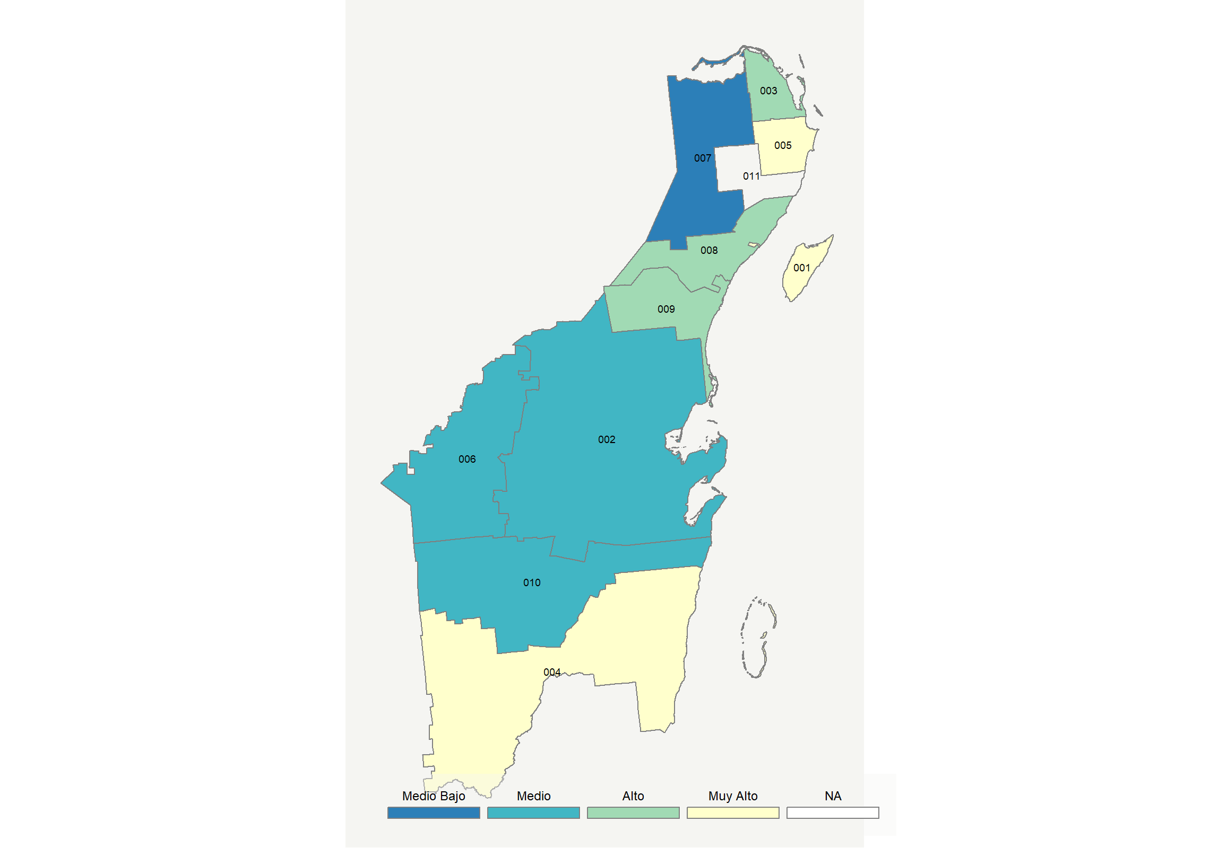

|  |  |  |  |  |  |  |  |  |  |  |  |  |  |
| --- | --- | --- | --- | --- | --- | --- | --- | --- | --- | --- | --- | --- | --- |
| **Clave del Municipio** | **Municipio** | **Telefonía fija a** | **Telefonía Celular a** | **Internet a** | **Televisión de paga a** | **Población Total a** | **Hasta 2 Salarios Mínimos b** | **Índice de Marginación** | **índice** | **Índice Escala 0-100** | **Lugar Nacional** | **Lugar Estatal** | **Estrato** |
| 001 | Cozumel | 23.9 | 89.2 | 45.4 | 72.9 | 86415 | 32.4 | -1.25 | 1.65 | 62.4 | 91 | 1 | Muy Alto |
| 002 | Felipe Carrillo Puerto | 8.7 | 60.1 | 9.9 | 57.9 | 81742 | 58.0 | 0.42 | 0.08 | 31.5 | 1050 | 7 | Medio |
| 003 | Isla Mujeres | 11.3 | 86.5 | 32.0 | 53.5 | 19495 | 32.8 | -0.69 | 0.87 | 47.1 | 351 | 6 | Alto |
| 004 | Othón P. Blanco | 24.3 | 88.1 | 36.3 | 58.3 | 224080 | 36.8 | -1.11 | 1.26 | 54.8 | 198 | 3 | Muy Alto |
| 005 | Benito Juárez | 29.2 | 95.0 | 46.1 | 56.7 | 743626 | 23.3 | -1.47 | 1.63 | 62.0 | 93 | 2 | Muy Alto |
| 006 | José María Morelos | 7.2 | 57.1 | 4.4 | 60.9 | 37502 | 62.3 | 0.30 | -0.07 | 28.5 | 1224 | 9 | Medio |
| 007 | Lázaro Cárdenas | 4.0 | 60.6 | 7.4 | 53.5 | 27243 | 60.6 | 0.30 | -0.10 | 28.0 | 1256 | 10 | Medio Bajo |
| 008 | Solidaridad | 14.5 | 93.8 | 32.4 | 51.7 | 209634 | 18.9 | -1.48 | 0.98 | 49.4 | 299 | 4 | Alto |
| 009 | Tulum | 6.9 | 87.7 | 30.1 | 67.6 | 32714 | 23.4 | -0.87 | 0.92 | 48.1 | 327 | 5 | Alto |
| 010 | Bacalar | 10.8 | 56.5 | 10.1 | 51.8 | 39111 | 63.3 | 0.20 | 0.02 | 30.3 | 1127 | 8 | Medio |
| a Porcentaje de viviendas que cuentas con el servicio  b Ingreso por trabajo de la población ocupada en porcentaje  Fuente: Elaboración propia con datos de Encuesta Intercensal 2015 de INEGI y CONAPO | | | | | | | | | | | | | |

**San Luis Potosí**

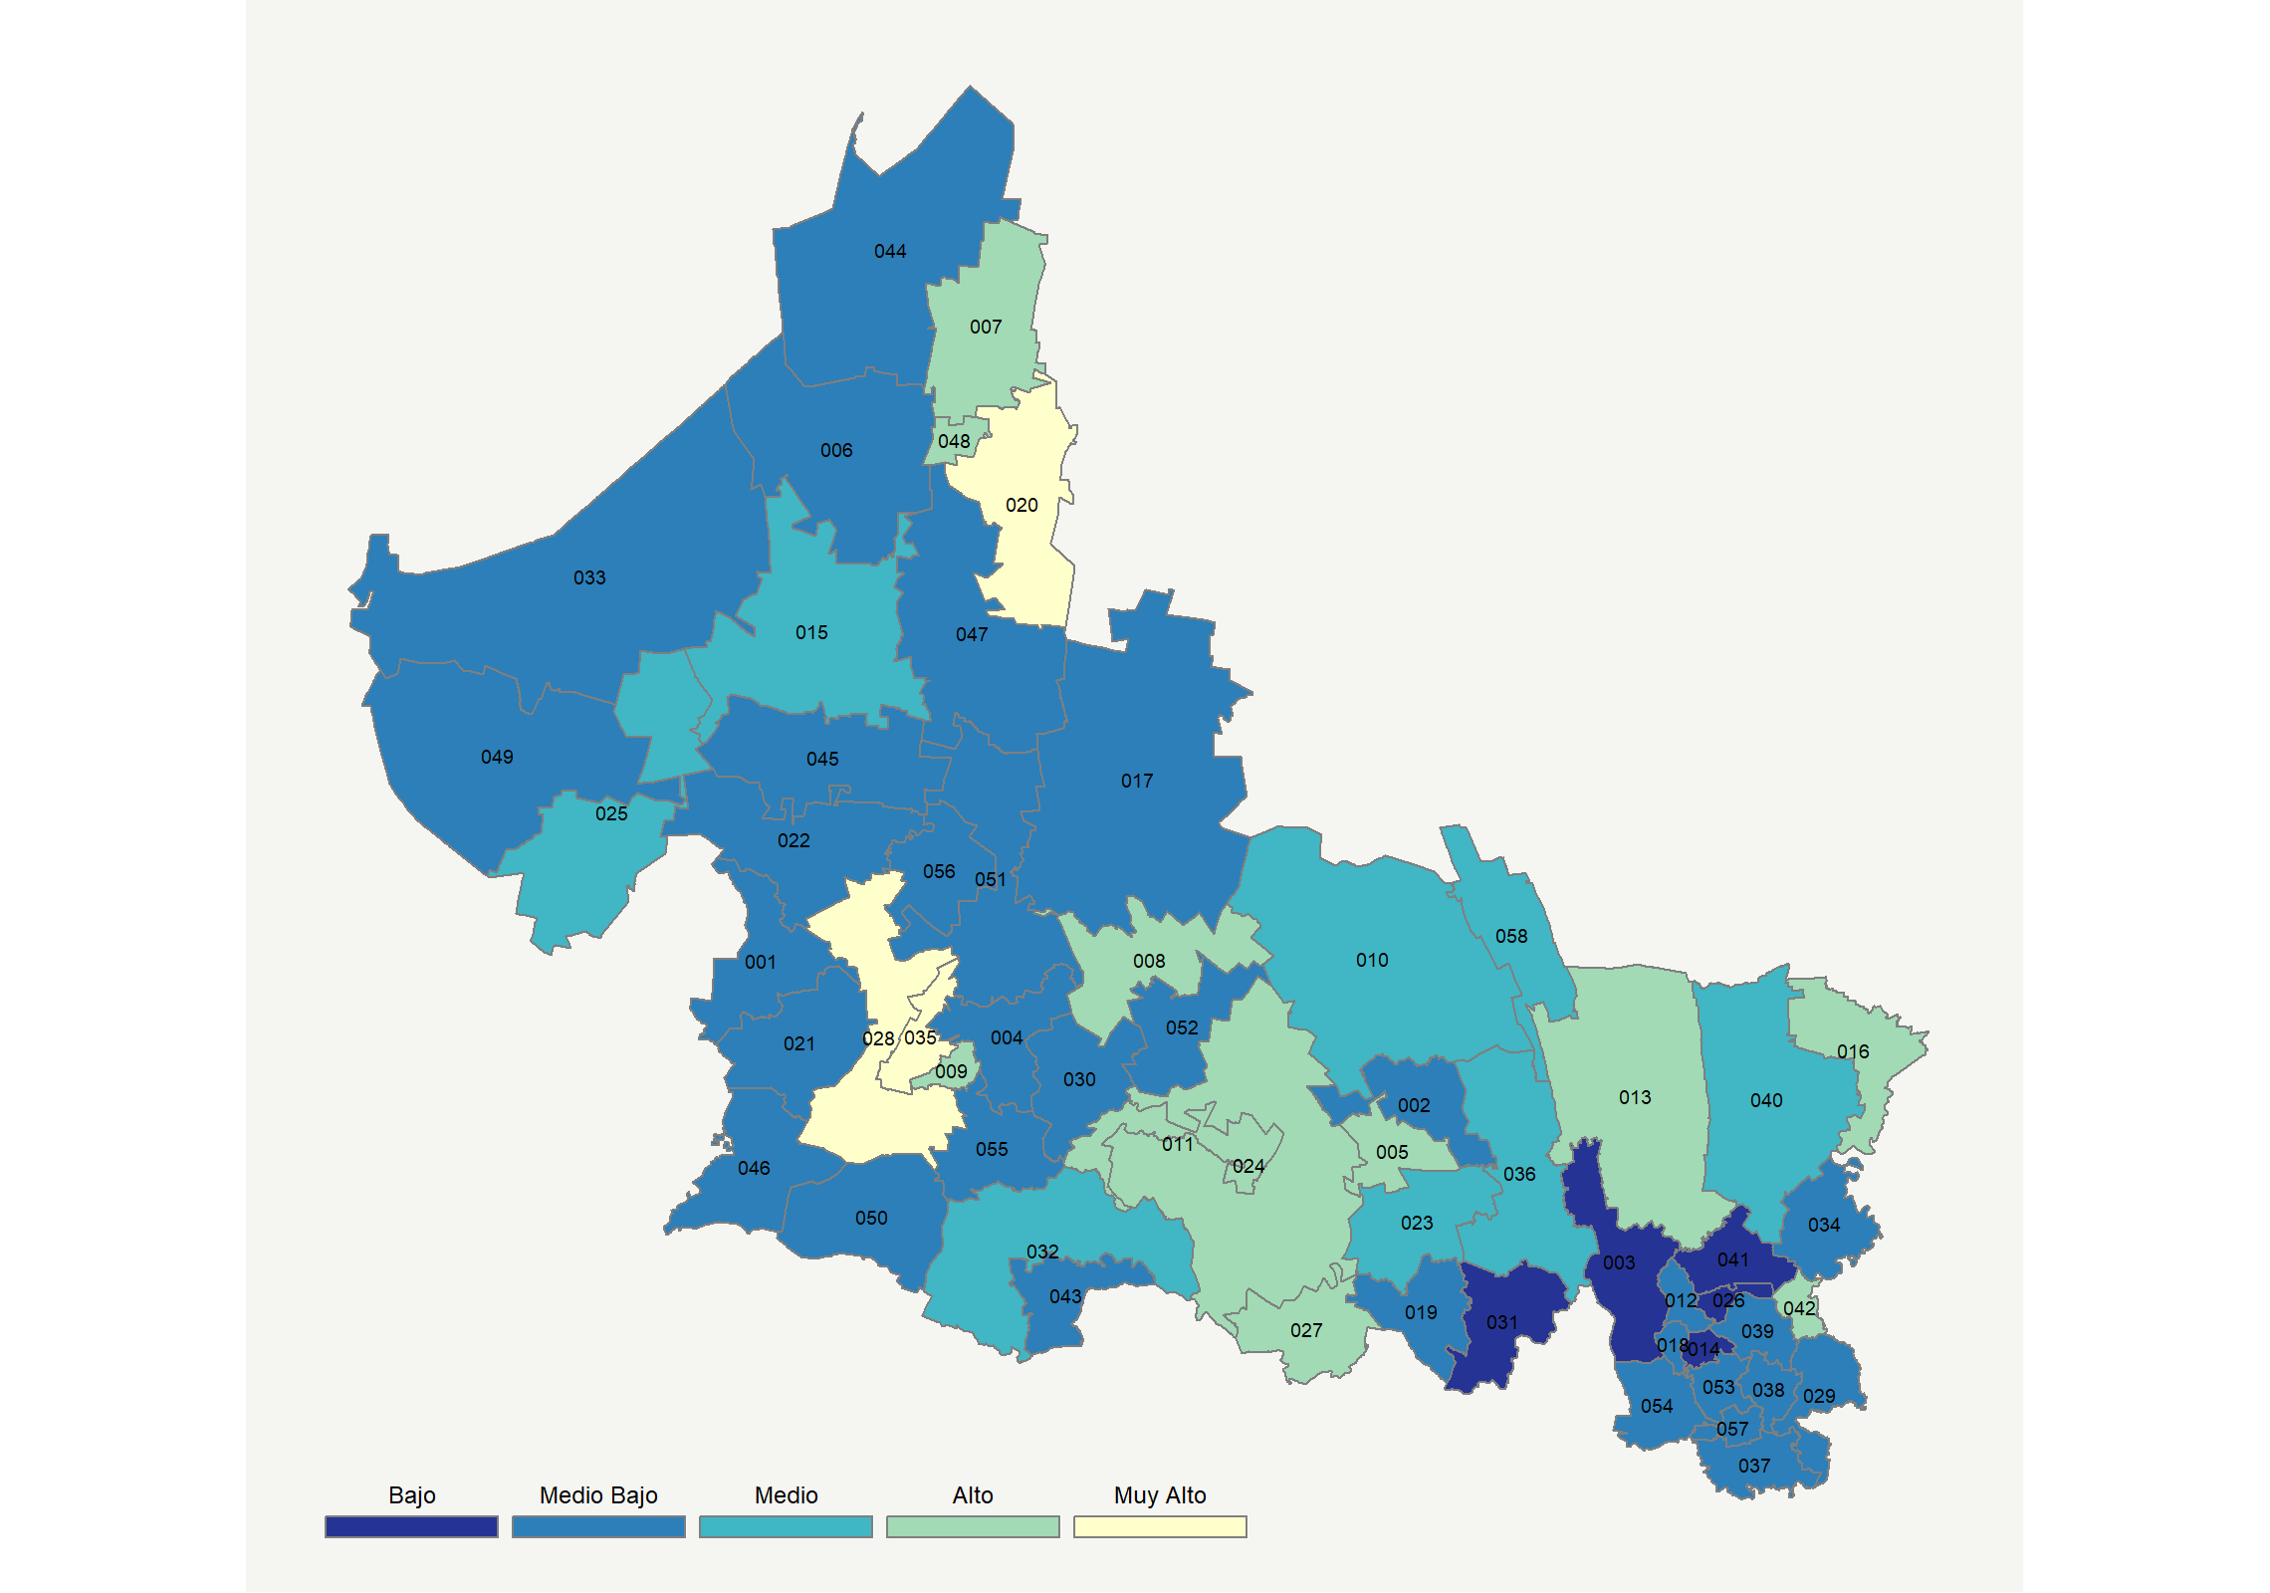

|  |  |  |  |  |  |  |  |  |  |  |  |  |  |
| --- | --- | --- | --- | --- | --- | --- | --- | --- | --- | --- | --- | --- | --- |
| **Clave del Municipio** | **Municipio** | **Telefonía fija a** | **Telefonía Celular a** | **Internet a** | **Televisión de paga a** | **Población Total a** | **Hasta 2 Salarios Mínimos b** | **Índice de Marginación** | **índice** | **Índice Escala 0-100** | **Lugar Nacional** | **Lugar Estatal** | **Estrato** |
| 001 | Ahualulco | 12.6 | 64.8 | 4.8 | 13.8 | 18369 | 65.9 | 0.26 | -0.42 | 21.6 | 1640 | 40 | Medio Bajo |
| 002 | Alaquines | 8.2 | 38.3 | 2.8 | 41.6 | 8296 | 73.1 | 0.60 | -0.49 | 20.2 | 1721 | 47 | Medio Bajo |
| 003 | Aquismón | 5.6 | 22.4 | 1.3 | 14.5 | 48772 | 83.1 | 2.11 | -1.03 | 9.6 | 2198 | 56 | Bajo |
| 004 | Armadillo de los Infante | 18.9 | 50.8 | 1.6 | 14.5 | 4064 | 59.3 | 0.39 | -0.52 | 19.6 | 1759 | 50 | Medio Bajo |
| 005 | Cárdenas | 28.4 | 71.2 | 9.8 | 52.4 | 18491 | 60.7 | -0.70 | 0.46 | 38.9 | 652 | 12 | Alto |
| 006 | Catorce | 21.9 | 30.7 | 2.7 | 44.6 | 9705 | 67.3 | 0.34 | -0.31 | 23.8 | 1518 | 38 | Medio Bajo |
| 007 | Cedral | 30.4 | 74.2 | 21.3 | 43.0 | 19176 | 51.5 | -0.74 | 0.69 | 43.5 | 460 | 7 | Alto |
| 008 | Cerritos | 31.4 | 71.1 | 18.9 | 48.3 | 21288 | 53.5 | -0.67 | 0.68 | 43.3 | 468 | 8 | Alto |
| 009 | Cerro de San Pedro * | 28.7 | 80.2 | 21.2 | 37.5 | 4535 | 33.2 | -0.54 | 0.66 | 42.9 | 483 | 10 | Alto |
| 010 | Ciudad del Maíz | 21.2 | 45.3 | 7.7 | 44.4 | 32867 | 60.4 | 0.02 | -0.06 | 28.8 | 1209 | 22 | Medio |
| 011 | Ciudad Fernández | 24.5 | 72.3 | 18.6 | 36.1 | 45385 | 56.1 | -0.62 | 0.43 | 38.5 | 685 | 13 | Alto |
| 012 | Tancanhuitz | 7.1 | 37.7 | 4.7 | 23.6 | 20550 | 73.5 | 1.11 | -0.67 | 16.7 | 1904 | 53 | Medio Bajo |
| 013 | Ciudad Valles | 27.3 | 83.0 | 29.5 | 52.5 | 177022 | 48.5 | -0.83 | 1.03 | 50.2 | 281 | 4 | Alto |
| 014 | Coxcatlán | 5.5 | 39.0 | 1.1 | 26.9 | 15184 | 67.4 | 0.56 | -0.74 | 15.4 | 1957 | 54 | Bajo |
| 015 | Charcas | 19.6 | 65.3 | 13.7 | 39.3 | 20839 | 50.8 | -0.45 | 0.20 | 33.8 | 924 | 18 | Medio |
| 016 | Ebano | 19.9 | 81.7 | 16.4 | 52.5 | 43569 | 58.7 | -0.40 | 0.58 | 41.3 | 545 | 11 | Alto |
| 017 | Guadalcázar | 15.5 | 31.6 | 1.4 | 39.2 | 26340 | 67.6 | 0.97 | -0.50 | 20.0 | 1735 | 49 | Medio Bajo |
| 018 | Huehuetlán | 8.2 | 40.9 | 4.8 | 32.3 | 15828 | 73.3 | 0.82 | -0.52 | 19.6 | 1760 | 51 | Medio Bajo |
| 019 | Lagunillas | 7.7 | 35.6 | 1.8 | 51.9 | 5462 | 67.8 | 0.62 | -0.44 | 21.3 | 1662 | 44 | Medio Bajo |
| 020 | Matehuala | 35.7 | 84.4 | 33.9 | 53.7 | 99015 | 49.8 | -1.12 | 1.30 | 55.6 | 179 | 3 | Muy Alto |
| 021 | Mexquitic de Carmona | 22.5 | 61.5 | 4.9 | 19.9 | 57184 | 49.7 | -0.19 | -0.22 | 25.6 | 1408 | 32 | Medio Bajo |
| 022 | Moctezuma | 12.7 | 57.6 | 5.8 | 16.6 | 19539 | 69.1 | 0.43 | -0.44 | 21.3 | 1659 | 43 | Medio Bajo |
| 023 | Rayón | 20.7 | 56.0 | 13.2 | 48.6 | 15279 | 59.9 | 0.29 | 0.22 | 34.2 | 898 | 17 | Medio |
| 024 | Rioverde | 29.7 | 74.7 | 19.9 | 44.3 | 94191 | 53.3 | -0.42 | 0.67 | 43.0 | 478 | 9 | Alto |
| 025 | Salinas | 21.0 | 71.7 | 9.8 | 35.6 | 31794 | 68.2 | -0.27 | 0.15 | 32.9 | 976 | 19 | Medio |
| 026 | San Antonio | 5.5 | 11.1 | 1.1 | 14.1 | 9361 | 76.6 | 1.01 | -1.16 | 7.1 | 2276 | 58 | Bajo |
| 027 | San Ciro de Acosta | 22.2 | 70.6 | 13.1 | 51.0 | 10257 | 58.5 | -0.22 | 0.41 | 38.0 | 709 | 14 | Alto |
| 028 | San Luis Potosí | 52.6 | 86.6 | 47.9 | 49.8 | 824229 | 29.6 | -1.70 | 1.90 | 67.4 | 49 | 1 | Muy Alto |
| 029 | San Martín Chalchicuautla | 11.7 | 41.3 | 2.9 | 38.2 | 21176 | 78.3 | 1.02 | -0.44 | 21.2 | 1665 | 45 | Medio Bajo |
| 030 | San Nicolás Tolentino | 38.5 | 26.2 | 2.2 | 32.3 | 5176 | 56.1 | -0.07 | -0.23 | 25.4 | 1422 | 33 | Medio Bajo |
| 031 | Santa Catarina * | 2.0 | 6.4 | 0.8 | 30.7 | 11791 | 76.0 | 2.26 | -1.08 | 8.6 | 2233 | 57 | Bajo |
| 032 | Santa María del Río | 17.1 | 59.6 | 6.9 | 42.8 | 39859 | 53.0 | 0.12 | -0.02 | 29.5 | 1169 | 21 | Medio |
| 033 | Santo Domingo | 42.7 | 38.5 | 3.5 | 21.7 | 12210 | 61.0 | 0.10 | -0.13 | 27.4 | 1294 | 24 | Medio Bajo |
| 034 | San Vicente Tancuayalab | 6.6 | 62.4 | 4.9 | 44.3 | 14700 | 71.9 | 0.25 | -0.20 | 26.0 | 1380 | 29 | Medio Bajo |
| 035 | Soledad de Graciano Sánchez | 45.3 | 88.1 | 39.1 | 43.1 | 309342 | 31.9 | -1.69 | 1.50 | 59.6 | 120 | 2 | Muy Alto |
| 036 | Tamasopo | 17.4 | 47.3 | 9.9 | 55.8 | 30087 | 64.8 | 0.54 | 0.08 | 31.4 | 1059 | 20 | Medio |
| 037 | Tamazunchale | 16.0 | 52.5 | 6.5 | 34.5 | 92291 | 60.8 | 0.39 | -0.21 | 25.7 | 1401 | 31 | Medio Bajo |
| 038 | Tampacán | 20.1 | 17.4 | 1.9 | 43.8 | 15382 | 67.9 | 0.59 | -0.50 | 20.1 | 1732 | 48 | Medio Bajo |
| 039 | Tampamolón Corona | 11.7 | 49.0 | 6.2 | 35.3 | 15598 | 73.3 | 0.96 | -0.32 | 23.7 | 1523 | 39 | Medio Bajo |
| 040 | Tamuín | 14.2 | 78.1 | 11.8 | 49.2 | 38751 | 52.5 | -0.34 | 0.30 | 35.9 | 819 | 15 | Medio |
| 041 | Tanlajás * | 5.5 | 24.5 | 1.9 | 17.9 | 19750 | 80.4 | 0.72 | -0.96 | 11.0 | 2142 | 55 | Bajo |
| 042 | Tanquián de Escobedo | 20.7 | 80.1 | 17.1 | 63.5 | 15120 | 67.6 | -0.17 | 0.72 | 44.0 | 445 | 6 | Alto |
| 043 | Tierra Nueva | 20.6 | 61.5 | 3.6 | 35.3 | 9383 | 57.7 | 0.18 | -0.11 | 27.8 | 1270 | 23 | Medio Bajo |
| 044 | Vanegas | 13.5 | 42.4 | 5.9 | 51.7 | 7629 | 73.3 | 0.55 | -0.18 | 26.4 | 1356 | 25 | Medio Bajo |
| 045 | Venado | 15.5 | 64.6 | 9.0 | 15.8 | 14486 | 71.3 | 0.06 | -0.25 | 24.9 | 1449 | 35 | Medio Bajo |
| 046 | Villa de Arriaga | 7.5 | 66.5 | 4.0 | 34.3 | 17888 | 54.4 | 0.11 | -0.28 | 24.4 | 1476 | 36 | Medio Bajo |
| 047 | Villa de Guadalupe | 18.2 | 33.6 | 1.3 | 40.5 | 9671 | 73.3 | 0.81 | -0.42 | 21.6 | 1642 | 41 | Medio Bajo |
| 048 | Villa de la Paz * | 27.7 | 73.5 | 21.0 | 53.8 | 5227 | 43.6 | -0.59 | 0.75 | 44.7 | 430 | 5 | Alto |
| 049 | Villa de Ramos | 24.8 | 54.5 | 5.9 | 14.3 | 37184 | 69.5 | 0.23 | -0.29 | 24.2 | 1489 | 37 | Medio Bajo |
| 050 | Villa de Reyes | 8.6 | 67.7 | 7.6 | 27.8 | 49385 | 40.6 | -0.29 | -0.23 | 25.3 | 1426 | 34 | Medio Bajo |
| 051 | Villa Hidalgo | 16.4 | 60.2 | 6.5 | 27.2 | 14830 | 47.2 | -0.29 | -0.21 | 25.7 | 1398 | 30 | Medio Bajo |
| 052 | Villa Juárez | 23.1 | 50.0 | 4.2 | 32.5 | 10048 | 69.3 | 0.25 | -0.20 | 26.0 | 1378 | 28 | Medio Bajo |
| 053 | Axtla de Terrazas | 11.3 | 55.8 | 5.2 | 43.9 | 37645 | 68.8 | 0.05 | -0.19 | 26.2 | 1368 | 27 | Medio Bajo |
| 054 | Xilitla | 7.3 | 47.5 | 4.7 | 25.4 | 52062 | 69.8 | 0.72 | -0.55 | 19.0 | 1791 | 52 | Medio Bajo |
| 055 | Zaragoza | 9.5 | 59.4 | 4.6 | 23.4 | 26236 | 38.1 | -0.26 | -0.42 | 21.6 | 1644 | 42 | Medio Bajo |
| 056 | Villa de Arista | 8.7 | 69.5 | 5.8 | 34.5 | 15258 | 66.1 | -0.06 | -0.18 | 26.3 | 1364 | 26 | Medio Bajo |
| 057 | Matlapa | 9.4 | 44.7 | 3.3 | 35.9 | 31109 | 69.8 | 0.62 | -0.46 | 20.8 | 1692 | 46 | Medio Bajo |
| 058 | El Naranjo | 15.6 | 66.4 | 7.6 | 63.5 | 21955 | 55.6 | -0.49 | 0.27 | 35.2 | 846 | 16 | Medio |
| a Porcentaje de viviendas que cuentas con el servicio  b Ingreso por trabajo de la población ocupada en porcentaje  Fuente: Elaboración propia con datos de Encuesta Intercensal 2015 de INEGI y CONAPO | | | | | | | | | | | | | |

**Sinaloa**

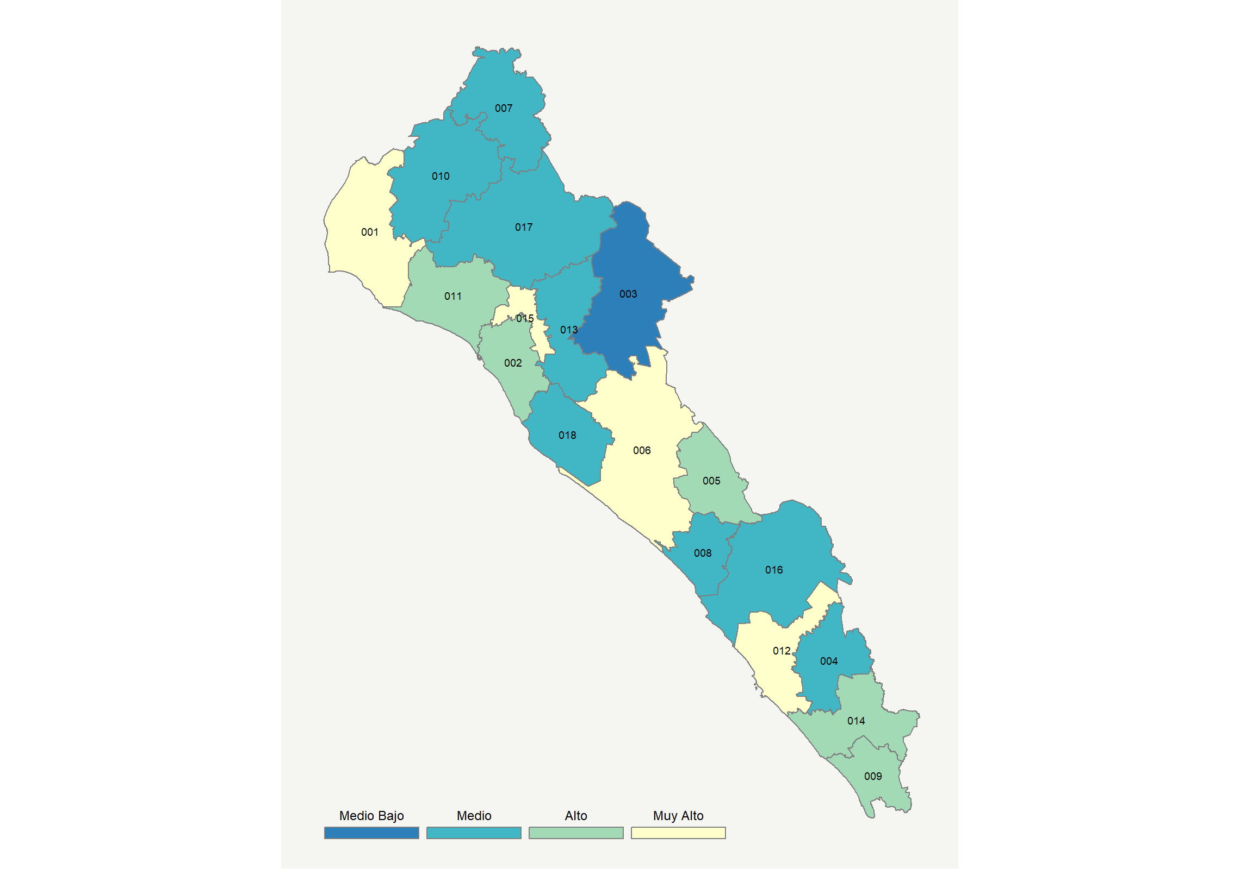

|  |  |  |  |  |  |  |  |  |  |  |  |  |  |
| --- | --- | --- | --- | --- | --- | --- | --- | --- | --- | --- | --- | --- | --- |
| **Clave del Municipio** | **Municipio** | **Telefonía fija a** | **Telefonía Celular a** | **Internet a** | **Televisión de paga a** | **Población Total a** | **Hasta 2 Salarios Mínimos b** | **Índice de Marginación** | **índice** | **Índice Escala 0-100** | **Lugar Nacional** | **Lugar Estatal** | **Estrato** |
| 001 | Ahome | 28.7 | 92.1 | 38.4 | 48.1 | 449215 | 36.5 | -1.22 | 1.31 | 55.7 | 178 | 4 | Muy Alto |
| 002 | Angostura | 20.2 | 86.2 | 16.6 | 75.9 | 47207 | 40.7 | -0.81 | 0.89 | 47.5 | 342 | 6 | Alto |
| 003 | Badiraguato | 9.3 | 50.6 | 4.1 | 57.2 | 31821 | 45.2 | 0.68 | -0.15 | 27.0 | 1316 | 18 | Medio Bajo |
| 004 | Concordia | 19.6 | 71.0 | 13.7 | 47.0 | 27157 | 35.3 | -0.55 | 0.34 | 36.7 | 777 | 12 | Medio |
| 005 | Cosalá | 19.9 | 61.1 | 10.7 | 75.7 | 16292 | 37.1 | -0.32 | 0.49 | 39.7 | 610 | 9 | Alto |
| 006 | Culiacán | 38.0 | 93.2 | 45.3 | 52.6 | 905265 | 21.6 | -1.50 | 1.69 | 63.3 | 80 | 1 | Muy Alto |
| 007 | Choix | 7.5 | 78.6 | 8.3 | 56.9 | 33027 | 52.1 | 0.32 | 0.20 | 33.8 | 929 | 17 | Medio |
| 008 | Elota | 13.2 | 81.5 | 9.8 | 53.0 | 53856 | 34.8 | -0.43 | 0.31 | 36.1 | 806 | 13 | Medio |
| 009 | Escuinapa | 22.0 | 77.8 | 20.8 | 63.0 | 59436 | 32.6 | -0.75 | 0.80 | 45.7 | 395 | 7 | Alto |
| 010 | El Fuerte | 12.6 | 81.3 | 14.9 | 41.3 | 100459 | 59.0 | -0.36 | 0.29 | 35.7 | 829 | 14 | Medio |
| 011 | Guasave | 24.0 | 88.5 | 23.0 | 61.1 | 295353 | 46.9 | -0.71 | 0.97 | 49.1 | 307 | 5 | Alto |
| 012 | Mazatlán | 41.0 | 89.4 | 43.7 | 49.0 | 502547 | 29.5 | -1.53 | 1.62 | 61.9 | 95 | 2 | Muy Alto |
| 013 | Mocorito | 16.4 | 77.2 | 8.4 | 58.5 | 45351 | 48.9 | -0.11 | 0.35 | 36.8 | 770 | 11 | Medio |
| 014 | Rosario | 20.6 | 73.7 | 17.1 | 50.3 | 53773 | 37.6 | -0.66 | 0.50 | 39.8 | 603 | 8 | Alto |
| 015 | Salvador Alvarado | 30.7 | 89.4 | 30.6 | 68.0 | 81109 | 30.7 | -1.35 | 1.35 | 56.5 | 161 | 3 | Muy Alto |
| 016 | San Ignacio | 17.1 | 67.4 | 10.6 | 63.0 | 21442 | 43.8 | -0.21 | 0.37 | 37.2 | 745 | 10 | Medio |
| 017 | Sinaloa | 12.5 | 78.8 | 8.4 | 49.7 | 88659 | 58.6 | 0.13 | 0.20 | 33.9 | 920 | 16 | Medio |
| 018 | Navolato | 10.5 | 87.3 | 14.9 | 31.3 | 154352 | 39.7 | -0.43 | 0.21 | 34.0 | 914 | 15 | Medio |
| a Porcentaje de viviendas que cuentas con el servicio  b Ingreso por trabajo de la población ocupada en porcentaje  Fuente: Elaboración propia con datos de Encuesta Intercensal 2015 de INEGI y CONAPO | | | | | | | | | | | | | |

**Sonora**

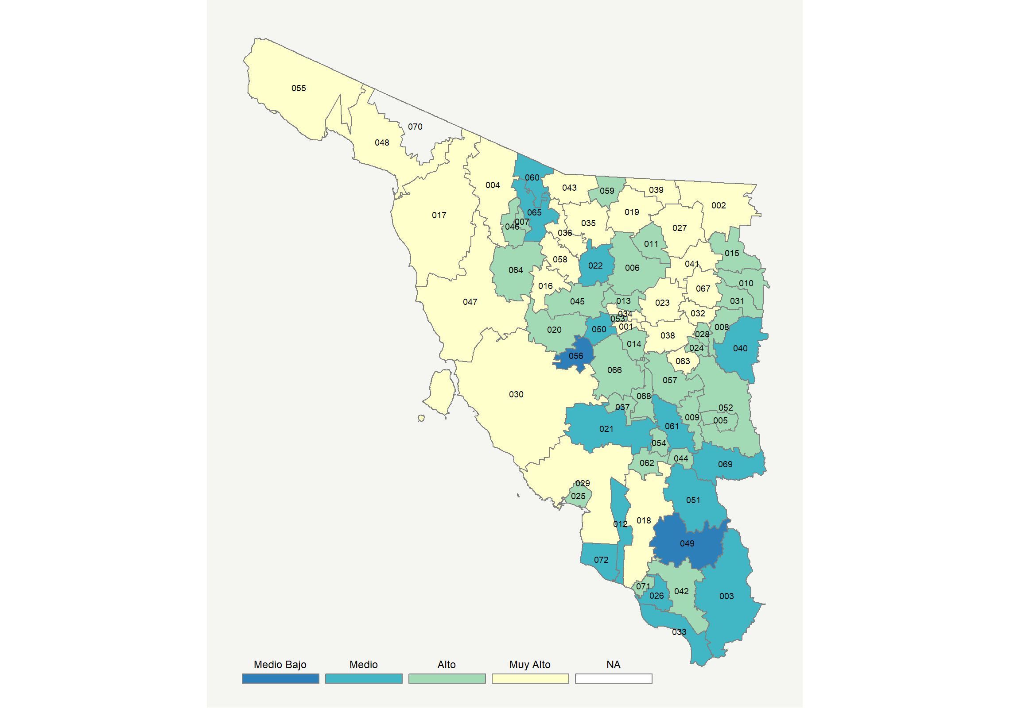

|  |  |  |  |  |  |  |  |  |  |  |  |  |  |
| --- | --- | --- | --- | --- | --- | --- | --- | --- | --- | --- | --- | --- | --- |
| **Clave del Municipio** | **Municipio** | **Telefonía fija a** | **Telefonía Celular a** | **Internet a** | **Televisión de paga a** | **Población Total a** | **Hasta 2 Salarios Mínimos b** | **Índice de Marginación** | **índice** | **Índice Escala 0-100** | **Lugar Nacional** | **Lugar Estatal** | **Estrato** |
| 001 | Aconchi * | 36.9 | 85.4 | 24.7 | 78.5 | 2756 | 18.8 | -1.04 | 1.38 | 57.2 | 153 | 19 | Muy Alto |
| 002 | Agua Prieta | 24.6 | 91.8 | 46.2 | 69.0 | 82918 | 33.3 | -1.46 | 1.66 | 62.6 | 85 | 10 | Muy Alto |
| 003 | Alamos | 13.9 | 75.4 | 12.9 | 56.3 | 25694 | 47.3 | -0.03 | 0.38 | 37.3 | 739 | 57 | Medio |
| 004 | Altar | 22.0 | 92.5 | 30.8 | 69.7 | 9578 | 36.6 | -1.09 | 1.26 | 54.7 | 200 | 25 | Muy Alto |
| 005 | Arivechi * | 27.0 | 58.5 | 15.3 | 51.9 | 1163 | 14.2 | -0.40 | 0.43 | 38.5 | 682 | 55 | Alto |
| 006 | Arizpe * | 29.9 | 84.0 | 17.9 | 68.1 | 2677 | 28.4 | -1.09 | 0.98 | 49.2 | 304 | 32 | Alto |
| 007 | Atil * | 29.9 | 89.1 | 6.9 | 78.2 | 582 | 50.9 | -1.03 | 0.87 | 47.2 | 349 | 37 | Alto |
| 008 | Bacadéhuachi * | 24.6 | 88.8 | 2.5 | 77.6 | 1083 | 33.9 | -0.75 | 0.67 | 43.2 | 471 | 43 | Alto |
| 009 | Bacanora * | 42.5 | 54.0 | 26.1 | 71.6 | 802 | 21.0 | -0.83 | 1.13 | 52.1 | 249 | 28 | Alto |
| 010 | Bacerac * | 33.9 | 79.0 | 19.6 | 58.4 | 1367 | 37.1 | -0.66 | 0.93 | 48.2 | 326 | 33 | Alto |
| 011 | Bacoachi * | 24.9 | 84.6 | 0.8 | 66.6 | 1554 | 21.5 | -1.25 | 0.47 | 39.2 | 640 | 54 | Alto |
| 012 | Bácum | 13.8 | 86.4 | 17.5 | 35.6 | 23053 | 53.5 | -0.52 | 0.36 | 37.0 | 753 | 59 | Medio |
| 013 | Banámichi * | 30.8 | 83.9 | 21.4 | 74.3 | 1612 | 24.4 | -1.23 | 1.14 | 52.5 | 239 | 27 | Alto |
| 014 | Baviácora * | 20.4 | 78.2 | 12.4 | 78.9 | 3312 | 26.6 | -1.07 | 0.75 | 44.7 | 431 | 40 | Alto |
| 015 | Bavispe * | 23.6 | 83.3 | 2.3 | 76.4 | 1457 | 34.0 | -0.98 | 0.58 | 41.4 | 540 | 50 | Alto |
| 016 | Benjamín Hill | 43.8 | 82.3 | 36.8 | 53.7 | 5233 | 31.4 | -1.46 | 1.49 | 59.2 | 126 | 17 | Muy Alto |
| 017 | Caborca | 26.0 | 91.0 | 38.1 | 61.1 | 85631 | 31.7 | -1.17 | 1.39 | 57.4 | 148 | 18 | Muy Alto |
| 018 | Cajeme | 32.9 | 90.5 | 38.1 | 48.5 | 433050 | 35.8 | -1.48 | 1.36 | 56.7 | 157 | 21 | Muy Alto |
| 019 | Cananea | 54.7 | 89.9 | 56.9 | 71.7 | 35892 | 14.1 | -1.87 | 2.43 | 77.8 | 10 | 1 | Muy Alto |
| 020 | Carbó * | 16.6 | 90.3 | 15.4 | 68.0 | 4840 | 27.4 | -0.79 | 0.76 | 44.8 | 424 | 39 | Alto |
| 021 | La Colorada * | 11.7 | 84.1 | 3.4 | 60.6 | 2076 | 24.3 | -0.69 | 0.24 | 34.7 | 875 | 64 | Medio |
| 022 | Cucurpe * | 7.3 | 87.7 | 8.5 | 60.8 | 965 | 19.4 | -0.86 | 0.33 | 36.4 | 792 | 60 | Medio |
| 023 | Cumpas | 38.8 | 81.9 | 28.2 | 80.8 | 6109 | 24.4 | -1.29 | 1.49 | 59.4 | 122 | 15 | Muy Alto |
| 024 | Divisaderos * | 32.6 | 78.5 | 6.2 | 80.2 | 717 | 33.2 | -0.98 | 0.82 | 46.1 | 382 | 38 | Alto |
| 025 | Empalme | 30.7 | 87.0 | 31.4 | 51.7 | 56177 | 32.3 | -1.26 | 1.16 | 52.9 | 233 | 26 | Alto |
| 026 | Etchojoa | 10.3 | 71.9 | 16.1 | 23.8 | 63216 | 65.3 | -0.15 | 0.00 | 29.8 | 1150 | 69 | Medio |
| 027 | Fronteras | 42.9 | 91.6 | 38.5 | 83.7 | 8666 | 19.7 | -1.60 | 1.94 | 68.2 | 45 | 6 | Muy Alto |
| 028 | Granados * | 37.1 | 87.5 | 11.6 | 74.8 | 1064 | 19.8 | -1.41 | 1.05 | 50.7 | 275 | 29 | Alto |
| 029 | Guaymas | 35.5 | 87.9 | 42.8 | 53.4 | 158046 | 34.5 | -1.26 | 1.55 | 60.4 | 110 | 13 | Muy Alto |
| 030 | Hermosillo | 39.8 | 94.2 | 53.5 | 54.9 | 884273 | 20.0 | -1.73 | 1.95 | 68.4 | 44 | 5 | Muy Alto |
| 031 | Huachinera * | 31.5 | 78.2 | 3.4 | 71.9 | 1231 | 47.3 | -0.77 | 0.64 | 42.5 | 496 | 47 | Alto |
| 032 | Huásabas * | 43.3 | 76.7 | 30.5 | 56.0 | 890 | 21.0 | -1.33 | 1.30 | 55.5 | 181 | 23 | Muy Alto |
| 033 | Huatabampo | 12.2 | 78.2 | 21.9 | 38.3 | 80524 | 57.6 | -0.54 | 0.39 | 37.6 | 726 | 56 | Medio |
| 034 | Huépac * | 41.4 | 79.8 | 27.7 | 79.8 | 927 | 19.4 | -1.37 | 1.49 | 59.4 | 123 | 16 | Muy Alto |
| 035 | Imuris | 31.1 | 88.4 | 35.6 | 79.3 | 12812 | 34.7 | -1.15 | 1.59 | 61.3 | 102 | 12 | Muy Alto |
| 036 | Magdalena | 40.8 | 90.8 | 45.8 | 63.4 | 31180 | 28.0 | -1.60 | 1.85 | 66.3 | 56 | 9 | Muy Alto |
| 037 | Mazatán * | 22.7 | 80.4 | 14.9 | 60.1 | 1237 | 18.2 | -1.15 | 0.66 | 43.0 | 482 | 45 | Alto |
| 038 | Moctezuma | 47.6 | 89.1 | 49.5 | 80.9 | 4967 | 21.4 | -1.40 | 2.23 | 73.8 | 24 | 3 | Muy Alto |
| 039 | Naco | 40.1 | 88.3 | 39.3 | 83.9 | 6160 | 28.0 | -1.55 | 1.88 | 67.0 | 52 | 7 | Muy Alto |
| 040 | Nácori Chico * | 14.2 | 69.2 | 6.4 | 59.6 | 2019 | 34.3 | -0.27 | 0.20 | 33.8 | 928 | 65 | Medio |
| 041 | Nacozari de García | 50.7 | 91.3 | 53.0 | 76.5 | 13843 | 15.0 | -1.67 | 2.33 | 76.0 | 19 | 2 | Muy Alto |
| 042 | Navojoa | 27.0 | 85.7 | 27.7 | 44.5 | 163650 | 45.3 | -1.01 | 0.92 | 48.1 | 329 | 34 | Alto |
| 043 | Nogales | 30.8 | 92.9 | 52.1 | 65.7 | 233952 | 27.3 | -1.56 | 1.88 | 67.0 | 53 | 8 | Muy Alto |
| 044 | Onavas * | 18.4 | 84.0 | 4.0 | 71.2 | 468 | 26.4 | -0.68 | 0.49 | 39.5 | 620 | 53 | Alto |
| 045 | Opodepe * | 27.5 | 72.7 | 15.7 | 50.4 | 2643 | 45.1 | -0.44 | 0.57 | 41.2 | 547 | 51 | Alto |
| 046 | Oquitoa * | 9.7 | 90.3 | 15.9 | 68.1 | 372 | 40.8 | -0.71 | 0.66 | 42.9 | 485 | 46 | Alto |
| 047 | Pitiquito | 27.6 | 88.5 | 30.6 | 65.5 | 9514 | 20.8 | -1.27 | 1.26 | 54.8 | 199 | 24 | Muy Alto |
| 048 | Puerto Peñasco | 30.0 | 92.3 | 42.9 | 63.5 | 62177 | 24.2 | -1.52 | 1.61 | 61.7 | 98 | 11 | Muy Alto |
| 049 | Quiriego * | 3.8 | 71.0 | 1.1 | 35.4 | 2839 | 64.4 | 1.05 | -0.35 | 22.9 | 1566 | 71 | Medio Bajo |
| 050 | Rayón * | 22.6 | 73.3 | 9.4 | 44.4 | 1444 | 25.4 | -0.90 | 0.28 | 35.5 | 835 | 62 | Medio |
| 051 | Rosario | 12.8 | 66.0 | 5.7 | 58.5 | 5025 | 33.6 | -0.30 | 0.11 | 32.1 | 1020 | 67 | Medio |
| 052 | Sahuaripa | 28.9 | 71.9 | 18.0 | 55.5 | 5626 | 22.9 | -0.84 | 0.70 | 43.8 | 458 | 42 | Alto |
| 053 | San Felipe de Jesús * | 23.0 | 82.0 | 12.2 | 83.5 | 407 | 13.0 | -1.33 | 0.88 | 47.2 | 347 | 36 | Alto |
| 054 | San Javier * | 7.7 | 92.9 | 9.5 | 74.0 | 557 | 19.0 | -0.60 | 0.56 | 40.9 | 556 | 52 | Alto |
| 055 | San Luis Río Colorado | 31.5 | 88.2 | 42.3 | 58.9 | 192739 | 30.2 | -1.29 | 1.53 | 60.1 | 114 | 14 | Muy Alto |
| 056 | San Miguel de Horcasitas | 4.4 | 80.7 | 7.9 | 29.3 | 9081 | 27.6 | 0.06 | -0.15 | 26.9 | 1320 | 70 | Medio Bajo |
| 057 | San Pedro de la Cueva * | 36.8 | 77.6 | 18.7 | 56.4 | 1481 | 30.2 | -0.99 | 0.92 | 48.0 | 334 | 35 | Alto |
| 058 | Santa Ana | 41.0 | 88.6 | 42.1 | 84.8 | 16248 | 27.9 | -1.51 | 1.98 | 68.9 | 41 | 4 | Muy Alto |
| 059 | Santa Cruz * | 23.6 | 90.6 | 23.4 | 60.4 | 1768 | 29.5 | -1.14 | 0.99 | 49.4 | 298 | 31 | Alto |
| 060 | Sáric * | 8.7 | 87.4 | 4.8 | 61.0 | 1567 | 38.0 | -0.79 | 0.26 | 35.1 | 858 | 63 | Medio |
| 061 | Soyopa * | 8.9 | 51.8 | 2.8 | 85.1 | 1420 | 17.4 | -0.65 | 0.14 | 32.6 | 986 | 66 | Medio |
| 062 | Suaqui Grande * | 15.5 | 89.6 | 10.7 | 66.9 | 1142 | 29.7 | -0.78 | 0.61 | 41.9 | 520 | 49 | Alto |
| 063 | Tepache * | 53.2 | 75.7 | 26.5 | 58.2 | 1230 | 38.8 | -1.05 | 1.38 | 57.1 | 155 | 20 | Muy Alto |
| 064 | Trincheras * | 19.9 | 85.1 | 13.3 | 60.0 | 1577 | 35.8 | -0.53 | 0.62 | 42.2 | 509 | 48 | Alto |
| 065 | Tubutama * | 5.3 | 87.5 | 3.6 | 70.4 | 1193 | 52.7 | -0.59 | 0.28 | 35.5 | 834 | 61 | Medio |
| 066 | Ures | 31.1 | 82.7 | 20.8 | 63.3 | 8704 | 20.1 | -1.18 | 1.00 | 49.7 | 291 | 30 | Alto |
| 067 | Villa Hidalgo * | 49.4 | 80.7 | 33.0 | 41.7 | 1523 | 10.0 | -1.41 | 1.34 | 56.3 | 167 | 22 | Muy Alto |
| 068 | Villa Pesqueira * | 24.7 | 81.7 | 11.6 | 67.1 | 1181 | 18.3 | -1.23 | 0.70 | 43.8 | 455 | 41 | Alto |
| 069 | Yécora | 16.5 | 75.7 | 9.1 | 59.7 | 6012 | 29.8 | -0.21 | 0.37 | 37.2 | 747 | 58 | Medio |
| 071 | Benito Juárez | 17.8 | 86.5 | 24.2 | 42.4 | 21957 | 56.1 | -0.77 | 0.67 | 43.1 | 477 | 44 | Alto |
| 072 | San Ignacio Río Muerto | 7.9 | 84.1 | 11.7 | 35.5 | 14549 | 59.0 | -0.36 | 0.10 | 31.9 | 1035 | 68 | Medio |
| a Porcentaje de viviendas que cuentas con el servicio  b Ingreso por trabajo de la población ocupada en porcentaje  Fuente: Elaboración propia con datos de Encuesta Intercensal 2015 de INEGI y CONAPO | | | | | | | | | | | | | |

**Tabasco**

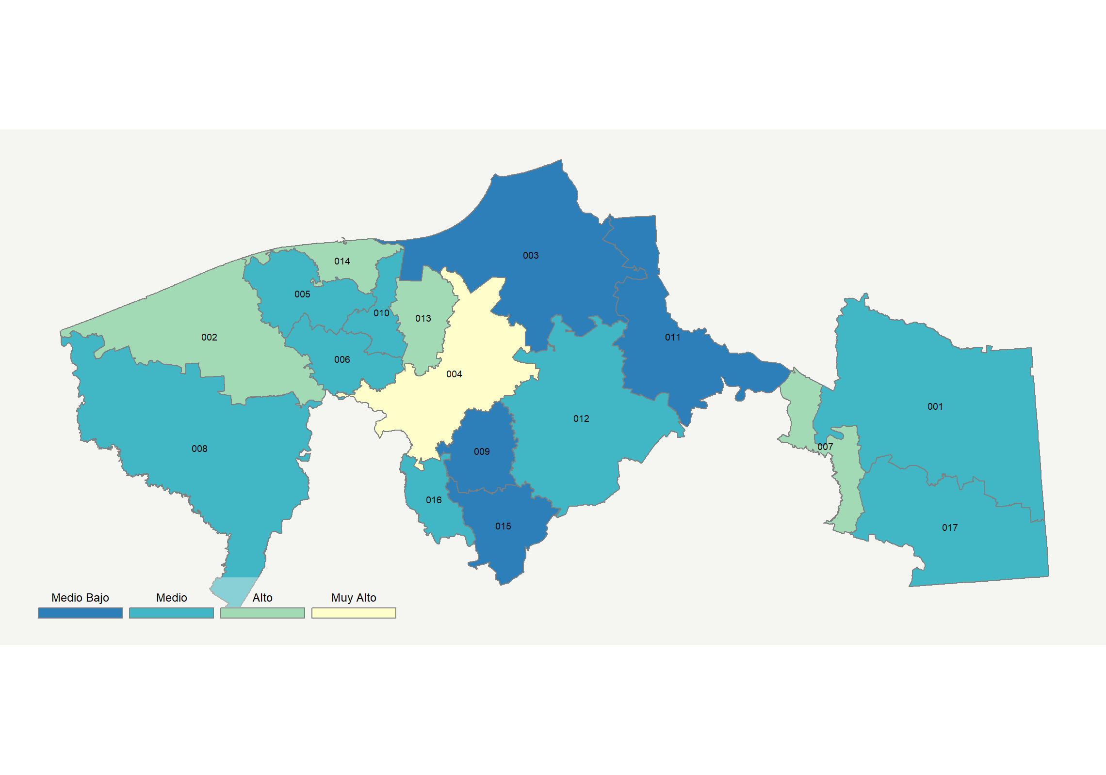

|  |  |  |  |  |  |  |  |  |  |  |  |  |  |
| --- | --- | --- | --- | --- | --- | --- | --- | --- | --- | --- | --- | --- | --- |
| **Clave del Municipio** | **Municipio** | **Telefonía fija a** | **Telefonía Celular a** | **Internet a** | **Televisión de paga a** | **Población Total a** | **Hasta 2 Salarios Mínimos b** | **Índice de Marginación** | **índice** | **Índice Escala 0-100** | **Lugar Nacional** | **Lugar Estatal** | **Estrato** |
| 001 | Balancán | 17.7 | 62.5 | 7.2 | 46.5 | 60516 | 64.8 | -0.05 | 0.06 | 31.2 | 1078 | 11 | Medio |
| 002 | Cárdenas | 12.1 | 75.7 | 18.9 | 53.5 | 258554 | 44.9 | -0.55 | 0.46 | 39.0 | 650 | 5 | Alto |
| 003 | Centla | 6.0 | 65.5 | 4.8 | 34.6 | 110130 | 51.8 | -0.11 | -0.29 | 24.2 | 1494 | 16 | Medio Bajo |
| 004 | Centro | 32.1 | 89.9 | 35.6 | 47.5 | 684847 | 24.0 | -1.48 | 1.27 | 54.9 | 196 | 1 | Muy Alto |
| 005 | Comalcalco | 11.1 | 78.6 | 13.8 | 58.2 | 201654 | 33.8 | -0.81 | 0.40 | 37.9 | 717 | 6 | Medio |
| 006 | Cunduacán | 5.7 | 76.8 | 9.7 | 38.7 | 138504 | 47.3 | -0.36 | -0.02 | 29.5 | 1166 | 13 | Medio |
| 007 | Emiliano Zapata | 14.1 | 84.8 | 14.6 | 63.8 | 30637 | 43.6 | -0.88 | 0.60 | 41.7 | 527 | 4 | Alto |
| 008 | Huimanguillo | 6.9 | 76.2 | 14.7 | 56.5 | 188792 | 50.9 | -0.23 | 0.31 | 36.1 | 804 | 7 | Medio |
| 009 | Jalapa | 6.6 | 72.0 | 7.1 | 34.0 | 38231 | 45.0 | -0.42 | -0.17 | 26.6 | 1338 | 14 | Medio Bajo |
| 010 | Jalpa de Méndez | 6.1 | 75.5 | 11.0 | 40.3 | 87249 | 36.3 | -0.79 | 0.02 | 30.4 | 1120 | 12 | Medio |
| 011 | Jonuta | 12.2 | 48.0 | 4.7 | 50.0 | 30567 | 67.4 | 0.01 | -0.19 | 26.1 | 1375 | 15 | Medio Bajo |
| 012 | Macuspana | 15.3 | 68.9 | 13.8 | 42.2 | 165729 | 44.5 | -0.57 | 0.20 | 33.8 | 925 | 9 | Medio |
| 013 | Nacajuca | 16.8 | 85.6 | 25.1 | 44.6 | 138366 | 28.5 | -1.09 | 0.69 | 43.5 | 463 | 3 | Alto |
| 014 | Paraíso | 12.9 | 85.4 | 24.4 | 72.7 | 94375 | 20.8 | -1.23 | 0.92 | 48.0 | 331 | 2 | Alto |
| 015 | Tacotalpa | 5.8 | 46.9 | 3.2 | 34.4 | 48784 | 57.3 | -0.08 | -0.52 | 19.7 | 1757 | 17 | Medio Bajo |
| 016 | Teapa | 10.5 | 74.9 | 10.2 | 40.7 | 58523 | 51.6 | -0.32 | 0.07 | 31.4 | 1062 | 10 | Medio |
| 017 | Tenosique | 22.0 | 67.3 | 13.5 | 38.7 | 59814 | 58.5 | -0.33 | 0.24 | 34.8 | 872 | 8 | Medio |
| a Porcentaje de viviendas que cuentas con el servicio  b Ingreso por trabajo de la población ocupada en porcentaje  Fuente: Elaboración propia con datos de Encuesta Intercensal 2015 de INEGI y CONAPO | | | | | | | | | | | | | |

**Tamaulipas**

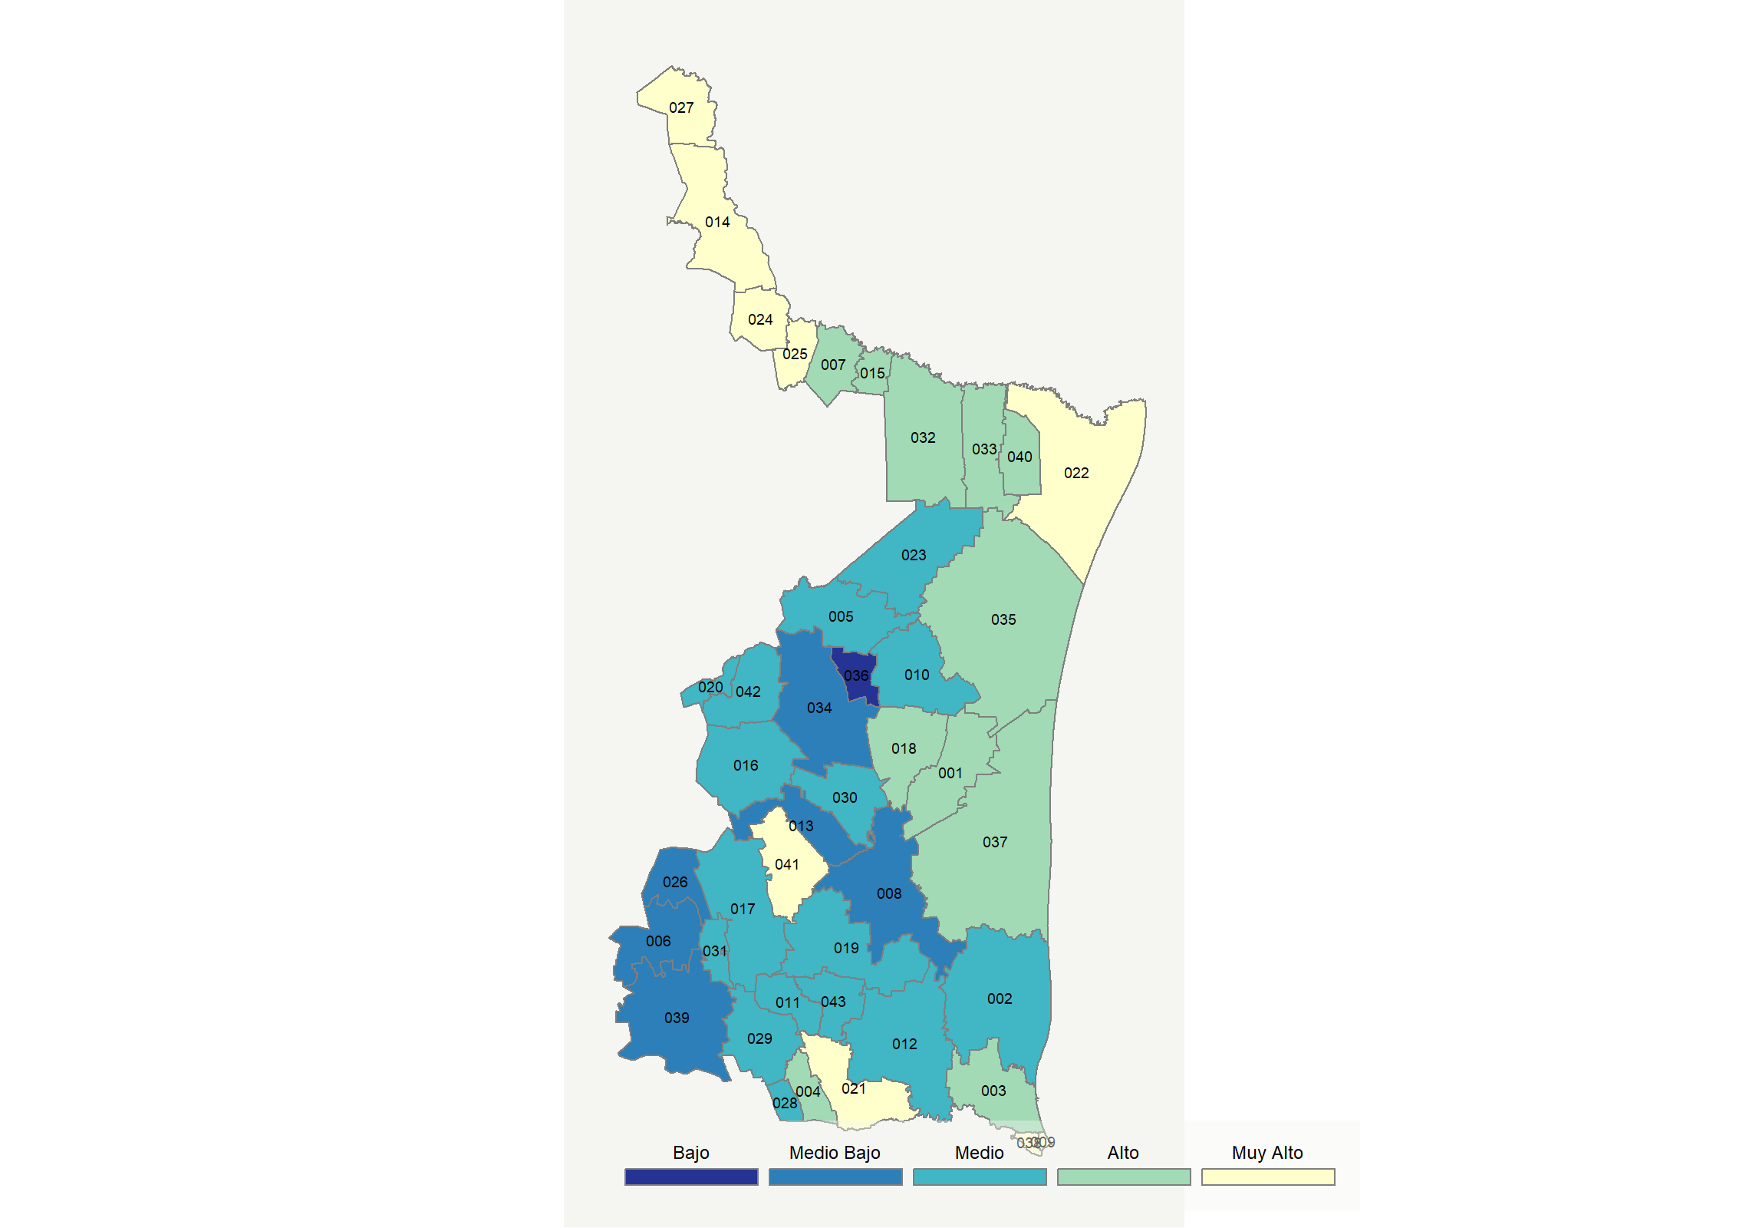

|  |  |  |  |  |  |  |  |  |  |  |  |  |  |
| --- | --- | --- | --- | --- | --- | --- | --- | --- | --- | --- | --- | --- | --- |
| **Clave del Municipio** | **Municipio** | **Telefonía fija a** | **Telefonía Celular a** | **Internet a** | **Televisión de paga a** | **Población Total a** | **Hasta 2 Salarios Mínimos b** | **Índice de Marginación** | **índice** | **Índice Escala 0-100** | **Lugar Nacional** | **Lugar Estatal** | **Estrato** |
| 001 | Abasolo | 15.0 | 84.0 | 9.0 | 61.2 | 12100 | 56.2 | -0.56 | 0.44 | 38.6 | 678 | 19 | Alto |
| 002 | Aldama | 11.7 | 78.3 | 10.9 | 63.6 | 29183 | 55.9 | -0.48 | 0.40 | 37.8 | 720 | 21 | Medio |
| 003 | Altamira | 22.7 | 89.1 | 33.5 | 53.9 | 235066 | 36.1 | -1.26 | 1.12 | 52.1 | 251 | 10 | Alto |
| 004 | Antiguo Morelos | 19.5 | 72.9 | 9.9 | 60.0 | 9902 | 68.5 | -0.06 | 0.41 | 38.0 | 710 | 20 | Alto |
| 005 | Burgos | 33.0 | 62.4 | 7.4 | 40.5 | 4428 | 43.3 | -0.24 | 0.25 | 34.9 | 866 | 26 | Medio |
| 006 | Bustamante | 10.4 | 31.1 | 0.3 | 34.2 | 8062 | 69.9 | 1.19 | -0.67 | 16.7 | 1902 | 42 | Medio Bajo |
| 007 | Camargo | 25.7 | 80.0 | 23.2 | 54.5 | 15762 | 29.7 | -1.26 | 0.84 | 46.6 | 367 | 13 | Alto |
| 008 | Casas * | 2.7 | 74.6 | 3.5 | 16.1 | 4179 | 60.2 | 0.22 | -0.49 | 20.2 | 1724 | 41 | Medio Bajo |
| 009 | Ciudad Madero | 53.5 | 90.4 | 52.2 | 59.5 | 209175 | 30.7 | -1.69 | 2.16 | 72.6 | 29 | 1 | Muy Alto |
| 010 | Cruillas * | 14.9 | 68.6 | 5.1 | 47.6 | 1937 | 48.9 | -0.03 | 0.04 | 30.7 | 1106 | 33 | Medio |
| 011 | Gómez Farías | 6.9 | 81.1 | 5.6 | 39.4 | 9186 | 71.9 | -0.14 | -0.05 | 28.9 | 1196 | 36 | Medio |
| 012 | González | 20.3 | 71.3 | 11.3 | 51.2 | 43757 | 63.4 | -0.29 | 0.35 | 36.8 | 773 | 25 | Medio |
| 013 | Güémez | 6.8 | 78.1 | 8.4 | 25.7 | 15560 | 63.6 | -0.11 | -0.17 | 26.7 | 1334 | 38 | Medio Bajo |
| 014 | Guerrero | 40.3 | 81.9 | 36.0 | 63.7 | 4439 | 29.1 | -1.16 | 1.52 | 59.8 | 118 | 6 | Muy Alto |
| 015 | Gustavo Díaz Ordaz | 28.1 | 79.8 | 27.3 | 31.7 | 15398 | 38.4 | -1.13 | 0.73 | 44.2 | 440 | 15 | Alto |
| 016 | Hidalgo | 10.4 | 75.8 | 7.2 | 38.1 | 22799 | 68.4 | -0.08 | -0.02 | 29.5 | 1163 | 34 | Medio |
| 017 | Jaumave | 16.9 | 57.1 | 15.3 | 60.5 | 15296 | 57.8 | -0.35 | 0.35 | 36.8 | 771 | 24 | Medio |
| 018 | Jiménez | 16.5 | 83.3 | 14.6 | 49.2 | 8165 | 55.8 | -0.70 | 0.46 | 38.9 | 654 | 18 | Alto |
| 019 | Llera | 10.4 | 71.3 | 7.7 | 47.5 | 16555 | 66.0 | 0.07 | 0.05 | 31.0 | 1094 | 32 | Medio |
| 020 | Mainero * | 20.8 | 70.7 | 12.3 | 50.1 | 2493 | 56.3 | -0.34 | 0.36 | 37.0 | 756 | 23 | Medio |
| 021 | El Mante | 37.1 | 82.1 | 32.8 | 48.8 | 117648 | 50.0 | -1.06 | 1.22 | 54.0 | 213 | 9 | Muy Alto |
| 022 | Matamoros | 35.8 | 86.4 | 37.3 | 40.2 | 520367 | 38.7 | -1.30 | 1.25 | 54.7 | 204 | 8 | Muy Alto |
| 023 | Méndez | 9.1 | 82.1 | 11.8 | 47.6 | 4122 | 46.6 | -0.17 | 0.24 | 34.6 | 879 | 28 | Medio |
| 024 | Mier | 44.5 | 79.0 | 32.4 | 57.5 | 4326 | 37.3 | -1.10 | 1.40 | 57.6 | 143 | 7 | Muy Alto |
| 025 | Miguel Alemán | 45.0 | 85.4 | 37.5 | 66.1 | 27447 | 27.4 | -1.56 | 1.69 | 63.3 | 79 | 4 | Muy Alto |
| 026 | Miquihuana * | 23.9 | 3.3 | 10.5 | 41.6 | 3555 | 70.6 | 0.74 | -0.39 | 22.1 | 1612 | 39 | Medio Bajo |
| 027 | Nuevo Laredo | 47.2 | 81.0 | 42.4 | 48.2 | 399431 | 31.5 | -1.44 | 1.60 | 61.5 | 99 | 5 | Muy Alto |
| 028 | Nuevo Morelos * | 9.8 | 83.3 | 5.8 | 58.1 | 3551 | 65.9 | -0.17 | 0.23 | 34.5 | 885 | 29 | Medio |
| 029 | Ocampo | 23.4 | 63.6 | 6.2 | 54.9 | 13828 | 56.9 | -0.25 | 0.24 | 34.6 | 878 | 27 | Medio |
| 030 | Padilla | 15.2 | 76.8 | 13.4 | 29.9 | 13927 | 57.2 | -0.66 | 0.13 | 32.5 | 995 | 31 | Medio |
| 031 | Palmillas * | 25.4 | 58.4 | 10.1 | 47.5 | 1705 | 60.6 | -0.02 | 0.23 | 34.4 | 890 | 30 | Medio |
| 032 | Reynosa | 28.2 | 89.5 | 32.1 | 44.8 | 646202 | 35.3 | -1.43 | 1.09 | 51.3 | 262 | 11 | Alto |
| 033 | Río Bravo | 27.8 | 83.2 | 30.1 | 33.3 | 126887 | 41.5 | -1.12 | 0.84 | 46.5 | 370 | 14 | Alto |
| 034 | San Carlos | 23.4 | 32.9 | 2.7 | 24.4 | 8723 | 64.9 | 0.23 | -0.49 | 20.3 | 1719 | 40 | Medio Bajo |
| 035 | San Fernando | 20.9 | 78.8 | 17.8 | 58.7 | 55981 | 50.7 | -0.51 | 0.67 | 43.1 | 474 | 16 | Alto |
| 036 | San Nicolás * | 0.3 | 8.2 | 0.3 | 46.4 | 1038 | 74.4 | 0.71 | -0.93 | 11.6 | 2114 | 43 | Bajo |
| 037 | Soto la Marina | 17.6 | 76.3 | 19.4 | 50.4 | 25419 | 50.0 | -0.36 | 0.54 | 40.5 | 574 | 17 | Alto |
| 038 | Tampico | 52.8 | 89.1 | 52.4 | 57.6 | 314418 | 33.9 | -1.69 | 2.12 | 71.8 | 32 | 2 | Muy Alto |
| 039 | Tula | 14.4 | 49.5 | 8.7 | 43.7 | 29560 | 66.2 | 0.30 | -0.12 | 27.7 | 1276 | 37 | Medio Bajo |
| 040 | Valle Hermoso | 31.2 | 84.9 | 28.4 | 35.3 | 64188 | 49.5 | -1.04 | 0.89 | 47.6 | 340 | 12 | Alto |
| 041 | Victoria | 37.1 | 90.1 | 51.0 | 53.6 | 346029 | 29.9 | -1.56 | 1.79 | 65.3 | 63 | 3 | Muy Alto |
| 042 | Villagrán | 19.0 | 60.9 | 7.7 | 35.4 | 6165 | 63.9 | -0.05 | -0.04 | 29.1 | 1188 | 35 | Medio |
| 043 | Xicoténcatl | 16.8 | 81.1 | 12.1 | 49.3 | 23739 | 55.4 | -0.68 | 0.38 | 37.4 | 734 | 22 | Medio |
| a Porcentaje de viviendas que cuentas con el servicio  b Ingreso por trabajo de la población ocupada en porcentaje  Fuente: Elaboración propia con datos de Encuesta Intercensal 2015 de INEGI y CONAPO | | | | | | | | | | | | | |

**Tlaxcala**

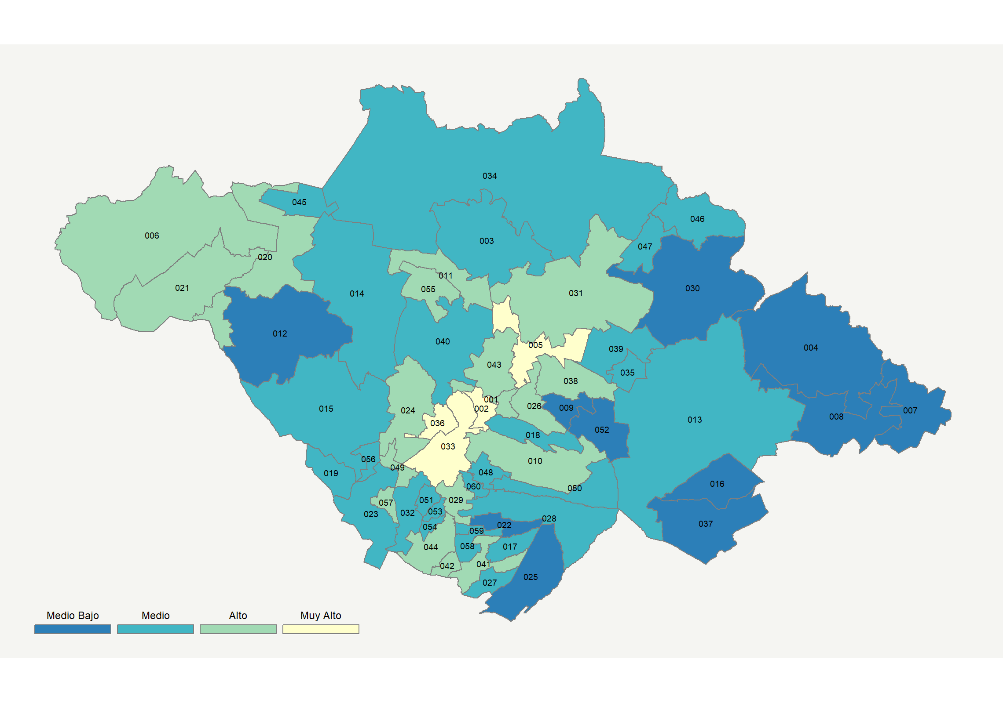

|  |  |  |  |  |  |  |  |  |  |  |  |  |  |
| --- | --- | --- | --- | --- | --- | --- | --- | --- | --- | --- | --- | --- | --- |
| **Clave del Municipio** | **Municipio** | **Telefonía fija a** | **Telefonía Celular a** | **Internet a** | **Televisión de paga a** | **Población Total a** | **Hasta 2 Salarios Mínimos b** | **Índice de Marginación** | **índice** | **Índice Escala 0-100** | **Lugar Nacional** | **Lugar Estatal** | **Estrato** |
| 001 | Amaxac de Guerrero | 32.2 | 75.9 | 25.9 | 40.4 | 11,144.00 | 51.3 | -1.25 | 0.82 | 46.1 | 383 | 7 | Alto |
| 002 | Apetatitlán de Antonio Carvajal | 36.9 | 82.6 | 33.5 | 47.0 | 15,271.00 | 43.2 | -1.15 | 1.22 | 54.0 | 212 | 4 | Muy Alto |
| 003 | Atlangatepec | 20.0 | 71.7 | 3.6 | 45.6 | 6,597.00 | 62.4 | -0.28 | 0.09 | 31.8 | 1038 | 40 | Medio |
| 004 | Atltzayanca | 9.7 | 58.7 | 2.1 | 14.1 | 17,173.00 | 68.5 | -0.01 | -0.59 | 18.3 | 1829 | 59 | Medio Bajo |
| 005 | Apizaco | 32.6 | 85.8 | 33.2 | 69.7 | 78,624.00 | 42.3 | -1.55 | 1.42 | 58.0 | 138 | 2 | Muy Alto |
| 006 | Calpulalpan | 21.4 | 78.7 | 16.3 | 58.9 | 48,385.00 | 51.3 | -1.08 | 0.64 | 42.6 | 495 | 13 | Alto |
| 007 | El Carmen Tequexquitla | 10.3 | 67.7 | 6.1 | 17.3 | 17,259.00 | 54.3 | -0.47 | -0.36 | 22.8 | 1573 | 54 | Medio Bajo |
| 008 | Cuapiaxtla | 7.7 | 69.5 | 4.7 | 21.0 | 15,337.00 | 59.5 | -0.55 | -0.38 | 22.4 | 1594 | 55 | Medio Bajo |
| 009 | Cuaxomulco | 9.1 | 76.1 | 4.4 | 27.0 | 5,272.00 | 56.1 | -0.71 | -0.23 | 25.4 | 1420 | 53 | Medio Bajo |
| 010 | Chiautempan | 32.8 | 76.7 | 25.6 | 35.0 | 70,011.00 | 51.7 | -1.25 | 0.77 | 45.1 | 420 | 9 | Alto |
| 011 | Muñoz de Domingo Arenas | 29.2 | 64.9 | 10.0 | 64.2 | 4,679.00 | 56.5 | -0.69 | 0.54 | 40.6 | 571 | 16 | Alto |
| 012 | Españita | 9.0 | 63.3 | 1.5 | 26.3 | 8,668.00 | 66.0 | -0.22 | -0.44 | 21.3 | 1657 | 57 | Medio Bajo |
| 013 | Huamantla | 15.4 | 70.0 | 13.1 | 25.5 | 92,887.00 | 57.0 | -0.72 | 0.01 | 30.1 | 1134 | 45 | Medio |
| 014 | Hueyotlipan | 26.3 | 61.7 | 11.1 | 50.7 | 14,575.00 | 51.2 | -0.57 | 0.34 | 36.6 | 779 | 24 | Medio |
| 015 | Ixtacuixtla de Mariano Matamoros | 22.1 | 71.4 | 17.4 | 31.2 | 38,324.00 | 51.5 | -0.91 | 0.30 | 35.8 | 821 | 27 | Medio |
| 016 | Ixtenco | 17.8 | 70.6 | 11.6 | 9.8 | 7,080.00 | 60.8 | -0.83 | -0.16 | 26.8 | 1328 | 52 | Medio Bajo |
| 017 | Mazatecochco de José María Morelos | 28.3 | 65.8 | 12.1 | 5.9 | 10,901.00 | 67.8 | -0.63 | -0.06 | 28.6 | 1219 | 49 | Medio |
| 018 | Contla de Juan Cuamatzi | 23.4 | 71.7 | 16.9 | 22.3 | 38,330.00 | 66.0 | -0.79 | 0.21 | 34.1 | 905 | 33 | Medio |
| 019 | Tepetitla de Lardizábal | 19.4 | 75.2 | 14.1 | 21.4 | 21,060.00 | 54.7 | -1.03 | 0.10 | 32.0 | 1029 | 39 | Medio |
| 020 | Sanctórum de Lázaro Cárdenas | 27.5 | 73.4 | 11.0 | 51.7 | 9,490.00 | 57.9 | -0.54 | 0.48 | 39.4 | 623 | 18 | Alto |
| 021 | Nanacamilpa de Mariano Arista | 24.7 | 79.8 | 18.1 | 49.5 | 18,115.00 | 62.4 | -0.89 | 0.65 | 42.7 | 492 | 12 | Alto |
| 022 | Acuamanala de Miguel Hidalgo | 20.2 | 67.1 | 11.3 | 10.5 | 5,925.00 | 65.1 | -0.66 | -0.15 | 26.9 | 1324 | 51 | Medio Bajo |
| 023 | Natívitas | 29.5 | 59.7 | 18.3 | 17.4 | 25,053.00 | 57.8 | -0.66 | 0.17 | 33.3 | 957 | 36 | Medio |
| 024 | Panotla | 29.7 | 73.0 | 27.4 | 37.6 | 27,154.00 | 42.3 | -1.09 | 0.75 | 44.8 | 427 | 10 | Alto |
| 025 | San Pablo del Monte | 28.3 | 61.0 | 13.0 | 5.0 | 77,242.00 | 42.3 | -0.79 | -0.10 | 28.0 | 1258 | 50 | Medio Bajo |
| 026 | Santa Cruz Tlaxcala | 19.3 | 81.6 | 17.5 | 44.1 | 20,242.00 | 46.8 | -1.01 | 0.50 | 39.8 | 605 | 17 | Alto |
| 027 | Tenancingo | 36.9 | 68.1 | 17.7 | 9.0 | 12,834.00 | 58.6 | -0.90 | 0.27 | 35.3 | 841 | 29 | Medio |
| 028 | Teolocholco | 25.5 | 66.9 | 17.4 | 13.9 | 24,380.00 | 60.9 | -0.82 | 0.12 | 32.3 | 1009 | 37 | Medio |
| 029 | Tepeyanco | 28.7 | 77.1 | 19.9 | 23.0 | 12,047.00 | 50.4 | -0.97 | 0.44 | 38.5 | 681 | 22 | Alto |
| 030 | Terrenate | 11.7 | 51.7 | 3.9 | 31.8 | 14,746.00 | 60.9 | -0.05 | -0.39 | 22.3 | 1605 | 56 | Medio Bajo |
| 031 | Tetla de la Solidaridad | 20.0 | 84.2 | 20.9 | 59.7 | 32,613.00 | 51.8 | -1.08 | 0.79 | 45.5 | 400 | 8 | Alto |
| 032 | Tetlatlahuca | 25.8 | 68.1 | 15.0 | 13.9 | 13,414.00 | 56.0 | -0.84 | 0.08 | 31.5 | 1057 | 41 | Medio |
| 033 | Tlaxcala | 44.9 | 87.2 | 46.9 | 51.5 | 95,051.00 | 35.3 | -1.69 | 1.77 | 64.9 | 67 | 1 | Muy Alto |
| 034 | Tlaxco | 20.7 | 67.7 | 8.3 | 52.1 | 42,536.00 | 67.5 | -0.43 | 0.25 | 34.9 | 863 | 31 | Medio |
| 035 | Tocatlán | 23.4 | 64.5 | 14.4 | 31.6 | 5,843.00 | 49.4 | -1.21 | 0.19 | 33.6 | 940 | 34 | Medio |
| 036 | Totolac | 40.7 | 84.8 | 36.0 | 45.3 | 21,814.00 | 33.5 | -1.42 | 1.35 | 56.5 | 163 | 3 | Muy Alto |
| 037 | Ziltlaltépec de Trinidad Sánchez Santos | 9.0 | 52.2 | 4.3 | 7.1 | 8,955.00 | 73.9 | -0.06 | -0.69 | 16.3 | 1915 | 60 | Medio Bajo |
| 038 | Tzompantepec | 20.4 | 82.8 | 22.9 | 48.7 | 16,359.00 | 50.0 | -1.14 | 0.71 | 44.0 | 450 | 11 | Alto |
| 039 | Xaloztoc | 19.9 | 75.6 | 13.3 | 35.5 | 23,905.00 | 56.6 | -0.85 | 0.25 | 34.9 | 865 | 32 | Medio |
| 040 | Xaltocan | 22.8 | 68.7 | 11.6 | 41.5 | 10,263.00 | 65.2 | -0.47 | 0.26 | 35.0 | 862 | 30 | Medio |
| 041 | Papalotla de Xicohténcatl | 38.7 | 68.5 | 22.0 | 13.0 | 30,364.00 | 52.9 | -1.15 | 0.45 | 38.9 | 658 | 20 | Alto |
| 042 | Xicohtzinco | 48.5 | 72.7 | 29.8 | 15.3 | 13,629.00 | 44.9 | -1.50 | 0.87 | 47.1 | 353 | 6 | Alto |
| 043 | Yauhquemehcan | 24.7 | 87.3 | 30.4 | 58.4 | 38,296.00 | 44.7 | -1.34 | 1.12 | 52.0 | 254 | 5 | Alto |
| 044 | Zacatelco | 38.1 | 72.4 | 24.3 | 15.7 | 42,686.00 | 53.6 | -1.30 | 0.57 | 41.2 | 552 | 15 | Alto |
| 045 | Benito Juárez | 25.3 | 70.5 | 14.8 | 39.6 | 6,038.00 | 46.4 | -1.05 | 0.37 | 37.3 | 741 | 23 | Medio |
| 046 | Emiliano Zapata | 12.1 | 56.5 | 0.6 | 65.2 | 4,561.00 | 77.8 | 0.03 | -0.04 | 29.1 | 1185 | 46 | Medio |
| 047 | Lázaro Cárdenas | 21.3 | 69.0 | 4.7 | 62.9 | 3,103.00 | 66.0 | -0.38 | 0.31 | 36.0 | 809 | 26 | Medio |
| 048 | La Magdalena Tlaltelulco | 24.3 | 69.1 | 14.8 | 15.0 | 18,873.00 | 52.2 | -1.10 | 0.07 | 31.3 | 1066 | 42 | Medio |
| 049 | San Damián Texóloc | 32.8 | 71.2 | 21.8 | 31.2 | 5,569.00 | 42.0 | -1.45 | 0.58 | 41.4 | 543 | 14 | Alto |
| 050 | San Francisco Tetlanohcan | 31.7 | 61.3 | 15.3 | 9.1 | 10,910.00 | 60.0 | -0.90 | 0.06 | 31.1 | 1084 | 43 | Medio |
| 051 | San Jerónimo Zacualpan | 31.5 | 71.1 | 17.2 | 19.5 | 3,767.00 | 42.3 | -1.03 | 0.31 | 36.1 | 800 | 25 | Medio |
| 052 | San José Teacalco | 8.1 | 70.8 | 2.0 | 18.8 | 5,923.00 | 59.6 | -0.73 | -0.45 | 21.1 | 1674 | 58 | Medio Bajo |
| 053 | San Juan Huactzinco | 25.4 | 74.0 | 16.0 | 16.0 | 7,511.00 | 50.3 | -1.14 | 0.18 | 33.4 | 951 | 35 | Medio |
| 054 | San Lorenzo Axocomanitla | 32.0 | 73.7 | 17.8 | 12.4 | 5,618.00 | 54.7 | -1.27 | 0.29 | 35.6 | 833 | 28 | Medio |
| 055 | San Lucas Tecopilco | 29.8 | 60.6 | 9.5 | 62.1 | 3,131.00 | 53.9 | -0.62 | 0.47 | 39.3 | 634 | 19 | Alto |
| 056 | Santa Ana Nopalucan | 16.7 | 68.9 | 11.4 | 22.1 | 7,773.00 | 52.4 | -1.04 | -0.06 | 28.7 | 1213 | 48 | Medio |
| 057 | Santa Apolonia Teacalco | 42.6 | 53.3 | 22.6 | 18.9 | 4,559.00 | 54.6 | -0.75 | 0.45 | 38.8 | 665 | 21 | Alto |
| 058 | Santa Catarina Ayometla | 33.3 | 60.4 | 16.9 | 9.0 | 8,817.00 | 59.3 | -1.03 | 0.12 | 32.2 | 1012 | 38 | Medio |
| 059 | Santa Cruz Quilehtla | 29.5 | 65.0 | 10.9 | 7.8 | 7,169.00 | 69.4 | -0.58 | -0.06 | 28.8 | 1208 | 47 | Medio |
| 060 | Santa Isabel Xiloxoxtla | 24.0 | 71.6 | 14.3 | 9.7 | 4,992.00 | 64.6 | -0.59 | 0.02 | 30.3 | 1130 | 44 | Medio |
| a Porcentaje de viviendas que cuentas con el servicio  b Ingreso por trabajo de la población ocupada en porcentaje  Fuente: Elaboración propia con datos de Encuesta Intercensal 2015 de INEGI y CONAPO | | | | | | | | | | | | | |

**Veracruz**

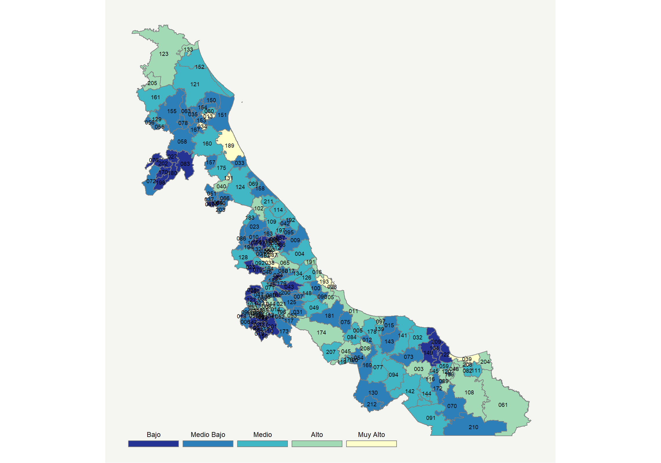

|  |  |  |  |  |  |  |  |  |  |  |  |  |  |
| --- | --- | --- | --- | --- | --- | --- | --- | --- | --- | --- | --- | --- | --- |
| **Clave del Municipio** | **Municipio** | **Telefonía fija a** | **Telefonía Celular a** | **Internet a** | **Televisión de paga a** | **Población Total a** | **Hasta 2 Salarios Mínimos b** | **Índice de Marginación** | **índice** | **Índice Escala 0-100** | **Lugar Nacional** | **Lugar Estatal** | **Estrato** |
| 001 | Acajete | 17.4 | 58.7 | 8.1 | 17.5 | 8,819 | 61.2 | 0.14 | -0.28 | 24.4 | 1480 | 121 | Medio Bajo |
| 002 | Acatlán | 13.3 | 59.2 | 4.5 | 7.8 | 3,147 | 76.0 | -0.03 | -0.54 | 19.3 | 1772 | 156 | Medio Bajo |
| 003 | Acayucan | 22.1 | 77.0 | 17.4 | 40.6 | 87,267 | 59.2 | -0.26 | 0.46 | 39.0 | 651 | 37 | Alto |
| 004 | Actopan | 25.6 | 59.6 | 10.7 | 23.8 | 43,388 | 62.6 | -0.18 | 0.00 | 29.9 | 1148 | 89 | Medio |
| 005 | Acula | 10.1 | 78.8 | 13.7 | 34.8 | 5,350 | 66.4 | 0.36 | 0.12 | 32.4 | 1003 | 69 | Medio |
| 006 | Acultzingo | 3.4 | 58.1 | 6.0 | 19.7 | 22,969 | 59.6 | 0.67 | -0.54 | 19.2 | 1778 | 158 | Medio Bajo |
| 007 | Camarón de Tejeda | 14.2 | 59.3 | 6.4 | 7.3 | 6,426 | 72.7 | 0.26 | -0.48 | 20.4 | 1710 | 148 | Medio Bajo |
| 008 | Alpatláhuac | 10.5 | 27.0 | 2.5 | 22.0 | 10,189 | 77.8 | 0.97 | -0.79 | 14.3 | 2017 | 181 | Bajo |
| 009 | Alto Lucero de Gutiérrez Barrios | 27.4 | 45.0 | 8.1 | 27.2 | 28,922 | 64.4 | -0.02 | -0.14 | 27.1 | 1309 | 100 | Medio Bajo |
| 010 | Altotonga | 13.7 | 56.0 | 13.3 | 21.1 | 65,548 | 66.6 | 0.39 | -0.20 | 25.9 | 1383 | 108 | Medio Bajo |
| 011 | Alvarado | 23.2 | 76.0 | 27.6 | 51.0 | 52,927 | 45.2 | -0.65 | 0.83 | 46.3 | 379 | 25 | Alto |
| 012 | Amatitlán | 20.4 | 53.1 | 2.1 | 30.8 | 7,987 | 56.0 | 0.18 | -0.28 | 24.3 | 1485 | 122 | Medio Bajo |
| 013 | Naranjos Amatlán | 40.1 | 80.6 | 32.0 | 56.2 | 28,295 | 47.5 | -0.92 | 1.32 | 56.0 | 172 | 9 | Muy Alto |
| 014 | Amatlán de los Reyes | 21.3 | 75.0 | 17.5 | 33.7 | 45,430 | 58.0 | -0.43 | 0.35 | 36.9 | 765 | 50 | Medio |
| 015 | Angel R. Cabada | 12.0 | 67.5 | 7.9 | 21.2 | 33,730 | 65.0 | 0.07 | -0.25 | 25.1 | 1443 | 116 | Medio Bajo |
| 016 | La Antigua | 29.6 | 84.8 | 29.3 | 33.3 | 26,920 | 36.4 | -1.20 | 0.87 | 47.0 | 357 | 24 | Alto |
| 017 | Apazapan | 27.9 | 60.7 | 12.3 | 22.4 | 4,009 | 55.4 | -0.46 | 0.07 | 31.3 | 1069 | 76 | Medio |
| 018 | Aquila | 0.8 | 36.8 | 0.6 | 2.1 | 1,924 | 83.9 | 1.57 | -1.13 | 7.7 | 2255 | 208 | Bajo |
| 019 | Astacinga | 12.4 | 49.5 | 0.6 | 7.1 | 6,534 | 68.3 | 1.40 | -0.75 | 15.1 | 1980 | 178 | Bajo |
| 020 | Atlahuilco | 3.3 | 18.1 | 0.5 | 4.6 | 10,933 | 76.4 | 1.89 | -1.24 | 5.4 | 2323 | 210 | Bajo |
| 021 | Atoyac | 23.7 | 69.6 | 17.3 | 44.7 | 23,896 | 66.7 | -0.29 | 0.46 | 38.9 | 657 | 38 | Alto |
| 022 | Atzacan | 13.1 | 59.0 | 6.3 | 16.4 | 21,360 | 73.3 | 0.48 | -0.40 | 21.9 | 1623 | 137 | Medio Bajo |
| 023 | Atzalan | 6.7 | 49.8 | 6.4 | 16.5 | 50,873 | 76.0 | 0.81 | -0.60 | 18.1 | 1834 | 164 | Medio Bajo |
| 024 | Tlaltetela | 10.2 | 61.1 | 6.3 | 5.5 | 15,818 | 75.9 | 0.52 | -0.56 | 19.0 | 1792 | 161 | Medio Bajo |
| 025 | Ayahualulco | 8.9 | 33.3 | 1.7 | 14.2 | 26,694 | 75.5 | 1.46 | -0.86 | 12.9 | 2070 | 188 | Bajo |
| 026 | Banderilla | 32.7 | 85.7 | 36.4 | 42.8 | 24,822 | 38.2 | -1.23 | 1.21 | 53.7 | 218 | 15 | Alto |
| 027 | Benito Juárez | 10.0 | 17.4 | 2.4 | 14.3 | 17,618 | 68.2 | 0.92 | -0.98 | 10.5 | 2160 | 201 | Bajo |
| 028 | Boca del Río | 49.7 | 90.4 | 51.9 | 56.3 | 142,207 | 24.0 | -1.72 | 2.06 | 70.5 | 39 | 2 | Muy Alto |
| 029 | Calcahualco | 13.5 | 19.0 | 0.6 | 12.3 | 12,929 | 77.5 | 1.22 | -0.98 | 10.7 | 2153 | 198 | Bajo |
| 030 | Camerino Z. Mendoza | 36.1 | 71.6 | 30.9 | 32.9 | 42,347 | 52.5 | -0.43 | 0.88 | 47.3 | 346 | 23 | Alto |
| 031 | Carrillo Puerto | 3.7 | 71.6 | 4.1 | 5.0 | 16,996 | 81.0 | 0.75 | -0.62 | 17.7 | 1859 | 167 | Medio Bajo |
| 032 | Catemaco | 16.5 | 67.9 | 12.9 | 38.1 | 49,651 | 67.6 | 0.11 | 0.14 | 32.7 | 982 | 65 | Medio |
| 033 | Cazones de Herrera | 14.2 | 58.0 | 3.9 | 18.5 | 23,675 | 67.1 | 0.50 | -0.43 | 21.4 | 1651 | 141 | Medio Bajo |
| 034 | Cerro Azul | 44.3 | 78.6 | 36.1 | 50.0 | 26,807 | 41.8 | -1.20 | 1.40 | 57.5 | 145 | 8 | Muy Alto |
| 035 | Citlaltépetl | 10.3 | 66.3 | 7.4 | 33.5 | 12,109 | 72.5 | 0.35 | -0.16 | 26.7 | 1332 | 104 | Medio Bajo |
| 036 | Coacoatzintla | 11.3 | 75.3 | 9.3 | 21.0 | 10,482 | 67.7 | 0.23 | -0.15 | 27.0 | 1315 | 101 | Medio Bajo |
| 037 | Coahuitlán | 10.4 | 60.0 | 0.9 | 18.6 | 8,566 | 82.1 | 1.35 | -0.55 | 19.2 | 1781 | 159 | Medio Bajo |
| 038 | Coatepec | 40.8 | 80.2 | 37.0 | 40.8 | 92,127 | 40.4 | -1.03 | 1.28 | 55.1 | 193 | 12 | Muy Alto |
| 039 | Coatzacoalcos | 33.6 | 89.3 | 41.8 | 45.3 | 319,187 | 29.9 | -1.38 | 1.41 | 57.8 | 142 | 7 | Muy Alto |
| 040 | Coatzintla | 31.0 | 81.0 | 33.1 | 51.1 | 56,897 | 33.6 | -0.83 | 1.14 | 52.4 | 242 | 18 | Alto |
| 041 | Coetzala | 3.3 | 50.7 | 1.8 | 15.6 | 2,236 | 71.9 | 1.07 | -0.77 | 14.8 | 1993 | 179 | Bajo |
| 042 | Colipa | 17.9 | 54.5 | 7.1 | 32.9 | 5,718 | 68.1 | 0.52 | -0.17 | 26.7 | 1335 | 105 | Medio Bajo |
| 043 | Comapa | 12.8 | 48.6 | 2.3 | 4.5 | 19,859 | 77.7 | 0.98 | -0.74 | 15.3 | 1965 | 175 | Bajo |
| 044 | Córdoba | 34.0 | 82.2 | 33.6 | 44.4 | 218,153 | 46.5 | -1.06 | 1.14 | 52.5 | 240 | 17 | Alto |
| 045 | Cosamaloapan de Carpio | 25.6 | 79.8 | 20.0 | 38.7 | 57,147 | 49.0 | -0.55 | 0.59 | 41.5 | 535 | 32 | Alto |
| 046 | Cosautlán de Carvajal | 14.5 | 50.7 | 4.5 | 7.3 | 16,353 | 76.0 | 0.48 | -0.61 | 17.9 | 1847 | 166 | Medio Bajo |
| 047 | Coscomatepec | 10.9 | 59.1 | 8.4 | 22.3 | 58,479 | 61.2 | 0.64 | -0.33 | 23.5 | 1532 | 125 | Medio Bajo |
| 048 | Cosoleacaque | 21.8 | 85.1 | 24.4 | 47.7 | 129,527 | 39.8 | -0.71 | 0.78 | 45.4 | 406 | 26 | Alto |
| 049 | Cotaxtla | 8.7 | 74.3 | 26.5 | 20.5 | 21,013 | 56.8 | 0.15 | 0.21 | 34.0 | 915 | 62 | Medio |
| 050 | Coxquihui | 6.5 | 55.3 | 5.0 | 9.0 | 16,754 | 72.4 | 1.70 | -0.67 | 16.8 | 1900 | 170 | Medio Bajo |
| 051 | Coyutla | 16.9 | 50.2 | 5.1 | 15.4 | 22,570 | 77.0 | 0.99 | -0.47 | 20.7 | 1696 | 147 | Medio Bajo |
| 052 | Cuichapa | 15.5 | 65.7 | 13.5 | 28.1 | 12,238 | 59.3 | -0.16 | 0.00 | 30.0 | 1139 | 87 | Medio |
| 053 | Cuitláhuac | 25.5 | 75.5 | 21.2 | 26.3 | 27,940 | 54.4 | -0.48 | 0.43 | 38.4 | 687 | 42 | Alto |
| 054 | Chacaltianguis | 15.9 | 68.5 | 9.4 | 19.6 | 12,494 | 65.5 | 0.10 | -0.16 | 26.9 | 1327 | 103 | Medio Bajo |
| 055 | Chalma | 14.3 | 59.2 | 3.8 | 43.7 | 13,479 | 62.0 | 0.67 | -0.14 | 27.2 | 1304 | 99 | Medio Bajo |
| 056 | Chiconamel | 12.1 | 52.4 | 1.1 | 46.4 | 6,684 | 68.7 | 1.05 | -0.28 | 24.5 | 1472 | 120 | Medio Bajo |
| 057 | Chiconquiaco | 15.9 | 31.8 | 2.4 | 7.0 | 14,394 | 83.6 | 1.00 | -0.82 | 13.7 | 2041 | 185 | Bajo |
| 058 | Chicontepec | 16.0 | 39.2 | 4.7 | 15.4 | 55,844 | 67.0 | 0.32 | -0.60 | 18.0 | 1841 | 165 | Medio Bajo |
| 059 | Chinameca | 17.7 | 71.3 | 13.8 | 32.9 | 16,241 | 48.6 | -0.18 | 0.16 | 33.0 | 965 | 64 | Medio |
| 060 | Chinampa de Gorostiza | 11.0 | 71.3 | 8.3 | 35.7 | 16,741 | 68.8 | 0.37 | -0.05 | 28.8 | 1201 | 93 | Medio |
| 061 | Las Choapas | 20.1 | 64.9 | 16.5 | 54.0 | 81,827 | 57.1 | 0.51 | 0.44 | 38.5 | 680 | 41 | Alto |
| 062 | Chocamán | 7.9 | 65.5 | 6.8 | 19.7 | 21,102 | 64.6 | 0.11 | -0.38 | 22.5 | 1593 | 134 | Medio Bajo |
| 063 | Chontla | 11.0 | 58.7 | 5.0 | 31.1 | 14,565 | 74.4 | 0.56 | -0.31 | 23.8 | 1516 | 124 | Medio Bajo |
| 064 | Chumatlán | 7.7 | 48.1 | 5.9 | 4.4 | 3,880 | 71.2 | 1.46 | -0.75 | 15.2 | 1969 | 176 | Bajo |
| 065 | Emiliano Zapata | 29.4 | 83.7 | 36.3 | 37.2 | 78,336 | 39.6 | -0.86 | 1.07 | 50.9 | 271 | 19 | Alto |
| 066 | Espinal | 15.7 | 57.2 | 4.5 | 9.3 | 27,297 | 73.9 | 0.75 | -0.50 | 20.0 | 1736 | 150 | Medio Bajo |
| 067 | Filomeno Mata | 0.8 | 50.5 | 1.2 | 7.3 | 18,367 | 79.9 | 1.55 | -0.92 | 11.8 | 2106 | 191 | Bajo |
| 068 | Fortín | 37.5 | 82.1 | 39.9 | 41.3 | 66,168 | 47.3 | -0.97 | 1.32 | 55.9 | 174 | 10 | Muy Alto |
| 069 | Gutiérrez Zamora | 21.2 | 69.4 | 21.6 | 29.5 | 24,791 | 58.6 | -0.31 | 0.35 | 36.8 | 772 | 51 | Medio |
| 070 | Hidalgotitlán | 13.3 | 38.6 | 3.7 | 36.6 | 19,587 | 71.5 | 0.90 | -0.44 | 21.2 | 1664 | 143 | Medio Bajo |
| 071 | Huatusco | 21.5 | 74.3 | 19.1 | 25.3 | 60,674 | 61.9 | -0.13 | 0.29 | 35.7 | 828 | 55 | Medio |
| 072 | Huayacocotla | 10.4 | 56.0 | 4.4 | 25.0 | 21,391 | 63.1 | 0.35 | -0.43 | 21.4 | 1652 | 142 | Medio Bajo |
| 073 | Hueyapan de Ocampo | 14.2 | 49.0 | 6.4 | 22.5 | 43,309 | 62.2 | 0.36 | -0.42 | 21.7 | 1633 | 139 | Medio Bajo |
| 074 | Huiloapan de Cuauhtémoc | 22.6 | 74.9 | 21.7 | 24.2 | 7,221 | 51.3 | -0.55 | 0.37 | 37.2 | 746 | 48 | Medio |
| 075 | Ignacio de la Llave | 16.9 | 58.8 | 8.5 | 15.1 | 17,105 | 69.5 | 0.62 | -0.31 | 23.9 | 1510 | 123 | Medio Bajo |
| 076 | Ilamatlán | 11.4 | 12.4 | 0.4 | 19.8 | 13,474 | 79.6 | 2.14 | -1.00 | 10.2 | 2172 | 202 | Bajo |
| 077 | Isla | 16.6 | 75.2 | 12.0 | 32.7 | 43,349 | 58.4 | -0.13 | 0.13 | 32.6 | 988 | 66 | Medio |
| 078 | Ixcatepec | 12.9 | 53.2 | 4.9 | 21.4 | 13,591 | 79.7 | 0.63 | -0.45 | 21.1 | 1671 | 145 | Medio Bajo |
| 079 | Ixhuacán de los Reyes | 6.6 | 47.5 | 1.2 | 16.5 | 11,442 | 74.1 | 0.79 | -0.75 | 15.2 | 1973 | 177 | Bajo |
| 080 | Ixhuatlán del Café | 14.6 | 60.3 | 4.7 | 13.0 | 23,005 | 74.9 | 0.26 | -0.45 | 21.1 | 1670 | 144 | Medio Bajo |
| 081 | Ixhuatlancillo | 21.0 | 78.7 | 22.3 | 29.5 | 24,896 | 55.7 | -0.13 | 0.45 | 38.9 | 660 | 39 | Alto |
| 082 | Ixhuatlán del Sureste | 18.2 | 78.2 | 14.6 | 44.1 | 15,800 | 27.7 | -0.63 | 0.38 | 37.4 | 737 | 47 | Medio |
| 083 | Ixhuatlán de Madero | 8.5 | 16.2 | 2.0 | 11.1 | 54,132 | 66.8 | 1.26 | -1.07 | 8.9 | 2222 | 205 | Bajo |
| 084 | Ixmatlahuacan | 18.4 | 72.2 | 15.3 | 22.0 | 5,790 | 64.5 | 0.46 | 0.09 | 31.7 | 1041 | 73 | Medio |
| 085 | Ixtaczoquitlán | 25.6 | 80.6 | 23.4 | 43.6 | 68,823 | 51.1 | -0.73 | 0.73 | 44.4 | 439 | 27 | Alto |
| 086 | Jalacingo | 8.6 | 61.2 | 10.1 | 9.0 | 44,488 | 81.9 | 0.52 | -0.45 | 21.1 | 1676 | 146 | Medio Bajo |
| 087 | Xalapa | 46.4 | 90.1 | 49.2 | 47.0 | 480,841 | 32.2 | -1.51 | 1.83 | 66.0 | 59 | 3 | Muy Alto |
| 088 | Jalcomulco | 11.1 | 47.4 | 14.3 | 28.6 | 5,006 | 79.9 | 0.42 | -0.22 | 25.5 | 1414 | 112 | Medio Bajo |
| 089 | Jáltipan | 21.4 | 76.7 | 19.7 | 39.4 | 41,644 | 49.4 | -0.45 | 0.49 | 39.6 | 617 | 35 | Alto |
| 090 | Jamapa | 9.7 | 80.9 | 8.7 | 22.2 | 11,361 | 43.4 | -0.14 | -0.12 | 27.5 | 1286 | 97 | Medio Bajo |
| 091 | Jesús Carranza | 20.7 | 49.8 | 8.5 | 41.3 | 29,413 | 59.6 | 0.47 | -0.04 | 29.2 | 1184 | 92 | Medio |
| 092 | Xico | 21.1 | 58.8 | 18.9 | 21.8 | 38,198 | 58.0 | -0.21 | 0.09 | 31.7 | 1044 | 74 | Medio |
| 093 | Jilotepec | 26.1 | 69.6 | 19.2 | 45.4 | 16,682 | 55.5 | -0.21 | 0.55 | 40.7 | 566 | 33 | Alto |
| 094 | Juan Rodríguez Clara | 15.3 | 71.9 | 8.9 | 31.4 | 38,895 | 67.6 | 0.14 | -0.01 | 29.7 | 1152 | 90 | Medio |
| 095 | Juchique de Ferrer | 22.2 | 45.9 | 8.8 | 28.7 | 15,916 | 77.8 | 0.48 | -0.19 | 26.2 | 1367 | 107 | Medio Bajo |
| 096 | Landero y Coss | 22.9 | 16.2 | 4.7 | 1.5 | 1,534 | 79.4 | -0.04 | -0.87 | 12.7 | 2078 | 189 | Bajo |
| 097 | Lerdo de Tejada | 29.4 | 78.7 | 22.1 | 40.7 | 19,606 | 49.3 | -0.97 | 0.71 | 43.9 | 451 | 28 | Alto |
| 098 | Magdalena | 2.5 | 38.5 | 0.8 | 10.5 | 3,043 | 68.6 | 0.77 | -0.98 | 10.6 | 2157 | 200 | Bajo |
| 099 | Maltrata | 16.7 | 59.6 | 10.0 | 14.8 | 18,096 | 70.2 | 0.20 | -0.27 | 24.6 | 1466 | 118 | Medio Bajo |
| 100 | Manlio Fabio Altamirano | 12.8 | 70.9 | 7.6 | 20.9 | 23,408 | 47.0 | -0.41 | -0.21 | 25.7 | 1397 | 111 | Medio Bajo |
| 101 | Mariano Escobedo | 24.5 | 59.4 | 19.3 | 26.0 | 37,285 | 57.7 | -0.16 | 0.21 | 34.0 | 910 | 61 | Medio |
| 102 | Martínez de la Torre | 27.0 | 79.3 | 21.4 | 23.9 | 110,415 | 50.9 | -0.68 | 0.47 | 39.3 | 633 | 36 | Alto |
| 103 | Mecatlán | 1.8 | 44.0 | 3.5 | 3.6 | 12,332 | 73.1 | 1.79 | -0.95 | 11.2 | 2135 | 195 | Bajo |
| 104 | Mecayapan | 3.9 | 36.4 | 1.4 | 10.7 | 17,312 | 70.5 | 1.07 | -0.96 | 10.9 | 2144 | 196 | Bajo |
| 105 | Medellín de Bravo | 18.2 | 91.7 | 32.2 | 43.7 | 75,346 | 33.5 | -0.97 | 0.93 | 48.3 | 321 | 21 | Alto |
| 106 | Miahuatlán | 6.5 | 57.0 | 5.1 | 7.6 | 4,685 | 79.2 | 0.35 | -0.66 | 16.9 | 1893 | 168 | Medio Bajo |
| 107 | Las Minas | 2.6 | 25.4 | 0.2 | 10.7 | 2,920 | 60.1 | 1.02 | -1.12 | 7.8 | 2254 | 207 | Bajo |
| 108 | Minatitlán | 33.1 | 75.6 | 33.9 | 54.0 | 157,393 | 39.6 | -0.64 | 1.18 | 53.1 | 229 | 16 | Alto |
| 109 | Misantla | 20.3 | 65.3 | 14.6 | 38.7 | 64,249 | 67.0 | -0.19 | 0.23 | 34.4 | 894 | 58 | Medio |
| 110 | Mixtla de Altamirano | 0.8 | 18.0 | 0.1 | 2.7 | 11,646 | 82.6 | 3.33 | -1.32 | 3.9 | 2358 | 212 | Bajo |
| 111 | Moloacán | 15.3 | 76.5 | 15.1 | 51.2 | 17,504 | 39.4 | -0.22 | 0.40 | 37.9 | 715 | 45 | Medio |
| 112 | Naolinco | 17.3 | 72.0 | 13.2 | 22.0 | 21,816 | 65.1 | -0.36 | 0.02 | 30.3 | 1123 | 84 | Medio |
| 113 | Naranjal | 7.7 | 63.5 | 7.1 | 19.4 | 4,559 | 74.7 | 0.65 | -0.40 | 22.1 | 1614 | 136 | Medio Bajo |
| 114 | Nautla | 27.8 | 58.9 | 12.0 | 29.8 | 10,866 | 63.9 | -0.12 | 0.12 | 32.4 | 1005 | 70 | Medio |
| 115 | Nogales | 28.5 | 75.1 | 28.6 | 28.5 | 37,908 | 54.2 | -0.69 | 0.68 | 43.4 | 466 | 29 | Alto |
| 116 | Oluta | 19.7 | 80.3 | 17.1 | 40.3 | 16,710 | 59.7 | -0.11 | 0.44 | 38.6 | 674 | 40 | Alto |
| 117 | Omealca | 19.3 | 57.2 | 5.2 | 16.0 | 24,020 | 73.1 | 0.51 | -0.35 | 23.0 | 1565 | 130 | Medio Bajo |
| 118 | Orizaba | 49.8 | 82.1 | 44.0 | 55.8 | 126,005 | 43.2 | -1.54 | 1.78 | 65.0 | 65 | 4 | Muy Alto |
| 119 | Otatitlán | 16.0 | 80.3 | 10.3 | 23.9 | 5,703 | 67.6 | 0.09 | 0.03 | 30.6 | 1112 | 82 | Medio |
| 120 | Oteapan | 5.7 | 79.2 | 10.9 | 27.5 | 16,222 | 54.0 | -0.03 | -0.09 | 28.1 | 1248 | 96 | Medio |
| 121 | Ozuluama de Mascareñas | 10.9 | 79.8 | 6.5 | 39.8 | 23,244 | 55.8 | 0.50 | 0.03 | 30.5 | 1116 | 83 | Medio |
| 122 | Pajapan | 4.1 | 48.2 | 4.2 | 13.8 | 17,480 | 75.4 | 0.80 | -0.74 | 15.3 | 1963 | 174 | Bajo |
| 123 | Pánuco | 22.3 | 77.9 | 16.5 | 37.7 | 100,549 | 46.4 | -0.46 | 0.42 | 38.1 | 699 | 43 | Alto |
| 124 | Papantla | 23.3 | 62.4 | 18.0 | 28.1 | 161,097 | 53.3 | 0.55 | 0.21 | 34.1 | 901 | 59 | Medio |
| 125 | Paso del Macho | 9.3 | 74.3 | 10.0 | 15.1 | 31,890 | 69.1 | 0.06 | -0.24 | 25.2 | 1437 | 114 | Medio Bajo |
| 126 | Paso de Ovejas | 22.1 | 66.7 | 13.3 | 25.2 | 33,392 | 41.9 | -0.55 | 0.09 | 31.7 | 1047 | 75 | Medio |
| 127 | La Perla | 7.0 | 31.8 | 4.1 | 7.7 | 26,880 | 82.5 | 1.48 | -0.93 | 11.7 | 2112 | 193 | Bajo |
| 128 | Perote | 19.2 | 71.0 | 14.2 | 21.5 | 72,795 | 51.1 | -0.49 | 0.06 | 31.1 | 1081 | 79 | Medio |
| 129 | Platón Sánchez | 15.1 | 62.7 | 9.5 | 42.8 | 18,145 | 64.4 | 0.26 | 0.04 | 30.7 | 1108 | 81 | Medio |
| 130 | Playa Vicente | 19.6 | 58.0 | 5.8 | 26.8 | 39,205 | 64.7 | 0.37 | -0.20 | 25.9 | 1385 | 109 | Medio Bajo |
| 131 | Poza Rica de Hidalgo | 44.3 | 89.0 | 52.6 | 67.7 | 200,119 | 32.9 | -1.25 | 2.10 | 71.3 | 34 | 1 | Muy Alto |
| 132 | Las Vigas de Ramírez | 9.6 | 61.7 | 6.3 | 9.3 | 19,725 | 68.2 | 0.13 | -0.51 | 19.8 | 1750 | 153 | Medio Bajo |
| 133 | Pueblo Viejo | 24.6 | 85.1 | 20.0 | 29.8 | 57,646 | 44.7 | -0.74 | 0.52 | 40.2 | 589 | 34 | Alto |
| 134 | Puente Nacional | 25.4 | 67.5 | 16.4 | 19.6 | 22,454 | 48.2 | -0.61 | 0.16 | 33.1 | 963 | 63 | Medio |
| 135 | Rafael Delgado | 11.7 | 60.5 | 9.6 | 23.2 | 23,112 | 62.9 | 0.11 | -0.26 | 24.8 | 1458 | 117 | Medio Bajo |
| 136 | Rafael Lucio | 22.8 | 66.9 | 21.4 | 32.8 | 8,068 | 48.6 | -0.39 | 0.38 | 37.5 | 733 | 46 | Medio |
| 137 | Los Reyes | 1.6 | 30.3 | 1.4 | 8.4 | 5,830 | 77.6 | 1.79 | -1.09 | 8.5 | 2234 | 206 | Bajo |
| 138 | Río Blanco | 38.2 | 81.7 | 36.7 | 45.6 | 41,927 | 44.7 | -1.41 | 1.29 | 55.5 | 184 | 11 | Muy Alto |
| 139 | Saltabarranca | 19.5 | 69.2 | 17.1 | 29.7 | 6,147 | 56.2 | 0.13 | 0.21 | 34.1 | 902 | 60 | Medio |
| 140 | San Andrés Tenejapan | 2.1 | 42.4 | 0.3 | 37.2 | 2,921 | 77.7 | 0.96 | -0.66 | 16.8 | 1897 | 169 | Medio Bajo |
| 141 | San Andrés Tuxtla | 17.6 | 66.5 | 13.9 | 23.5 | 164,834 | 63.4 | 0.13 | 0.01 | 30.1 | 1136 | 86 | Medio |
| 142 | San Juan Evangelista | 18.1 | 63.7 | 4.2 | 38.5 | 33,929 | 69.8 | 0.47 | -0.08 | 28.3 | 1232 | 95 | Medio |
| 143 | Santiago Tuxtla | 11.4 | 62.2 | 6.1 | 15.6 | 57,466 | 70.6 | 0.52 | -0.42 | 21.7 | 1635 | 140 | Medio Bajo |
| 144 | Sayula de Alemán | 18.7 | 62.2 | 7.0 | 37.6 | 32,721 | 67.3 | 0.43 | -0.03 | 29.4 | 1175 | 91 | Medio |
| 145 | Soconusco | 18.0 | 75.4 | 16.9 | 35.8 | 16,363 | 55.3 | -0.24 | 0.31 | 36.0 | 808 | 53 | Medio |
| 146 | Sochiapa | 7.0 | 71.1 | 4.3 | 6.7 | 3,656 | 77.5 | 0.23 | -0.54 | 19.2 | 1776 | 157 | Medio Bajo |
| 147 | Soledad Atzompa | 6.7 | 49.4 | 1.3 | 4.9 | 23,130 | 86.1 | 1.81 | -0.85 | 13.1 | 2061 | 187 | Bajo |
| 148 | Soledad de Doblado | 18.4 | 69.7 | 10.5 | 19.1 | 27,770 | 57.2 | -0.32 | -0.08 | 28.4 | 1231 | 94 | Medio |
| 149 | Soteapan | 4.6 | 37.5 | 2.4 | 5.7 | 35,155 | 62.3 | 1.68 | -0.97 | 10.7 | 2152 | 197 | Bajo |
| 150 | Tamalín | 11.0 | 66.6 | 4.4 | 34.6 | 11,750 | 70.8 | 0.19 | -0.21 | 25.8 | 1391 | 110 | Medio Bajo |
| 151 | Tamiahua | 13.3 | 59.1 | 8.8 | 17.5 | 23,120 | 72.5 | 0.48 | -0.33 | 23.5 | 1533 | 126 | Medio Bajo |
| 152 | Tampico Alto | 14.6 | 80.1 | 8.6 | 32.4 | 12,320 | 60.8 | 0.32 | 0.06 | 31.1 | 1079 | 78 | Medio |
| 153 | Tancoco | 12.8 | 63.5 | 2.5 | 22.0 | 5,792 | 72.0 | 0.11 | -0.39 | 22.1 | 1611 | 135 | Medio Bajo |
| 154 | Tantima | 10.0 | 60.0 | 2.0 | 33.2 | 12,983 | 74.2 | 0.49 | -0.36 | 22.8 | 1575 | 132 | Medio Bajo |
| 155 | Tantoyuca | 8.4 | 67.5 | 6.6 | 21.5 | 103,616 | 72.0 | 1.18 | -0.34 | 23.3 | 1545 | 129 | Medio Bajo |
| 156 | Tatatila | 3.8 | 30.7 | 1.5 | 6.8 | 5,767 | 65.3 | 0.86 | -1.06 | 9.0 | 2217 | 204 | Bajo |
| 157 | Castillo de Teayo | 22.3 | 51.0 | 9.2 | 26.1 | 20,037 | 67.8 | 0.42 | -0.15 | 26.9 | 1325 | 102 | Medio Bajo |
| 158 | Tecolutla | 16.9 | 61.7 | 13.1 | 17.6 | 23,865 | 68.3 | 0.34 | -0.14 | 27.2 | 1303 | 98 | Medio Bajo |
| 159 | Tehuipango | 6.5 | 42.9 | 11.0 | 1.2 | 26,322 | 73.7 | 3.55 | -0.73 | 15.6 | 1948 | 172 | Bajo |
| 160 | Álamo Temapache | 20.0 | 61.4 | 13.3 | 27.2 | 104,694 | 66.6 | 0.12 | 0.02 | 30.3 | 1124 | 85 | Medio |
| 161 | Tempoal | 17.3 | 65.7 | 10.2 | 43.6 | 35,823 | 63.9 | 0.53 | 0.13 | 32.4 | 996 | 67 | Medio |
| 162 | Tenampa | 17.3 | 39.6 | 3.3 | 4.1 | 6,677 | 82.1 | 0.62 | -0.73 | 15.4 | 1954 | 173 | Bajo |
| 163 | Tenochtitlán | 25.7 | 35.2 | 3.5 | 24.4 | 5,189 | 79.2 | 0.73 | -0.41 | 21.9 | 1627 | 138 | Medio Bajo |
| 164 | Teocelo | 20.9 | 68.7 | 20.2 | 26.3 | 16,480 | 60.6 | -0.33 | 0.27 | 35.2 | 851 | 56 | Medio |
| 165 | Tepatlaxco | 19.3 | 21.5 | 3.6 | 8.6 | 8,417 | 78.1 | 1.59 | -0.83 | 13.6 | 2043 | 186 | Bajo |
| 166 | Tepetlán | 14.9 | 37.6 | 2.8 | 11.6 | 9,668 | 80.3 | 0.59 | -0.72 | 15.6 | 1946 | 171 | Bajo |
| 167 | Tepetzintla | 12.2 | 61.4 | 5.2 | 20.7 | 14,736 | 71.0 | 0.15 | -0.38 | 22.5 | 1592 | 133 | Medio Bajo |
| 168 | Tequila | 2.6 | 33.2 | 0.8 | 10.0 | 15,018 | 70.3 | 1.89 | -1.04 | 9.5 | 2203 | 203 | Bajo |
| 169 | José Azueta | 14.9 | 65.6 | 8.0 | 18.7 | 22,923 | 70.4 | 0.36 | -0.24 | 25.1 | 1441 | 115 | Medio Bajo |
| 170 | Texcatepec | 4.8 | 8.9 | 0.4 | 8.3 | 10,934 | 69.8 | 1.72 | -1.27 | 4.9 | 2334 | 211 | Bajo |
| 171 | Texhuacán | 7.0 | 55.8 | 3.8 | 20.9 | 5,284 | 76.2 | 1.27 | -0.55 | 19.1 | 1785 | 160 | Medio Bajo |
| 172 | Texistepec | 12.7 | 56.2 | 5.0 | 34.4 | 20,887 | 68.4 | 0.57 | -0.27 | 24.6 | 1467 | 119 | Medio Bajo |
| 173 | Tezonapa | 9.6 | 43.0 | 5.3 | 26.4 | 56,956 | 75.8 | 1.05 | -0.54 | 19.4 | 1769 | 155 | Medio Bajo |
| 174 | Tierra Blanca | 21.6 | 77.7 | 28.2 | 34.5 | 106,277 | 48.0 | -0.54 | 0.65 | 42.8 | 487 | 30 | Alto |
| 175 | Tihuatlán | 19.0 | 75.3 | 20.9 | 34.6 | 96,418 | 47.7 | 0.14 | 0.41 | 38.0 | 712 | 44 | Medio |
| 176 | Tlacojalpan | 21.7 | 72.8 | 12.3 | 20.6 | 4,953 | 66.3 | 0.21 | 0.07 | 31.2 | 1072 | 77 | Medio |
| 177 | Tlacolulan | 4.7 | 31.3 | 2.5 | 15.2 | 11,431 | 67.3 | 0.57 | -0.92 | 11.7 | 2109 | 192 | Bajo |
| 178 | Tlacotalpan | 24.8 | 70.7 | 17.7 | 31.2 | 13,421 | 58.6 | -0.05 | 0.34 | 36.7 | 775 | 52 | Medio |
| 179 | Tlacotepec de Mejía | 9.1 | 71.4 | 5.4 | 5.2 | 3,833 | 77.9 | 0.06 | -0.50 | 20.1 | 1728 | 149 | Medio Bajo |
| 180 | Tlachichilco | 12.9 | 11.8 | 0.6 | 19.6 | 11,630 | 76.7 | 1.21 | -0.98 | 10.7 | 2154 | 199 | Bajo |
| 181 | Tlalixcoyan | 10.2 | 69.7 | 11.9 | 20.2 | 37,857 | 52.3 | 0.03 | -0.17 | 26.6 | 1339 | 106 | Medio Bajo |
| 182 | Tlalnelhuayocan | 20.9 | 77.1 | 19.1 | 23.9 | 18,715 | 50.7 | -0.36 | 0.30 | 35.8 | 824 | 54 | Medio |
| 183 | Tlapacoyan | 19.8 | 76.5 | 14.8 | 20.1 | 61,982 | 70.1 | -0.04 | 0.13 | 32.4 | 999 | 68 | Medio |
| 184 | Tlaquilpa | 9.8 | 39.6 | 0.3 | 8.4 | 7,709 | 70.1 | 1.41 | -0.89 | 12.4 | 2085 | 190 | Bajo |
| 185 | Tlilapan | 6.5 | 54.8 | 5.5 | 37.8 | 5,258 | 63.3 | 0.39 | -0.33 | 23.3 | 1543 | 128 | Medio Bajo |
| 186 | Tomatlán | 21.9 | 73.8 | 13.8 | 18.6 | 6,869 | 68.0 | -0.31 | 0.09 | 31.8 | 1040 | 72 | Medio |
| 187 | Tonayán | 6.6 | 35.6 | 3.7 | 4.1 | 5,670 | 69.9 | 0.49 | -0.95 | 11.3 | 2129 | 194 | Bajo |
| 188 | Totutla | 15.6 | 55.7 | 6.5 | 5.6 | 17,428 | 74.3 | 0.47 | -0.51 | 19.8 | 1746 | 151 | Medio Bajo |
| 189 | Tuxpan | 32.0 | 85.1 | 35.6 | 52.0 | 161,829 | 39.5 | -0.99 | 1.27 | 55.0 | 195 | 13 | Muy Alto |
| 190 | Tuxtilla | 25.8 | 50.5 | 2.4 | 17.6 | 2,185 | 63.9 | -0.08 | -0.36 | 22.9 | 1571 | 131 | Medio Bajo |
| 191 | Ursulo Galván | 38.8 | 81.2 | 27.3 | 31.6 | 30,580 | 40.6 | -1.06 | 0.92 | 48.0 | 333 | 22 | Alto |
| 192 | Vega de Alatorre | 22.7 | 74.7 | 15.3 | 37.5 | 20,275 | 61.4 | -0.37 | 0.36 | 37.0 | 752 | 49 | Medio |
| 193 | Veracruz | 39.4 | 91.1 | 43.5 | 52.6 | 609,964 | 29.8 | -1.51 | 1.65 | 62.5 | 90 | 6 | Muy Alto |
| 194 | Villa Aldama | 13.4 | 48.9 | 10.4 | 5.9 | 11,760 | 60.7 | 0.31 | -0.52 | 19.7 | 1754 | 154 | Medio Bajo |
| 195 | Xoxocotla | 3.3 | 48.5 | 0.5 | 17.1 | 5,446 | 80.5 | 1.67 | -0.80 | 14.1 | 2023 | 182 | Bajo |
| 196 | Yanga | 28.1 | 65.6 | 15.9 | 25.6 | 17,896 | 55.7 | -0.47 | 0.24 | 34.7 | 873 | 57 | Medio |
| 197 | Yecuatla | 21.8 | 55.8 | 5.8 | 44.0 | 12,108 | 78.9 | 0.51 | 0.00 | 30.0 | 1141 | 88 | Medio |
| 198 | Zacualpan | 6.2 | 50.3 | 1.3 | 10.6 | 7,194 | 69.8 | 1.47 | -0.79 | 14.3 | 2015 | 180 | Bajo |
| 199 | Zaragoza | 1.2 | 77.0 | 11.8 | 22.5 | 11,354 | 50.1 | -0.05 | -0.23 | 25.5 | 1417 | 113 | Medio Bajo |
| 200 | Zentla | 21.4 | 58.6 | 6.4 | 10.6 | 13,409 | 74.3 | 0.09 | -0.33 | 23.3 | 1542 | 127 | Medio Bajo |
| 201 | Zongolica | 6.0 | 27.0 | 5.1 | 20.8 | 43,871 | 69.2 | 1.53 | -0.82 | 13.8 | 2040 | 184 | Bajo |
| 202 | Zontecomatlán de López y Fuentes | 3.5 | 4.9 | 0.2 | 18.4 | 14,620 | 58.2 | 1.99 | -1.22 | 5.8 | 2317 | 209 | Bajo |
| 203 | Zozocolco de Hidalgo | 4.6 | 59.3 | 3.4 | 19.2 | 15,031 | 77.6 | 2.19 | -0.58 | 18.5 | 1816 | 163 | Medio Bajo |
| 204 | Agua Dulce | 33.7 | 82.4 | 28.4 | 62.1 | 48,091 | 33.8 | -0.85 | 1.21 | 53.8 | 217 | 14 | Alto |
| 205 | El Higo | 18.1 | 81.2 | 9.4 | 72.9 | 19,478 | 55.5 | -0.47 | 0.60 | 41.8 | 524 | 31 | Alto |
| 206 | Nanchital de Lázaro Cárdenas del Río | 41.9 | 86.3 | 42.5 | 55.9 | 30,039 | 19.6 | -1.44 | 1.66 | 62.6 | 87 | 5 | Muy Alto |
| 207 | Tres Valles | 17.0 | 76.3 | 12.3 | 23.7 | 46,672 | 61.7 | -0.08 | 0.06 | 31.1 | 1089 | 80 | Medio |
| 208 | Carlos A. Carrillo | 30.7 | 79.3 | 28.8 | 45.5 | 24,565 | 40.5 | -0.69 | 0.95 | 48.7 | 311 | 20 | Alto |
| 209 | Tatahuicapan de Juárez | 0.9 | 43.6 | 1.1 | 23.0 | 15,614 | 72.1 | 0.75 | -0.81 | 13.9 | 2029 | 183 | Bajo |
| 210 | Uxpanapa | 16.6 | 18.8 | 2.1 | 46.4 | 29,434 | 68.8 | 0.68 | -0.51 | 19.8 | 1747 | 152 | Medio Bajo |
| 211 | San Rafael | 23.8 | 70.4 | 12.8 | 22.0 | 29,631 | 64.9 | -0.31 | 0.10 | 32.0 | 1028 | 71 | Medio |
| 212 | Santiago Sochiapan | 25.1 | 33.2 | 1.3 | 18.8 | 12,512 | 70.3 | 1.01 | -0.56 | 19.0 | 1794 | 162 | Medio Bajo |
| a Porcentaje de viviendas que cuentas con el servicio  b Ingreso por trabajo de la población ocupada en porcentaje  Fuente: Elaboración propia con datos de Encuesta Intercensal 2015 de INEGI y CONAPO | | | | | | | | | | | | | |

**Yucatán**

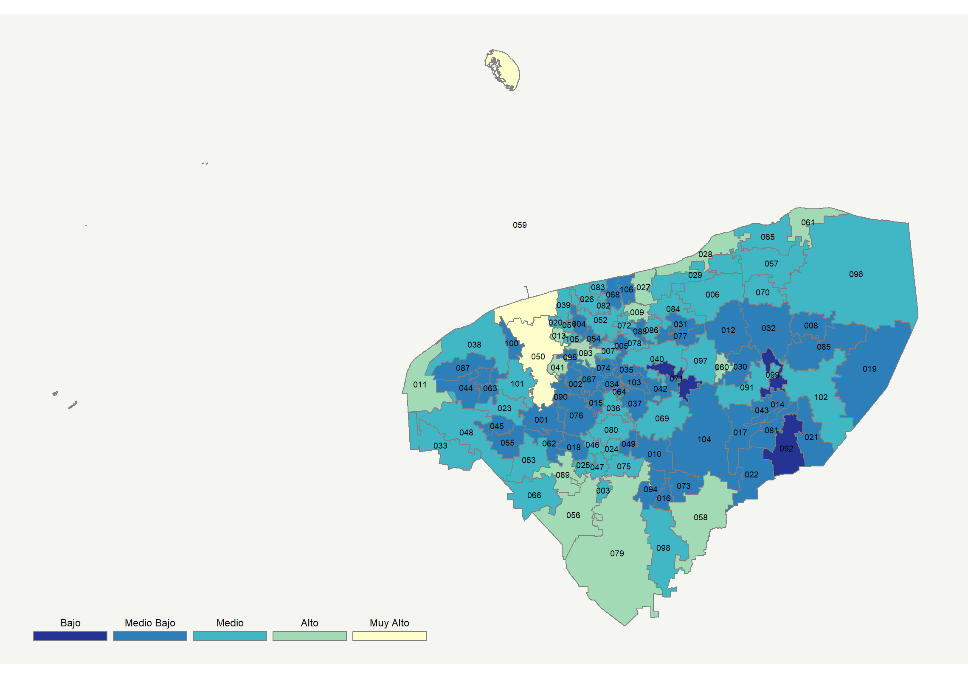

|  |  |  |  |  |  |  |  |  |  |  |  |  |  |
| --- | --- | --- | --- | --- | --- | --- | --- | --- | --- | --- | --- | --- | --- |
| **Clave del Municipio** | **Municipio** | **Telefonía fija a** | **Telefonía Celular a** | **Internet a** | **Televisión de paga a** | **Población Total a** | **Hasta 2 Salarios Mínimos b** | **Índice de Marginación** | **índice** | **Índice Escala 0-100** | **Lugar Nacional** | **Lugar Estatal** | **Estrato** |
| 001 | Abalá | 0.4 | 69.4 | 3.2 | 25.8 | 6,502 | 53.6 | 0.66 | -0.48 | 20.4 | 1712 | 94 | Medio Bajo |
| 002 | Acanceh | 3.3 | 77.4 | 5.4 | 27.1 | 16,127 | 51.0 | -0.31 | -0.29 | 24.3 | 1487 | 74 | Medio Bajo |
| 003 | Akil | 4.8 | 71.1 | 6.8 | 67.5 | 11,312 | 78.9 | 0.23 | 0.16 | 33.1 | 964 | 28 | Medio |
| 004 | Baca | 3.9 | 73.7 | 6.3 | 27.9 | 5,811 | 60.5 | -0.16 | -0.28 | 24.3 | 1483 | 73 | Medio Bajo |
| 005 | Bokobá | 2.0 | 74.1 | 0.8 | 34.1 | 2,191 | 54.1 | -0.07 | -0.37 | 22.5 | 1587 | 87 | Medio Bajo |
| 006 | Buctzotz | 4.7 | 71.6 | 10.6 | 52.0 | 8,887 | 69.0 | -0.07 | 0.08 | 31.5 | 1051 | 36 | Medio |
| 007 | Cacalchén | 5.2 | 78.6 | 9.0 | 41.4 | 7,224 | 59.1 | -0.40 | 0.00 | 30.0 | 1144 | 42 | Medio |
| 008 | Calotmul | 3.1 | 55.6 | 3.8 | 47.1 | 3,992 | 77.9 | 0.63 | -0.32 | 23.6 | 1528 | 81 | Medio Bajo |
| 009 | Cansahcab | 7.4 | 75.3 | 18.8 | 71.5 | 4,580 | 70.8 | 0.23 | 0.58 | 41.3 | 544 | 8 | Alto |
| 010 | Cantamayec | 1.5 | 57.7 | 4.6 | 47.1 | 2,519 | 59.1 | 1.26 | -0.31 | 23.8 | 1511 | 77 | Medio Bajo |
| 011 | Celestún | 3.6 | 82.5 | 9.4 | 79.8 | 7,836 | 63.0 | -0.25 | 0.45 | 38.9 | 661 | 12 | Alto |
| 012 | Cenotillo | 6.7 | 73.2 | 5.7 | 34.2 | 3,886 | 73.7 | 0.32 | -0.19 | 26.3 | 1366 | 65 | Medio Bajo |
| 013 | Conkal | 13.2 | 89.8 | 24.6 | 38.7 | 11,141 | 39.7 | -1.07 | 0.59 | 41.6 | 532 | 7 | Alto |
| 014 | Cuncunul | 4.0 | 61.7 | 5.5 | 42.7 | 1,572 | 61.5 | 0.46 | -0.25 | 24.9 | 1450 | 71 | Medio Bajo |
| 015 | Cuzamá | 1.9 | 73.1 | 9.2 | 35.9 | 5,181 | 61.2 | 0.40 | -0.16 | 26.7 | 1333 | 63 | Medio Bajo |
| 016 | Chacsinkín | 4.5 | 59.2 | 0.9 | 66.0 | 3,015 | 70.6 | 0.73 | -0.12 | 27.5 | 1282 | 57 | Medio Bajo |
| 017 | Chankom | 6.2 | 38.1 | 5.1 | 32.1 | 4,583 | 63.1 | 1.09 | -0.58 | 18.5 | 1817 | 99 | Medio Bajo |
| 018 | Chapab | 3.3 | 64.4 | 4.8 | 54.9 | 3,153 | 66.9 | 0.66 | -0.12 | 27.6 | 1280 | 56 | Medio Bajo |
| 019 | Chemax | 0.9 | 49.5 | 3.8 | 26.3 | 36,881 | 66.4 | 1.52 | -0.65 | 17.1 | 1884 | 102 | Medio Bajo |
| 020 | Chicxulub Pueblo | 5.7 | 82.4 | 13.2 | 27.2 | 4,468 | 46.8 | -0.34 | -0.01 | 29.7 | 1151 | 43 | Medio |
| 021 | Chichimilá | 3.5 | 56.0 | 2.1 | 17.1 | 8,371 | 76.5 | 0.92 | -0.69 | 16.4 | 1912 | 103 | Medio Bajo |
| 022 | Chikindzonot | 5.3 | 37.2 | 1.7 | 43.3 | 4,166 | 84.0 | 1.53 | -0.56 | 18.8 | 1798 | 98 | Medio Bajo |
| 023 | Chocholá | 2.8 | 78.7 | 15.7 | 52.5 | 4,691 | 53.0 | -0.18 | 0.25 | 34.8 | 867 | 22 | Medio |
| 024 | Chumayel | 4.7 | 70.0 | 7.6 | 71.1 | 3,308 | 78.8 | 1.00 | 0.21 | 34.0 | 912 | 24 | Medio |
| 025 | Dzán | 6.3 | 75.2 | 8.3 | 41.3 | 5,357 | 77.6 | 0.18 | -0.03 | 29.3 | 1178 | 45 | Medio |
| 026 | Dzemul | 7.1 | 75.8 | 7.6 | 39.0 | 3,662 | 60.4 | -0.16 | -0.05 | 28.9 | 1200 | 47 | Medio |
| 027 | Dzidzantún | 8.4 | 79.2 | 21.6 | 70.6 | 8,176 | 59.8 | -0.73 | 0.69 | 43.5 | 462 | 5 | Alto |
| 028 | Dzilam de Bravo | 2.4 | 86.1 | 9.9 | 80.9 | 2,744 | 55.6 | -0.25 | 0.49 | 39.6 | 614 | 11 | Alto |
| 029 | Dzilam González | 3.6 | 72.0 | 10.1 | 73.7 | 6,120 | 68.6 | -0.34 | 0.30 | 35.8 | 823 | 19 | Medio |
| 030 | Dzitás | 0.9 | 58.0 | 8.1 | 44.1 | 3,783 | 70.0 | 0.97 | -0.26 | 24.7 | 1464 | 72 | Medio Bajo |
| 031 | Dzoncauich | 7.2 | 62.0 | 2.9 | 53.9 | 2,609 | 78.7 | 0.75 | -0.14 | 27.2 | 1300 | 59 | Medio Bajo |
| 032 | Espita | 3.3 | 59.4 | 5.2 | 41.0 | 16,071 | 66.3 | 0.76 | -0.32 | 23.7 | 1522 | 80 | Medio Bajo |
| 033 | Halachó | 3.8 | 64.8 | 6.3 | 72.5 | 20,152 | 61.9 | 0.37 | 0.12 | 32.4 | 1002 | 30 | Medio |
| 034 | Hocabá | 0.7 | 68.7 | 2.3 | 27.0 | 6,089 | 61.6 | 0.72 | -0.49 | 20.2 | 1723 | 95 | Medio Bajo |
| 035 | Hoctún | 6.0 | 68.6 | 5.3 | 30.0 | 5,976 | 57.6 | 0.64 | -0.30 | 24.0 | 1502 | 75 | Medio Bajo |
| 036 | Homún | 2.4 | 74.2 | 4.3 | 55.3 | 7,670 | 63.0 | 0.17 | -0.05 | 29.0 | 1192 | 46 | Medio |
| 037 | Huhí | 2.2 | 72.6 | 5.1 | 46.8 | 5,218 | 70.3 | 0.49 | -0.14 | 27.2 | 1305 | 60 | Medio Bajo |
| 038 | Hunucmá | 6.0 | 79.4 | 11.9 | 27.5 | 32,475 | 60.7 | -0.08 | -0.06 | 28.7 | 1212 | 50 | Medio |
| 039 | Ixil | 1.9 | 81.9 | 14.1 | 26.7 | 4,073 | 58.1 | -0.15 | -0.06 | 28.7 | 1210 | 49 | Medio |
| 040 | Izamal | 5.9 | 73.6 | 9.0 | 45.4 | 26,801 | 63.6 | -0.12 | 0.01 | 30.1 | 1135 | 41 | Medio |
| 041 | Kanasín | 14.0 | 91.6 | 21.5 | 39.0 | 96,317 | 44.7 | -0.95 | 0.55 | 40.8 | 563 | 9 | Alto |
| 042 | Kantunil | 0.8 | 70.1 | 2.2 | 33.2 | 5,455 | 59.4 | 0.48 | -0.41 | 21.8 | 1628 | 90 | Medio Bajo |
| 043 | Kaua | 0.6 | 67.2 | 3.2 | 42.3 | 3,119 | 72.4 | 0.69 | -0.32 | 23.7 | 1520 | 79 | Medio Bajo |
| 044 | Kinchil | 0.9 | 74.1 | 12.4 | 30.4 | 7,187 | 69.8 | 0.33 | -0.15 | 26.9 | 1323 | 62 | Medio Bajo |
| 045 | Kopomá | 0.7 | 62.6 | 1.7 | 50.5 | 2,515 | 68.9 | 0.10 | -0.30 | 23.9 | 1507 | 76 | Medio Bajo |
| 046 | Mama | 8.5 | 61.2 | 5.5 | 57.1 | 3,210 | 76.8 | 0.66 | -0.03 | 29.4 | 1173 | 44 | Medio |
| 047 | Maní | 7.2 | 72.4 | 5.7 | 55.2 | 5,637 | 73.4 | 0.57 | 0.05 | 30.9 | 1099 | 38 | Medio |
| 048 | Maxcanú | 5.3 | 64.6 | 10.7 | 62.0 | 22,619 | 57.2 | 0.30 | 0.14 | 32.6 | 987 | 29 | Medio |
| 049 | Mayapán | 1.5 | 57.9 | 1.9 | 62.2 | 3,700 | 71.4 | 2.02 | -0.20 | 25.9 | 1387 | 68 | Medio Bajo |
| 050 | Mérida | 41.5 | 92.0 | 49.7 | 54.8 | 892,363 | 34.6 | -1.48 | 1.87 | 66.8 | 54 | 1 | Muy Alto |
| 051 | Mocochá | 4.5 | 78.6 | 12.6 | 26.2 | 3,218 | 54.1 | -0.31 | -0.09 | 28.1 | 1246 | 54 | Medio |
| 052 | Motul | 8.6 | 74.4 | 10.8 | 29.7 | 36,097 | 51.1 | -0.37 | -0.07 | 28.6 | 1221 | 51 | Medio |
| 053 | Muna | 12.7 | 69.6 | 14.2 | 45.6 | 12,722 | 67.5 | -0.17 | 0.21 | 34.0 | 908 | 23 | Medio |
| 054 | Muxupip | 4.1 | 67.6 | 4.7 | 21.2 | 2,837 | 60.9 | 0.06 | -0.45 | 21.0 | 1682 | 93 | Medio Bajo |
| 055 | Opichén | 2.3 | 63.3 | 2.4 | 60.7 | 6,789 | 51.8 | 0.33 | -0.14 | 27.1 | 1307 | 61 | Medio Bajo |
| 056 | Oxkutzcab | 22.2 | 64.3 | 16.8 | 65.0 | 31,202 | 69.7 | 0.18 | 0.59 | 41.6 | 531 | 6 | Alto |
| 057 | Panabá | 9.9 | 71.3 | 5.8 | 71.0 | 7,792 | 73.4 | 0.07 | 0.26 | 35.1 | 859 | 21 | Medio |
| 058 | Peto | 12.7 | 66.5 | 18.4 | 65.4 | 25,264 | 65.3 | 0.27 | 0.50 | 39.8 | 604 | 10 | Alto |
| 059 | Progreso | 14.8 | 92.6 | 39.1 | 67.8 | 59,122 | 39.8 | -1.06 | 1.32 | 56.0 | 171 | 2 | Muy Alto |
| 060 | Quintana Roo | 0.7 | 75.3 | 18.0 | 70.2 | 963 | 66.7 | 0.28 | 0.43 | 38.4 | 688 | 14 | Alto |
| 061 | Río Lagartos | 15.1 | 84.4 | 23.6 | 64.8 | 3,502 | 58.1 | -0.13 | 0.84 | 46.5 | 372 | 3 | Alto |
| 062 | Sacalum | 1.6 | 75.0 | 7.2 | 41.7 | 4,819 | 62.0 | 0.27 | -0.13 | 27.3 | 1297 | 58 | Medio Bajo |
| 063 | Samahil | 4.4 | 72.9 | 4.7 | 23.2 | 5,119 | 67.2 | 0.10 | -0.38 | 22.5 | 1588 | 88 | Medio Bajo |
| 064 | Sanahcat | 1.6 | 64.0 | 2.8 | 28.7 | 1,678 | 61.2 | 0.15 | -0.49 | 20.2 | 1726 | 96 | Medio Bajo |
| 065 | San Felipe | 7.2 | 88.5 | 5.5 | 73.1 | 1,945 | 60.5 | -0.32 | 0.40 | 37.9 | 718 | 16 | Medio |
| 066 | Santa Elena | 9.2 | 64.1 | 5.0 | 66.4 | 4,047 | 68.8 | 0.39 | 0.11 | 32.0 | 1026 | 34 | Medio |
| 067 | Seyé | 1.5 | 71.9 | 4.4 | 25.1 | 9,724 | 46.8 | -0.18 | -0.42 | 21.7 | 1637 | 91 | Medio Bajo |
| 068 | Sinanché | 3.1 | 73.2 | 4.8 | 41.9 | 3,088 | 66.0 | 0.01 | -0.18 | 26.4 | 1361 | 64 | Medio Bajo |
| 069 | Sotuta | 3.4 | 63.3 | 12.4 | 60.0 | 8,902 | 59.5 | 0.58 | 0.11 | 32.1 | 1023 | 33 | Medio |
| 070 | Sucilá | 5.8 | 79.1 | 7.1 | 62.6 | 3,918 | 70.3 | 0.02 | 0.21 | 34.0 | 913 | 25 | Medio |
| 071 | Sudzal | 0.7 | 56.6 | 2.0 | 16.8 | 1,710 | 52.3 | 0.20 | -0.73 | 15.4 | 1956 | 104 | Bajo |
| 072 | Suma | 1.3 | 78.2 | 13.3 | 30.1 | 1,762 | 63.3 | -0.29 | -0.09 | 28.2 | 1242 | 52 | Medio |
| 073 | Tahdziú | 5.1 | 46.4 | 9.5 | 50.8 | 5,111 | 73.5 | 1.07 | -0.20 | 25.9 | 1384 | 67 | Medio Bajo |
| 074 | Tahmek | 0.9 | 73.9 | 3.9 | 33.3 | 3,641 | 66.8 | 0.24 | -0.33 | 23.4 | 1536 | 82 | Medio Bajo |
| 075 | Teabo | 2.4 | 70.5 | 13.9 | 72.7 | 6,551 | 70.7 | 0.66 | 0.34 | 36.7 | 776 | 17 | Medio |
| 076 | Tecoh | 1.6 | 72.9 | 9.1 | 23.3 | 17,609 | 57.3 | 0.30 | -0.31 | 23.8 | 1517 | 78 | Medio Bajo |
| 077 | Tekal de Venegas | 1.8 | 60.6 | 3.3 | 38.0 | 2,616 | 70.4 | 0.61 | -0.41 | 21.9 | 1626 | 89 | Medio Bajo |
| 078 | Tekantó | 2.9 | 72.9 | 11.9 | 35.3 | 3,786 | 64.5 | 0.29 | -0.09 | 28.1 | 1244 | 53 | Medio |
| 079 | Tekax | 14.3 | 65.8 | 13.4 | 66.5 | 42,440 | 63.9 | -0.05 | 0.41 | 38.1 | 706 | 15 | Alto |
| 080 | Tekit | 3.2 | 72.4 | 9.3 | 73.1 | 10,232 | 66.4 | 0.15 | 0.27 | 35.2 | 843 | 20 | Medio |
| 81 | Tekom | 1.0 | 62.5 | 1.0 | 21.1 | 3,216 | 73.9 | 0.85 | -0.65 | 17.2 | 1880 | 101 | Medio Bajo |
| 082 | Telchac Pueblo | 8.0 | 76.2 | 13.6 | 37.2 | 3,704 | 62.6 | -0.29 | 0.09 | 31.6 | 1048 | 35 | Medio |
| 083 | Telchac Puerto | 6.5 | 81.6 | 5.9 | 45.6 | 1,778 | 56.1 | -0.34 | 0.03 | 30.4 | 1119 | 40 | Medio |
| 084 | Temax | 3.1 | 71.1 | 2.9 | 67.2 | 7,210 | 71.4 | 0.31 | 0.03 | 30.6 | 1115 | 39 | Medio |
| 085 | Temozón | 1.1 | 58.2 | 2.4 | 22.2 | 15,503 | 75.2 | 0.88 | -0.64 | 17.3 | 1878 | 100 | Medio Bajo |
| 086 | Tepakán | 0.9 | 57.5 | 30.5 | 24.8 | 2,134 | 67.4 | 0.72 | 0.06 | 31.0 | 1092 | 37 | Medio |
| 087 | Tetiz | 3.3 | 69.8 | 7.2 | 14.9 | 5,124 | 75.5 | 0.91 | -0.45 | 21.0 | 1680 | 92 | Medio Bajo |
| 088 | Teya | 0.9 | 61.1 | 18.6 | 24.5 | 1,916 | 59.7 | 0.27 | -0.20 | 26.0 | 1379 | 66 | Medio Bajo |
| 089 | Ticul | 17.6 | 76.4 | 19.1 | 74.4 | 40,161 | 60.2 | -0.45 | 0.80 | 45.6 | 398 | 4 | Alto |
| 090 | Timucuy | 1.0 | 74.2 | 4.5 | 12.8 | 7,362 | 56.2 | 0.73 | -0.54 | 19.3 | 1774 | 97 | Medio Bajo |
| 091 | Tinum | 3.5 | 67.9 | 13.4 | 53.8 | 11,942 | 66.7 | 0.20 | 0.11 | 32.2 | 1015 | 32 | Medio |
| 092 | Tixcacalcupul | 1.4 | 49.4 | 3.5 | 13.9 | 7,157 | 75.3 | 1.50 | -0.79 | 14.3 | 2012 | 105 | Bajo |
| 093 | Tixkokob | 11.2 | 81.4 | 23.8 | 37.6 | 17,787 | 52.1 | -0.69 | 0.44 | 38.6 | 673 | 13 | Alto |
| 094 | Tixmehuac | 2.5 | 50.5 | 2.3 | 63.7 | 4,813 | 73.4 | 0.95 | -0.23 | 25.3 | 1425 | 70 | Medio Bajo |
| 095 | Tixpéhual | 2.6 | 78.0 | 6.5 | 21.2 | 5,407 | 58.0 | -0.20 | -0.33 | 23.3 | 1540 | 83 | Medio Bajo |
| 096 | Tizimín | 12.0 | 70.9 | 13.2 | 46.1 | 77,621 | 63.9 | 0.25 | 0.19 | 33.7 | 932 | 26 | Medio |
| 097 | Tunkás | 4.4 | 67.6 | 4.8 | 56.2 | 3,522 | 69.1 | 0.71 | -0.06 | 28.8 | 1203 | 48 | Medio |
| 098 | Tzucacab | 6.7 | 61.6 | 5.9 | 71.1 | 14,784 | 66.8 | 0.36 | 0.11 | 32.2 | 1014 | 31 | Medio |
| 099 | Uayma | 0.0 | 52.3 | 0.9 | 12.0 | 4,056 | 64.0 | 1.04 | -0.87 | 12.8 | 2074 | 106 | Bajo |
| 100 | Ucú | 2.3 | 84.1 | 4.7 | 31.1 | 3,682 | 62.1 | 0.12 | -0.21 | 25.8 | 1393 | 69 | Medio Bajo |
| 101 | Umán | 7.2 | 87.4 | 19.9 | 37.3 | 55,261 | 52.8 | -0.62 | 0.34 | 36.6 | 783 | 18 | Medio |
| 102 | Valladolid | 10.2 | 76.7 | 16.1 | 35.8 | 80,313 | 58.9 | 0.09 | 0.18 | 33.4 | 953 | 27 | Medio |
| 103 | Xocchel | 1.9 | 73.5 | 3.0 | 30.7 | 3,482 | 59.4 | 0.51 | -0.37 | 22.7 | 1581 | 86 | Medio Bajo |
| 104 | Yaxcabá | 2.0 | 47.2 | 5.9 | 49.2 | 15,203 | 57.1 | 1.17 | -0.35 | 23.1 | 1558 | 84 | Medio Bajo |
| 105 | Yaxkukul | 3.9 | 84.1 | 11.9 | 23.7 | 3,109 | 59.1 | -0.30 | -0.09 | 28.1 | 1247 | 55 | Medio |
| 106 | Yobaín | 3.1 | 69.8 | 5.7 | 26.5 | 2,227 | 65.0 | 0.09 | -0.37 | 22.7 | 1579 | 85 | Medio Bajo |
| a Porcentaje de viviendas que cuentas con el servicio  b Ingreso por trabajo de la población ocupada en porcentaje  Fuente: Elaboración propia con datos de Encuesta Intercensal 2015 de INEGI y CONAPO | | | | | | | | | | | | | | |

**Zacatecas**

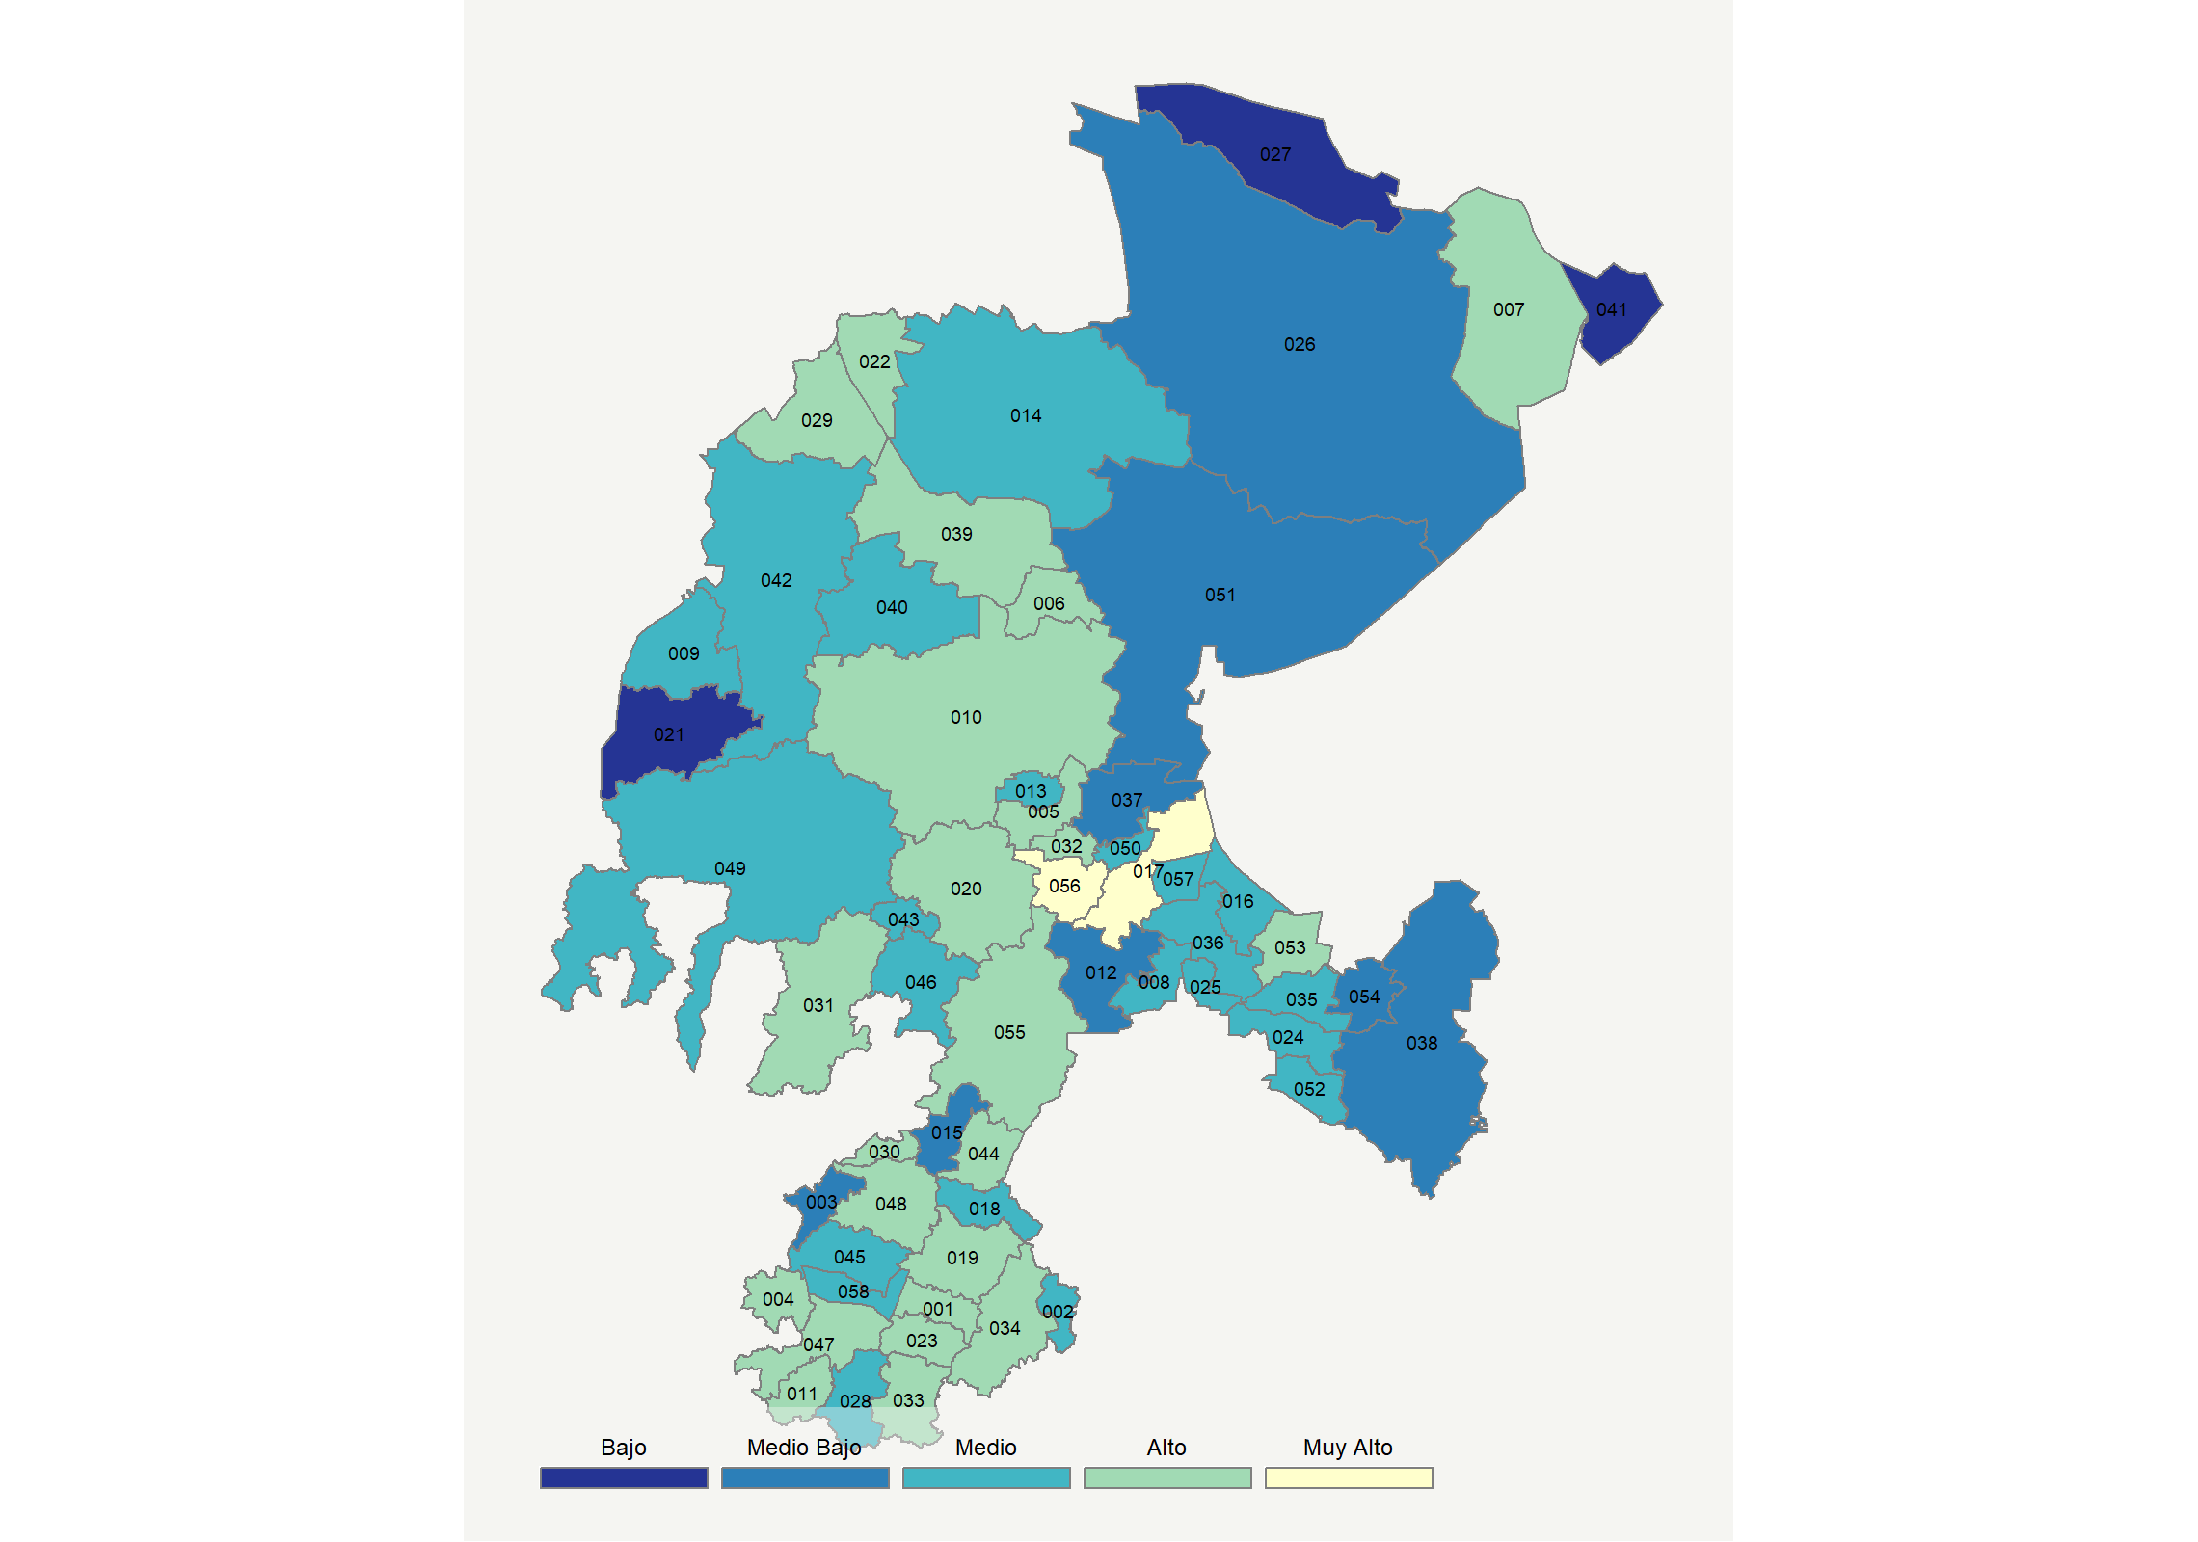

|  |  |  |  |  |  |  |  |  |  |  |  |  |  |
| --- | --- | --- | --- | --- | --- | --- | --- | --- | --- | --- | --- | --- | --- |
| **Clave del Municipio** | **Municipio** | **Telefonía fija a** | **Telefonía Celular a** | **Internet a** | **Televisión de paga a** | **Población Total a** | **Hasta 2 Salarios Mínimos b** | **Índice de Marginación** | **índice** | **Índice Escala 0-100** | **Lugar Nacional** | **Lugar Estatal** | **Estrato** |
| 001 | Apozol | 29.7 | 74.0 | 12.9 | 37.5 | 6,086 | 66.7 | -0.32 | 0.41 | 38.0 | 707 | 24 | Alto |
| 002 | Apulco | 37.7 | 33.1 | 7.4 | 32.7 | 4,738 | 48.3 | -0.25 | -0.05 | 29.0 | 1190 | 45 | Medio |
| 003 | Atolinga | 36.1 | 29.3 | 7.6 | 31.8 | 2,427 | 46.2 | -0.46 | -0.11 | 27.7 | 1275 | 49 | Medio Bajo |
| 004 | Benito Juárez | 33.7 | 76.1 | 15.5 | 32.7 | 3,990 | 42.7 | -0.66 | 0.51 | 40.0 | 600 | 18 | Alto |
| 005 | Calera | 27.4 | 80.3 | 22.0 | 25.7 | 45,204 | 45.8 | -1.14 | 0.53 | 40.3 | 587 | 17 | Alto |
| 006 | Cañitas de Felipe Pescador | 32.2 | 63.8 | 12.5 | 44.6 | 8,393 | 58.8 | -0.90 | 0.42 | 38.3 | 695 | 23 | Alto |
| 007 | Concepción del Oro | 23.0 | 73.3 | 19.2 | 67.0 | 12,944 | 35.7 | -1.04 | 0.78 | 45.2 | 413 | 9 | Alto |
| 008 | Cuauhtémoc | 21.2 | 60.6 | 8.4 | 37.8 | 12,590 | 63.5 | -0.52 | 0.04 | 30.6 | 1110 | 42 | Medio |
| 009 | Chalchihuites | 32.3 | 69.4 | 13.3 | 26.2 | 11,416 | 43.9 | -0.62 | 0.29 | 35.7 | 826 | 29 | Medio |
| 010 | Fresnillo | 32.0 | 73.7 | 26.3 | 51.6 | 230,865 | 47.4 | -1.02 | 0.93 | 48.2 | 325 | 6 | Alto |
| 011 | Trinidad García de la Cadena | 47.9 | 66.3 | 20.7 | 41.4 | 2,884 | 34.7 | -0.75 | 0.87 | 47.1 | 354 | 8 | Alto |
| 012 | Genaro Codina | 8.8 | 59.5 | 1.2 | 17.6 | 8,185 | 53.1 | -0.06 | -0.58 | 18.5 | 1818 | 55 | Medio Bajo |
| 013 | General Enrique Estrada | 21.2 | 77.2 | 9.7 | 23.0 | 6,325 | 46.7 | -0.72 | 0.06 | 31.2 | 1076 | 40 | Medio |
| 014 | General Francisco R. Murguía | 24.0 | 44.4 | 7.6 | 42.8 | 21,809 | 57.3 | -0.37 | -0.04 | 29.1 | 1187 | 44 | Medio |
| 015 | El Plateado de Joaquín Amaro | 15.7 | 34.3 | 2.9 | 28.5 | 1,160 | 49.4 | -0.29 | -0.55 | 19.0 | 1790 | 54 | Medio Bajo |
| 016 | General Pánfilo Natera | 32.1 | 65.0 | 7.5 | 21.0 | 23,192 | 69.1 | -0.15 | 0.05 | 30.9 | 1097 | 41 | Medio |
| 017 | Guadalupe | 38.8 | 89.6 | 48.5 | 53.3 | 187,918 | 29.2 | -1.66 | 1.75 | 64.5 | 70 | 2 | Muy Alto |
| 018 | Huanusco | 29.4 | 41.7 | 11.8 | 42.0 | 4,084 | 58.4 | -0.46 | 0.11 | 32.2 | 1018 | 36 | Medio |
| 019 | Jalpa | 36.8 | 68.5 | 21.0 | 34.5 | 24,093 | 52.8 | -0.83 | 0.64 | 42.5 | 498 | 12 | Alto |
| 020 | Jerez | 49.0 | 67.6 | 28.9 | 43.5 | 59,125 | 54.0 | -1.09 | 1.12 | 52.1 | 253 | 3 | Alto |
| 021 | Jiménez del Teul | 15.7 | 3.8 | 2.8 | 23.5 | 4,275 | 58.5 | 0.42 | -0.91 | 11.9 | 2103 | 58 | Bajo |
| 022 | Juan Aldama | 42.6 | 61.6 | 20.3 | 29.5 | 21,806 | 58.1 | -0.94 | 0.59 | 41.6 | 533 | 15 | Alto |
| 023 | Juchipila | 45.4 | 69.5 | 25.1 | 39.9 | 12,627 | 46.6 | -1.04 | 0.95 | 48.6 | 313 | 4 | Alto |
| 024 | Loreto | 22.5 | 75.6 | 14.6 | 42.7 | 53,441 | 55.5 | -0.82 | 0.41 | 38.0 | 713 | 26 | Medio |
| 025 | Luis Moya | 26.9 | 65.3 | 11.8 | 33.7 | 13,292 | 58.1 | -0.71 | 0.21 | 34.1 | 903 | 32 | Medio |
| 026 | Mazapil | 9.2 | 28.4 | 1.7 | 70.2 | 17,457 | 51.5 | 0.11 | -0.28 | 24.4 | 1481 | 52 | Medio Bajo |
| 027 | Melchor Ocampo | 1.9 | 18.1 | 0.2 | 46.7 | 2,938 | 53.0 | -0.16 | -0.80 | 14.1 | 2022 | 57 | Bajo |
| 028 | Mezquital del Oro | 26.6 | 38.9 | 9.6 | 35.8 | 2,484 | 35.7 | -0.34 | -0.08 | 28.3 | 1235 | 47 | Medio |
| 029 | Miguel Auza | 32.6 | 75.8 | 13.8 | 31.0 | 23,827 | 54.6 | -0.97 | 0.43 | 38.4 | 690 | 21 | Alto |
| 030 | Momax | 37.8 | 74.3 | 17.7 | 31.1 | 2,404 | 54.4 | -0.61 | 0.60 | 41.7 | 530 | 14 | Alto |
| 031 | Monte Escobedo | 40.0 | 65.9 | 14.3 | 44.8 | 9,129 | 50.4 | -0.50 | 0.62 | 42.1 | 511 | 13 | Alto |
| 032 | Morelos | 40.4 | 75.1 | 23.9 | 42.2 | 12,354 | 34.8 | -1.32 | 0.92 | 48.0 | 332 | 7 | Alto |
| 033 | Moyahua de Estrada | 40.2 | 61.0 | 13.8 | 32.4 | 3,947 | 41.7 | -0.69 | 0.42 | 38.3 | 694 | 22 | Alto |
| 034 | Nochistlán de Mejía | 35.1 | 73.2 | 19.8 | 30.9 | 27,750 | 46.8 | -0.97 | 0.59 | 41.5 | 534 | 16 | Alto |
| 035 | Noria de Ángeles | 18.4 | 67.3 | 5.9 | 36.1 | 16,864 | 54.9 | -0.37 | -0.02 | 29.4 | 1171 | 43 | Medio |
| 036 | Ojocaliente | 25.5 | 67.7 | 11.1 | 31.9 | 43,471 | 60.7 | -0.52 | 0.18 | 33.4 | 954 | 33 | Medio |
| 037 | Pánuco | 15.8 | 66.5 | 7.4 | 17.4 | 17,647 | 50.2 | -0.42 | -0.25 | 25.0 | 1447 | 51 | Medio Bajo |
| 038 | Pinos | 17.9 | 50.8 | 3.5 | 25.8 | 73,151 | 60.8 | -0.01 | -0.37 | 22.6 | 1583 | 53 | Medio Bajo |
| 039 | Río Grande | 40.8 | 70.5 | 20.3 | 38.9 | 63,880 | 50.8 | -0.93 | 0.76 | 44.8 | 425 | 10 | Alto |
| 040 | Sain Alto | 36.2 | 43.1 | 6.0 | 26.1 | 22,278 | 65.2 | -0.36 | -0.08 | 28.4 | 1229 | 46 | Medio |
| 041 | El Salvador | 6.2 | 22.5 | 0.5 | 44.2 | 2,455 | 68.3 | 0.27 | -0.71 | 15.9 | 1929 | 56 | Bajo |
| 042 | Sombrerete | 28.8 | 68.1 | 14.9 | 32.4 | 62,433 | 46.2 | -0.80 | 0.33 | 36.5 | 790 | 28 | Medio |
| 043 | Susticacán | 56.2 | 33.2 | 7.0 | 23.5 | 1,329 | 59.5 | -0.30 | 0.15 | 32.9 | 970 | 34 | Medio |
| 044 | Tabasco | 34.6 | 66.8 | 12.6 | 41.3 | 15,484 | 59.5 | -0.65 | 0.46 | 38.9 | 655 | 20 | Alto |
| 045 | Tepechitlán | 27.3 | 68.6 | 13.8 | 36.8 | 8,855 | 54.0 | -0.46 | 0.33 | 36.5 | 788 | 27 | Medio |
| 046 | Tepetongo | 44.0 | 50.3 | 10.2 | 31.7 | 7,071 | 62.8 | -0.28 | 0.29 | 35.6 | 831 | 30 | Medio |
| 047 | Teúl de González Ortega | 43.1 | 65.1 | 25.9 | 45.3 | 5,378 | 44.3 | -0.84 | 0.95 | 48.6 | 314 | 5 | Alto |
| 048 | Tlaltenango de Sánchez Román | 27.6 | 77.5 | 22.9 | 38.9 | 26,645 | 48.0 | -0.98 | 0.67 | 43.1 | 473 | 11 | Alto |
| 049 | Valparaíso | 34.0 | 54.8 | 11.6 | 35.8 | 32,606 | 50.8 | -0.44 | 0.25 | 34.8 | 870 | 31 | Medio |
| 050 | Vetagrande | 24.1 | 70.7 | 12.2 | 24.5 | 9,796 | 42.8 | -0.69 | 0.13 | 32.4 | 998 | 35 | Medio |
| 051 | Villa de Cos | 26.1 | 47.3 | 7.6 | 23.6 | 35,252 | 56.6 | -0.45 | -0.19 | 26.1 | 1376 | 50 | Medio Bajo |
| 052 | Villa García | 18.4 | 68.5 | 8.7 | 39.5 | 18,745 | 50.3 | -0.79 | 0.09 | 31.8 | 1039 | 37 | Medio |
| 053 | Villa González Ortega | 33.8 | 62.3 | 18.5 | 29.5 | 13,099 | 51.6 | -0.64 | 0.41 | 38.0 | 711 | 25 | Alto |
| 054 | Villa Hidalgo | 19.0 | 64.9 | 7.6 | 26.7 | 19,155 | 63.3 | -0.19 | -0.10 | 27.9 | 1263 | 48 | Medio Bajo |
| 055 | Villanueva | 37.4 | 65.0 | 12.7 | 38.9 | 30,240 | 53.6 | -0.75 | 0.46 | 39.1 | 646 | 19 | Alto |
| 056 | Zacatecas | 49.0 | 88.5 | 55.2 | 59.8 | 146,147 | 28.5 | -1.79 | 2.15 | 72.2 | 31 | 1 | Muy Alto |
| 057 | Trancoso | 18.7 | 67.7 | 12.1 | 32.4 | 19,413 | 46.5 | -0.92 | 0.09 | 31.7 | 1045 | 38 | Medio |
| 058 | Santa María de la Paz | 36.9 | 33.9 | 15.9 | 24.8 | 2,656 | 51.3 | -0.44 | 0.07 | 31.2 | 1074 | 39 | Medio |
| a Porcentaje de viviendas que cuentas con el servicio  b Ingreso por trabajo de la población ocupada en porcentaje  Fuente: Elaboración propia con datos de Encuesta Intercensal 2015 de INEGI y CONAPO | | | | | | | | | | | | | |